# Computer Science Applications

## Activity 2.5.8: Static Variable and Methods

Copy and paste screenshots and/or answer questions from the activity.

#26 Screenshot of your Song() class

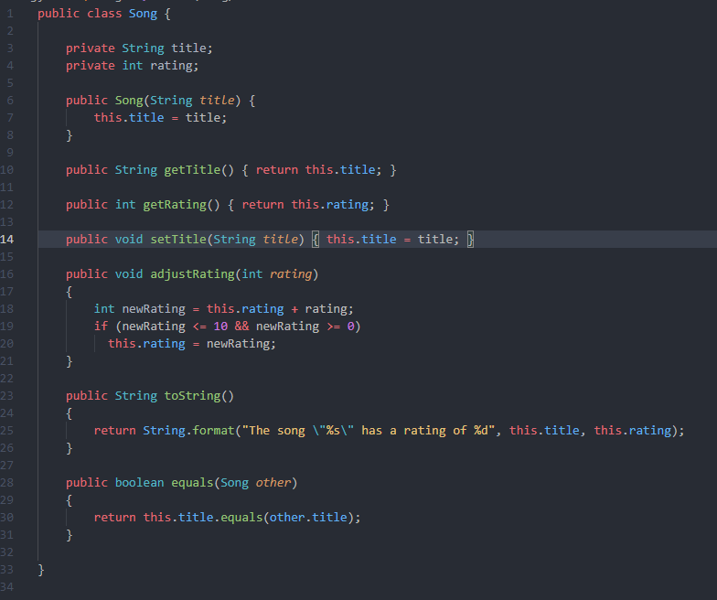

#27 Screenshot of your modified MediaLib() class

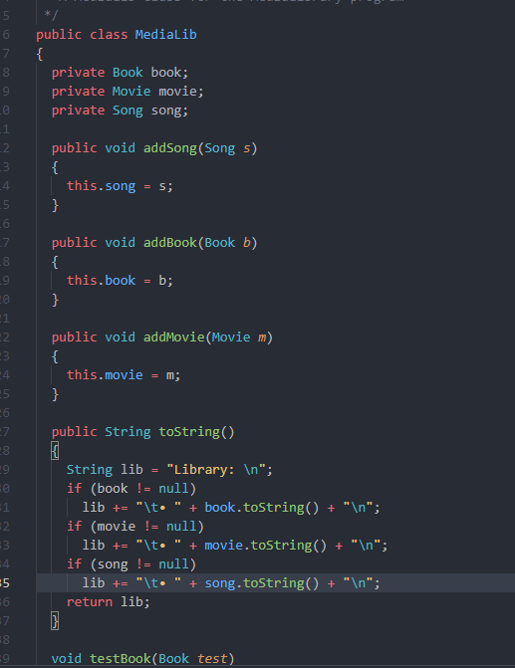

#28 Screenshot of code and output

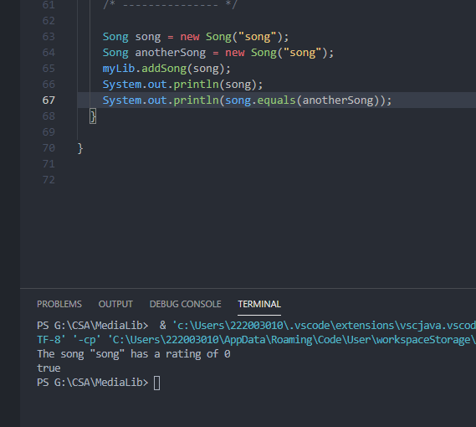

#29 Screenshot of your output… individually track the number of books, the number of movies, and the number of songs that you have added to all of your libraries.

