# Computer Science Applications

## Activity 2.5.9: Scope and Access--FRQ

In this part of the activity, you will answer a Free Response Question (FRQ). Recall that an FRQ defines a set of requirements that an algorithm must meet. You provide answers to the FRQ in the form of handwritten Java code on the actual AP Exam. For the practice question below, type your answer in a notepad document. Do not use a compiler to create your answer.

**AP Exam**: The structure of this FRQ is similar to what you will see on an AP exam in that it has two parts, part a) and part b). You should answer parts a) and b) in the order presented. However, if you cannot answer part a) continue on to part b) as solutions are graded independently and you may get full credit for either part.

The FRQ you will answer is titled *Book*and requires you to write constructors and methods.

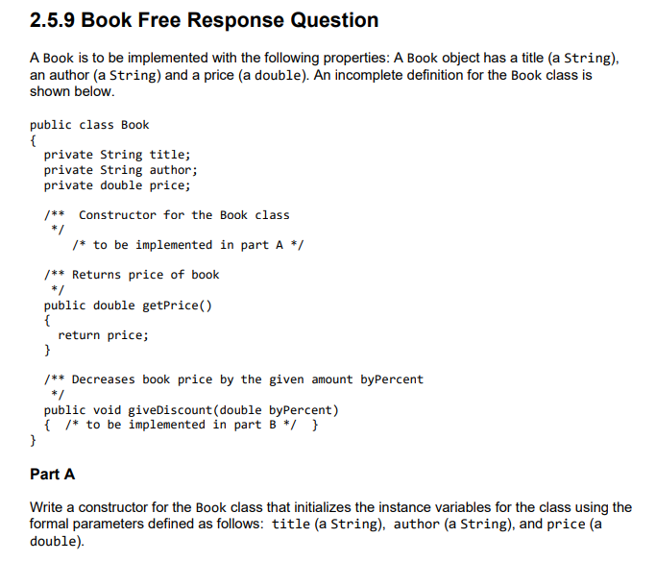

public Book(String title, String author, double price)

{

this.title = title;

this.author = author;

this.price = price;

}

