# Computer Science Applications

**Activity 3.6.1 Array Creation and Access**

Copy and paste screenshots and/or answer questions from the activity.

#8 Screenshot of code and output

#16 Screenshot of code and output

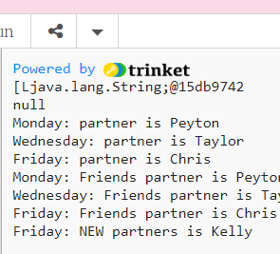

#27 Screenshot of code and output

