# Computer Science Applications

**Activity 3.6.2 Traversing Arrays**

Copy and paste screenshots and/or answer questions from the activity.

#2-4 Screenshot of code and output for steps 2-4

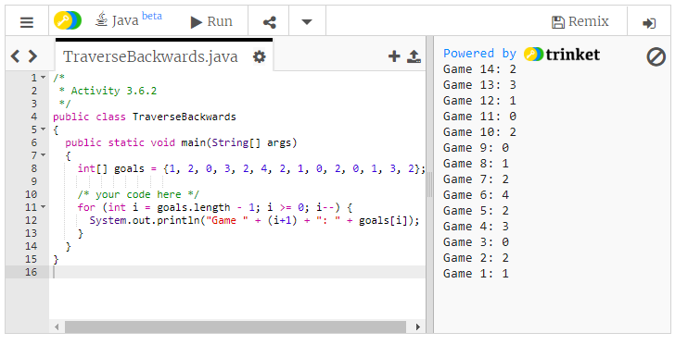

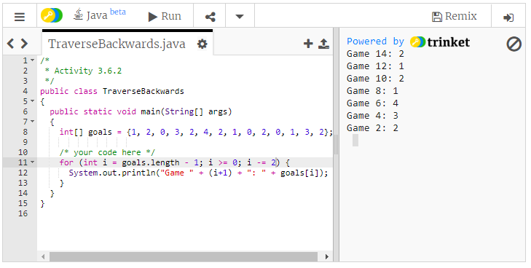

#10 Screenshot of code and output

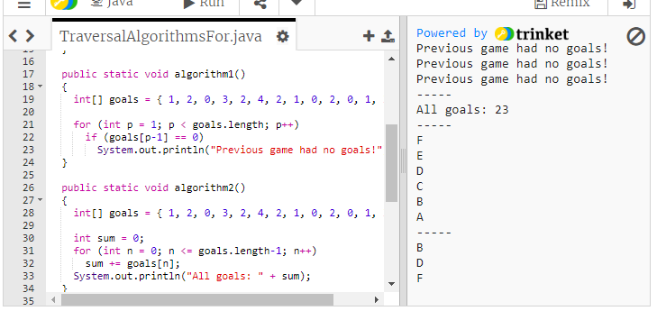

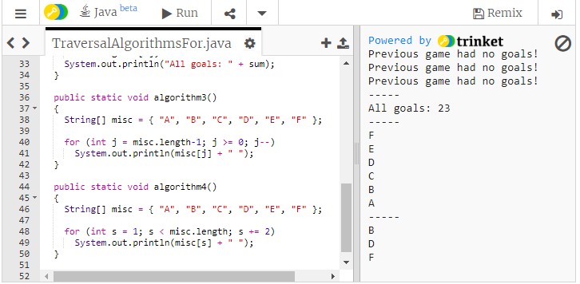

#11 Screenshot of code and output

