# Computer Science Applications

## Project 1.3.8

**Requirements of this project**

1. Your program should present the user with several choices. Each of those choices will branch into other choices. This can be done by setting Boolean variables or executing different sections of code based on the user’s input.

Looking back at previous programs and the requirements stated above, you know you will need:

* At least three Boolean expressions that change the path in the program
* Print statements, depending on current and previous choices.
* At least three nested if/else-if/else clauses

2-3. Decide on your game story and decompose the problem.

a. Create a diagram or a high-level flowchart of the story. Do not go into too much detail and review the project requirements and the feasibility of your design. This should give you a broad idea of what you want the program to do.

**Create an account on lucidchart.com**

**\***Once your flowchart is complete, past a copy here…

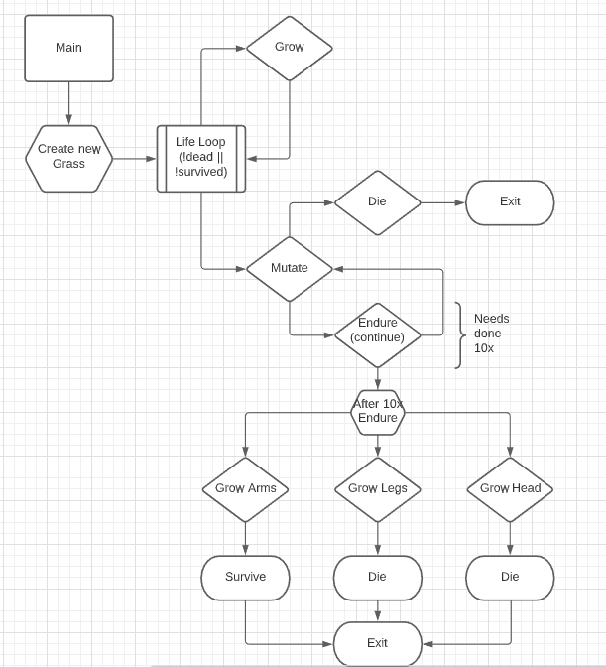

b. Confirm that the feature sets you are designing meet all of the requirements. Document which feature will meet each requirement. For example, which feature will demonstrate the conditional statements? Which features show the Boolean expression? Output statements? Adjust your diagram if necessary.

4. Use Visual Studio Code to create and develop your program. Refer back to your milestone chart to stay on track.

5. Evaluate your solution. Does your program function as expected? Does your program meet all the requirements?

6. Submit this document and a screencast of 30 seconds or less showing the running of your program. Use screencastomatic.com to create your video.