# Computer Science Applications

## Activity 1.1.4: Compound Assignment Operators

Copy and paste screenshots and/or answer questions from the activity.

#2 Rewrite VariableReview to use one variable, x, in each of the three statements to produce the same result.

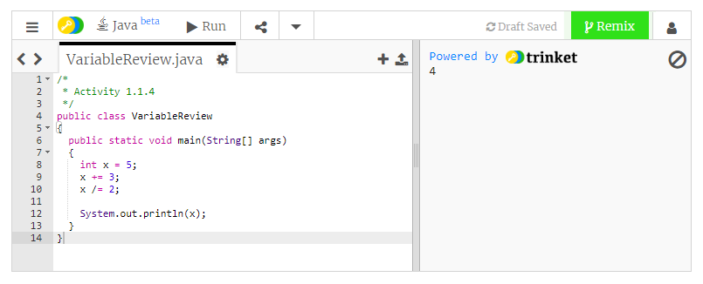

#11 Screenshot completed code and output

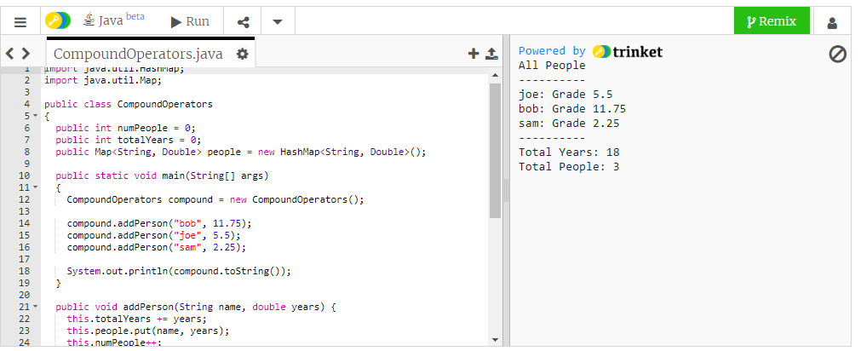

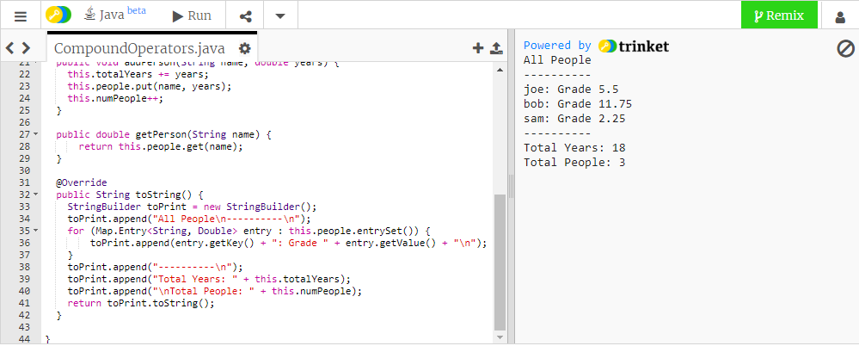

#13 Screenshot completed code and output

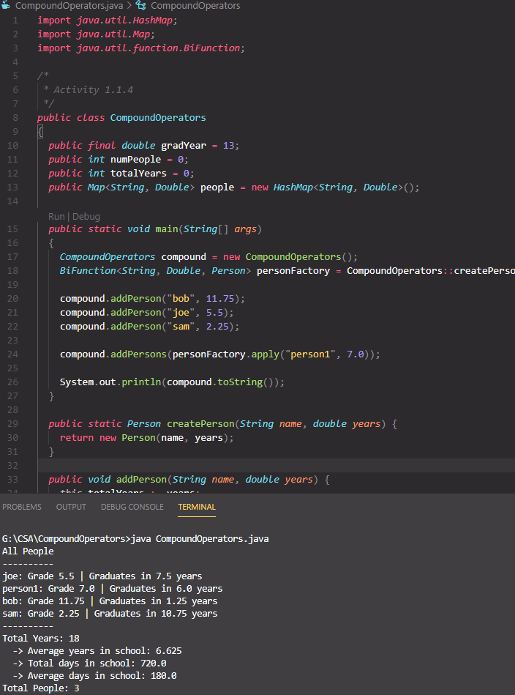

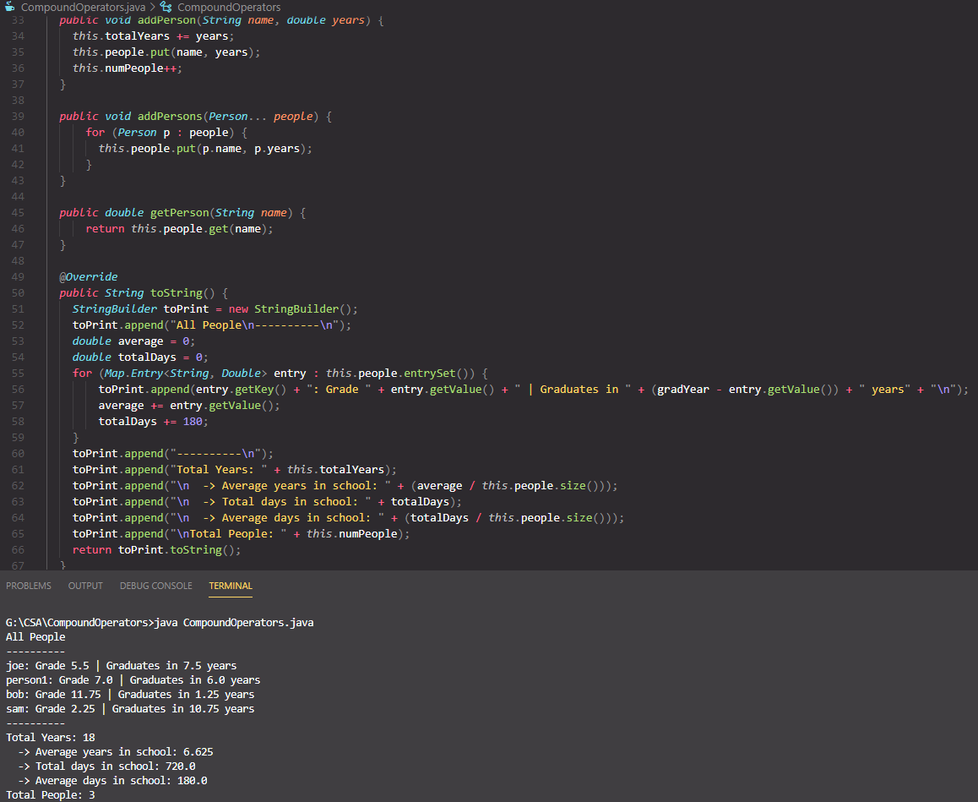

#14 Enhance your program one last time by creating a new variable, gradYear, and initialize it with the value of 13 to represent the end of your senior year. Why 13?

13 because kindergarten doesn’t get a numeric value assigned for its grade so in total K-12 = 13 grades

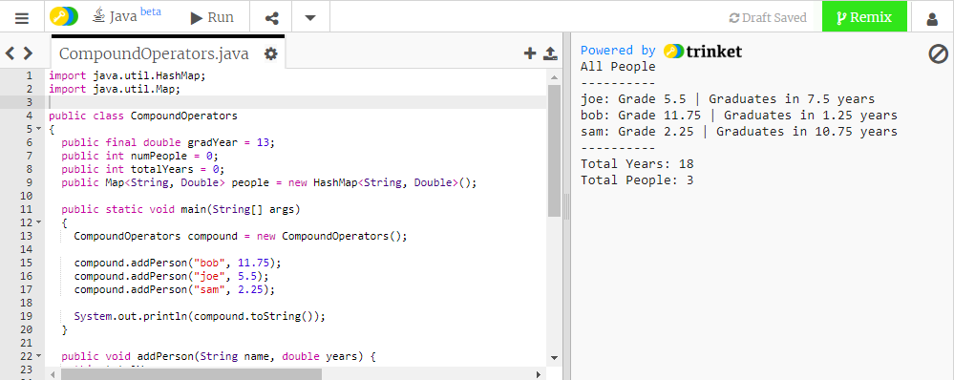

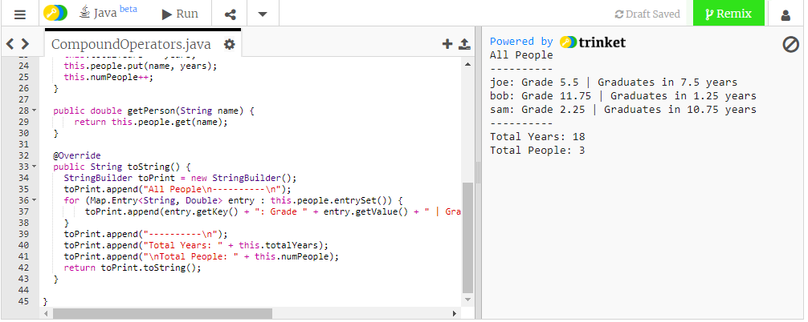

#16 Screenshot completed code and output

Goto #13