# Computer Science Applications

## Activity 1.1.5: Casting and Range of Variables

Copy and paste screenshots and/or answer questions from the activity.

#5 Screenshot completed code and output

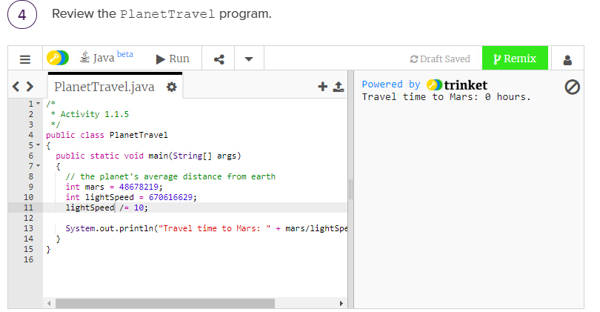

#6 Did you expect a result of 0? Can you think of a reason why the calculation is zero?

The result of mars / lightSpeed is a decimal and we have integer values therefore it truncates to 0

#10 Screenshot of code and output

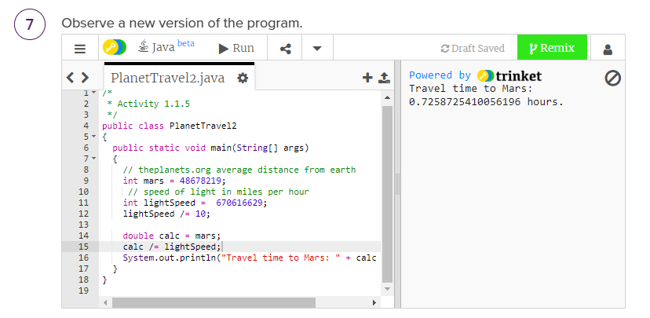

#16 Screenshot of code and output

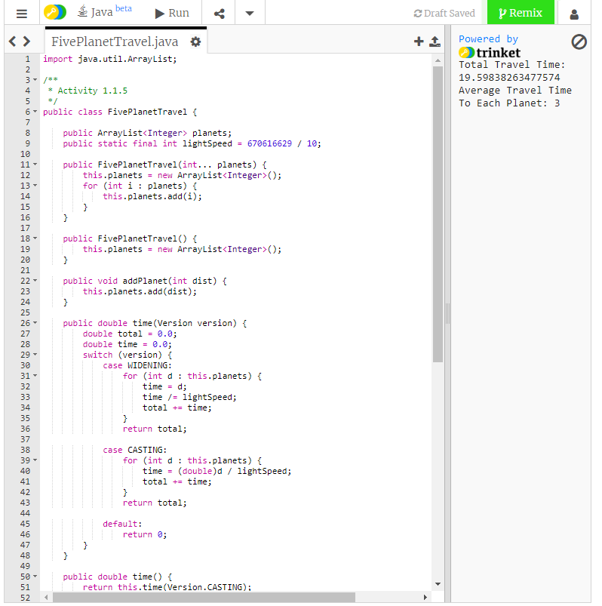

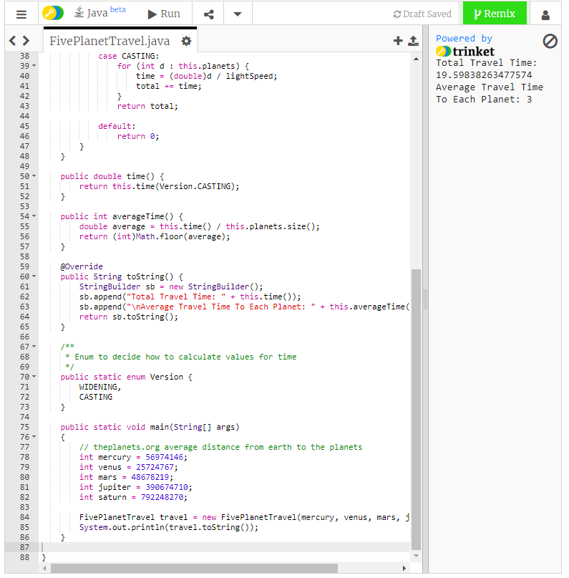

|  |  |  |
| --- | --- | --- |
| X | (x + .5) | (int) (x +.5) |
| 0.3 | 0.8 | 0 |
| 0.6 | 1.1 | 1 |
| 3.4 | 3.9 | 3 |
| 3.8 | 4.3 | 4 |
| 15.0 | 15.5 | 15 |
| 21.5 | 22 | 22 |
| 99.9 | 100.4 | 100 |

#24 Screenshot of code and output

