# Computer Science Applications

## Activity 1.2.3: Calling a Void Method

Copy and paste screenshots and/or answer questions from the activity.

#3 Your prediction and a screenshot of the actual output

The cake will be printed with 3 tiers.

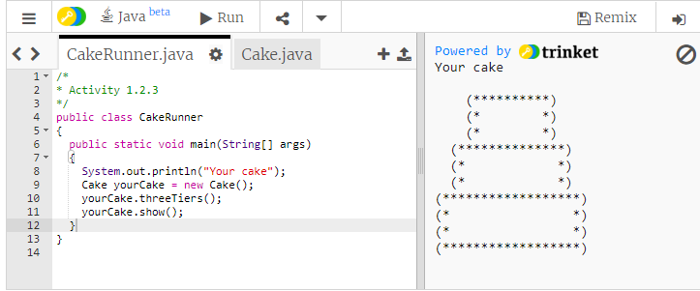

#4 Your prediction and a screenshot of the actual output

It will show a 1 tier cake after the first 3 tier cake

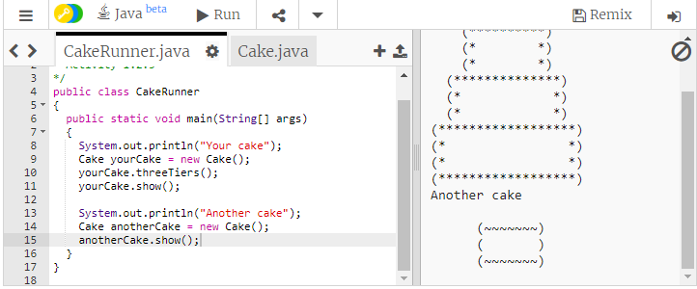

#6

|  |  |
| --- | --- |
| Summarize the first line of code in the main method. | Print an empty line to the console |
| A constructor is called. Summarize the lines of code in the constructor. | “Preparing a small cake” is printed and the oneTier() method is called |
| In main, what method executes after cake1 is created? | cake1.oneTier(); |
| How does this method prepare a cake? | It initializes the cake with one tier |
| Back in main, what is called next? | cake1.show(); |
| Summarize the lines of code in this method. | Prints out the candles and layers |
| Finally, what line of code executes last? | “Do you like your cake?” is printed to the console |

#7 Predict the flow of control in the following program.

An empty variable called cake2 is created. An empty line and “Congratulaions!” are printed to the console. cake2’s value is initialized to a new cake with 2 tiers. Candles are added to cake2. cake2 is printed to the console.

#8 How many times was the main method’s flow of control interrupted by a call to a Cake constructor or method?

3

#13 Back in CakeRunner3’s Result window, what line reports the error?

NullPointerException

#14 What line do you think you need to change to fix the problem?

The line that initializes yourCake to null

#15 Fix the error in your program. Screenshot your fixed program.

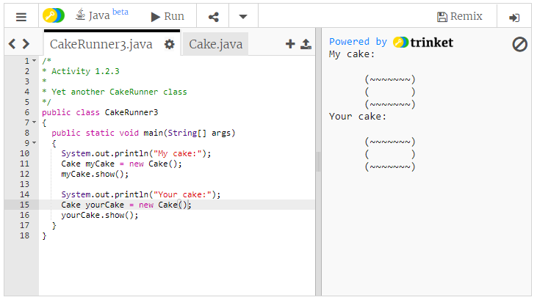

#16 Screenshot of your two graphical cakes

