# Computer Science Applications

## Activity 1.2.4: Calling a Void Method with Parameters

Copy and paste screenshots and/or answer questions from the activity.

#12 Screenshot of code and output

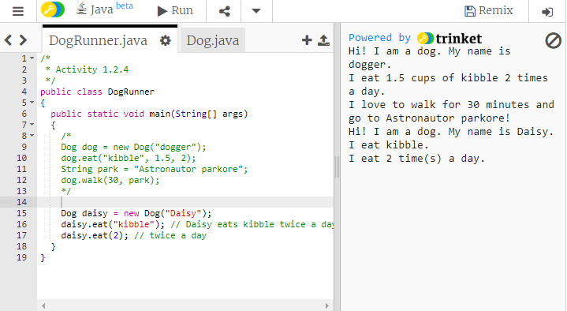

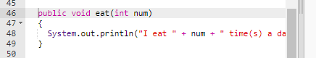

#14 Screenshot of code and output.







