# Computer Science Applications

## Activity 1.2.9: Using a Math Class

Copy and paste screenshots and/or answer questions from the activity.

#1 What is the package to which the Math class belongs?

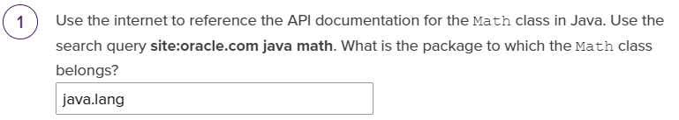

#7 Screenshot of code and output

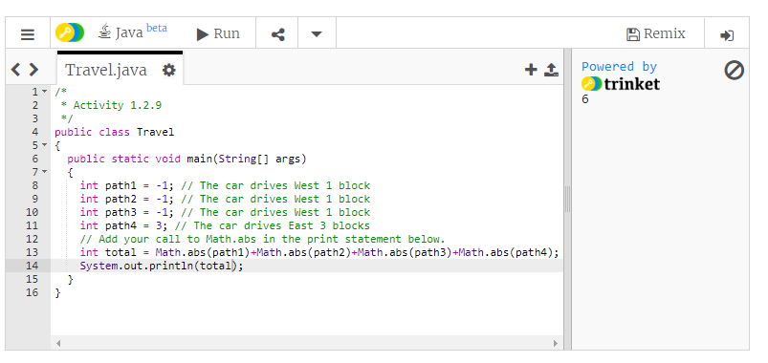

#12 Screenshot of code and output

// Find 8x8x8x8 // Find the square root of 64// Find the square root of 65

// Find the square root of the absolute value of the difference // between 12 squared and 5 squared.

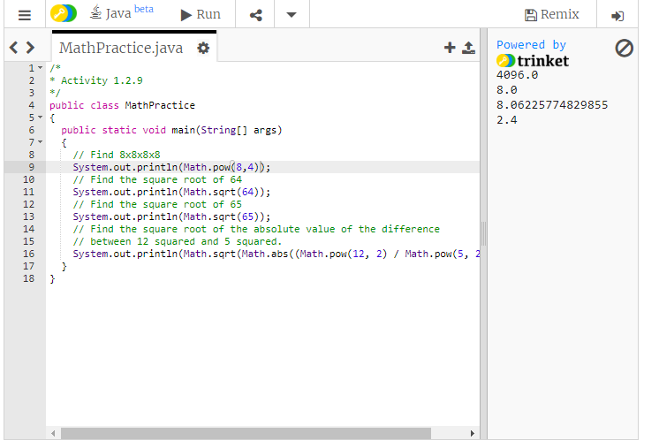

#15 Screenshot of code and output

