**ECONOMICS**

**PERSONAL FINANCE UNIT**

***Investing Basics***

**Directions:** Go to the following link <https://www.wealthsimple.com/en-us/learn/investing-basics#real_estate_investing_basics> to read about some of the basics of investing.

1. According to the article, what is investing?
   1. Committing money to earn a financial return
2. People typically invest with a specific _goal_ in mind. What is yours?
   1. To become rich
3. Us the “money under a mattress” graphic to explain why investing is important.
   1. Money that is sitting around is useless as it could be in a bank, growing off interest, or it could be invested and growing somewhat randomly.

**THINGS TO CONSIDER BEFORE INVESTING**

1. Should you invest if you have credit card debt? Why or why not?
   1. No, investing does not guarantee you will make a positive return and if not you will be in an even worse spot.
2. 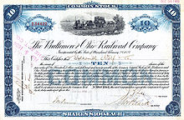Why should you have an emergency fund? How much should you have ion this fund before investing?
   1. Yes, so that there is always a fund of money that is untouched and constantly added to in case of an emergency. At least 6 months of living expenses should be in this fund before investing.

**BEGINNERS INVESTING TIPS**

1. What is “life-style creep”?
   1. As you make more money, everything that was one a want becomes a need
2. How is it possible to save money and lose it at the same time?
   1. When investing over a long period of time, the inflation rate will often outpace the interest.
3. What are some ideas for investing if you don’t have much money?
   1. You could use an app that rounds up your purchases and invests it.
4. Explain in your own words “risk tolerance”.
   1. What you are able to lose
5. What does it mean to “diversify” your investments?
   1. Investing in more than one stock
6. Why should you make a plan and stick with it? In other words, what are some common mistakes people make when they don’t have a plan?
   1. People without a plan will often get paper hands and sell when they shouldn’t instead of holding. Making sure you stick to a plan keeps you on track and makes sure you make the correct decisions
7. 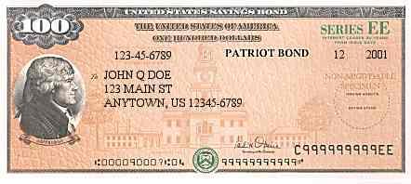Briefly explain these three types of investments.
   1. Stocks – A piece of a company anyone can purchase and be a small owner of
   2. Bonds – A loan with interest often given by the govt.
   3. Real Estate – Purchasing properties such as houses or apartments
8. What are some possible consequences of real estate investing?
   1. Complications with the house and the housing market. You often never know if it will be a profit or loss.