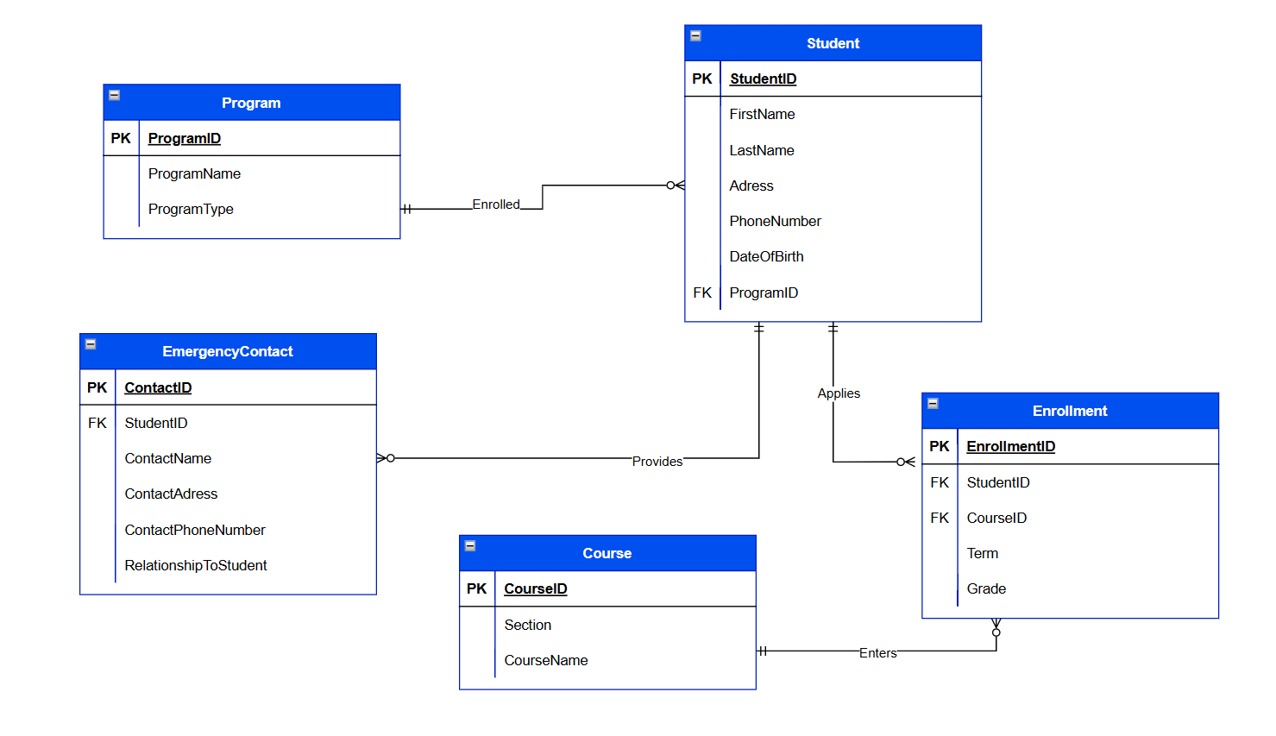
Git hub repository: https://github.com/Sombereric/Relational_DataBase_FinalProject.git
Real World Scenario: School Database

