TELCOM 2310 Project 1 Report

Somdipa Majumdar

According to pseudo code provided in assignment, I have used java as main application to generate all output.txt files, and call python to draw pictures(generate .png files).

In my java code, I created Performance class to contain all code, include pkt_in_q, and pkt_droped. And when run this program, the main function will pass several parameters to it, to get final result.

The result output

- = 30, μ = 50, n = 50
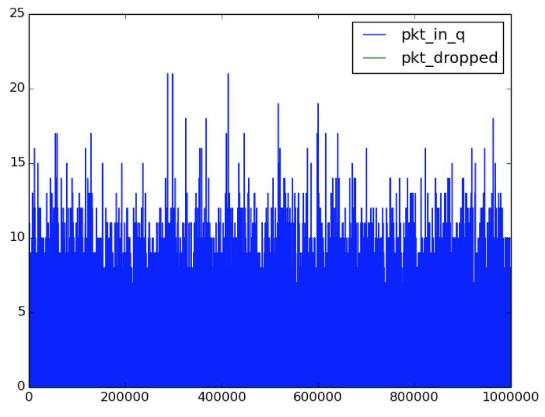

When arrive date is less than departure rate, and n=50, we can see package in queue is floating, but not greater than 25. It means we don’t have any packaged dropped.
- = 30, μ = 50, n = 100
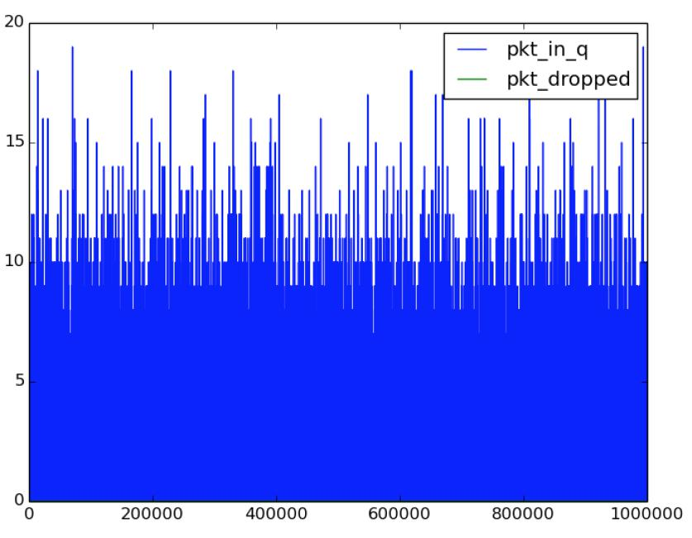

Since arrive date is less than departure rate, and buﬀer is big enough, all first 9 images looks like this. Means no package dropped.

λ = 30, μ = 50, n = 150
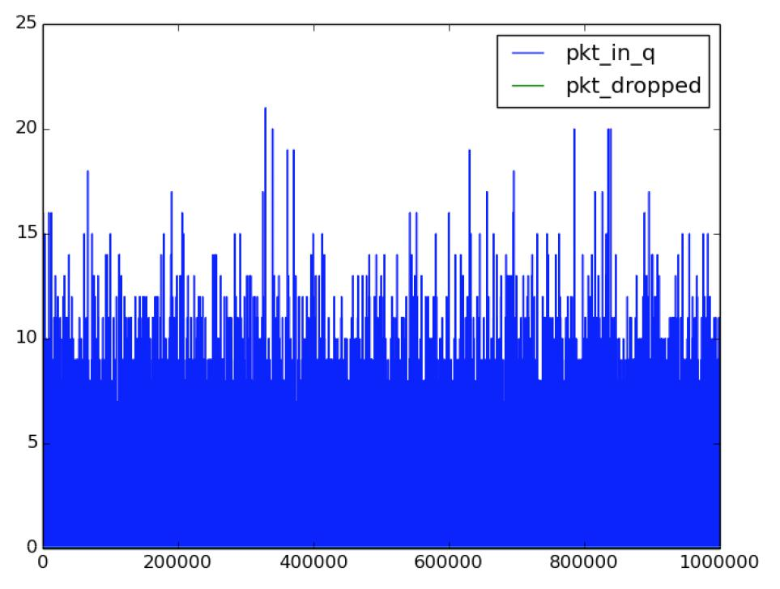

Since arrive date is less than departure rate, and buﬀer is big enough, all first 9 images looks like this. Means no package dropped.

- = 30, μ = 100, n = 50
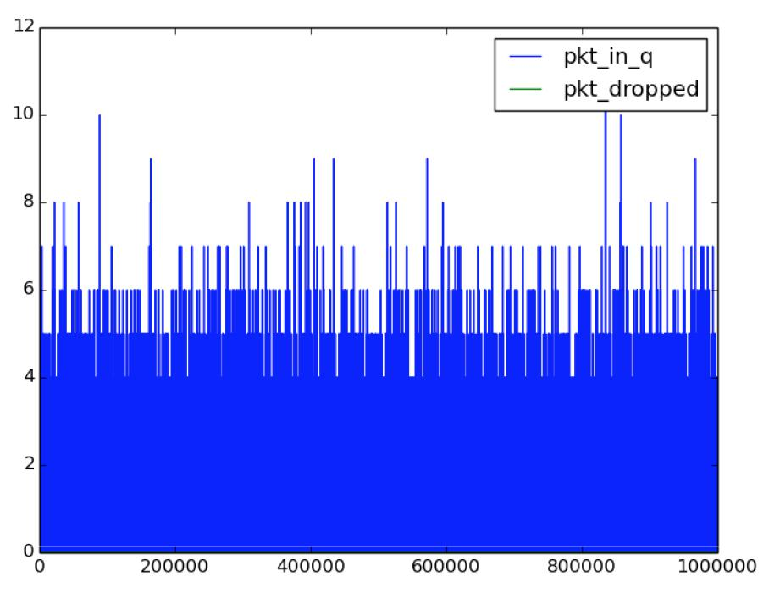

As departure rate is increase, and arrive date is keep same, we can see buﬀer occupied is even small. Also, no package dropped.

λ = 30, μ = 100, n = 100
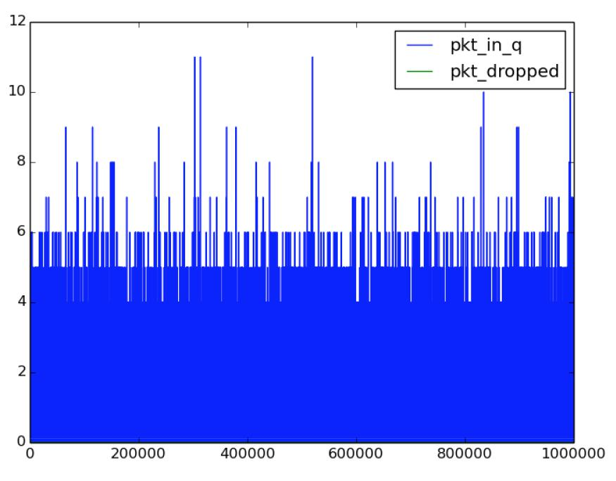

Departure is greater than arrive rate, and buﬀer is big enough, we don’t even take more 12 occupied. So no package dropped.

- = 30, μ = 100, n = 150
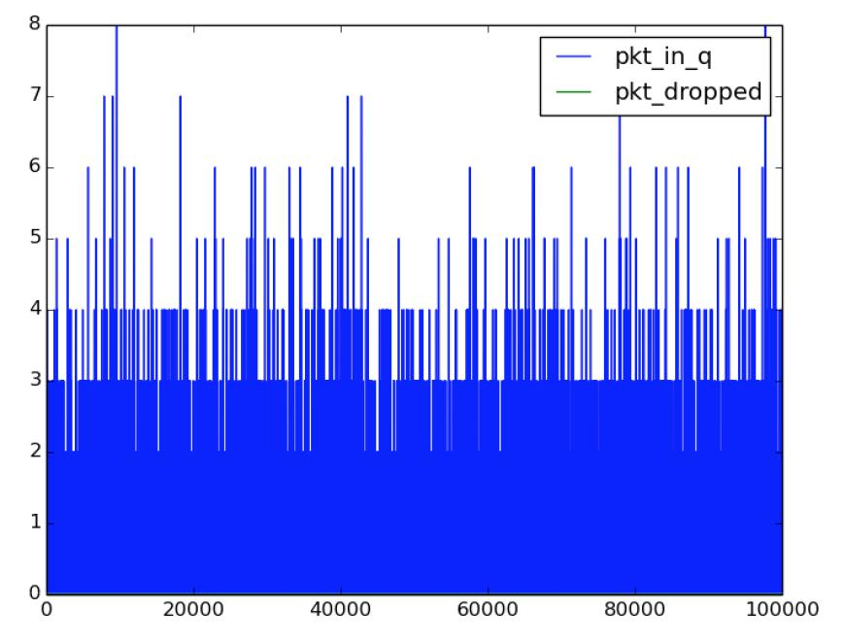

mu is greater than lambda, n = 150 >> 8. So no package dropped

λ = 30, μ = 120, n = 50
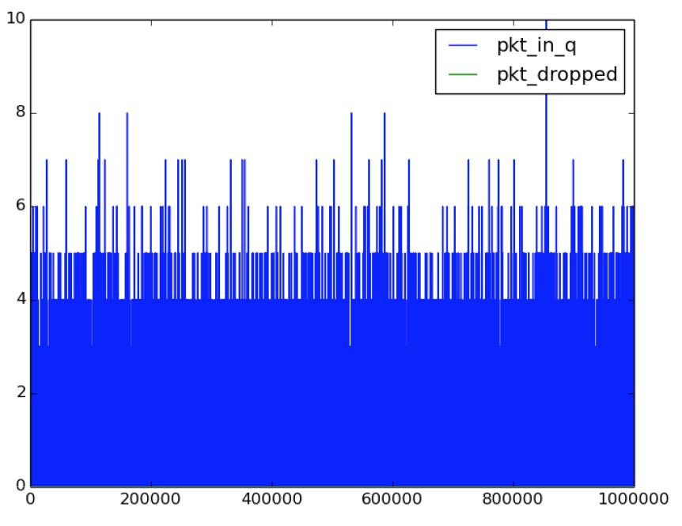

when departure rate is increased to 120, and arrive date is keep 30. We have no more than 10 buﬀer are occupied. And no package dropped.

- = 30, μ = 120, n = 100
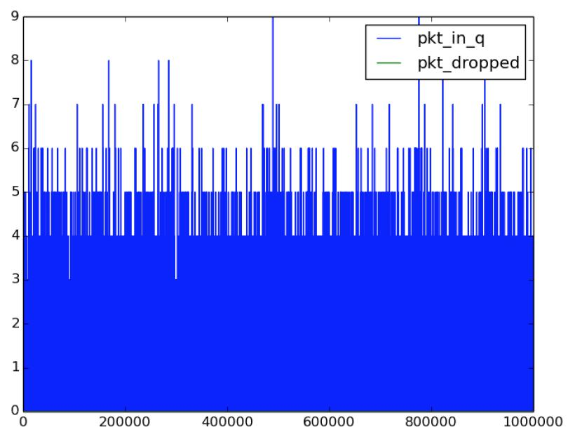

As we said, no package dropped.

λ = 30, μ = 120, n = 150
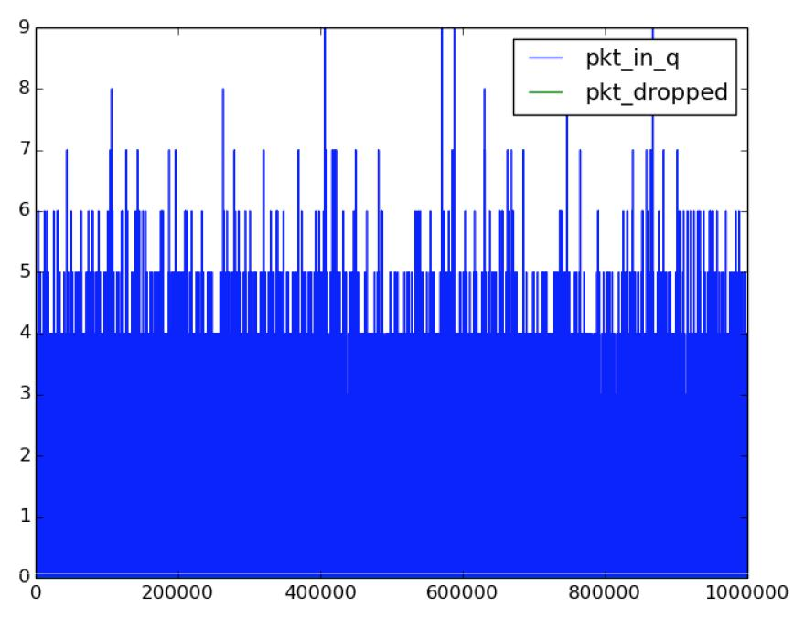

lambda << mu, so no package dropped.

Things start changed here

- = 80, μ = 50, n = 50
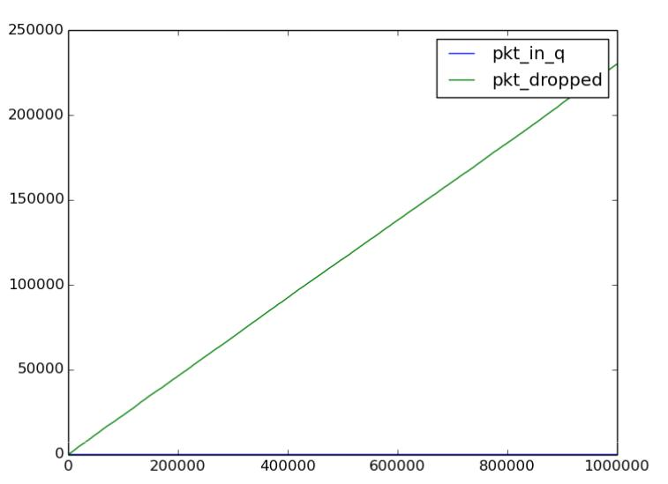

We can see from there, arrive date is greater than departure rate, and with test case increase, the dropped package in also increasing. We can see it is linear model, and it meets our expectation.

λ = 80, μ = 50, n = 100
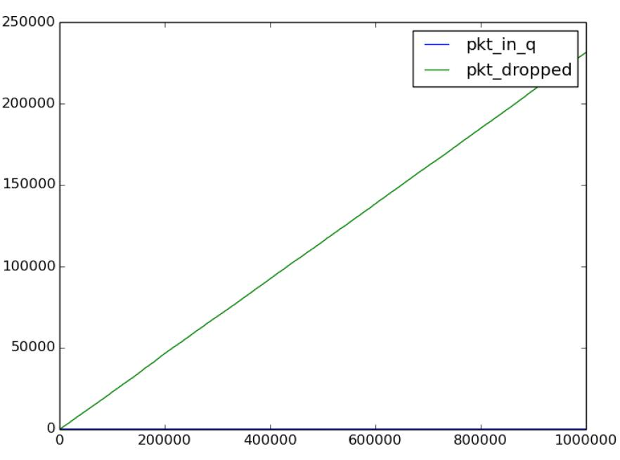

As buﬀer increased, it doesn’t help too much. We can still see dropped package increased by linear mode, when test package increased.

- = 80, μ = 50, n = 150
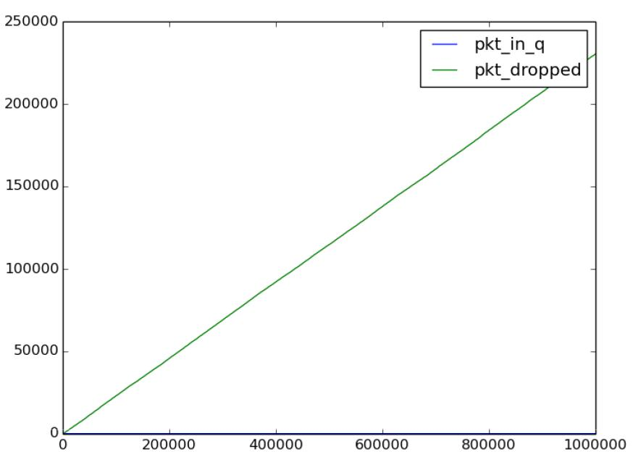

As buﬀer increased to 150, we can still see when arrive rate < departure rate, loss package increase by linear model.

λ = 80, μ = 100, n = 50
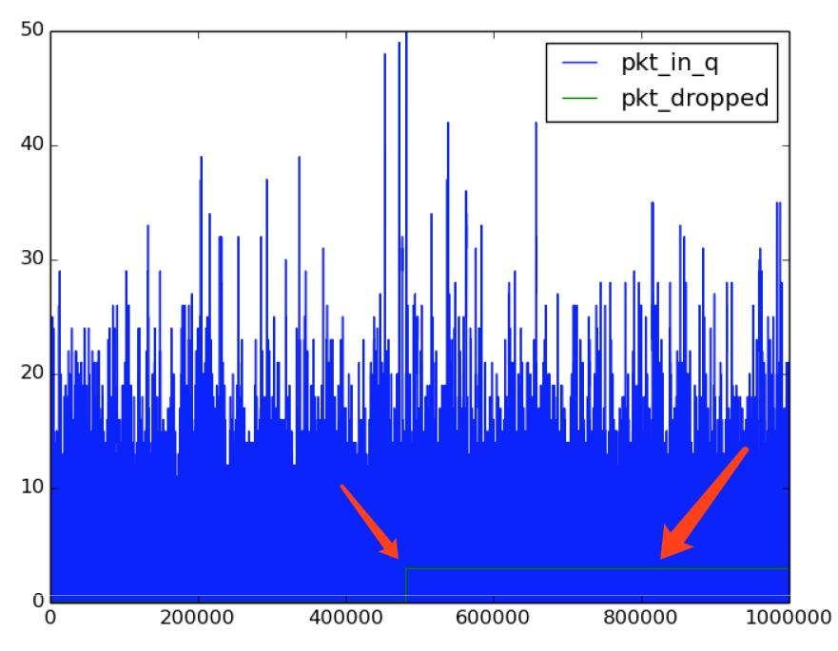

When departure rate is greater than arrive date, we should expect that there is not too much package dropped. However, if we see it, it sometimes may exceed the maximum buﬀer(n=50), so that several packaged dropped. But after that, we can see dropped package doesn’t change, it means we don’t loss package any more. So it is

acceptable, but we’d better increase our buﬀer to avoid loss package if arrive rate is almost same but still less then departure rate.

- = 80, μ = 100, n = 100
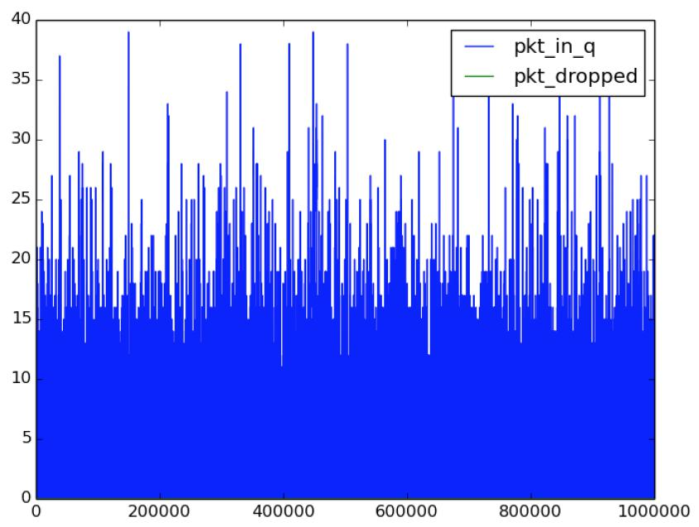

Like I assumed, if we increase buﬀer size, the above situation never happen again. When arrive date is less than departure rate, and buﬀer size is enough, we never meet loss package.

λ = 80, μ = 100, n = 150
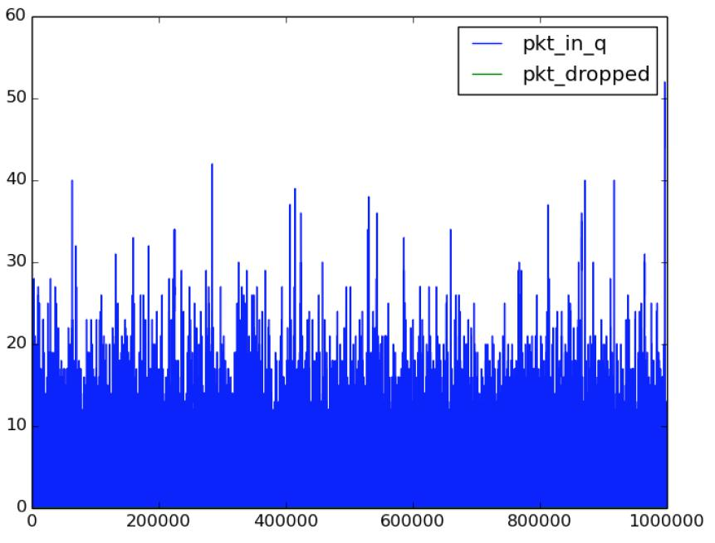

Like I assumed, no package loss if arrive < departure and buﬀer size in big enough.

- = 80, μ = 120, n = 50
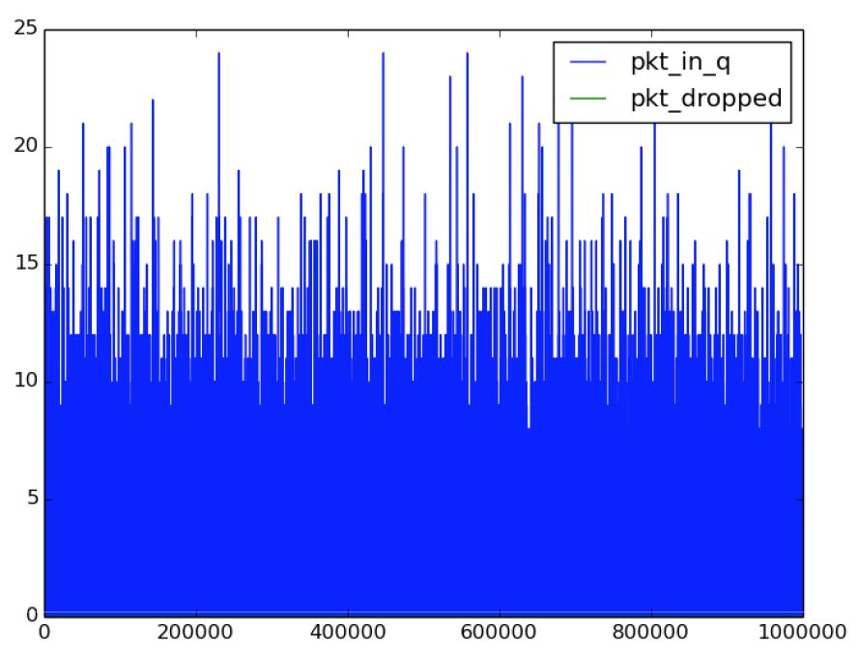

When departure changed bigger, we can expect even buﬀer is smaller, there is still no package loss, like this picture.

λ = 80, μ = 120, n = 100
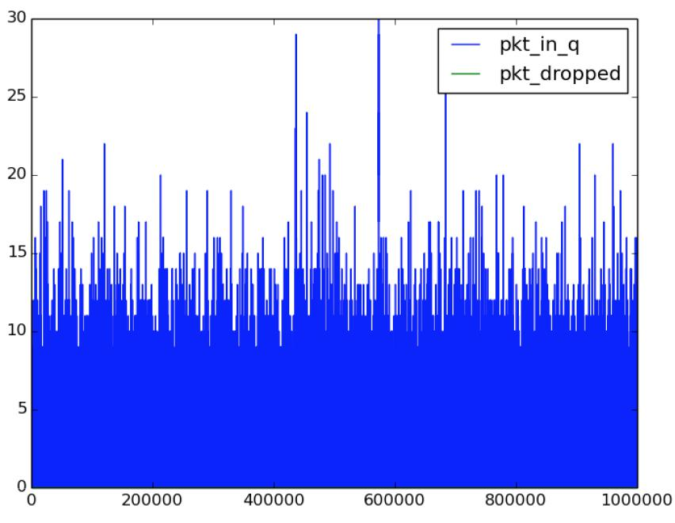

When departure > arrive, and with big buﬀer, we expected no package loss here. And picture is same as we expected.

- = 80, μ = 120, n = 150
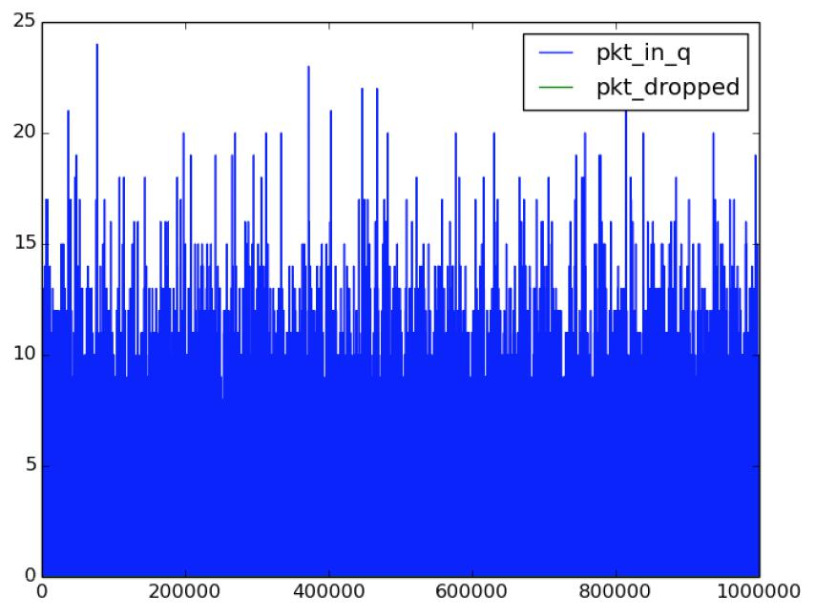

When buﬀer size increase to 150, we should not expected any loss package, under the situation if arrive < departure

λ = 120, μ = 50, n = 50
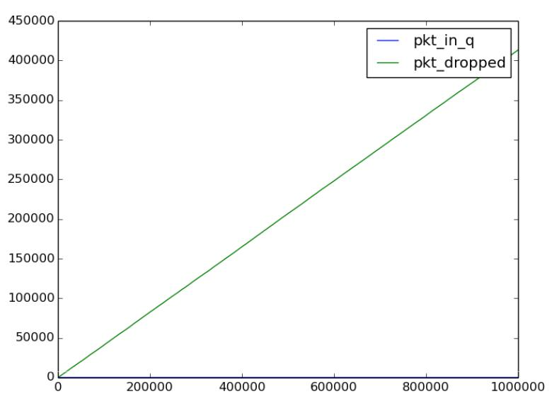

Now, let’s see if arrive date is greater than departure rate, like I described above, we expected dropped package is increased, and we can’t see any package in queue, because it’s scale is to bigger than buﬀer size. We can also see it is almost 420,000 packaged dropped, which is can be calculated by (arrive rate - departure rate) * time

- = 120, μ = 50, n = 100
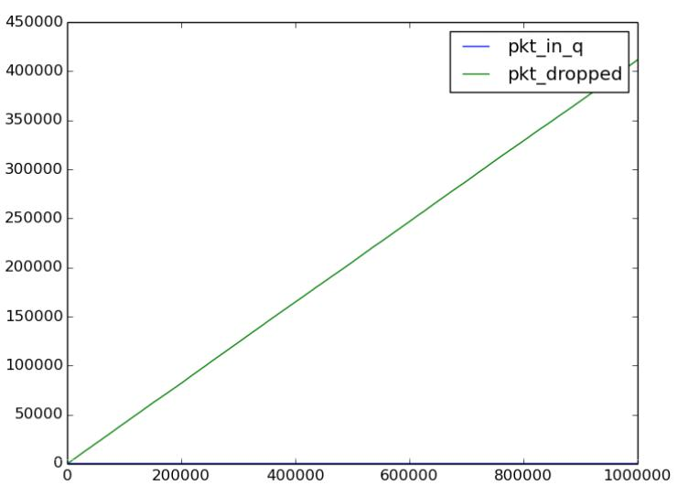

Like described above, when arrive > departure, no matter how much buﬀer is, we can expected a loss package in linear model. And like I calculated, its loss package is about 420,000, which also can be calculated by (arrive rate - departure rate) * time

λ = 120, μ = 50, n = 150
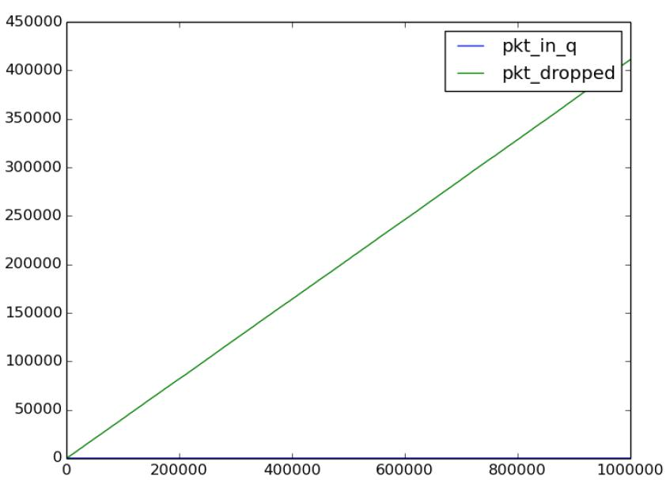

Like described, no matter how much buﬀer is, we can only expect a loss package increased with scale increased. Since arrive rate and departure rate is not change, so we expected same loss package

- = 120, μ = 100, n = 50
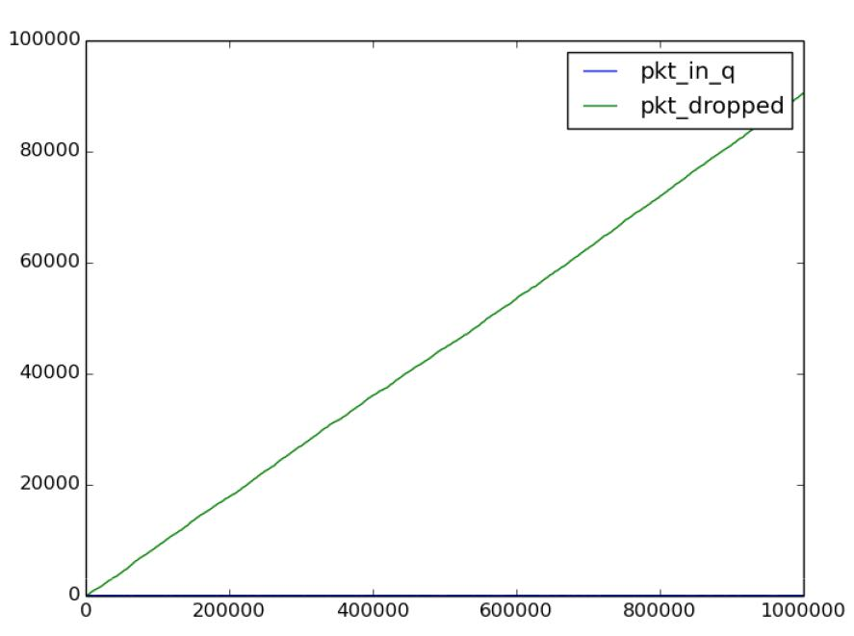

When we increased departure rate but still less than arrive rate, we still expected a linear but its maximum y decrease. Like this picture said, its maximum y decreased to around 100,000. We can see arrive rate - departure rate = 20, which occupied 2/7 of above calculation. Then average dropped package = 2/7 * 42000 = 12000 which is about same with 10000.

λ = 120, μ = 100, n = 100
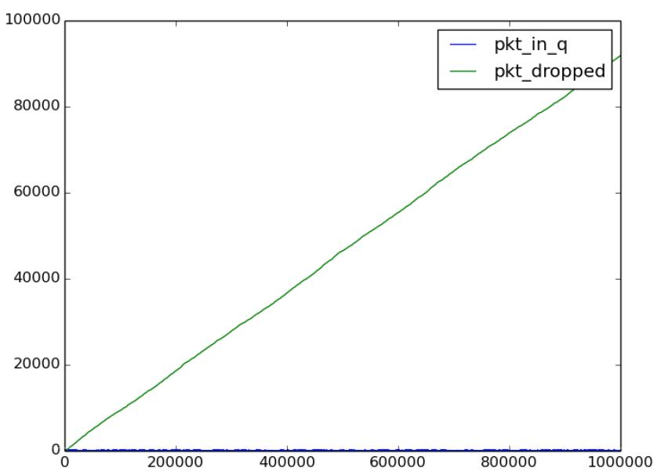
When increase buﬀer size, but keep arrive < departure, we still expected increasing loss package with scale increased. Since arrive rate and departure rate doesn’t change, so we still expected same loss package.

- = 120, μ = 100, n = 150
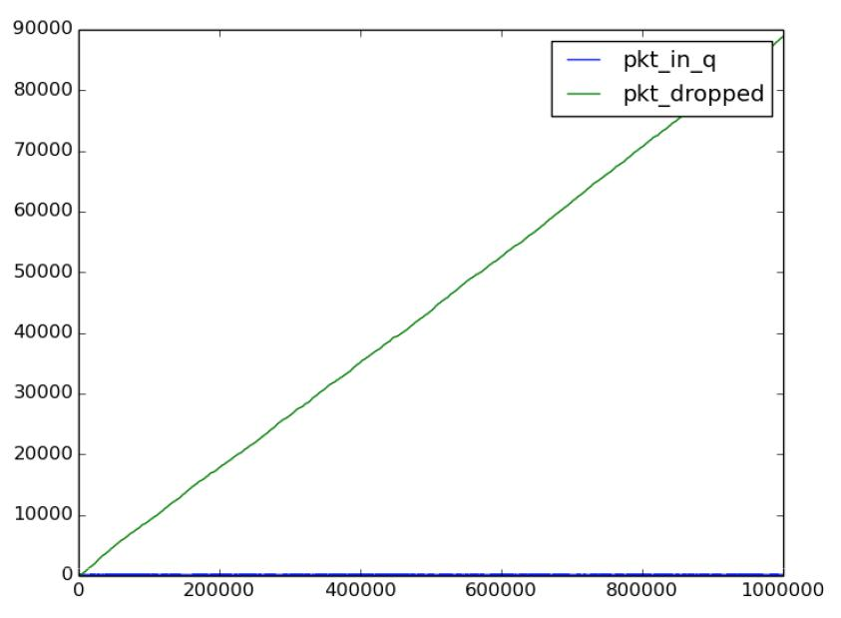

Like described above, when arrive rate and departure rate doesn’t change, we expect same package loss number, around 100,000.

λ = 120, μ = 120, n = 50
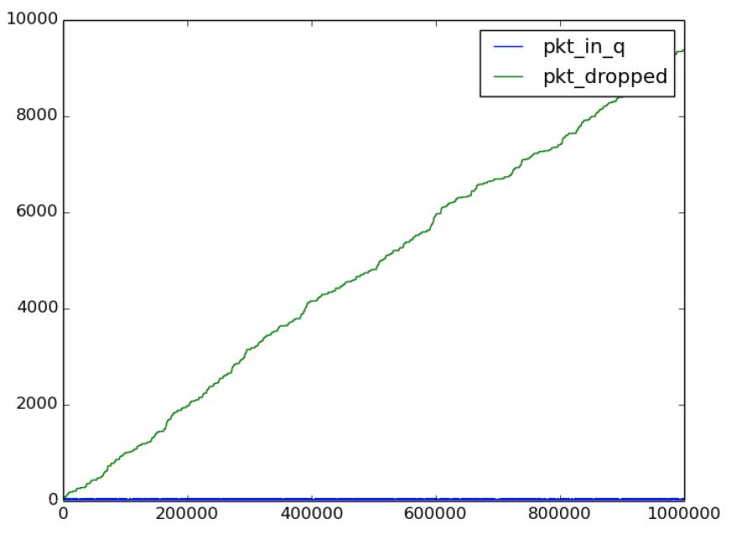
When departure rate increase until it is same as arrive rate, although it is same, it is still an increased in loss package. As we can see, the package in queue is keep full, so anything more than the buﬀer size can taken, would be dropped. But because it is about same rate, so randomly package dropped cannot get to big enough, which is just about 10,000 out of 1000,000 trails

- = 120, μ = 120, n = 100
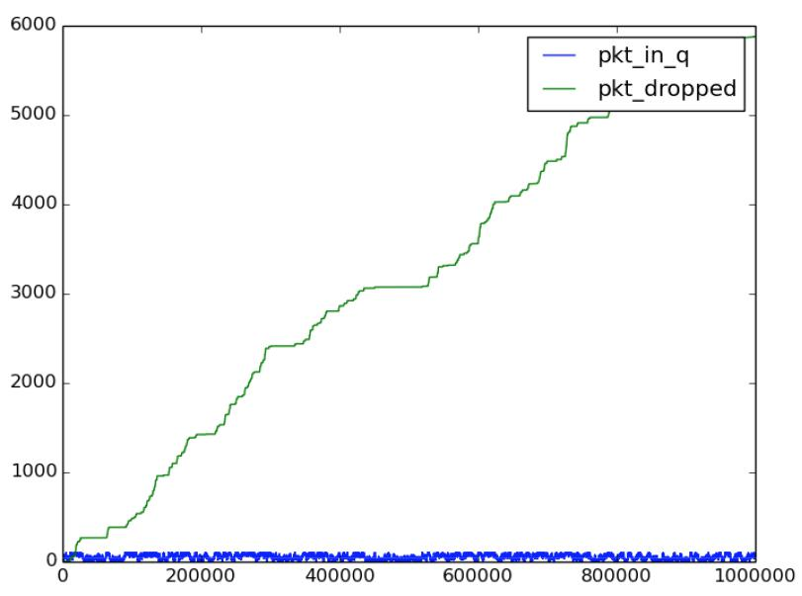

As we can see, when buﬀer increased, it doesn’t change too much. But we can see package in queue is about same, and due to increase of buﬀer, the package dropped also increased, and it is about a linear model.
- = 120, μ = 120, n = 150
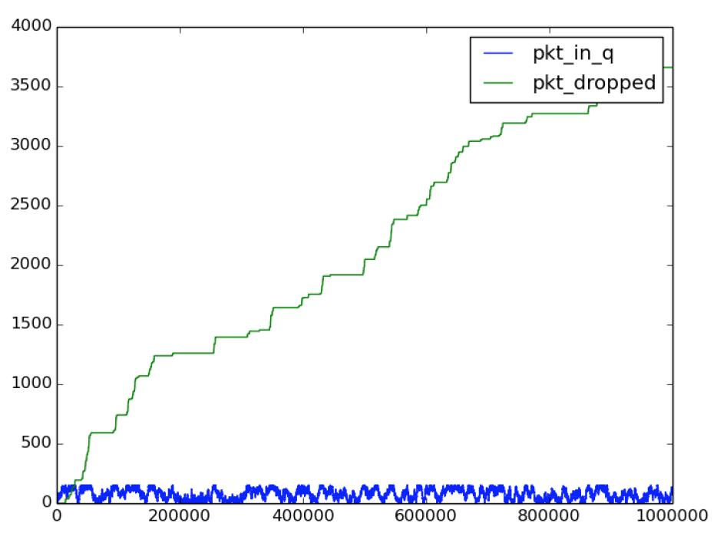

As picture said, the buﬀer contains package in queue is not very stable, and when it exceeds its maximum size, the package dropped will increased. Since it is random number in our code, so we expected random increase of package dropped.

II

when rate changed like this
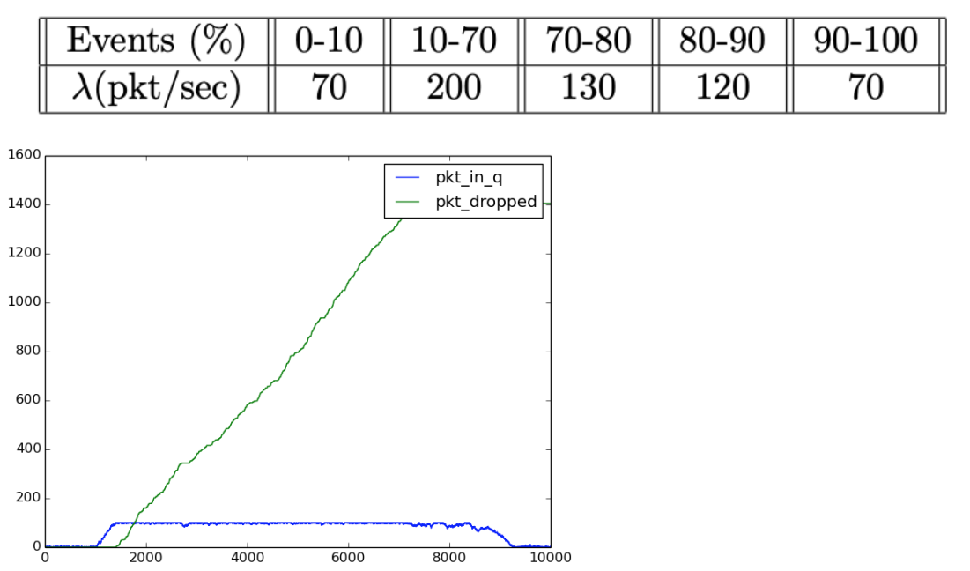
Let scale = 10,000,

when lambda=70 << 120, we can’t see any package dropped.

when lambda = 200 >>120, we can see buﬀer was filled very soon, and then package dropped increase as a linear model.

when lambda = 130 > 120, but about same, we can see package increased speed is much slowdown.

when lambda = 120 = departure rate, we can hardly tell package dropped increase by linear, but it is still slightly increased randomly like I described above.

when lambda = 70 < departure rate 120, we can see buﬀer is quickly cleaned up, and no more increase in package dropped.
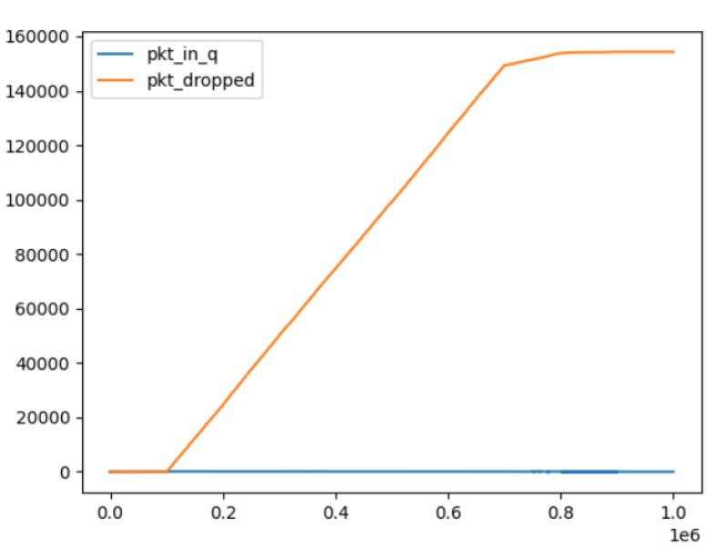

Also, when scale = 1,000,000, because it’s zoom in, so we can’t tell when lambda = 70, how its package in queue increased quickly. But we definitely know it is filled up really quick, and then package dropped increase as linear, until lambda = 130.

When lambda = 130, we can see package dropped increase speed is much slow down, which meets our expectation.

When lambda = 120, we can see it’s still increased, but randomly, until lambda = 70, then all package dropped keep same until done.

