REFERENCES

1. Count the number of digits of a number

<https://www.geeksforgeeks.org/program-count-digits-integer-3-different-methods/#other-approach-counting-digits-using-log-base-10-function-o1-time-and-o1-space>

1. Algorithm reference (from tutorial 4 week 5)

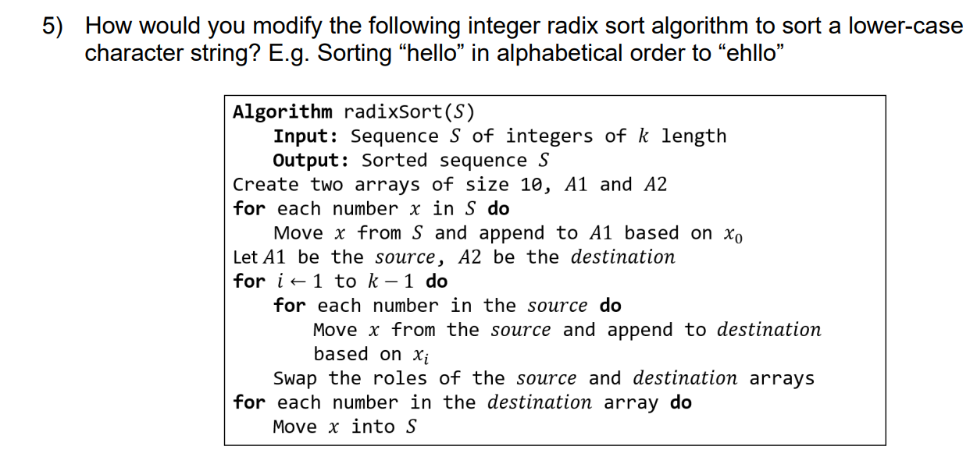

1. Find maximum

<https://docs.vultr.com/java/examples/find-largest-element-of-an-array>

1. <https://stackoverflow.com/questions/36476183/string-radix-sort-stringindexoutofboundseception>