

**SE Seminar #3 Report**

**A Smart Meter for Energy Measurement using Raspberry Pi**

**01286391 Seminar in Software Engineering**

**Software Engineering Program**

**Faculty of Engineering, KMITL**

By

65011277 Chanasorn Howattanakulphong

**Introduction**  
This seminar on the topic, “**A Smart Meter for Energy Measurement using Raspberry Pi**”, was given by Mr. Nattapong Wattanasiri. He covered topics on smart meters and showed us examples of the projects.

**Requirements needed to create a smart meter**

* Measure electrical parameters : I , V , P ,Q, Power Factor( PF) and total energy usage (KWh , KVARh)
* Data-logging
* Communication between server via DLSM/COSEm protocol
* TOU

**How can I and V be measured with an embedded system?**

* An Analog to Digital Converter (ADC) is employed to gauge the voltage.
* The processor interacts with the ADC chip.

**Voltage Sensing**

Improve the precision of voltage sensing by incorporating a voltage divider circuit for exact voltage scaling. This straightforward yet effective method employs two resistors to proportionally reduce input voltages. By judiciously choosing resistor values, the voltage divider caters to a broad spectrum of voltages, adjusting them to the measurement abilities of sensors or monitoring circuits. The accuracy provided by this method guarantees precise voltage measurements while preserving scalability and adaptability to fluctuating input voltages. This economical solution offers a practical way of fine-tuning electronic systems for various voltage levels.

Current Sensing

* Use R shunt technique.
* Use Current Transformer (CT)

**Basic concepts explained during the seminar**

* Power Factor: The power factor is a metric that indicates how efficiently electrical power is transformed into productive work output. It is determined by the ratio of real power (the usable power) to apparent power (the total power).
* Data Buffering: Data buffering refers to the temporary storage of data in a buffer (a type of memory) prior to processing or transmission. Buffers assist in managing changes in data flow rates among different system elements.
* RMS Calculation (Root Mean Square): RMS is a statistical measure that represents the magnitude of a variable that changes over time. For alternating current voltage or current, RMS gives an equivalent constant direct current value that creates the same heating effect.
* Discrete Integration: Discrete integration involves the accumulation of individual data points over a period of time, mimicking the process of calculating the integral of a continuous function.
* IIR Filter (Infinite Impulse Response): IIR filters are either digital or analog filters with feedback, distinguished by their capability to have an impulse response that lasts indefinitely in time.
* FFT (Fast Fourier Transform): FFT is an algorithm that calculates the discrete Fourier transform, offering a method to examine a signal in terms of its frequency components.

**Example application - KMITL Smartmeter**

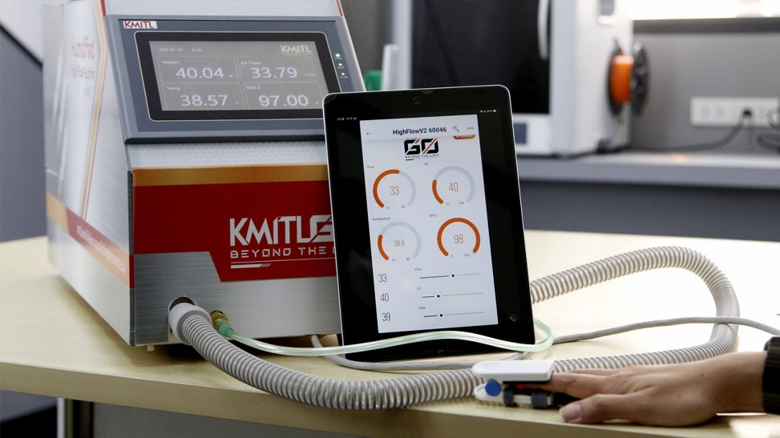

The software development for KMITL Smartmeter equips users with uninterrupted access to a cloud server where the entire meter network, including Meter_1 and Meter_2, is consolidated. Users can conveniently sign in to the cloud server, allowing for efficient management and supervision of the smart meter infrastructure. This cloud-based solution guarantees that live data from individual meters is readily available and promotes smooth operations via an intuitive interface.

**What I have learned from this seminar**

During the seminar on "A Smart Meter for Energy Measurement using Raspberry Pi" conducted by Mr. Nattapong Wattanasiri, we delved into the intricacies of smart meters and saw practical examples of projects. We learned about the requirements necessary to create a smart meter, which includes measuring electrical parameters such as I, V, P, Q, Power Factor (PF), and total energy usage (KWh, KVARh), data logging, communication between servers via DLSM/COSEm protocol, and Time of Use (TOU).

We also discussed how I and V can be measured with an embedded system. An Analog to Digital Converter (ADC) is used to gauge the voltage, and the processor communicates with the ADC chip. To enhance voltage sensing accuracy, a voltage divider circuit was suggested for precise voltage scaling. This method uses two resistors to proportionally scale down input voltages, accommodating a wide range of voltages and adapting them to the measurement capabilities of sensors or monitoring circuits.

The seminar also covered several basic concepts. Power Factor, a measure of how effectively electrical power is converted into useful work output, was discussed. Data Buffering, the temporary storage of data in a buffer before processing or transmission, was another key topic. RMS Calculation (Root Mean Square), a statistical measure representing the magnitude of a varying quantity, was explained. Discrete Integration, the accumulation of discrete data points over time, was also discussed. IIR Filter (Infinite Impulse Response), a filter with feedback that has an impulse response extending infinitely in time, was introduced. Lastly, FFT (Fast Fourier Transform), an algorithm that computes the discrete Fourier transform, was presented.

The seminar concluded with an example application - KMITL Smartmeter. The software development for KMITL Smartmeter allows users to access a cloud server where the entire meter network is consolidated. Users can sign in to the cloud server for efficient management and supervision of the smart meter infrastructure. This cloud-based solution ensures that live data from individual meters is readily available and promotes smooth operations through an intuitive interface.­­­