

**SE Seminar #6 Report**

**ODOO ERP : A successful Open-Source Enterprise Software**

**01286391 Seminar in Software Engineering**

**Software Engineering Program**

**Faculty of Engineering, KMITL**

By

65011277 Chanasorn Howattanakulphong

**Introduction**

In this seminar, Mr. Phairoj Jatanachai, a special speaker, discusses the topic "ODOO ERP: A Successful Open-Source Enterprise Software."

**Understanding ODOO**

ODOO is an online business management software offering a comprehensive suite of modules to address front-end to back-end business needs. With 66 official apps and a vast selection of third-party apps, ODOO facilitates the management of finances, sales, inventory, manufacturing, human resources, marketing, and team productivity.

**ODOO Ecosystem**

ODOO boasts a modular structure that aids developers in rapid project development. Before delving into Odoo development, it's crucial to familiarize oneself with the various characters in the Odoo ecosystem.

**Unique Value Proposition**

**- Fully Integrated and Full-Featured:** ODOO apps are seamlessly integrated for automated business processes, ensuring data centralization and real-time updates.

**- Scalable for Any Business:** ODOO's scalability, with apps tailored to specific needs, makes it suitable for businesses ranging from SMEs with one user to MNCs with 300,000 users.

**- Highly Customizable and Intuitive:** Beyond standard features, ODOO can be customized to suit unique workflows, with an intuitive design allowing management without extensive IT knowledge.

**Supported Platforms**

ODOO supports various platforms such as Shop Floor, Expense, Point of Sale IoT, Front desk, and Inventory Kiosk.

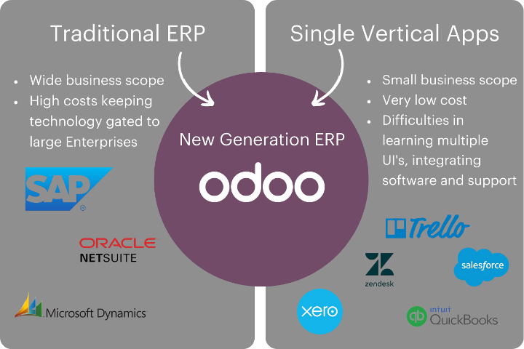

**Implementation**

**-** Integrates AI-powered bookkeeping with Sales Management and Inventory & Manufacturing modules.

**-** Manages finances efficiently with features like bank synchronization, automated reconciliation, flexible fiscal localization, and customizable reporting.

**-** Tracks budget, facilitates expense submission validation, and provides a clear overview of expenditure per employee or team.

**-** Streamlines document management, saving time on bill recording, contract scanning, and approval processes.

**-** Automates billing for sales, delivery orders, contracts, and timesheets, generating customizable analysis reports with data from integrated apps.

- Facilitates paperless processes by recording bills, scanning contracts, and approving documents efficiently.

**Website Management**

Create a unique online experience and build stunning websites with ODOO, including features like:

- Easily create a business website by drag-and-dropping ready-made building blocks.

- Develop a Learning Management System (LMS) for knowledge-sharing and community-based learning.

- Run an integrated online store that converts visitors into customers, connected with Odoo Website Builder and Sales Management apps.

- Increase website traffic, anticipate customer needs, and build a documentation library and community.

- Engage with visitors in real-time, providing support and answering questions.

**What I Have Learned:**

During today's seminar on software engineering, our focus centered on "ODOO ERP: A Successful Open-Source Enterprise Software." The presentation, led by special speaker Mr. Phairoj Jatanachai, delved into the capabilities and attributes of Odoo, an online business management software. Odoo provides an extensive range of business modules, addressing facets from finances and sales to human resources and marketing. The Odoo ecosystem stands out for its innate modularity, empowering developers to swiftly construct projects. Key elements of its value proposition include seamless integration, scalability across businesses of all sizes, and robust customization options. The platform accommodates various functionalities, encompassing shop floor management, expenses, point of sale, inventory, and more. Odoo's adaptability is showcased through its application in diverse business functions, including finance, accounting, expenses, and invoicing. Furthermore, the platform extends its utility to website creation, blogs, eLearning, eCommerce, forums, and live chat, rendering it a versatile solution for businesses with multifaceted requirements.

**Question:**

What sets Odoo apart as an open-source enterprise software, and which specific features contribute to its effectiveness in overseeing diverse aspects of business operations?