

**SE Seminar #4 Report**

**Computer Vision System for Water level Monitoring**

**01286391 Seminar in Software Engineering**

**Software Engineering Program**

**Faculty of Engineering, KMITL**

By

65011277 Chanasorn Howattanakulphong

**Introduction**  
This seminar on the topic, “**Computer Vision System for Water level Monitoring**”, covered topics on water level monitoring with computer vision.

**The flooding and drought occurrences stem from various factors:**

* Climate change-induced irregular weather patterns, leading to heightened rainfall intensity.
* Improper land management practices such as unplanned urban development and deforestation in flood-prone areas, amplifying runoff and decreasing water absorption.
* Outdated and insufficient infrastructure like drainage systems incapable of managing extreme rainfall, resulting in water accumulation in low-lying regions and streets.
* Flawed water management strategies, including imbalances in water discharge from reservoirs and dams, which can exacerbate river-level surges and worsen flooding situations.

**Challenges with the Flooding Alarm System:**

* Slow response times persist due to the system's centralized nature.
* Reliance on manual labor for data collection and transmission to the central unit.
* Particularly pronounced issues in rural areas.

**Watermanagement System**

**Floodgate Station**

* Gate Controller: This device manages the opening and closing of the floodgate, controlling the flow of water.
* Staff gauge for water level sensor: It measures and indicates the water level, providing crucial data for decision-making regarding floodgate operation.
* Float switch: Another water level sensing mechanism that triggers the gate controller when water reaches a specific level, usually by activating a switch.
* Flow rate sensor (Optional): This sensor, if included, measures the rate at which water flows through the floodgate, providing additional information about the volume or speed of water passing through the station.

**Alternative Sensor**

* Ultrasonic Sensor: These sensors are cost-effective and relatively easy to install. They use sound waves to measure water levels. However, their accuracy may be influenced by factors such as water currents and the presence of debris, potentially affecting their reliability.
* Radar / LiDAR (Light Detection and Ranging): Radar or LiDAR sensors are highly accurate and effective in challenging conditions. They use electromagnetic waves (Radar) or laser pulses (LiDAR) to measure distances, making them robust against environmental factors.

However, these technologies can be expensive to implement and might require a clear line-of-sight to the water surface, which could pose limitations in certain scenarios.

**Reading staffgauge with camera**

- Existing deployment of staff gauges in all stations.

- Utilization of cameras with computer vision capabilities.

- Computer vision analysis providing near-real-time water level updates for swift responses to potential floods or droughts.

- Cost-effective solution by integrating cameras with existing staff gauges.

- Avoidance of installing entirely new sensor networks, contributing to cost savings.

**Reading staffgauge with computer vision**

Programming for a Computer Vision System involves the process of comprehending images and videos, understanding their storage methods, and manipulating and retrieving data from them. To establish a computer vision system, it is essential to:

- Obtain access to the image source, such as an IP Camera.

- Engage in image processing procedures.

- Generate output that transforms the results into useful data or images.

**OpenCV**

OpenCV is a comprehensive open-source library designed for real-time computer vision, machine learning, and image processing.

- As a cross-platform library, it is written in C++.

- OpenCV also provides bindings for Python, Java, and MATLAB, extending its accessibility and usability across different programming languages.

**Application of OpenCV**

-2D and 3D feature toolkits

- Face recognition

- Gesture recognition

- Stereo vision: depth perception from 2 cameras

- Object Detection, Anomaly / Defect Detection

**Camera specifications**

- Connect to the camera using an Ethernet cable for image access.

- Utilize the RTSP (Real-Time Streaming Protocol) for seamless image streaming.

- Opt for an IP66 or IP67 rating, ensuring the camera is dustproof and capable of withstanding heavy rain.

**Measure the Staffgauge with RPi**

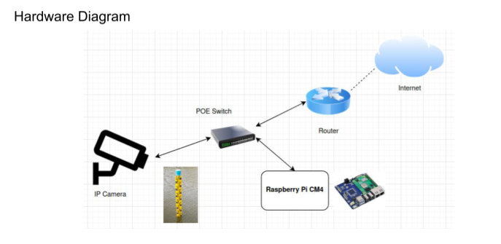

**RTSP Snapshot**

- Require RTSP URL of camera (source)

- Caution, need to drop/skip frame if FPS is higher than loop-time

**Find ROI**

- Object Detection with staff gauge model can be used

- YOLOv4, 5 are the recommended for RPi4

**The Flood Level Extraction process comprises the following steps:**

- Initial image preprocessing.

- Identification of the waterline and staff gauge line within the image.

- Determination of length features, including the number of pixels corresponding to the staff gauge and numerical markings.

- Utilization of interpolation techniques to calculate the actual water level based on the identified features.

**What I have learned from this seminar**

From this seminar, I have gained valuable insights into the complex dynamics of flooding and drought occurrences, understanding the multifaceted factors that contribute to these environmental challenges. The link between climate change-induced irregular weather patterns, improper land management practices, and inadequate infrastructure became clear, emphasizing the need for comprehensive solutions. The discussion on the challenges associated with flooding alarm systems highlighted the importance of addressing issues such as slow response times, manual data collection, and the specific challenges faced in rural areas. Additionally, exploring the components and alternative sensors in water management systems, particularly the Floodgate Station, deepened my understanding of the technological advancements aimed at efficient flood control. The integration of cameras with computer vision for reading staff gauges and the application of OpenCV in various fields, including 2D and 3D feature toolkits, face and gesture recognition, and object detection, expanded my knowledge of practical applications in computer vision. Overall, this seminar has broadened my perspective on the interconnected issues of water management, technological solutions, and the critical role of environmental awareness.