

**Homework # 4**

**01286232 Software Engineering Principle**

**Software Engineering Program,**

**Department of Computer Engineering,**

**School of Engineering, KMITL**

By

65011277 Chanasorn Howattanakulphong

I created a simpler version of my python project from last year (See the first picture), the concept is to hit spacebar when the rabbit approaches the circle. The rabbits spins until it meets the circle, then proceed to respawn at a random location. If you hit the button at the correct timing, it displays a label “Hit!” along with a sound and displays “Missed!” otherwise. Upon hitting the button, the rabbit also respawns.

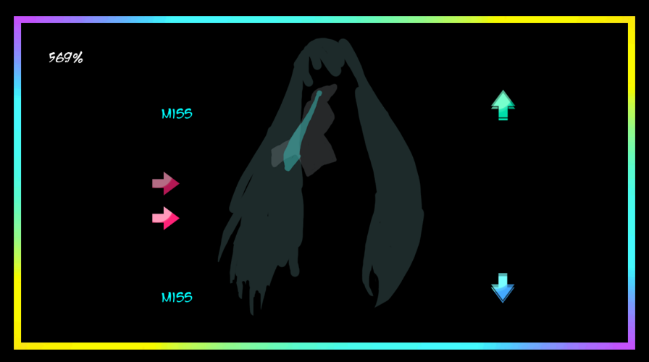

(Old project)

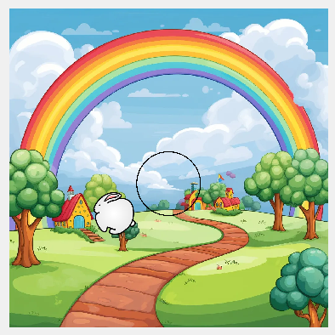

(Current work)

(When hit)

(When misses)