Name-Surname: Chayut Liewlom ID: 63011134

Software Engineering Lab

Direction Lab #2

20th January 2022

1. Modify program 2.1 to display text “Hello World!” on output screen.

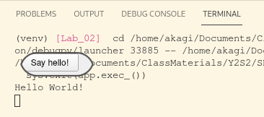

2. Modify program 2.2 by adding reset button to reset number to 0.

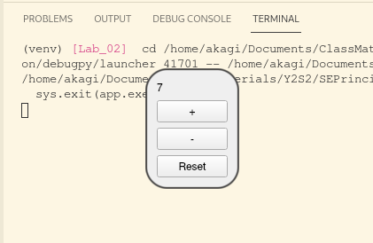

3. Create digital clock window to display current time (look at program 2.3 for how to use periodic timer).

To get current time use time module and call:

time.strftime(“%X”)

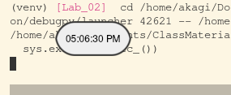

4. Create an application to convert from Thai Baht to US Dollar and vice versa (assume that 1 USD = 30 THB).

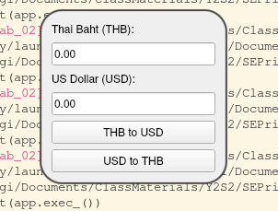

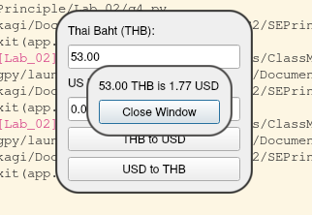

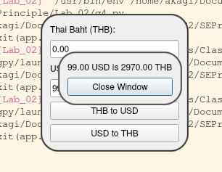

Homework: Draft a design for a simple GUI application based on your own idea. Try applying what you have learned in this lab to create a prototype from that design. The GUI should at least contain textboxes, labels and buttons.

