Name-Surname: Chayut Liewlom ID: 63011134
Software Engineering Lab
Direction Lab #3
27th January 2022
1. Type the program 3.1 in Visual Studio Code and run it.

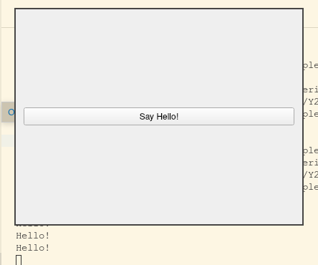

2. Modify program 3.2 so that when user clicks on the button “-”, the number is decremented. After that, add the reset button to reset number to 0.
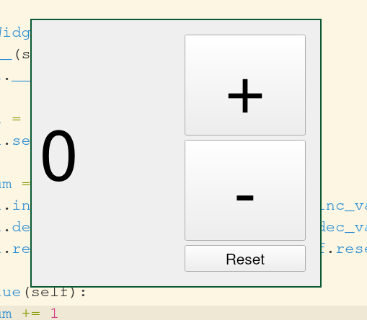

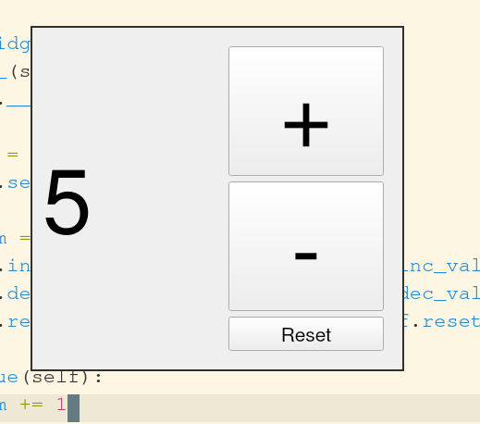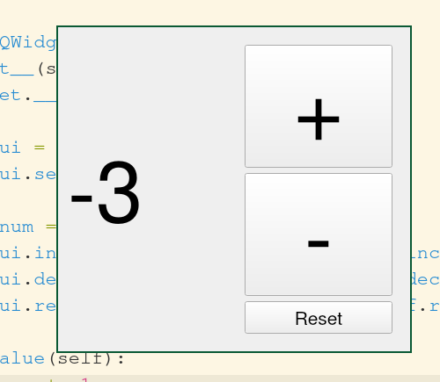

3. Create a phone dial pad user interface as follows.

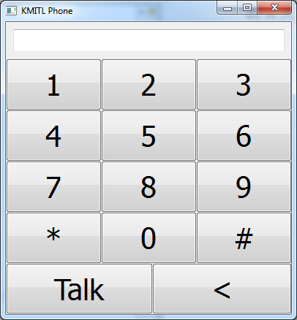
1. When pressing the buttons 0-9, *, and #, the number or the symbol will be appended to the display area on the top.
2. When pressing the “<” button, the rightmost character in the display area will be deleted.
3. When pressing the “Talk” button, a dialog that displays the message below will pop up:
“Dialling <<current number displayed>>”.

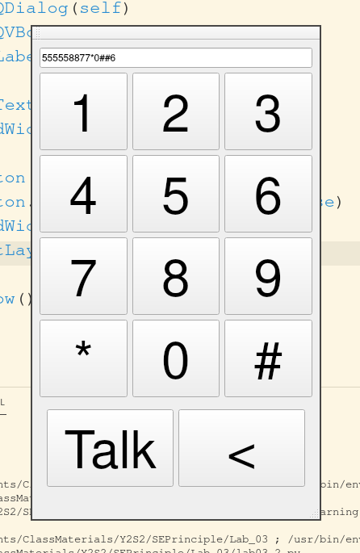

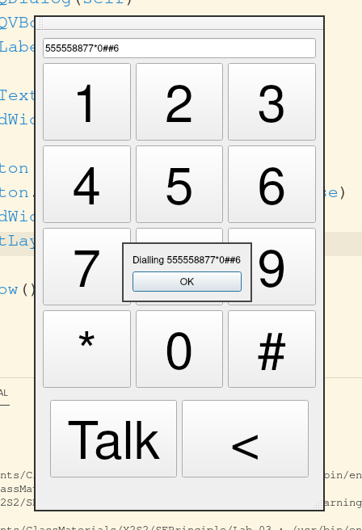

Homework: Continue designing a simple GUI application based on your own idea. Apply what you have learned in this lab to create a prototype GUI program from that design. The GUI should at least contain textboxes, labels and buttons. Your GUI program should contain no less than 80 lines of codes.

