Name-Surname: Chayut Liewlom ID: 63011134
Software Engineering Lab
Direction Lab #5
10th February 2022
1. The table below summarizes the tasks in a project. Draw an activity network and a Gantt chart of this project by hand on the space below, assuming the start date is today. Then determine the critical path and the expected finish date of the project.

Task | Duration (days) | Predecessors
T1 | 10
T2 | 25
T3 | 15
T4 | 5 | T3 (M1)
T5 | 10 | T1, T2, T3 (M2)
T6 | 15
T7 | 20 | T5 (M3)
T8 | 25 | T4, T6 (M4)
T9 | 5 | T8 (M5)
T10 | 10 | T7, T9 (M6)
T11 | 35 | T6 (M7)
T12 | 10 | T11 (M8)

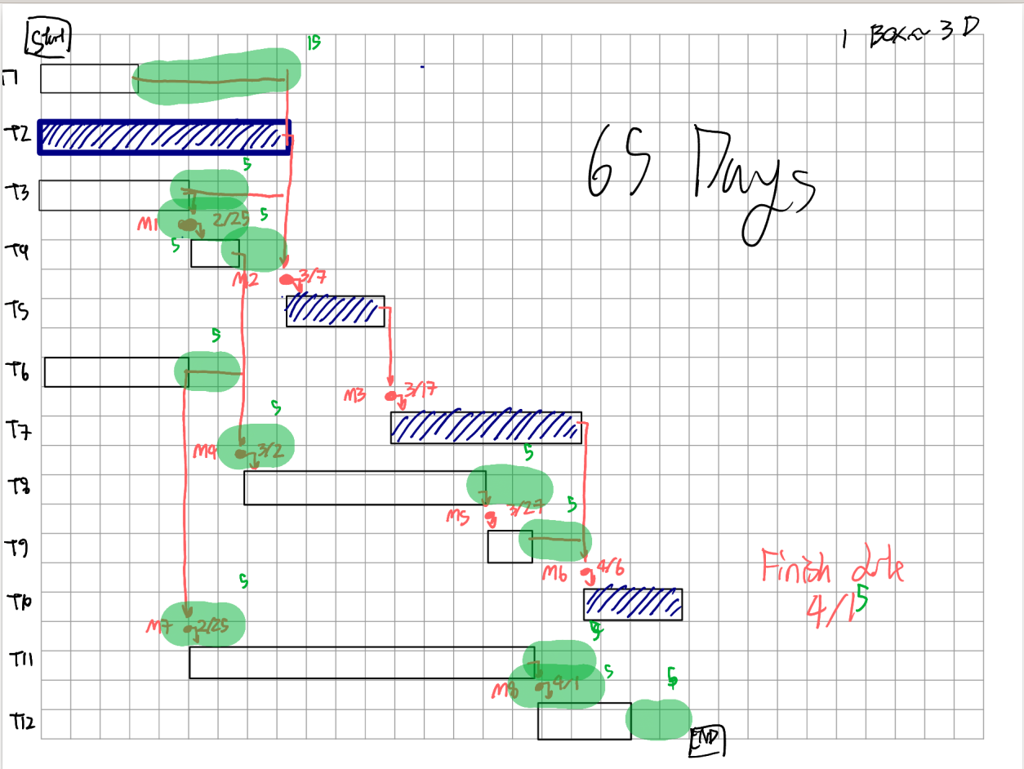

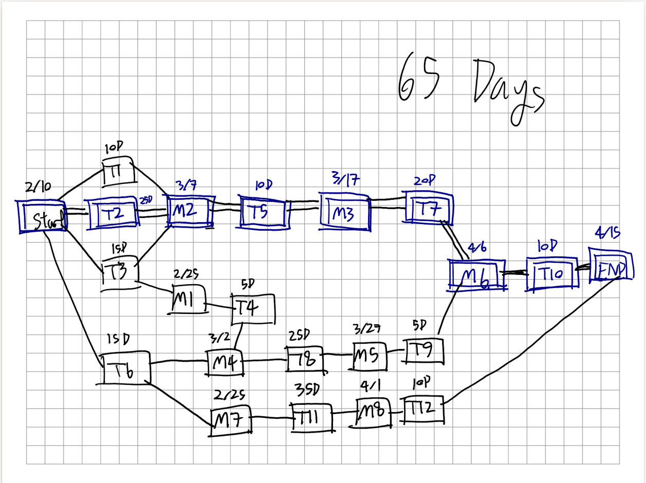

2. Create a new project file in Project Libre and input the task table in question 1. Use Project Libre to generate a network diagram and a Gantt chart. Also, use the program to find the critical path and the expected finish date of the project.
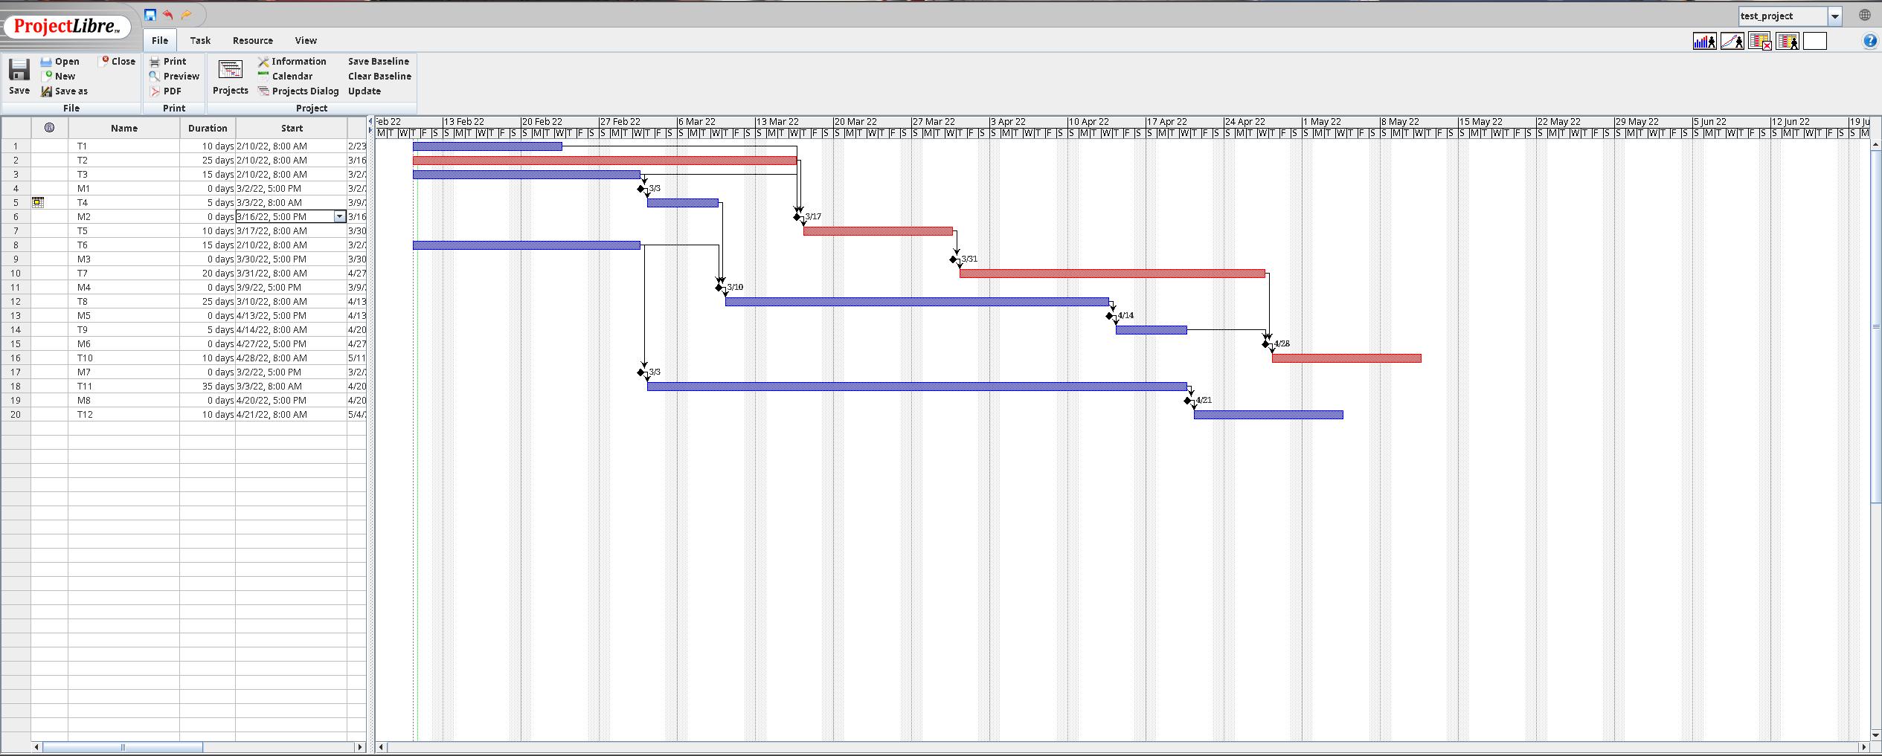

3. Imagine that you and your team are hired by a software company to develop a website which provides information about the restaurants in Thailand. List all the tasks involved in this project (including their durations and dependencies). Then use Project Libre to create your software development plan. The following are some of the common tasks in a website development project. You may add other tasks, you think, necessary.

Requirement
- Fact finding
- Study an existing similar website
- Do a survey on restaurants
- Identify the functions of the website
- Identify restaurant data and classification
- Obtain server requirement (hardware and software)
- Prototyping
- Design mock-ups screens
- Create mock-ups screens
- Prepare requirement specification

Design
- Design the data model
- Design the user interface
- Layout design
- Artwork design
- Design the software architecture

Implementation
- Set up the development environment
- Set up the development servers
- Set up the development computers
- Implement the data model
- Set up the development DBMS
- Create databases
- Programming
- Client-side coding
- Server-side coding
- Graphics
- Create graphic files
- Integration

Data Collection
- Obtain restaurant data
- Data entry

Testing
- Unit testing
- GUI testing
- Integration testing
- End-user testing
- Alpha testing
- Beta testing

Deployment
- Arrange web hosting
- Install website

Milestone 1
- Requirement specification completed
- Customers agreed with the specification

Milestone 2
- Design documents completed

Milestone 3
- Implementation completed

Milestone 4
- Testing passed

Milestone 5
- Website deployed


Group Homework: Working as a group (i.e. your SE project group), use Project Libre to create a schedule for your team development activities of the SE Python project. This project schedule contains a Gantt chart and a network diagram of your team SE Python project.
Put this project schedule in your project proposal to submit as this homework; the proposal contains
- Project title and team members (with their names and student IDs)
- Project description (at least 1 page long)
- Draft UI Design (at least 2 screens)
- Breakdown of the software project activities and their durations
- Project plan (your project schedule) printed from Project Libre

