Task 1.1:

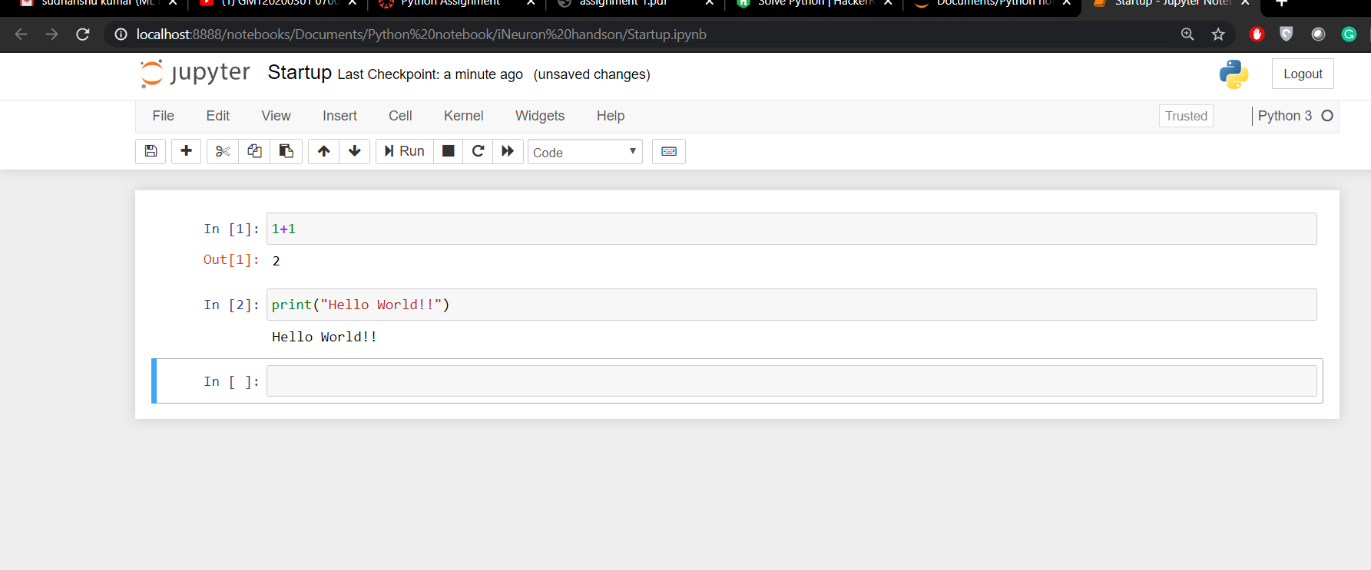
Screenshot of jupyter notebooks after successful installation

Task 1.2:

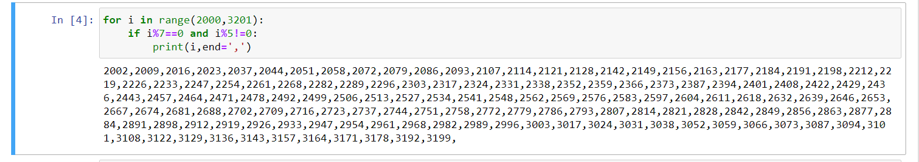

Task 1.3:

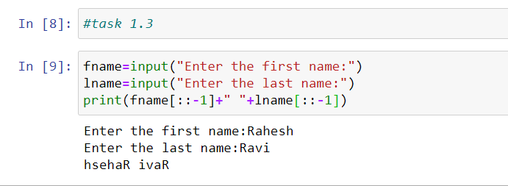

Task 1.4

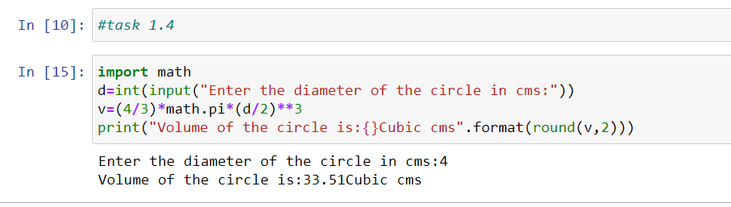

Task 2.1
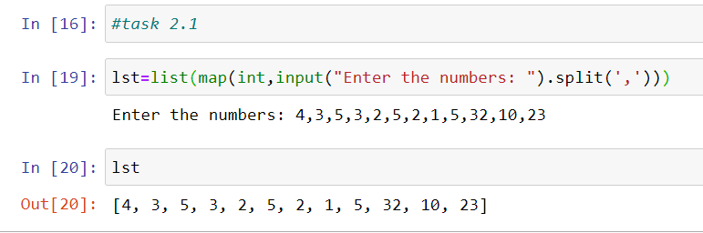

Task 2.2

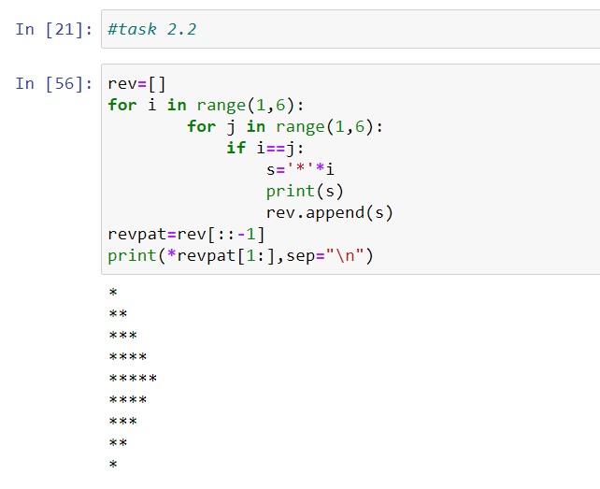
Task 2.3

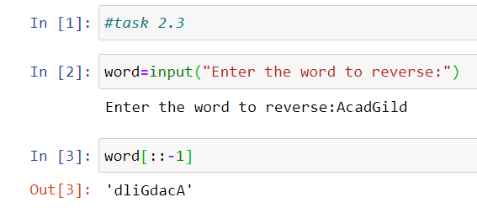

Task 2.4

