D3 Project - Debt and debt service, 2017 estimates

Content

Dataset 2

Preprocessing 2

Tasks 2

Visual design 3

Presentation slides 4

Prototype interaction 6

Show Data filter 6

Usage filter 8

Interacting directly using the graphs 9

List of figures

Figure 1 Dataset overview 2

Figure 2 Prototype mockup creditor groups 3

Figure 3 Prototype mockup creditor group 3

Figure 4 D3 Application 3

Figure 5 Jahresende aufgeteilt 6

Figure 6 Ursprüngliche Schuld aufgeteilt 7

Figure 7 Brücken 8

Figure 8 Finanzunternehmen & Oberbank AG 9

# Dataset

* Semantics: Credit Group, debitors, creditor, debts beginning/end of year
* Number of Items: 699 Items
* Number of Features: 28
* Types: Categorical, numerical, label, sequential

## Preprocessing

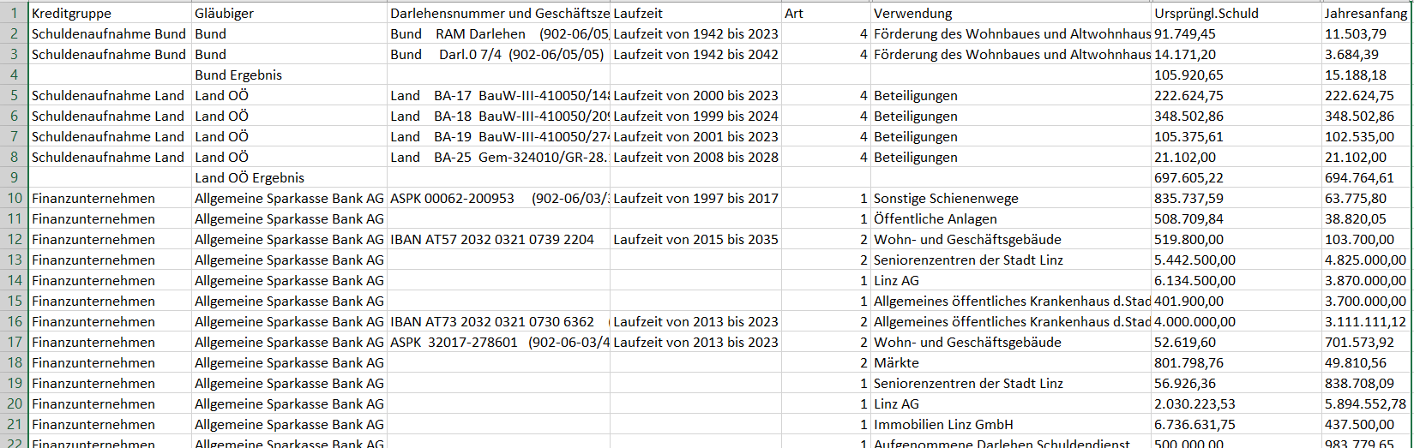

Figure Dataset overview

We had to change the separator from semicolons to tabs, since we were not allowed to use another library (although we could’ve used the d3-selection library to use semicolons). We also had to change the numbers format to use a comma as thousands separator.

# Tasks

* Which credit groups have the highest debts?
* Which creditor has the highest debt within a credit group?
* How did the debts change over the year?

# Visual design

The prototype for our presentation looked like this:

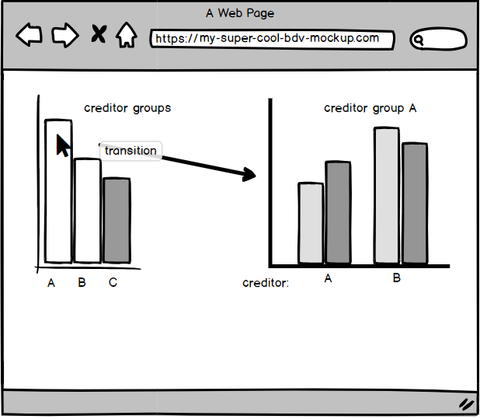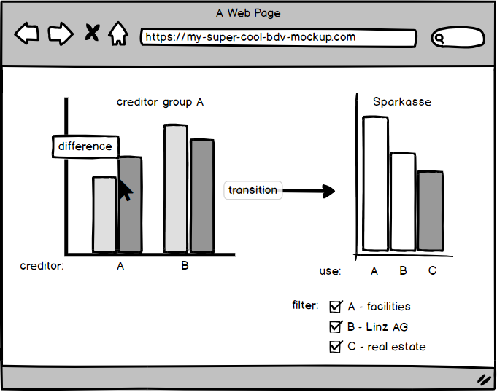

|  |  |
| --- | --- |
| Figure 2 Prototype mockup creditor groups | Figure 3 Prototype mockup creditor group |

We changed it according to the feedback to show the user all the data at once:

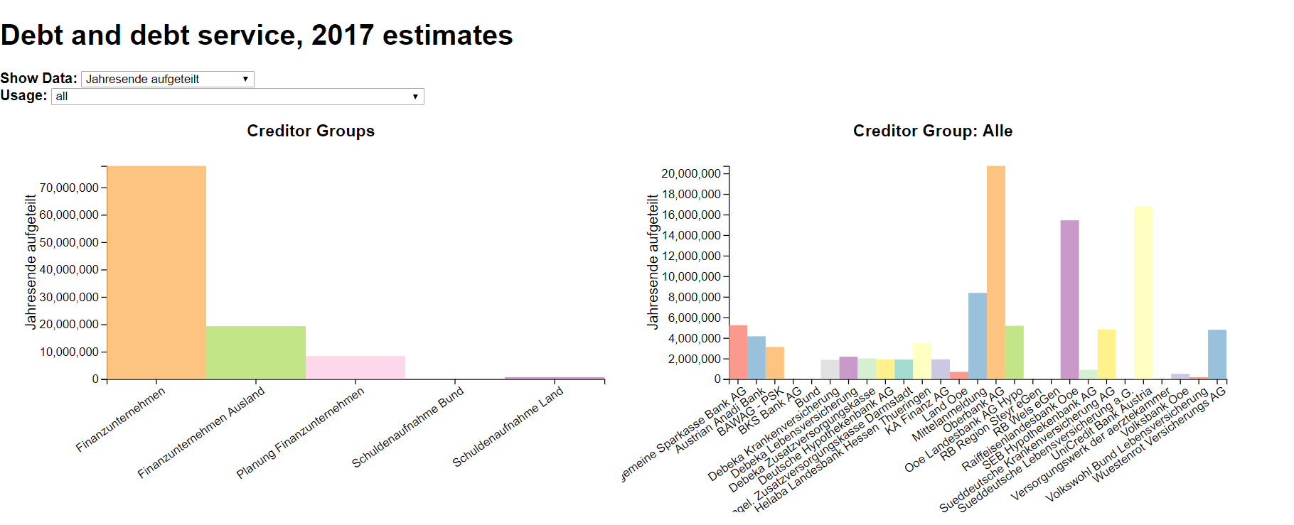

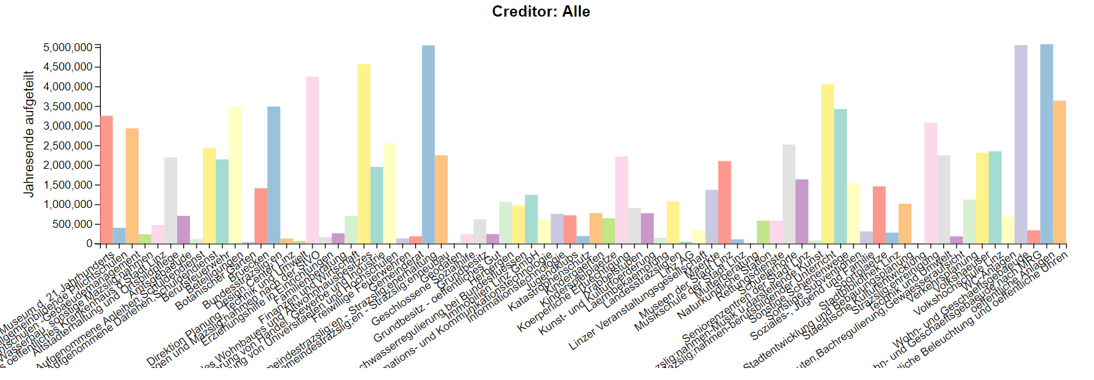

Figure D3 Application

# Presentation slides

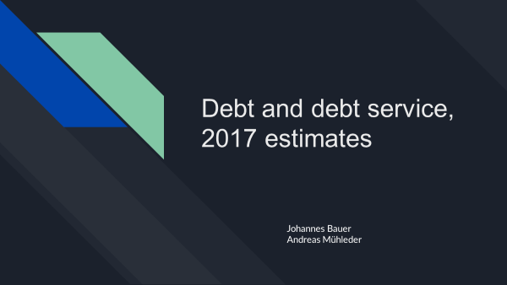

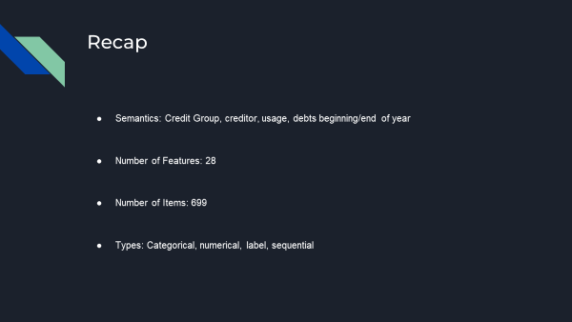

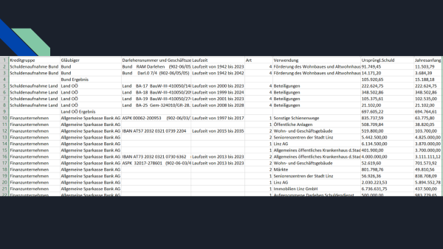

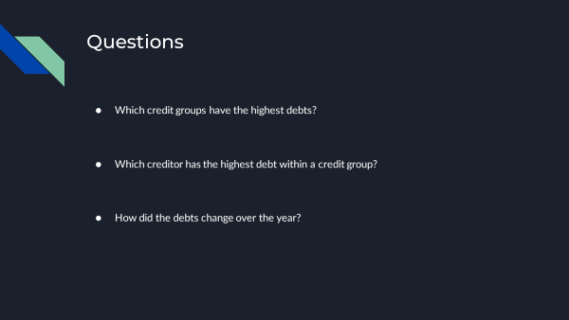

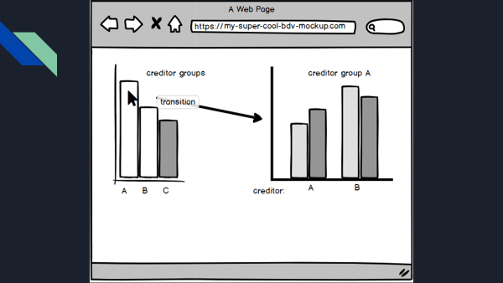

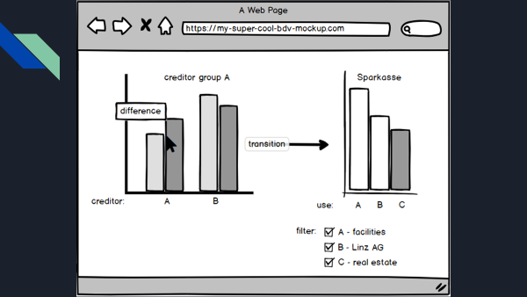

# Prototype interaction

The prototype offers a lot of functionalities to the user for exploring the data in more detail. We decided to stick to bar charts and offer the user the best possible interaction to explore all the data within the dataset. The following operations are available in the interactive Data Visualization:

## Show Data filter

This filter offers the opportunity to list the data directly for the selected field of interest. All the shown data automatically updates according to the used filter option.

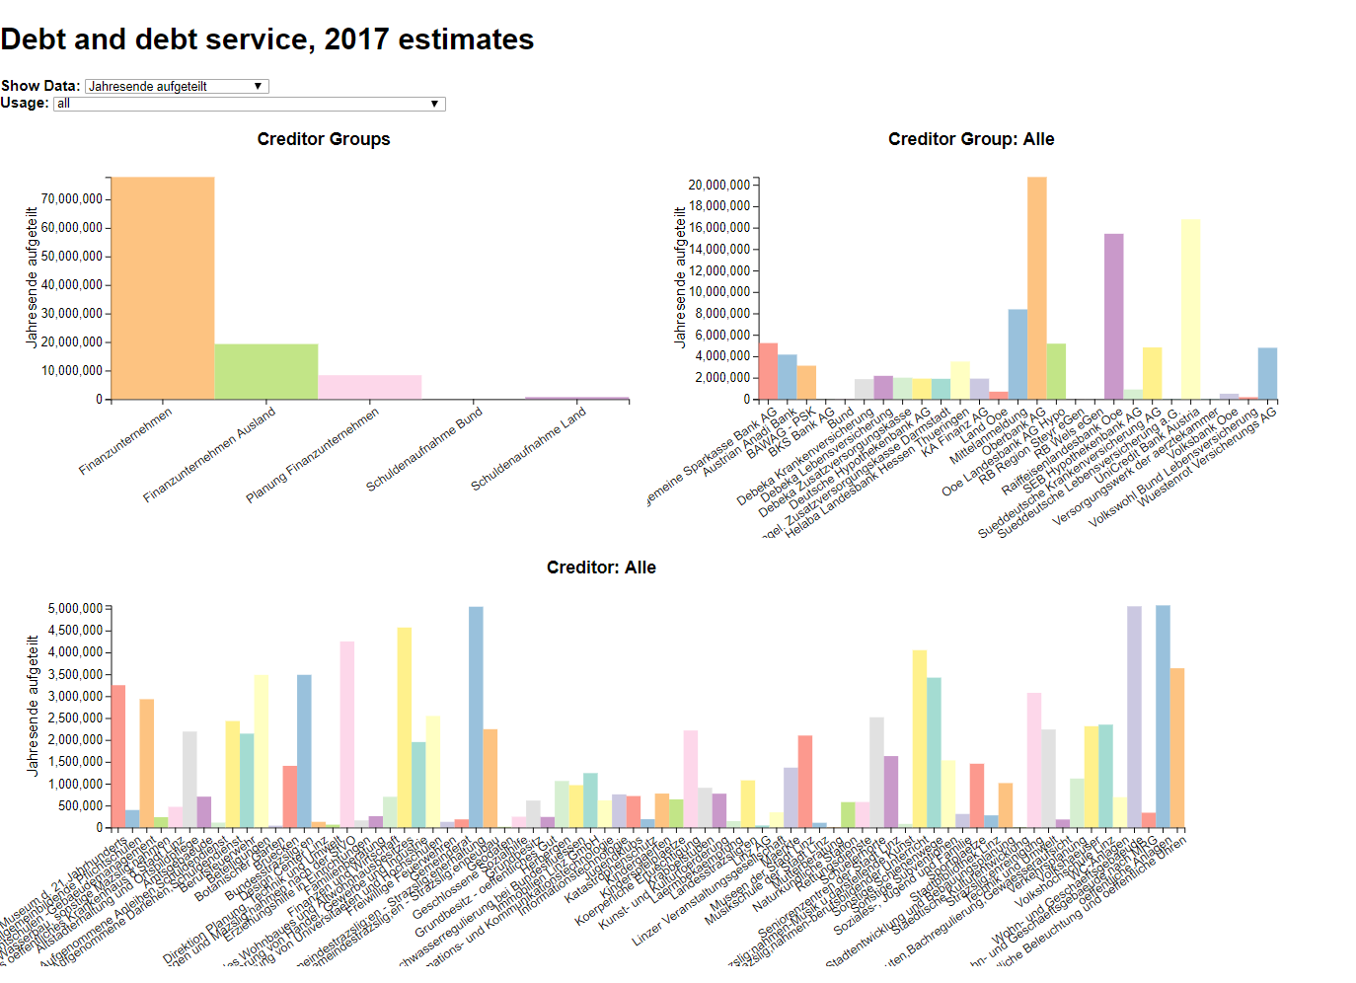

Figure Jahresende aufgeteilt

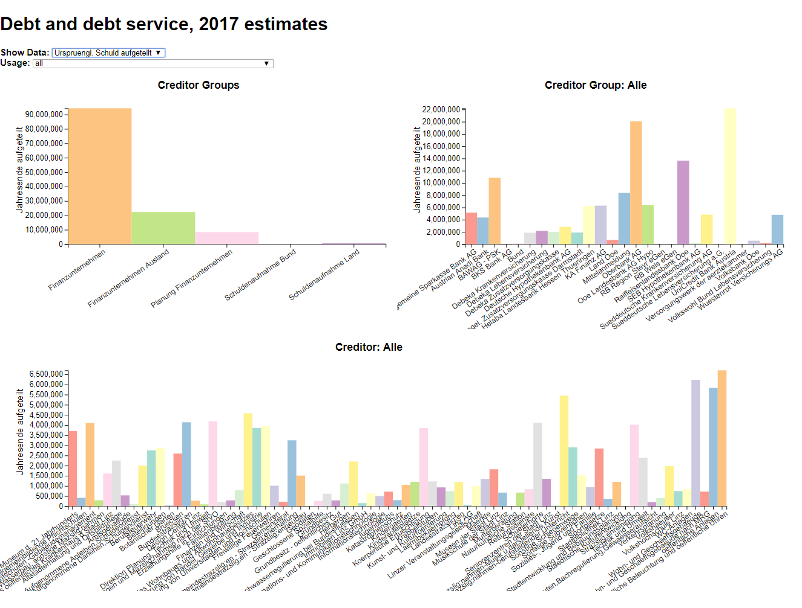

Figure Ursprüngliche Schuld aufgeteilt

## Usage filter

This filter offers to opportunity to get more insights on the usage of the debts. When selecting a value, all the bar charts are updated and only the ones according to the chosen usage option are displayed.

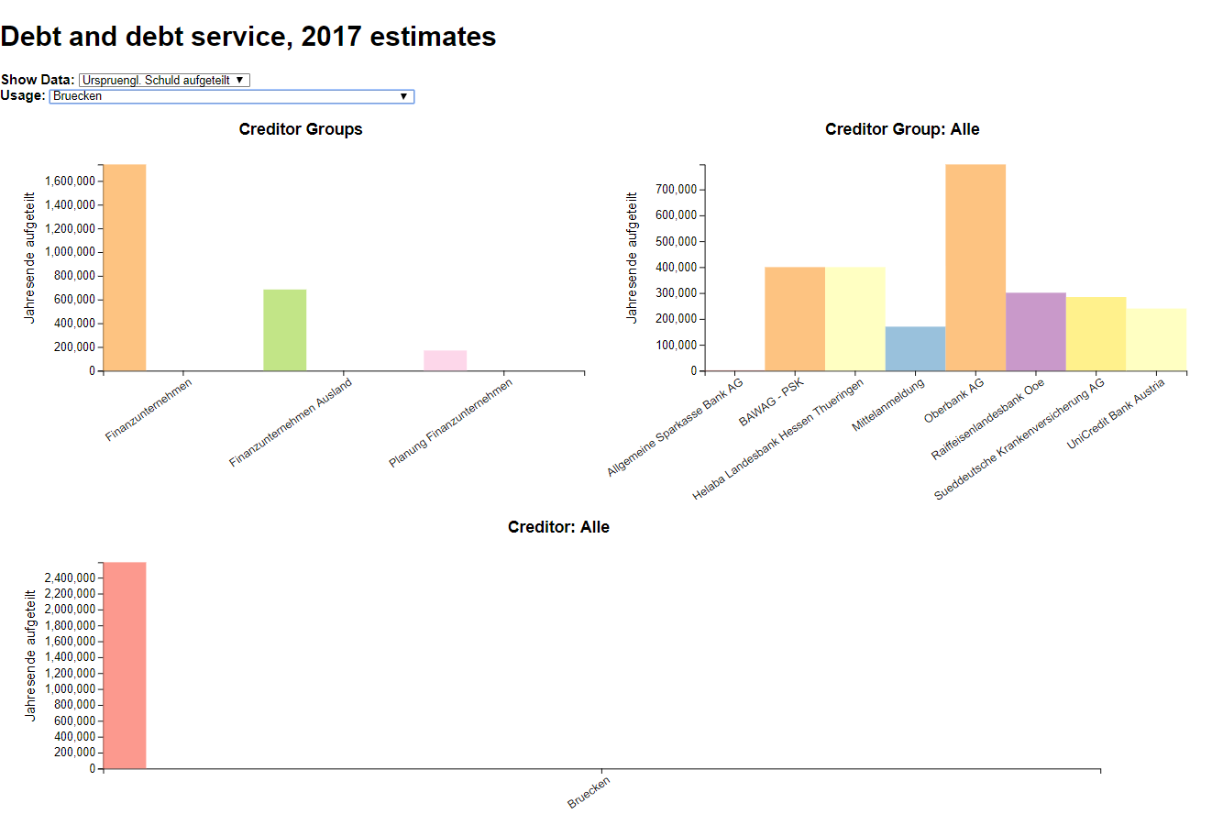

c

Figure 7 Brücken

## Interacting directly using the graphs

As a last filter option, the filtering can be done directly selecting creditor groups and/or a single creditor group in the diagram. The selected rectangle will change its opacity and all the following diagrams will just show the data according to the selected one. To deselect the selection again, just click it again.

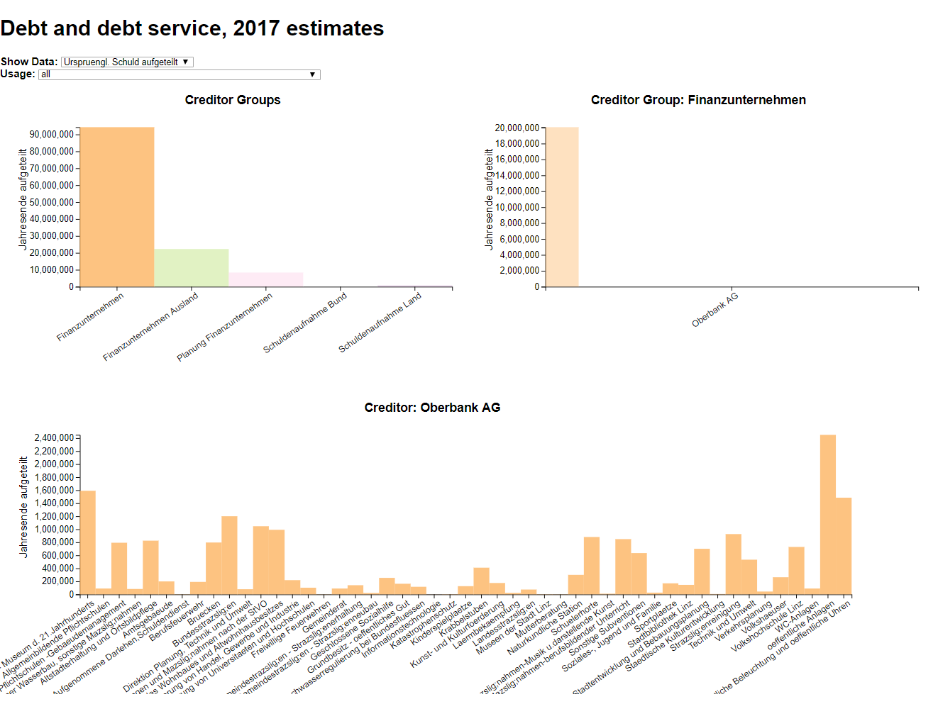

Figure Finanzunternehmen & Oberbank AG