Guess Word

Instalation – for Windows users

- To run this program on a Windows based computer; you will first need to install Python. Navigate to the official Python website and download Python 3.x

- Run the installer you downloaded to install Python.

- Download the Guess Word game into a directory on your computer.

Starting Guess Word – for Windows users

- Navigate to the directory where you save Guess Word, copy the entire file path to the inner directory by clicking and selecting the file path at the top of the File Explorer window.

- As Guess Word is a console application, you will launch the game from the Command Prompt. Press the windows button or access the Start Menu; and type "CMD" then press Enter to launch the Command Prompt.

- In the Command Prompt window, type "cd" and press the spacebar, now right click your mouse and select Paste. This will change your working directory to the directory where Guess Word is located.

- Now type "python GuessWord.py" to launch the game.

Playing the game

- When you start the game you'll be presented with the welcome menu. If you type 1 and Enter, the game will start.
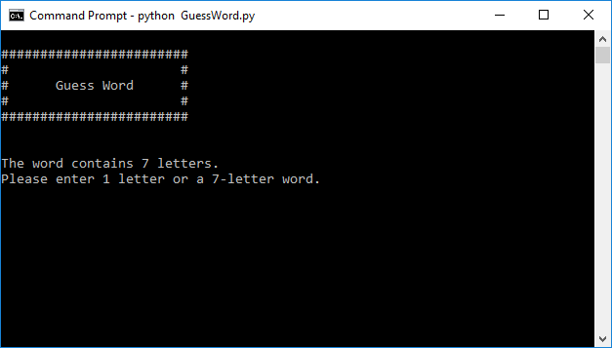
- Start by entering letters one at a time and pressing Enter, and the game will tell you if you guessed a letter which is in the word.

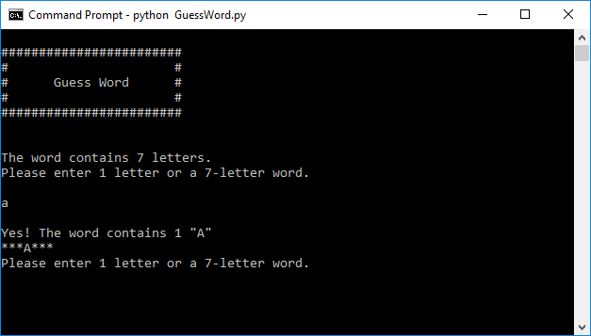

- If you think you have an idea what the word might be, you can also enter a word with the same number of characters as the actual word. You'll be told how many characters the word as when the game starts.

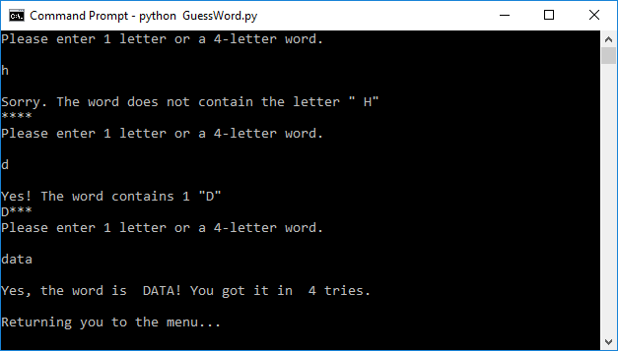
- If you run out of guesses; the default is set to 8 (you can set a higher or lower limit by pressing 0 at the menu), the game will end and return you to the main menu automatically.

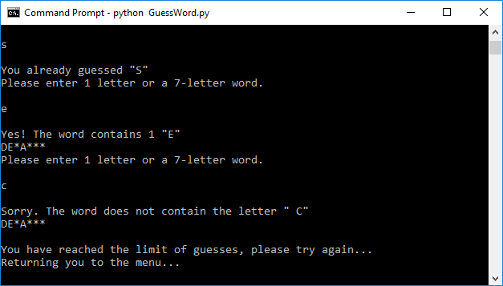

Optional Settings

- If you press 0 and Enter at the menu, you will be able to change from the default word list (words.txt) where the words for the game are selected from to an advanced alternative (advanced.txt)

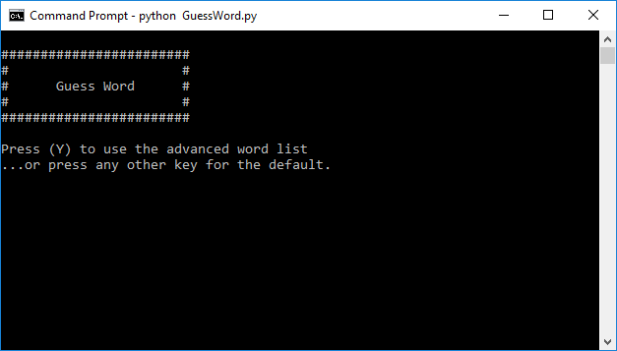

- After selecting this first option you are presented with one more menu where you can change the default guess limit, which times out the game when you make too many guesses. The default is 8.
