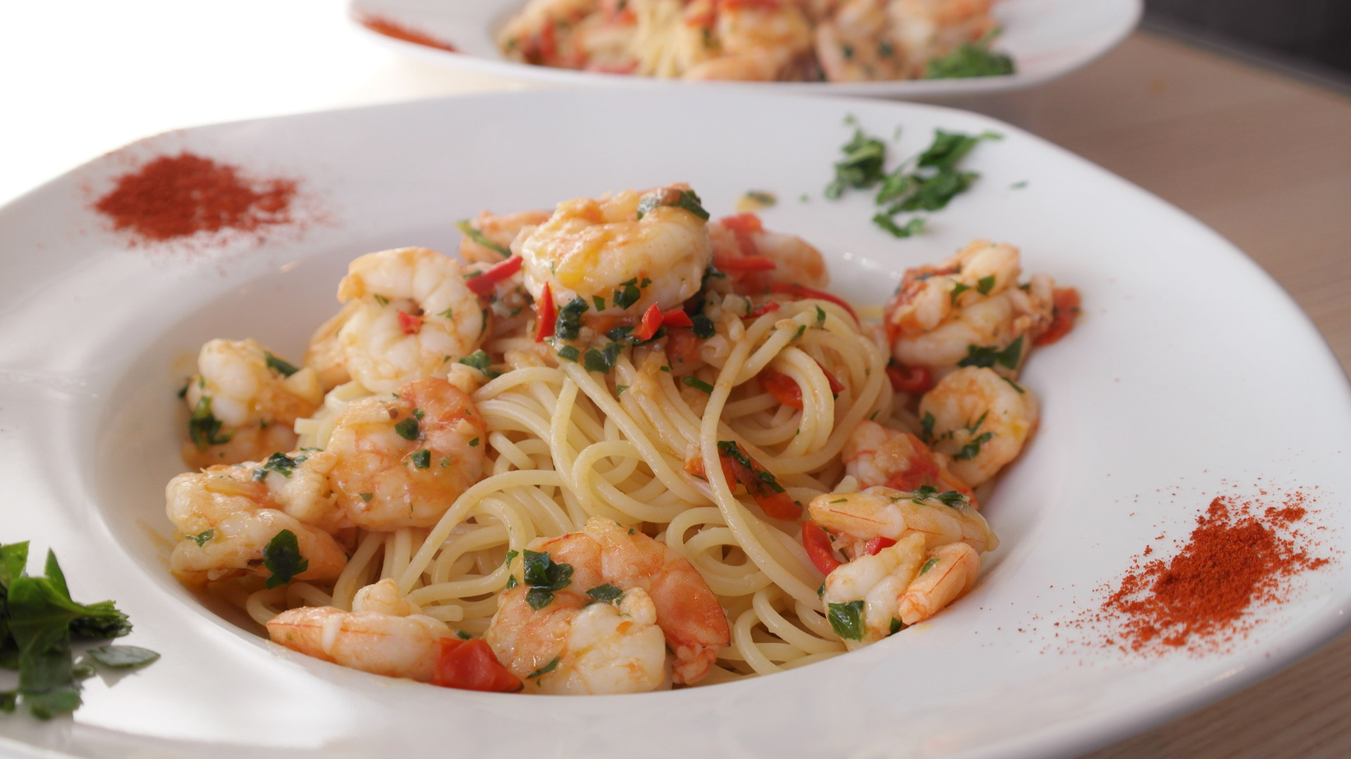
{% for paso in pasos %}
- {{ loop.index }}. {{ paso }}
{% endfor %}
{% for ingrediente in ingredientes %}
{{ ingrediente }}
{% endfor %}
Ingredients
Instructions
{{ nombre }}
SERVINGS: 4
PREPPING TIME: 15 MIN
COOKING TIME: 20 MIN

