My Hackpad:
By Andrei Ermolaev
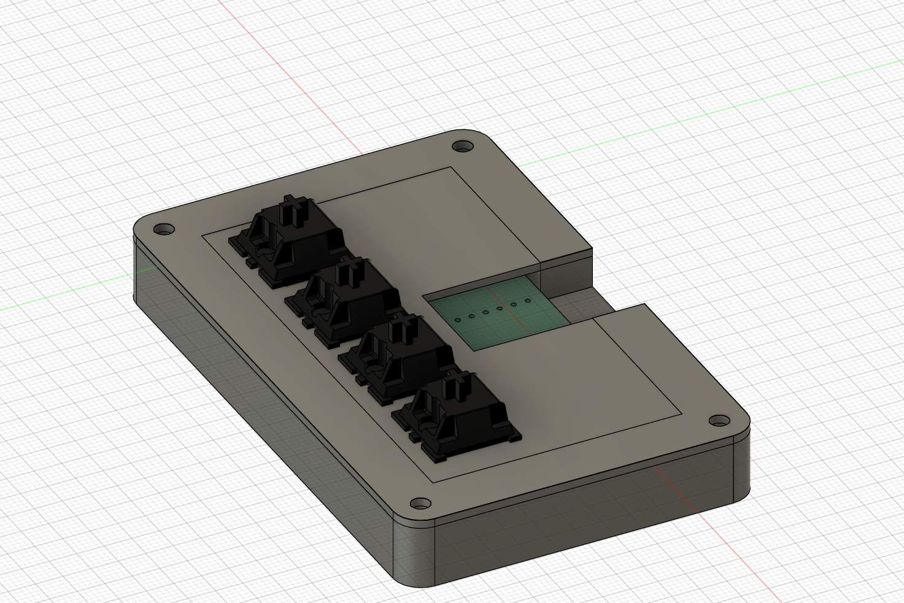

Inspiration:
I saw an Instagram Reel on my FYP by willdoesbuild that told me about the Hack Club Blueprint Project. I decided to try it out. I hope I get approved.

Challenges:
This was my first ever Hardware Project. I had to learn how to use Fusion 360 and KiCad. I only had some Blender experience. The Hackpad guide really helped me.

Specifications:
- 4x Cherry MX Switches
- 2x SK6812 MINI Leds
- 1x XIAO RP2040
- 4x Blank DSA Keycaps
- 4x M3x16 Bolt
- 4x M3 Heatset

Case Bottom:
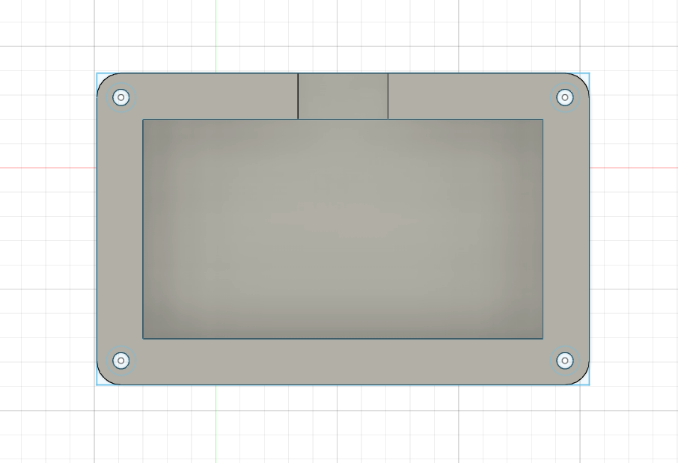

Case Top:
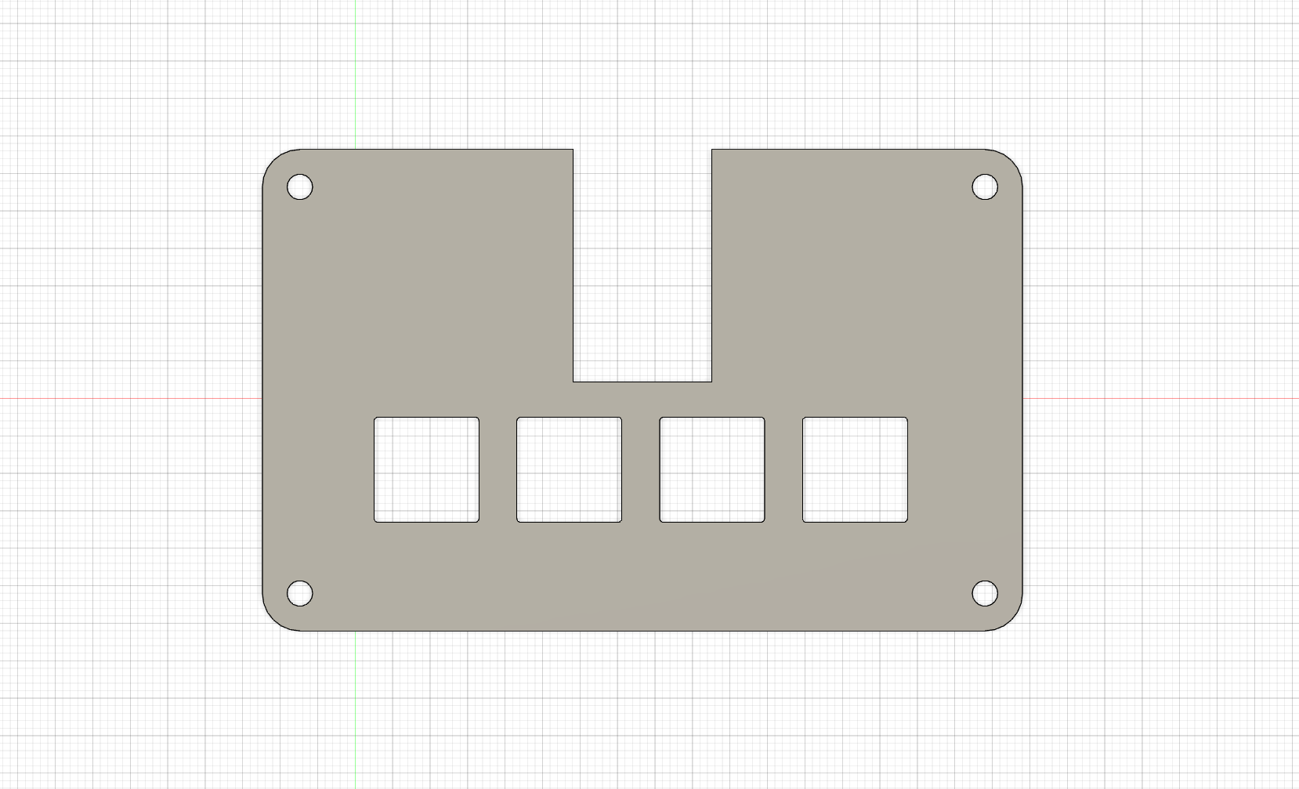

PCB:
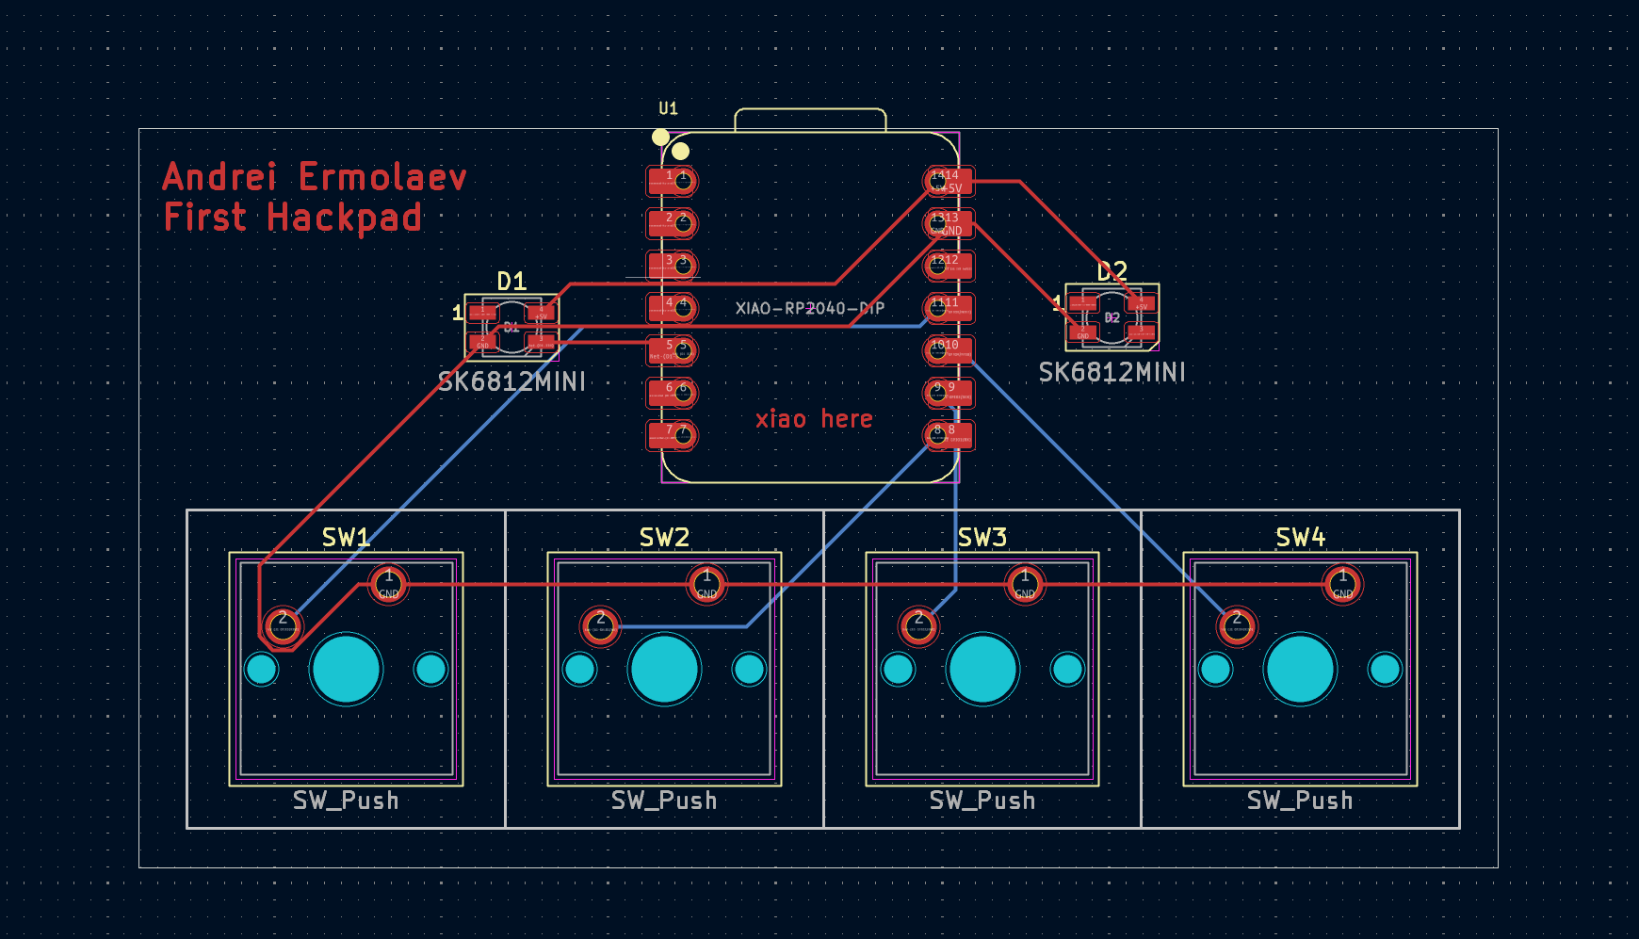

Schematic:
