**Sales Form**

**Database Design (ER Diagram):**

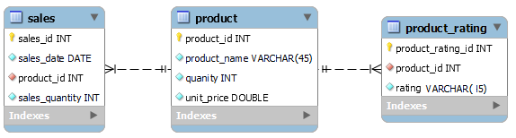

**Form Design:**

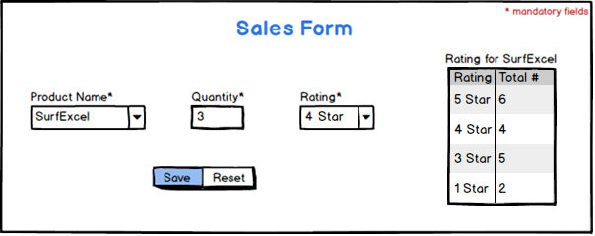

**Description:**

Create a database schema as shown in above ER-Diagram. Insert 5 records to product table from database side.

While form loading product name drop-down list must be populated with all inserted products. Upon selecting any product, rating for that product will be displayed in tabular form as shown in above image which contains two columns i.e. star rating which is from 5 to 1 and total number of rating given for each group. Make sure, if total number of rating for any group is 0, that group must not be displayed (as 2 star rating for SurfExcel is 0, that’s why not displayed). Then fill the quantity, select any rating (from 5 to 1) and save the form data. Sales data will be stored in sales table where sales_date is current system date. Rating data will be stored in rating table. Required quantity must be deducted from product table after saving.

**Validations:**

* One product name must be selected before saving.
* Quantity must be a positive number and required quantity must be available in product table.
* One rating must be selected.

**Recommendation:**

* Use of Store Procedure in database side is preferable.
* Use of Exception Handling is a must.
* Implementation of layered architecture is preferable. (i.e. Controller, Service, Data Access)