MINISTRY OF SCIENCE, HIGHER EDUCATION AND INNOVATIONS
OF THE KYRGYZ REPUBLIC
KYRGYZ STATE TECHNICAL UNIVERSITY named after I. Razzakov
INSTITUTE OF INFORMATION TECHNOLOGIES
DEPARTMENT OF "SOFTWARE OF COMPUTER SYSTEMS"
710400 “Software Engineering”
Term project
For the course: Database Management Systems
On the topic: Development of a web application for managing
a clothing factory warehouse (WarehouseOfClothes)
Prepared by:
Student of group SE(b)-1-23
Klyuchevsky D.
Instructor:
Senior Lecturer
Makieva Z.D.
Bishkek, 2026

Table of Content
1. Technical Specification 2
1.1. Introduction 2
1.2. Objective of the Work 2
1.3. Problem Specification 3
1.4. Purpose and Goals of System Creation 3
1.5. Functional Requirements 4
1.6. Client-Side Requirements 4
2. Server Side 5
2.1. Database 5
2.2. Tables 6
2.3. Stored procedures 13
2.4. Views 15
2.5. Triggers 17
3. Client side 19
3.1. Description of project creation 19
3.2. More detailed analysis 22
1. Models (Entity) 22
2. Views (Controllers) 24
3. Forms 26
4. URL routing 27
5. Permissions and Roles 28
6. Templates (Presentation) 29
4. Launching the program 32
5. Screenshots of the program 33
6. Conclusion 42
7. List of Used Literature 42
8. Application appendix 43

1. Technical Specification
1.1. Introduction
In the context of the modern garment-industry market, effective management of warehouse, production and financial resources is becoming a key success factor for a clothing factory. Such an enterprise needs to control the receipt and consumption of raw materials (fabric, threads, accessories), the manufacture of finished items, sales to clients, salary payouts to employees and the use of borrowed funds — all on a single budget.
The web application WarehouseOfClothes was developed in order to replace manual (paper-based and spreadsheet) accounting with a unified digital management system. Without such a system, the factory cannot reliably track raw-material stock, control production cost, manage finished-product inventory, prevent sales below cost, or analyse who and when performed each operation. Implementing this web application is therefore a relevant task that allows the factory to operate more efficiently and to make data-driven decisions.
1.2. Objective of the Work
The objective of the work is to design and implement a comprehensive web application for a clothing factory warehouse. The main task is to create tools that will allow authorized users to:
- view and manage the factory budget;
- record and pay off business loans;
- manage employees, positions and salary payments;
- track purchases of raw materials with units of measurement;
- manage the catalogue of finished products and their recipes (ingredients);
- register production operations with raw-material consumption check;
- register sales of finished products with automatic price calculation;
- automatically update the budget on every financial operation;
- submit and process production requests with multi-stage workflow;
- view analytics, top products and the ratio of revenue to expenses.
1.3. Problem Specification
During the analysis of the existing management processes of a clothing factory, the following problems were identified:
- Absence of a unified accounting tool — purchases, production and sales are kept in separate Excel sheets, making it difficult to track real stock.
- Lack of automatic budget control: any cash operation is registered manually, which produces arithmetic errors and disagreements between departments.
- Inability to forbid a sale below cost or production with insufficient raw materials — such checks have to be done by the operator, who can forget them.
- Absence of role-based access control: every user can see and modify any data, which contradicts internal company policy.
- No analytical reports — the manager has no consolidated view of top-selling products, total expenses and current stock.
1.4. Purpose and Goals of System Creation
1.4.1. Purpose
Development of a web application for managing a clothing-factory warehouse to provide directors, accountants, warehouse keepers, production specialists and sales managers with effective tools for comprehensive resource management, simplifying the processes of budget control, procurement, production, sales and HR.
1.4.2. Goals
The main goals of creating the new system are:
- simplify the process of warehouse accounting and financial planning;
- ensure quick access to information about loans and their repayment status;
- automate employee management, salary payments and position tracking;
- provide transparent control over raw-material purchases and units of measure;
- enable efficient management of the finished-product line, production and sales;
- implement role-based access so that each user only sees their working area.
1.5. Functional Requirements
- Creating and editing the budget record.
- Recording business loans (up to three simultaneously) and paying them off.
- Creating, editing and viewing employees, positions and units of measurement.
- Processing salary payments with automatic budget deduction.
- Recording raw-material purchases through a stored procedure that verifies the budget and atomically updates stock and budget via an INSERT trigger.
- Managing the catalogue of finished products and their recipes (ingredients).
- Performing a production operation only if raw materials are sufficient; the system automatically consumes raw materials and increases the product stock.
- Recording sales with auto-calculated price (cost × 1.30); the budget is increased on every sale.
- Production requests: an end-to-end workflow (created → checking raw stock → purchasing raw materials → producing → selling → completed).
- Three SQL views give read-only reports: raw-stock view, finished-product-stock view, and materials-needed-for-production view.
- Analytics dashboard with charts of top sold products and revenue vs expenses.
- Role-based access control: director (full access), accountant (budget, salary, loans), warehouse keeper (purchases), production worker (production, recipes), sales manager (sales).
- Account management: the director can create and revoke accounts of employees.
1.6. Client-Side Requirements
- The client can use one of the following web browsers: Google Chrome, Mozilla Firefox, Microsoft Edge, Yandex Browser.
- To use the system, the user must authenticate with a valid username and password.
- After logging in, access to specific functions (budget editing, loan management, purchases, sales, salary payouts) is controlled by role-based permissions.
- The interface automatically adapts to the user’s role, hiding irrelevant sections and menu items.
- The user interface must be simple, clean and convenient for daily work.
- The main pages of the application are accessible through the top navigation bar.
- The system must display important information — current budget, active loans, the authorized user — in a visible area of the interface.
- Pages must support basic operations: adding, editing, deleting and viewing history of records.
- Error messages must be displayed in a user-friendly way when a business rule is violated, e.g. insufficient budget, sale below cost, missing raw materials.

2. Server Side
2.1. Database
The application uses Microsoft SQL Server as its DBMS. The schema is generated and maintained by Django ORM migrations; all tables therefore receive the prefix warehouse_. Together with Django service tables (auth_user, django_session, django_migrations, etc.) the database contains 22 tables; 14 of them are the domain tables of the WarehouseOfClothes system. In addition the database has 2 user-defined stored procedures, 1 INSERT trigger and 3 SQL views — all of them created in migration 0002_create_sql_logic.py.
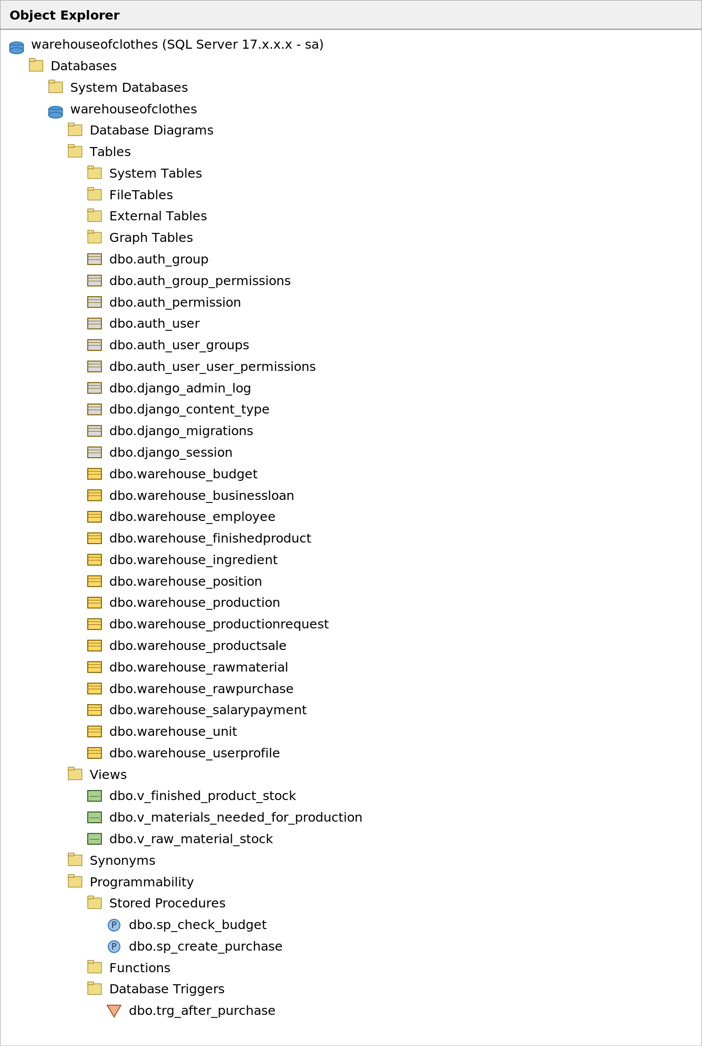
Image 1. The list of all tables of the system in MSSQL.
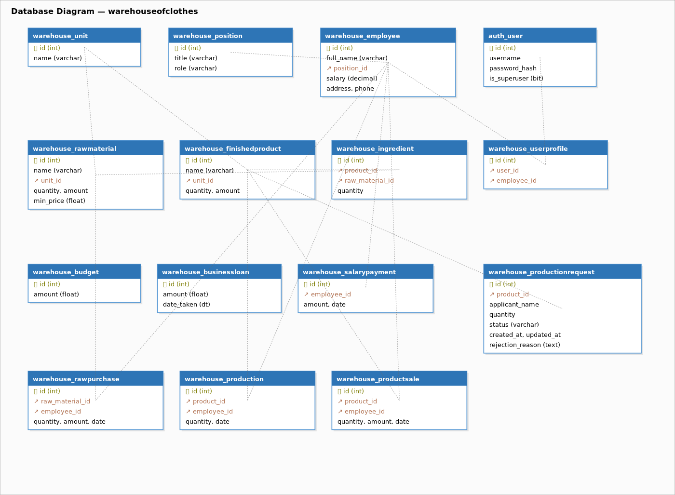
Image 1.5. Entity-Relationship diagram of the database.
2.2. Tables
1. “Budget” table
Stores the current value of the factory’s budget. There must always be exactly one row (an in-app guard in the model forbids creating a second instance).
Table structure:
Column | Type | Description
id | BigAutoField | Primary Key
amount | Float | Current budget amount (KGS).
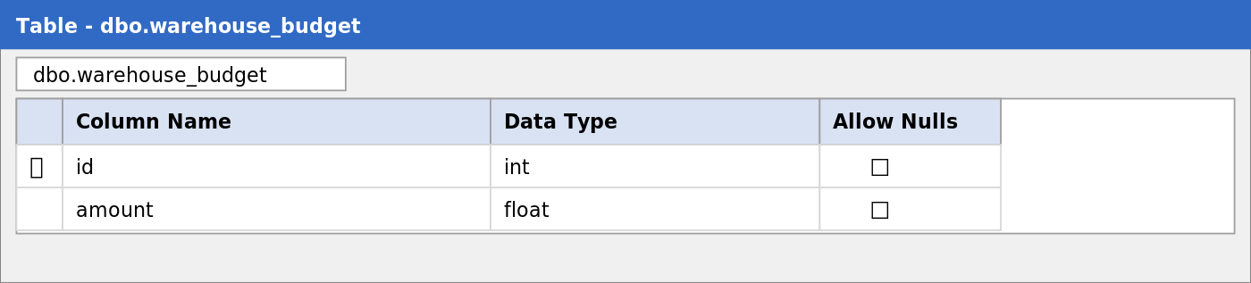
Image 2. Structure of the table Budget.
2. “Unit” table
Reference list of measurement units (pcs, kg, m, etc.) used both for raw materials and for finished products.
Table structure:
Column | Type | Description
id | BigAutoField | Primary Key.
name | CharField(50), UNIQUE | Name of the unit.
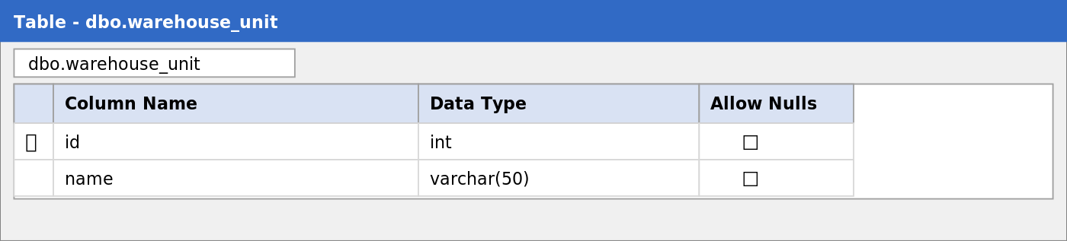
Image 3. Structure of the table Unit.
3. “Position” table
Reference list of employee positions; each position is linked to one application role (director / accountant / warehouse / production / sales / none) that governs RBAC permissions.
Table structure:
Column | Type | Description
id | BigAutoField | Primary Key.
title | CharField(100), UNIQUE | Position title.
role | CharField(20) | Role-based-access role (choice field).
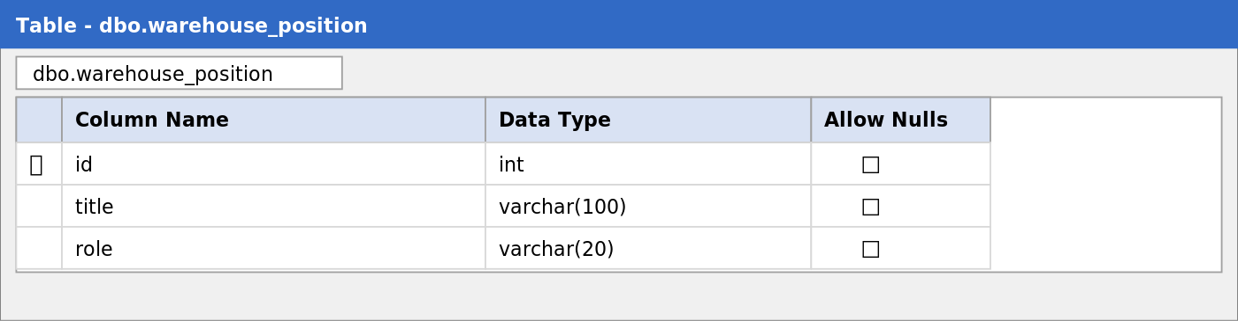
Image 4. Structure of the table Position.
4. “Employee” table
Stores information about the factory employees.
Table structure:
Column | Type | Description
id | BigAutoField | Primary Key.
full_name | CharField(200) | Full name of the employee.
position_id | FK → Position (PROTECT) | Position of the employee.
salary | Decimal(10,2) | Monthly salary.
address | CharField(255), nullable | Residential address.
phone | CharField(20), nullable | Contact phone number.
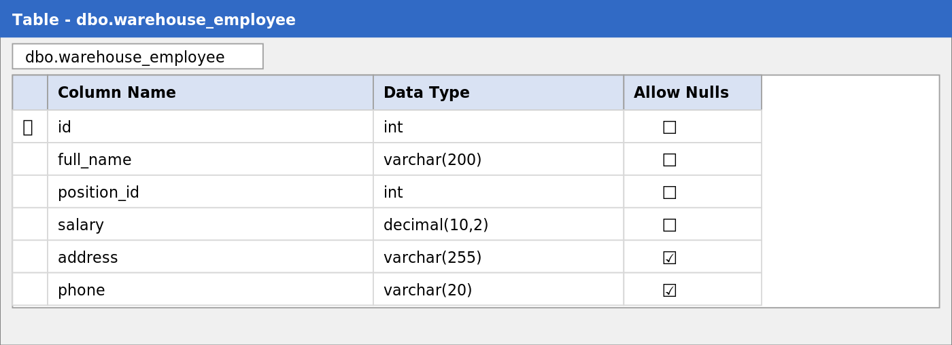
Image 5. Structure of the table Employee.
5. “UserProfile” table
Links a Django auth_user record with an Employee record and thus inherits the role from Employee.position.role. Used by the permission system.
Table structure:
Column | Type | Description
id | BigAutoField | Primary Key.
user_id | OneToOne → auth_user (CASCADE) | Django user.
employee_id | OneToOne → Employee (PROTECT) | Linked employee.
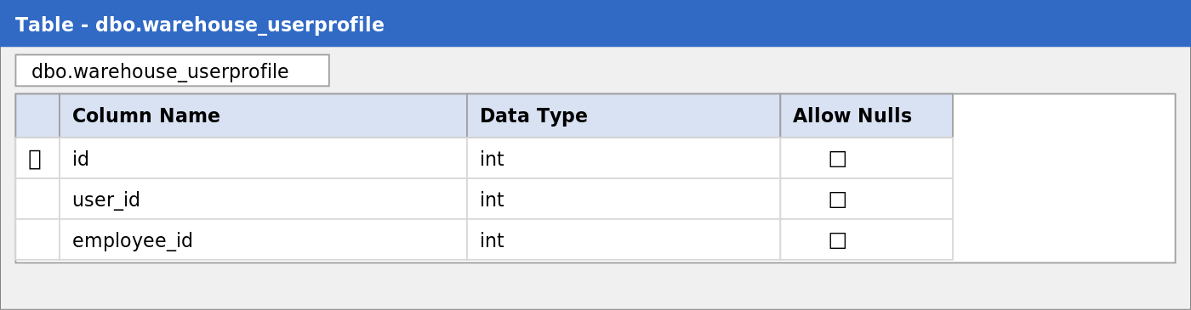
Image 6. Structure of the table UserProfile.
6. “RawMaterial” table
Catalogue of raw materials with their current stock, average value of the stock and a fallback minimum price.
Table structure:
Column | Type | Description
id | BigAutoField | Primary Key.
name | CharField(200) | Name of the raw material.
unit_id | FK → Unit (PROTECT) | Unit of measurement.
quantity | Float | Current quantity on stock.
amount | Float | Total cost of the stock.
min_price | Float | Minimum / base price per 1 unit.
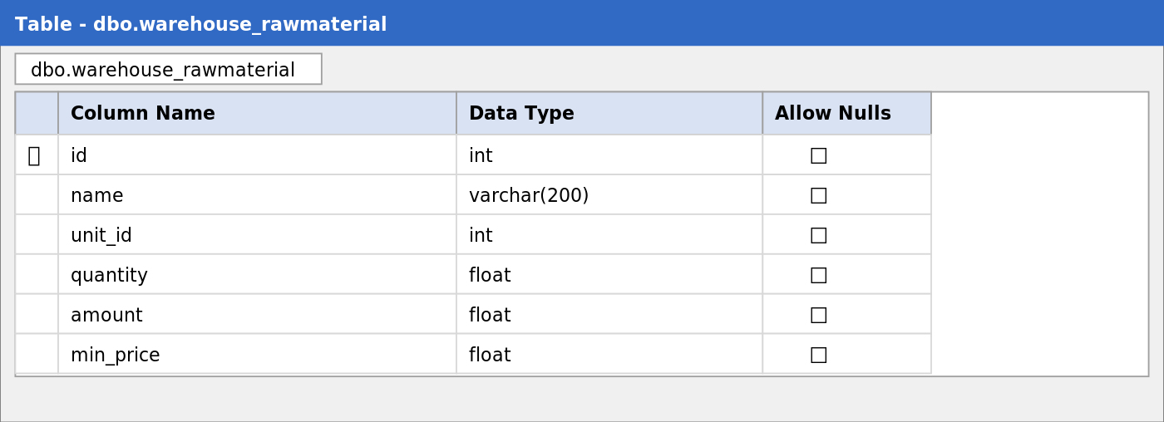
Image 7. Structure of the table RawMaterial.
7. “FinishedProduct” table
Catalogue of finished products with their stock and total stock value.
Table structure:
Column | Type | Description
id | BigAutoField | Primary Key.
name | CharField(200) | Name of the product.
unit_id | FK → Unit (PROTECT) | Unit of measurement.
quantity | Float | Quantity on stock.
amount | Float | Total cost of the stock.
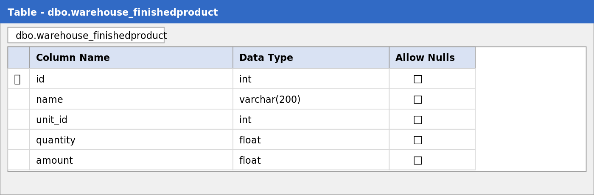
Image 8. Structure of the table FinishedProduct.
8. “Ingredient” table
Recipe table: which raw materials and in which proportion are required to manufacture one unit of a finished product. The pair (product, raw_material) is unique.
Table structure:
Column | Type | Description
id | BigAutoField | Primary Key.
product_id | FK → FinishedProduct (CASCADE) | Finished product.
raw_material_id | FK → RawMaterial (PROTECT) | Raw material.
quantity | Float | Raw material per 1 unit of product.
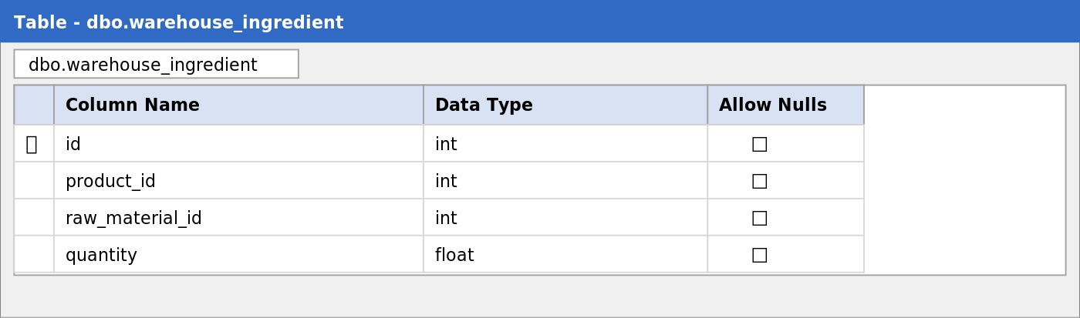
Image 9. Structure of the table Ingredient.
9. “RawPurchase” table
Records every purchase of raw materials. The INSERT is performed via stored procedure sp_create_purchase; the AFTER-INSERT trigger trg_after_purchase updates stock and budget atomically.
Table structure:
Column | Type | Description
id | BigAutoField | Primary Key.
raw_material_id | FK → RawMaterial (PROTECT) | Purchased material.
quantity | Float | Quantity purchased.
amount | Float | Total purchase amount.
date | DateTime auto_now_add | Date of purchase.
employee_id | FK → Employee (PROTECT) | Employee who registered.
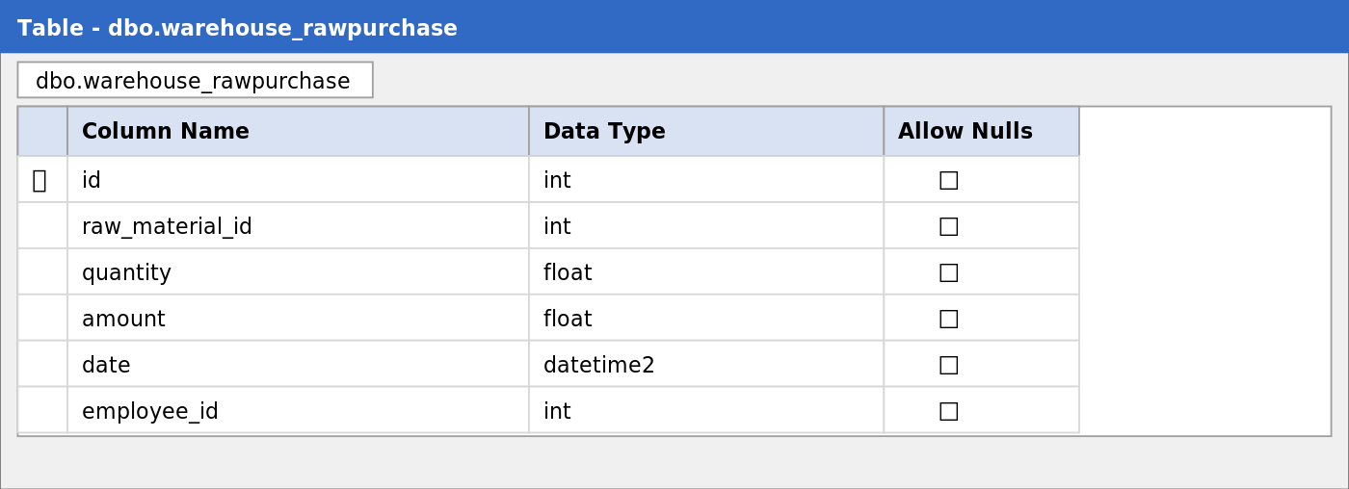
Image 10. Structure of the table RawPurchase.
10. “Production” table
Records every act of producing finished products.
Table structure:
Column | Type | Description
id | BigAutoField | Primary Key.
product_id | FK → FinishedProduct (PROTECT) | Manufactured product.
quantity | Float | Produced quantity.
date | DateTime auto_now_add | Date of production.
employee_id | FK → Employee (PROTECT) | Employee responsible.
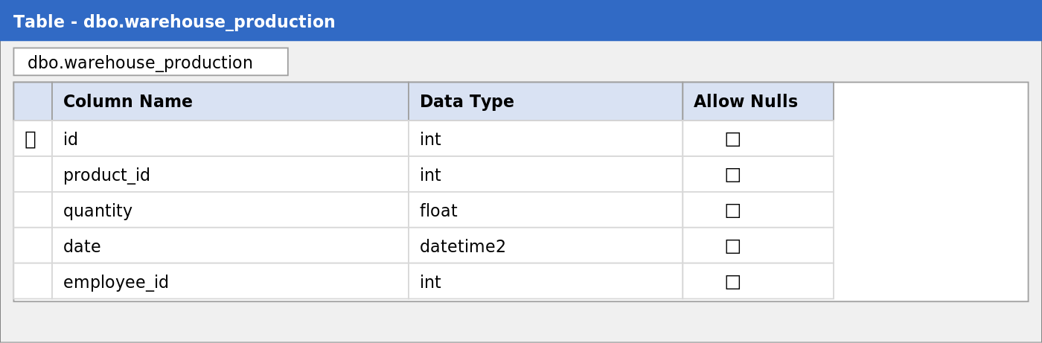
Image 11. Structure of the table Production.
11. “ProductSale” table
Records sales of finished products. Sale price is calculated automatically as unit_cost × 1.30 × qty (the system forbids selling below cost).
Table structure:
Column | Type | Description
id | BigAutoField | Primary Key.
product_id | FK → FinishedProduct (PROTECT) | Sold product.
quantity | Float | Sold quantity.
amount | Float | Total sale amount.
date | DateTime auto_now_add | Date of sale.
employee_id | FK → Employee (PROTECT) | Employee who registered.
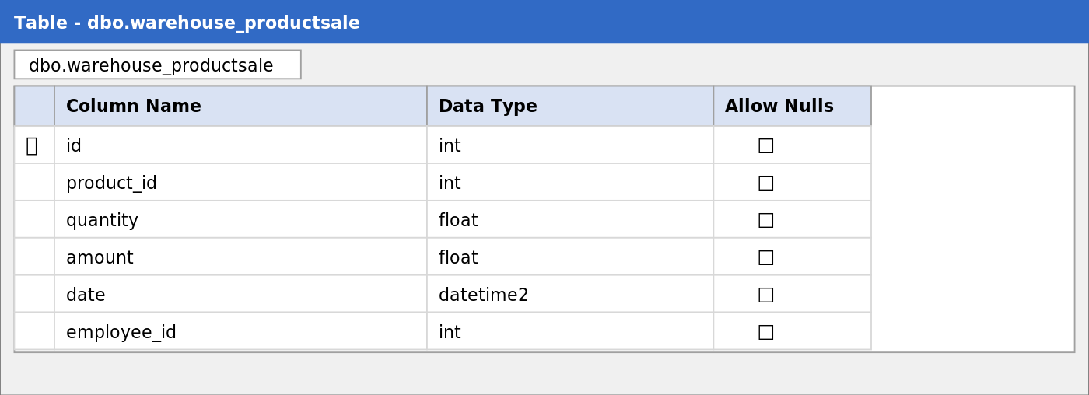
Image 12. Structure of the table ProductSale.
12. “SalaryPayment” table
Records salary payouts to employees. The corresponding amount is deducted from the budget by the view.
Table structure:
Column | Type | Description
id | BigAutoField | Primary Key.
employee_id | FK → Employee (PROTECT) | Receiving employee.
amount | Float | Amount paid.
date | DateTime auto_now_add | Payment date.
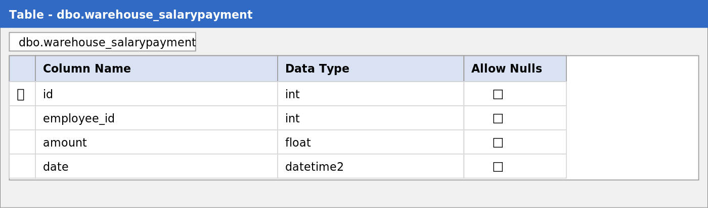
Image 13. Structure of the table SalaryPayment.
13. “BusinessLoan” table
Records active loans of the factory. A business rule (enforced in the model) limits the number of simultaneously active loans to three.
Table structure:
Column | Type | Description
id | BigAutoField | Primary Key.
amount | Float | Loan amount.
date_taken | DateTime auto_now_add | Date received.
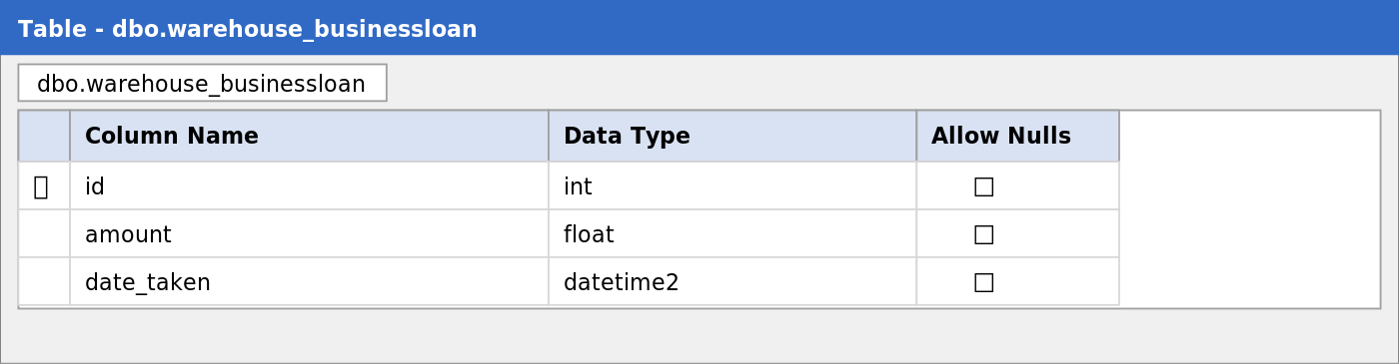
Image 14. Structure of the table BusinessLoan.
14. “ProductionRequest” table
Stores production requests filed by employees with a multi-step status workflow (created → checking raw stock → purchasing → producing → selling → completed; or → error with a rejection reason).
Table structure:
Column | Type | Description
id | BigAutoField | Primary Key.
applicant_name | CharField(200) | Full name of the applicant.
product_id | FK → FinishedProduct (CASCADE) | Requested product.
quantity | Float | Requested quantity.
status | CharField(50) | Current status of the request.
rejection_reason | TextField, nullable | Reason if the request fails.
created_at | DateTime auto_now_add | Creation timestamp.
updated_at | DateTime auto_now | Last status change.
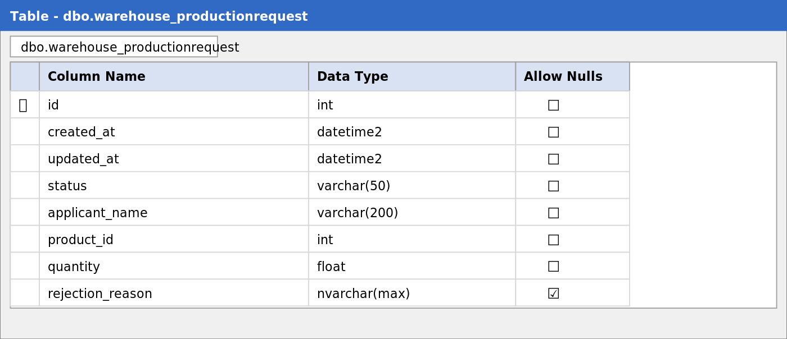
Image 15. Structure of the table ProductionRequest.

2.3. Stored procedures
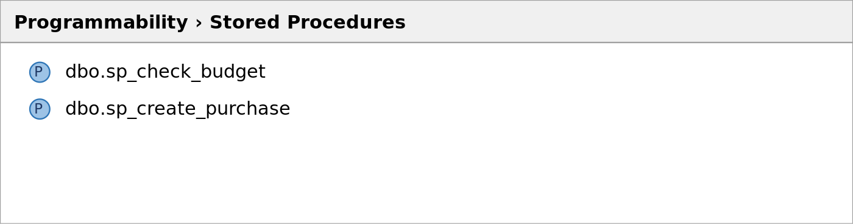
Image 16. List of user-defined stored procedures in DBMS.
Two user-defined stored procedures are created in the database. Together they encapsulate the most critical write operation of the system — buying raw materials. The application calls only sp_create_purchase; it in turn checks the budget via sp_check_budget and, if the funds are sufficient, performs an INSERT into warehouse_rawpurchase. The actual update of stock and budget is then performed by the trigger trg_after_purchase (see § 2.5).
Name | Description
sp_check_budget | Checks whether the current budget covers the given amount. Reads the single row of warehouse_budget, returns 0 if there is enough money and 1 otherwise via an OUTPUT parameter.
sp_create_purchase | Creates a new purchase: calls sp_check_budget, and only if the budget is sufficient INSERTs into warehouse_rawpurchase. The result (0 / 1) is returned via OUTPUT parameter so the Django view can show either a success message or an «insufficient funds» error.
Code of sp_check_budget
CREATE OR ALTER PROCEDURE sp_check_budget
@p_amount decimal(18,2),
@result int OUTPUT
AS
BEGIN
DECLARE @v_budget decimal(18,2);
SELECT TOP 1 @v_budget = amount
FROM warehouse_budget
ORDER BY id ASC;
IF @v_budget IS NULL
SET @result = 1;
ELSE IF @v_budget >= @p_amount
SET @result = 0;
ELSE
SET @result = 1;
END;
Code of sp_create_purchase
CREATE OR ALTER PROCEDURE sp_create_purchase
@p_raw_id int,
@p_qty float,
@p_amount float,
@p_date datetime2,
@p_employee_id int,
@result int OUTPUT
AS
BEGIN
DECLARE @v_check int;
EXEC sp_check_budget @p_amount, @v_check OUTPUT;
IF @v_check = 0
BEGIN
INSERT INTO warehouse_rawpurchase
(raw_material_id, quantity, amount, date, employee_id)
VALUES(@p_raw_id, @p_qty, @p_amount, @p_date, @p_employee_id);
SET @result = 0;
END
ELSE
BEGIN
SET @result = 1;
END
END;
Calling the procedure from the Django view
with connection.cursor() as cursor:
cursor.execute("""
SET NOCOUNT ON;
DECLARE @res INT;
EXEC sp_create_purchase %s, %s, %s, %s, %s, @res OUTPUT;
SELECT @res;
""", [raw_id, quantity, amount, timezone.now(), employee_id])
result = cursor.fetchone()[0]
if result == 0:
messages.success(request, "Raw material purchased, budget updated.")
else:
messages.error(request, "Insufficient budget for purchase.")

2.4. Views
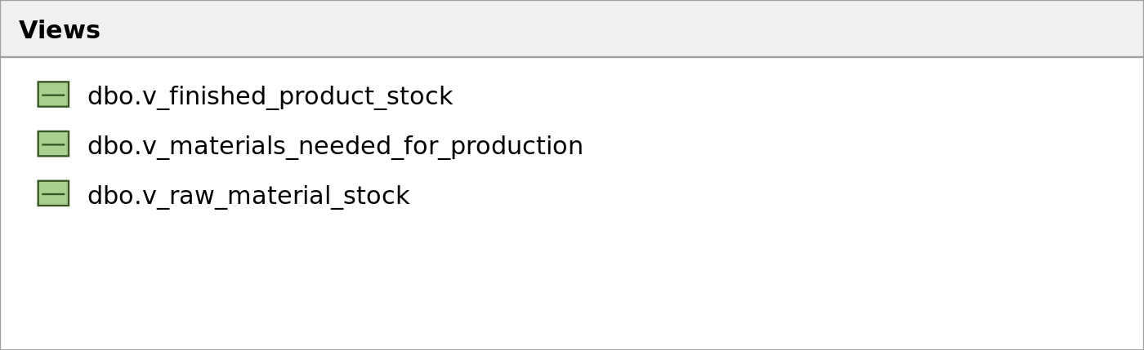
Image 17. List of SQL views in DBMS.
Three SQL views are used as a thin read-only reporting layer. They are queried directly with raw SQL from Django views (see RawSQL examples in § 3.2.2). Putting the join into a view keeps the Python code clean and lets the DBMS choose an optimal execution plan.
Name | Description
v_raw_material_stock | Joins warehouse_rawmaterial with warehouse_unit to expose current raw-material stock together with its unit name.
v_finished_product_stock | Same idea for finished products: joins warehouse_finishedproduct with warehouse_unit.
v_materials_needed_for_production | Joins warehouse_ingredient with warehouse_finishedproduct and warehouse_rawmaterial — gives a denormalised recipe view for the «materials needed» report.
Code of v_raw_material_stock
CREATE OR ALTER VIEW v_raw_material_stock AS
SELECT
r.id AS raw_id,
r.name AS raw_name,
u.name AS unit_name,
r.quantity,
r.amount
FROM warehouse_rawmaterial r
JOIN warehouse_unit u ON r.unit_id = u.id;
Code of v_finished_product_stock
CREATE OR ALTER VIEW v_finished_product_stock AS
SELECT
p.id AS product_id,
p.name AS product_name,
u.name AS unit_name,
p.quantity,
p.amount
FROM warehouse_finishedproduct p
JOIN warehouse_unit u ON p.unit_id = u.id;
Code of v_materials_needed_for_production
CREATE OR ALTER VIEW v_materials_needed_for_production AS
SELECT
p.id AS product_id,
p.name AS product_name,
r.id AS raw_id,
r.name AS raw_name,
i.quantity AS ingredient_qty
FROM warehouse_ingredient i
JOIN warehouse_finishedproduct p ON i.product_id = p.id
JOIN warehouse_rawmaterial r ON i.raw_material_id = r.id;

2.5. Triggers
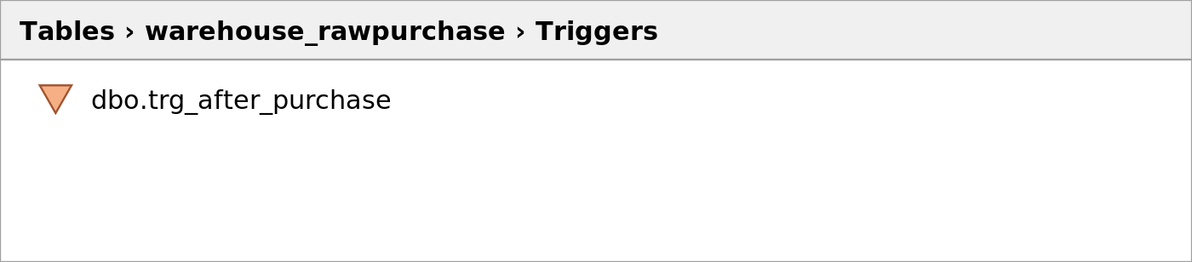
Image 18. List of triggers in DBMS.
The system uses one INSERT trigger that keeps stock and budget in sync after every purchase of raw materials. Because the trigger is set-based it works correctly even for bulk INSERTs that aggregate by raw_material_id; the budget is decreased by SUM(amount), and stock is increased by the per-material totals.
Name | Description
trg_after_purchase | Fires after a row is inserted into warehouse_rawpurchase. It deducts the total purchase amount from the single budget row and increases the stock (quantity, amount) of the affected raw materials.
Code of trg_after_purchase
CREATE OR ALTER TRIGGER trg_after_purchase
ON warehouse_rawpurchase
AFTER INSERT
AS
BEGIN
-- Deduct from Budget
UPDATE warehouse_budget
SET amount = amount - i.total_amount
FROM warehouse_budget
CROSS JOIN (
SELECT SUM(amount) AS total_amount FROM inserted
) i
WHERE id = (
SELECT TOP 1 id FROM warehouse_budget ORDER BY id ASC
);
-- Update RawMaterial stock
UPDATE r
SET quantity = r.quantity + i.total_qty,
amount = r.amount + i.total_amount
FROM warehouse_rawmaterial r
JOIN (
SELECT raw_material_id,
SUM(quantity) AS total_qty,
SUM(amount) AS total_amount
FROM inserted
GROUP BY raw_material_id
) i ON r.id = i.raw_material_id;
END;
Besides the database trigger, the application has several «business triggers» implemented in the service layer: the view production_create checks raw-material sufficiency before producing; sale_create forbids a sale below cost and updates the budget; salary_create deducts the salary from the budget; loan_create increases the budget; the model BusinessLoan refuses to store more than three loans simultaneously. Together they form an additional layer of business rules that guarantee data consistency.

3. Client side
3.1. Description of project creation
The web application is developed in Python using the Django 5.2.7 framework and the classic MVT (Model-View-Template) architectural pattern, which is Django’s flavour of MVC. The project is managed with pip / venv; dependencies are listed in requirements.txt.
Used tools and technologies:
- Python 3.13 — the programming language used for the project.
- Django 5.2.7 — a full-stack web framework that provides ORM, routing, templates, forms, authentication and the admin site out of the box.
- Django ORM — object-relational mapping that maps Python classes to MSSQL tables and generates migrations.
- mssql-django + ODBC Driver 17 for SQL Server — JDBC-style driver that lets Django talk to Microsoft SQL Server.
- Django Templates — built-in HTML templating engine used in the View layer to render the pages.
- Bootstrap 5 (CDN) — CSS framework used to style cards, tables, buttons and modals.
- django-widget-tweaks — a small package used to add CSS classes to form widgets directly in templates.
- python-dotenv — loads database credentials from a .env file.
- pip — package manager and dependency management tool (configured in requirements.txt).
- PyCharm — the IDE in which the project is developed.
Steps to create the project:
1. Create and activate a virtual environment:
python -m venv venv
venv\Scripts\activate
2. Install the dependencies:
pip install django mssql-django python-dotenv
3. Generate the project skeleton and the warehouse application:
django-admin startproject clothes_factory_warehouse .
python manage.py startapp warehouse
4. Register the application in clothes_factory_warehouse/settings.py:
INSTALLED_APPS = [
'django.contrib.admin',
'django.contrib.auth',
'django.contrib.contenttypes',
'django.contrib.sessions',
'django.contrib.messages',
'django.contrib.staticfiles',
'warehouse',
'widget_tweaks',
]
5. Configure the MSSQL connection using credentials read from .env:
DATABASES = {
"default": {
"ENGINE": "mssql",
"NAME": os.getenv("DB_NAME"),
"HOST": os.getenv("DB_HOST"),
"PORT": os.getenv("DB_PORT"),
"OPTIONS": {
"driver": "ODBC Driver 17 for SQL Server",
"extra_params":
"Trusted_Connection=yes;TrustServerCertificate=yes",
},
}
}
6. Run the migrations: the 0001_initial migration creates all 14 domain tables and Django service tables; 0002_create_sql_logic provisions the stored procedures, the trigger and the three views; 0003_seed_workwear_data fills the catalogues with a workwear demo dataset; later migrations add loans, salary payments, production requests, the role field on Position and the UserProfile entity.
python manage.py migrate
7. Create a Django superuser to bootstrap the system:
python manage.py createsuperuser
8. Run the development server:
python manage.py runserver 8080
Resulting project structure:
WarehouseOfClothes/
├── clothes_factory_warehouse/ # project settings
│ ├── settings.py
│ ├── urls.py
│ └── wsgi.py
├── warehouse/ # business application
│ ├── models.py # database models
│ ├── views.py # controllers
│ ├── auth_views.py # authentication views
│ ├── forms.py # Django forms
│ ├── permissions.py # RBAC decorators
│ ├── context_processors.py # role flags for templates
│ ├── urls.py # URL routing
│ ├── migrations/ # 0001..0007 schema + SQL logic
│ ├── templates/warehouse/ # HTML templates
│ └── static/ # CSS / JS / images
├── manage.py
├── requirements.txt
└── .env # database credentials
3.2. More detailed analysis
Below each main directory of the warehouse application is analysed with example code.
1. Models (Entity layer)
Located in warehouse/models.py. Each class inherits from django.db.models.Model and corresponds to one table in the database. Django ORM automatically generates the schema from these classes and creates migrations for any change. Verbose names are written in Russian so that they appear correctly in the admin site and on form labels. Below is an example of one of the richer entities — RawMaterial:
class RawMaterial(models.Model):
name = models.CharField(max_length=200, verbose_name="Наименование сырья")
unit = models.ForeignKey(Unit, on_delete=models.PROTECT, verbose_name="Ед. изм.")
quantity = models.FloatField(default=0.0, verbose_name="Остаток")
amount = models.FloatField(default=0.0, verbose_name="Общая стоимость остатка")
min_price = models.FloatField(default=0.0, verbose_name="Мин. цена за единицу")
@property
def unit_cost(self):
"""Actual cost per unit. Falls back to min_price if stock is 0."""
if self.quantity > 0:
return self.amount / self.quantity
return self.min_price
class Meta:
verbose_name = "Сырьё"
verbose_name_plural = "Сырьё
The model demonstrates several typical Django techniques:
- ForeignKey to Unit with on_delete=PROTECT — a unit cannot be deleted if there is a raw material that uses it.
- @property unit_cost — a computed attribute used everywhere when the actual unit cost is required (cost calculation, materials-needed report, sale-below-cost check).
- Meta.verbose_name — human-readable name shown by the admin and the templates.
2. Views (Controllers)
Located in warehouse/views.py and warehouse/auth_views.py. Views accept an HttpRequest, perform the business logic and return an HttpResponse. They use a few helper functions for generic CRUD (generic_list, generic_form, generic_delete) and specific functions for non-trivial operations (purchase_create, production_create, sale_create, salary_create, loan_create, loan_payoff, production_request_create, analytics_dashboard). Below is the production view, which checks raw-material availability before committing the operation:
@role_required(Position.ROLE_PRODUCTION)
def production_create(request):
if request.method == 'POST':
form = ProductionForm(request.POST)
if form.is_valid():
emp = _resolve_employee(request)
production = form.save(commit=False)
production.employee = emp
product = production.product
qty = production.quantity
ingredients = product.ingredient_set.all()
missing = []
for ing in ingredients:
needed = ing.quantity * qty
if ing.raw_material.quantity < needed:
missing.append(
f"<b>{ing.raw_material.name}</b> &mdash; "
f"need {needed:,.2f}, available {ing.raw_material.quantity:,.2f}"
)
if missing:
messages.error(request, mark_safe(
"Insufficient raw materials:<ul><li>"
+ "</li><li>".join(missing) + "</li></ul>"))
else:
for ing in ingredients:
raw = ing.raw_material
needed = ing.quantity * qty
unit_cost = raw.amount / raw.quantity
raw.quantity -= needed
raw.amount -= needed * unit_cost
raw.save()
product.quantity += qty
product.save()
production.save()
messages.success(request, f"Produced {qty} of {product.name}.")
return redirect('production_list')
else:
form = ProductionForm()
return render(request, 'warehouse/form.html',
{'form': form, 'title': 'Новое производство'})
3. Forms
Located in warehouse/forms.py. Django forms generate the HTML inputs, perform server-side validation and convert POST data into clean Python types. Most forms are ModelForms — bound directly to a model — and one is a plain Form (RawPurchaseForm), because the actual database write is done by the stored procedure rather than by ORM:
class RawPurchaseForm(forms.Form):
raw_material = forms.ModelChoiceField(
queryset=RawMaterial.objects.all(), label="Сырьё")
quantity = forms.FloatField(label="Количество")
amount = forms.FloatField(label="Сумма закупки")
class ProductSaleForm(forms.ModelForm):
class Meta:
model = ProductSale
fields = ['product', 'quantity'] # amount is computed in the view
class ProductionForm(forms.ModelForm):
class Meta:
model = Production
exclude = ['date', 'employee'] # date is auto, employee from request
4. URL routing
Located in warehouse/urls.py. Maps each URL to a view function. CRUD URLs follow Django’s naming convention list / add / <pk>/edit / <pk>/delete and are organised by domain section. Below is a representative excerpt:
from django.urls import path
from . import views, auth_views
urlpatterns = [
path('', views.index, name='index'),
# Auth
path('login/', auth_views.login_view, name='login'),
path('logout/', auth_views.logout_view, name='logout'),
# Reference data
path('units/', views.unit_list, name='unit_list'),
path('positions/', views.position_list, name='position_list'),
path('employees/', views.employee_list, name='employee_list'),
# Stock
path('raw_materials/', views.raw_material_list, name='raw_material_list'),
path('finished_products/', views.finished_product_list, name='finished_product_list'),
path('ingredients/', views.ingredient_list, name='ingredient_list'),
# Operations
path('purchase/add/', views.purchase_create, name='purchase_create'),
path('production/', views.production_list, name='production_list'),
path('sale/add/', views.sale_create, name='sale_create'),
path('salaries/', views.salary_list, name='salary_list'),
path('loans/', views.loan_list, name='loan_list'),
# SQL Views (raw SQL reports)
path('view/raw_stock/', views.view_raw_stock, name='view_raw_stock'),
path('view/product_stock/', views.view_product_stock, name='view_product_stock'),
path('view/materials_needed/', views.view_materials_needed, name='view_materials_needed'),
# Analytics dashboard
path('analytics/dashboard/', views.analytics_dashboard, name='analytics_dashboard'),
]
5. Permissions and roles (RBAC)
Located in warehouse/permissions.py. Every Position has a role attribute (director, accountant, warehouse, production, sales, none). Each Django auth_user can be linked to one Employee via UserProfile, from which the system resolves the user’s role. Two decorators wrap the views to enforce access:
def role_required(*allowed_roles):
"""Decorator: only users with one of the roles (director always passes)."""
def decorator(view_func):
@wraps(view_func)
@login_required
def _wrapped(request, *args, **kwargs):
if has_role(request.user, *allowed_roles):
return view_func(request, *args, **kwargs)
messages.error(request, "У вас нет прав на это действие.")
return redirect('index')
return _wrapped
return decorator
def director_required(view_func):
"""Decorator: only director / superuser."""
@wraps(view_func)
@login_required
def _wrapped(request, *args, **kwargs):
if is_director(request.user):
return view_func(request, *args, **kwargs)
messages.error(request, "Только для директора.")
return redirect('index')
return _wrapped
Templates also adapt to the role thanks to context_processors.auth_context, which exposes flags is_director, can_warehouse, can_production, can_sales, can_accountant for every page — this is how irrelevant menu items disappear for users with restricted roles.
6. Templates (Presentation)
Located in warehouse/templates/. The shared layout warehouse/templates/base.html includes a top navigation bar that is built from the role flags above. Each domain page extends base.html and provides its content block. Below is a fragment of the dashboard (warehouse/index.html):
{% if is_director %}
<div class="col-md-4">
<div class="card h-100 border-primary">
<div class="card-header bg-primary text-white">📘 Справочники</div>
<div class="list-group list-group-flush">
<a href="{% url 'unit_list' %}" class="list-group-item">📏 Единицы измерения</a>
<a href="{% url 'position_list' %}" class="list-group-item">👔 Должности</a>
<a href="{% url 'employee_list' %}" class="list-group-item">👥 Сотрудники</a>
<a href="{% url 'account_list' %}" class="list-group-item">👤 Аккаунты</a>
</div>
</div>
</div>
{% endif %}
{% if is_director or can_warehouse %}
<a href="{% url 'raw_material_list' %}"
class="list-group-item">🧶 Сырьё</a>
{% endif %}
Templates are rendered through Django’s template engine. Bootstrap 5 is loaded from the CDN, plus a custom CSS block in base.html that defines a soft-gradient palette and elevated cards. Forms are rendered with django-widget-tweaks (|add_class) to attach Bootstrap classes without rewriting the form widgets in Python.

4. Launching the program
To launch the project on localhost the following steps are required:
1. Make sure the MSSQL instance is running and a database matching DB_NAME in the .env file exists. Driver «ODBC Driver 17 for SQL Server» must be installed.
2. Activate the virtual environment and install the dependencies:
venv\Scripts\activate
pip install -r requirements.txt
3. Run the migrations — this creates the tables, the stored procedures, the trigger, the views and seeds the catalogues:
python manage.py migrate
4. Create the first director (superuser) so that an administrator can log in:
python manage.py createsuperuser
5. Start the development server:
python manage.py runserver 8080
6. Open http://127.0.0.1:8080 in the browser, log in with the superuser account, then via Аккаунты create accounts for the rest of the staff.

5. Screenshots of the program
Below the main pages of the application are presented. Screenshots are captured against the workwear demo dataset that is seeded by migration 0003_seed_workwear_data.
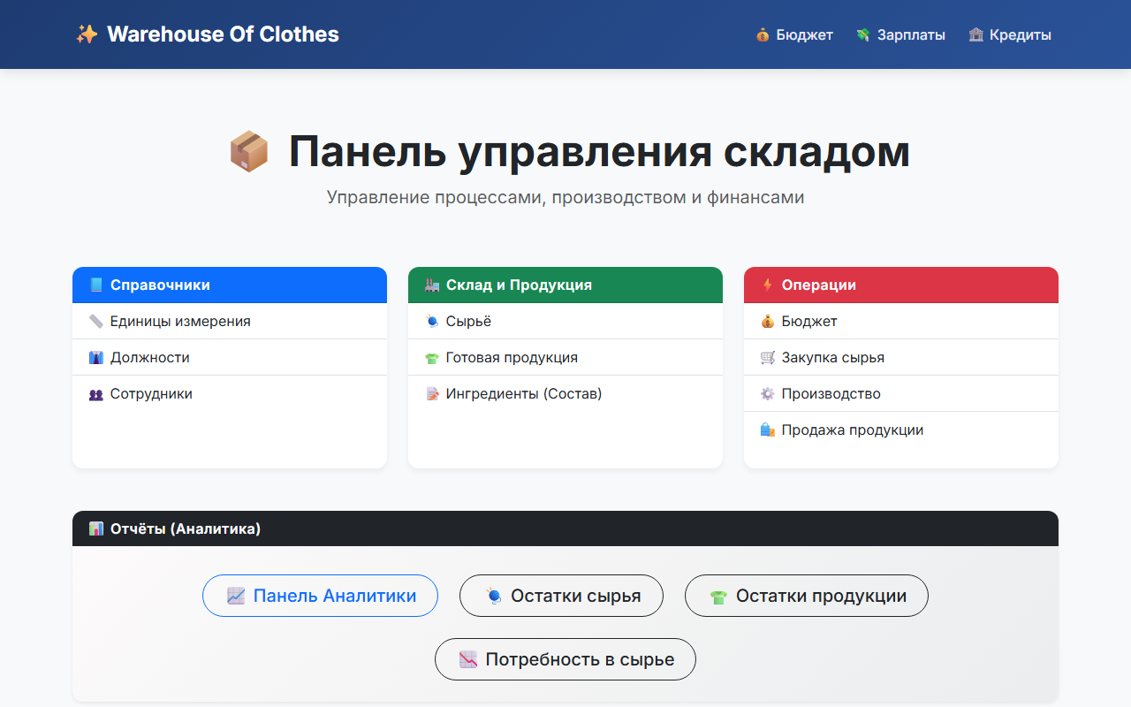
Image 19. Dashboard — the main page seen after a successful login. Tiles and menu items are shown only for the sections that the user’s role grants access to.
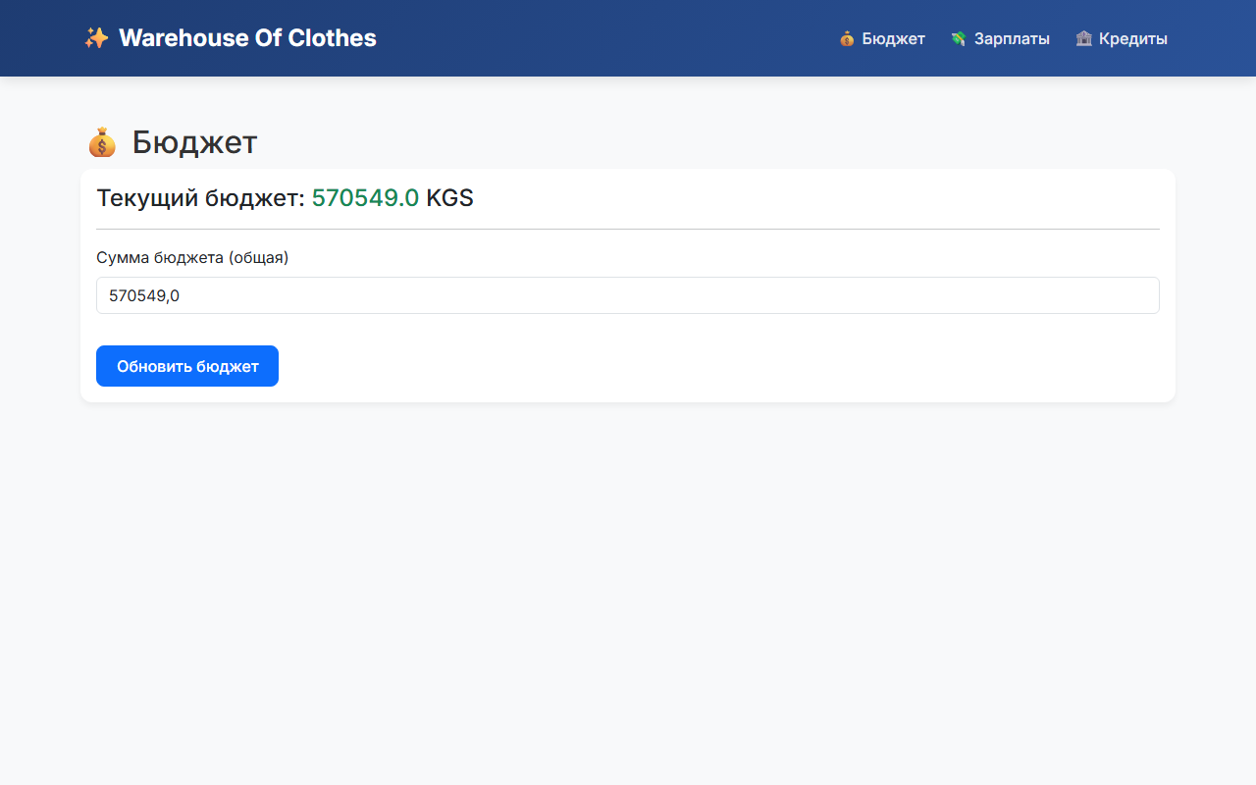
Image 20. Budget page — read and edit the single budget record. Access is restricted to the accountant and the director.
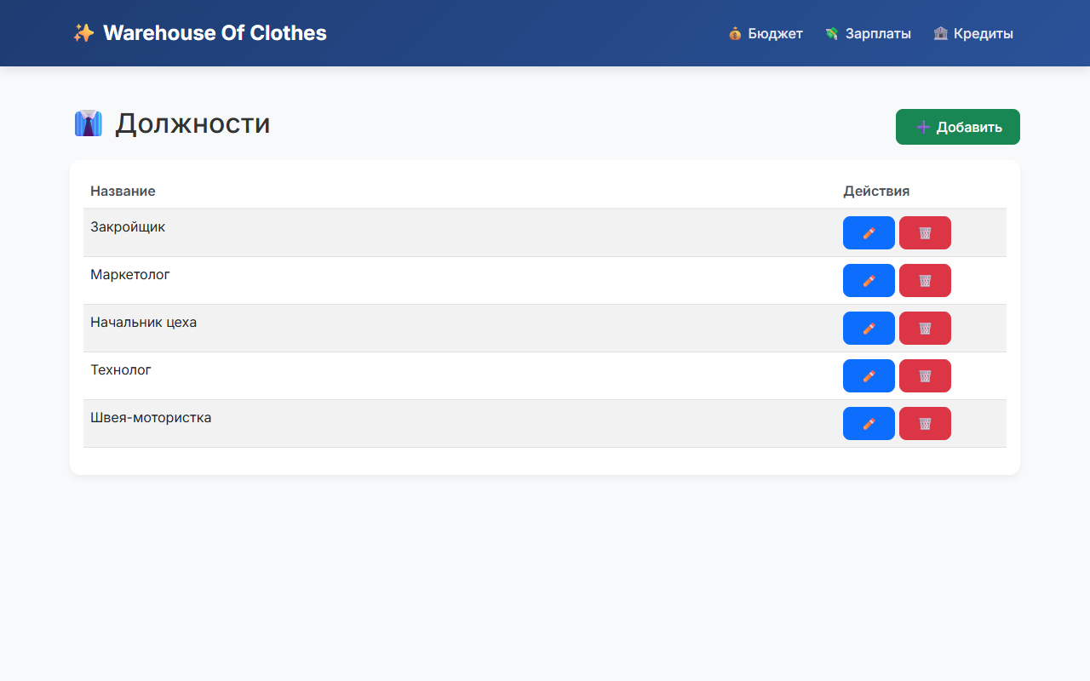
Image 21. Positions reference — each position is bound to a role that drives RBAC.
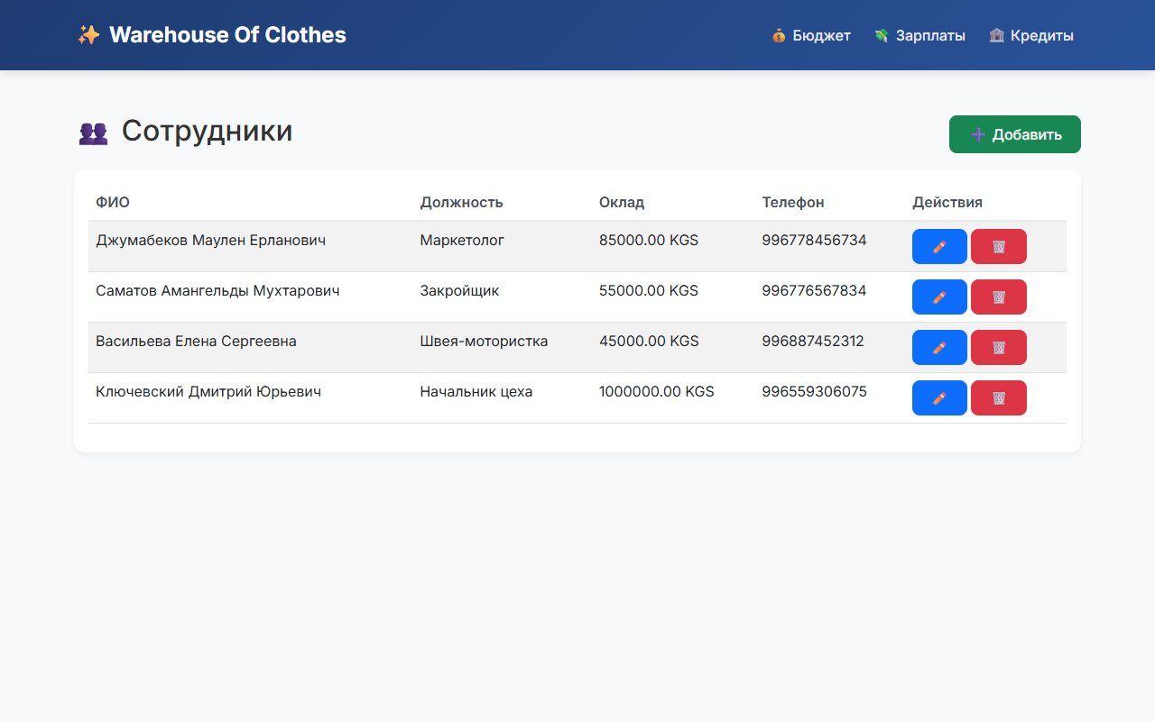
Image 22. Employees reference — full information about staff members.
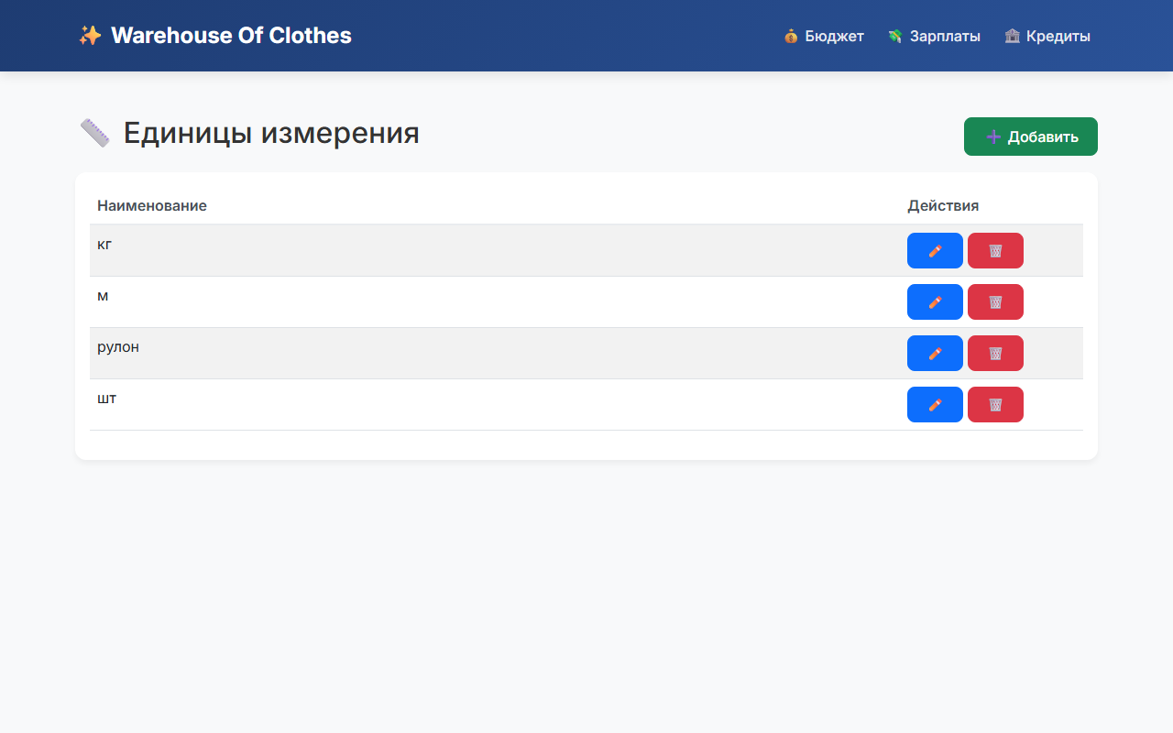
Image 23. Units of measurement reference.
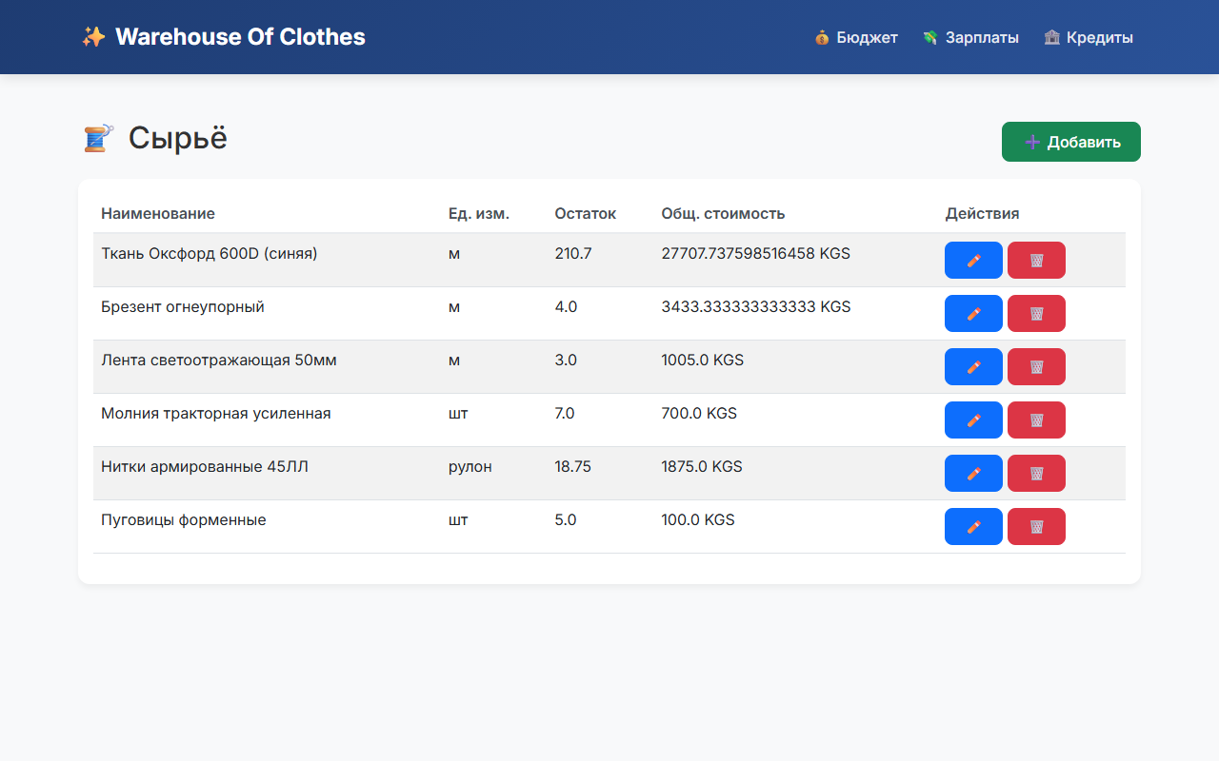
Image 24. Raw materials reference — current stock, total stock value and minimum (fallback) unit price.
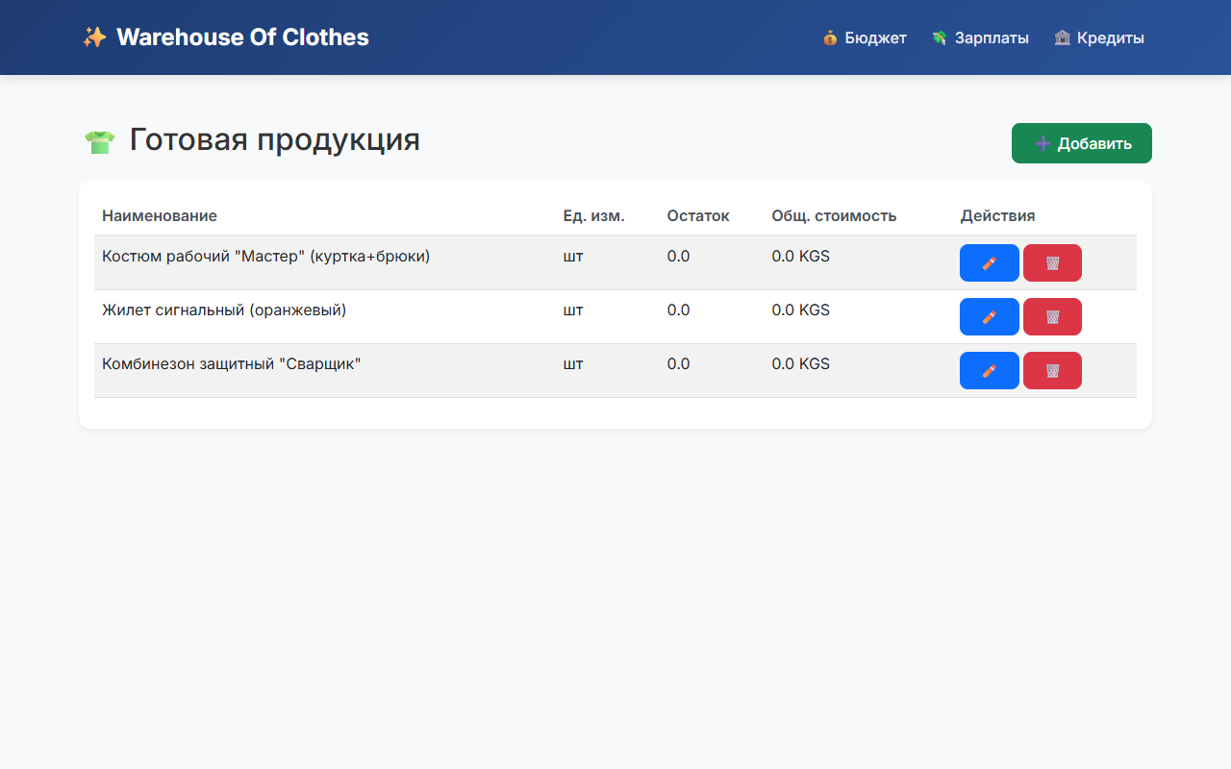
Image 25. Finished products reference.
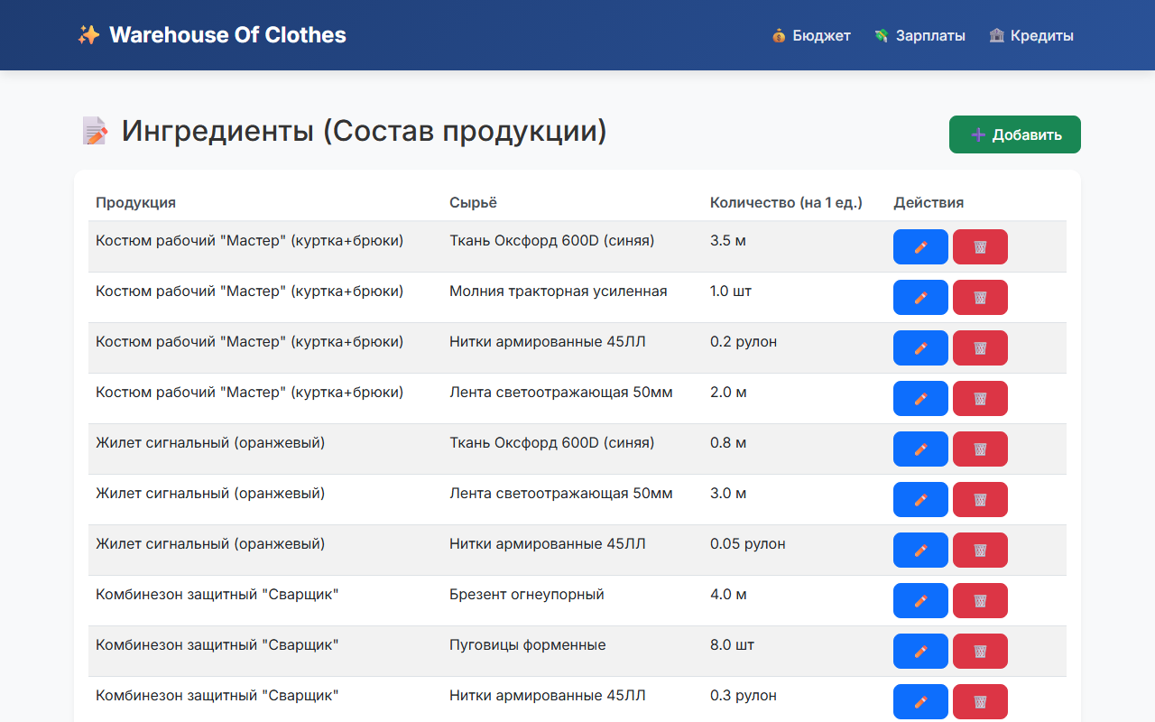
Image 26. Recipes — how much of each raw material is required to produce one unit of a finished product.
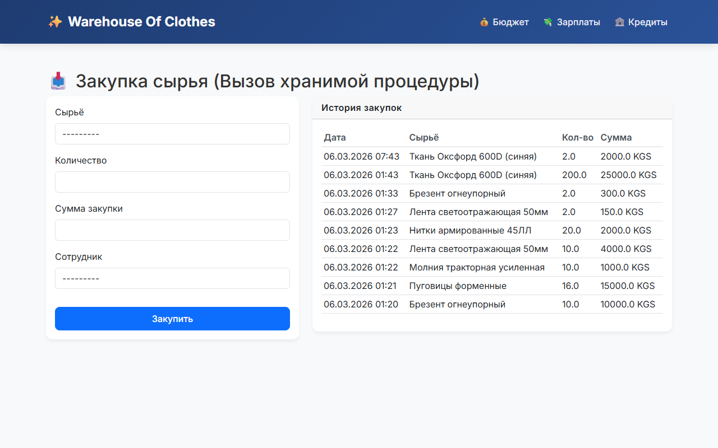
Image 27. Raw material purchase form — the actual INSERT goes through the sp_create_purchase stored procedure.
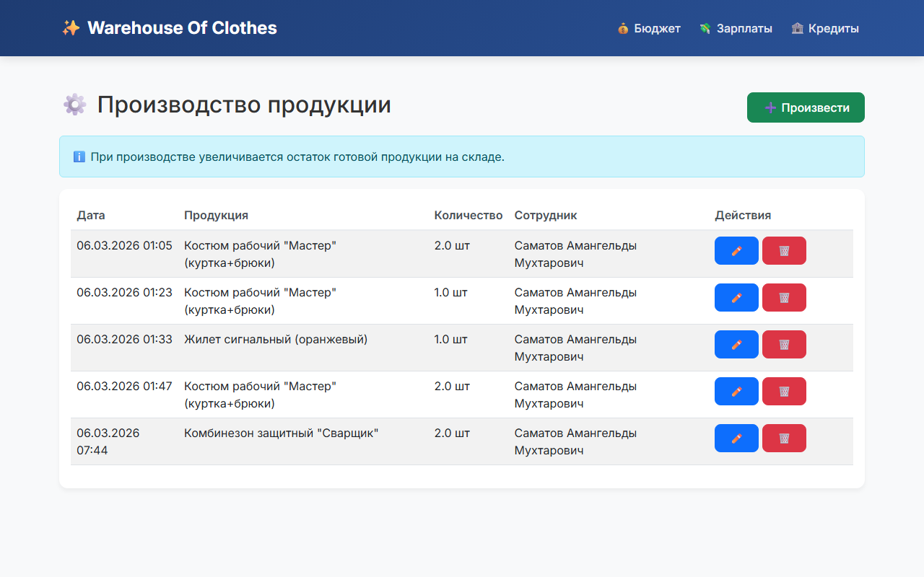
Image 28. Production page — manufacturing finished products from raw materials. The view rejects the operation if any of the ingredients is not enough.
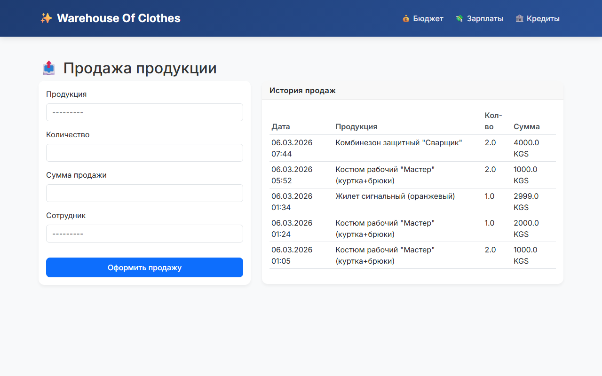
Image 29. Sale page — sells finished products. The price is automatically computed as unit_cost × 1.30 × qty; the budget is increased.
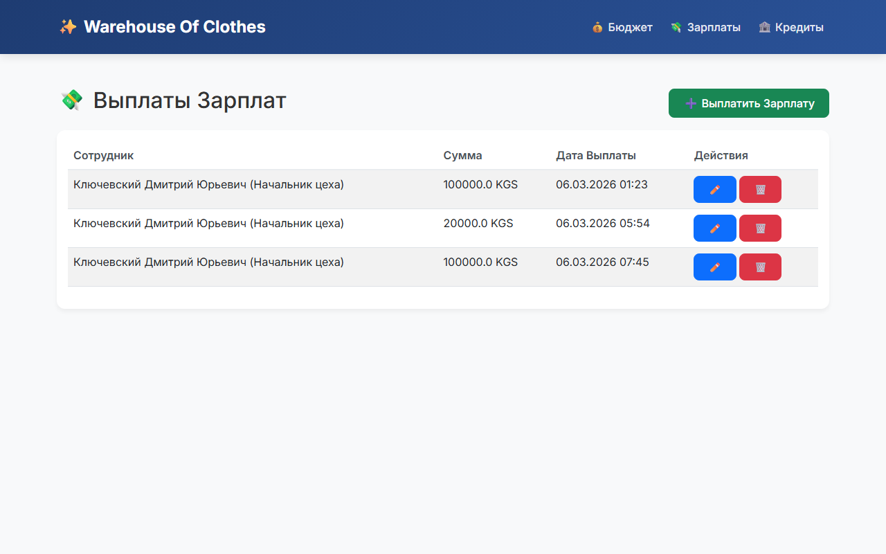
Image 30. Salary payouts — each payout deducts the corresponding amount from the budget.
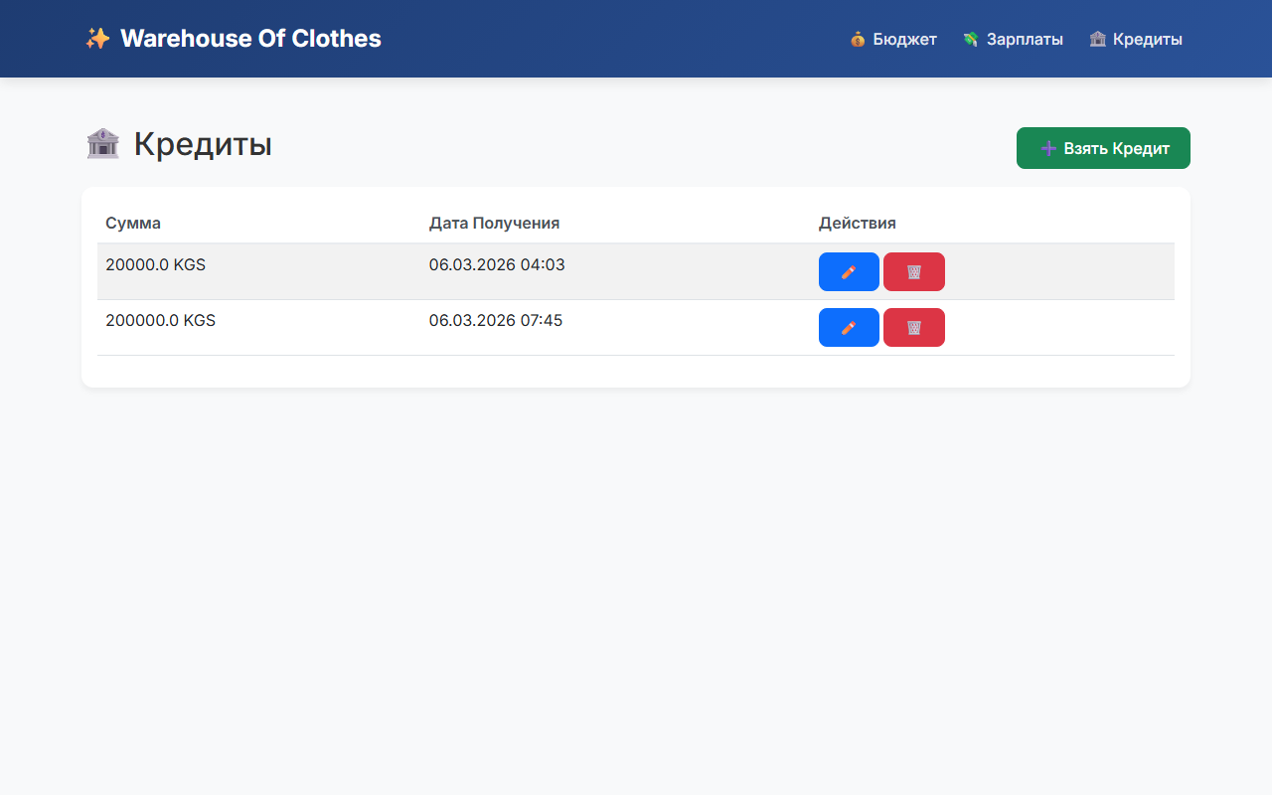
Image 31. Business loans — taking a new loan increases the budget; paying it off (button «Погасить») decreases the budget.
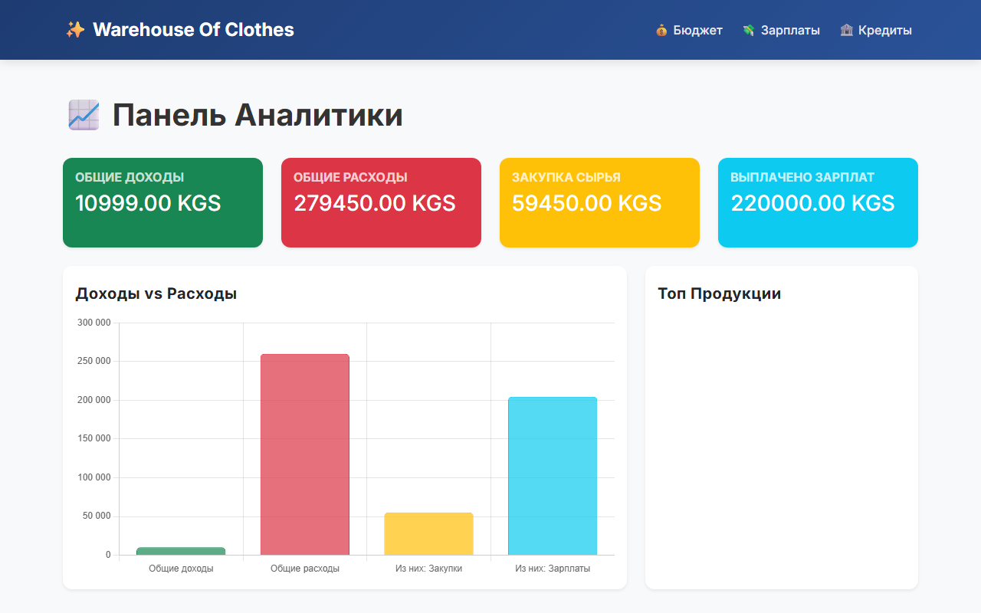
Image 32. Analytics dashboard — chart of top-sold products and the ratio of revenue to expenses, plus drill-down tables of sales, purchases and salary payouts.

6. Conclusion
During the development of this web application as part of the term project, valuable experience was gained in working with the Django framework, the Python programming language and the Microsoft SQL Server DBMS. Skills in designing relational schemas, writing stored procedures, triggers and views, and connecting them to an application were significantly improved.
The server side was implemented on MSSQL using SQL Server Management Studio and Django migrations (RunSQL), while the client side was built with Python and Django (MVT pattern) in PyCharm. Domain logic was distributed across the layers in the following way: data integrity rules live in the DBMS (stored procedures, trigger, FK constraints, views), while business workflow and authorisation live in Django (RBAC decorators, model save guards, service-layer code in the views).
The result is a self-contained system that covers the full workflow of a garment factory: from raw-material purchase to finished-product sale, with real-time budget control, role-based access and analytics. The architecture follows clean-architecture principles — models, forms, views, permissions and templates are organised in separate modules.
7. List of Used Literature
1. Django Software Foundation. Django 5.2 documentation. — https://docs.djangoproject.com/en/5.2/
2. Microsoft. Transact-SQL Reference (CREATE PROCEDURE, CREATE TRIGGER, CREATE VIEW). — https://learn.microsoft.com/en-us/sql/t-sql/
3. Microsoft. mssql-django driver documentation. — https://github.com/microsoft/mssql-django
4. Bootstrap. Bootstrap 5 documentation. — https://getbootstrap.com/docs/5.3/
5. Mark Lutz. Learning Python, 5th ed. — O’Reilly Media, 2013.
6. Itzik Ben-Gan. T-SQL Fundamentals, 4th ed. — Microsoft Press, 2020.
7. Training materials of the department «Software of computer systems», KSTU named after I. Razzakov.

8. Application appendix
This appendix lists additional source files that are useful for a more complete acquaintance with the project.
1. Production-request workflow (process_production_request)
The function below is the heart of the multi-step production request feature: it walks the request through five statuses (checking raw stock → purchasing → producing → selling → completed), automatically purchases missing raw materials if the budget allows it, performs the production and the sale, and updates the budget at every step.
def process_production_request(req, acting_employee=None):
try:
req.status = ProductionRequest.STATUS_CHECKING_RAW
req.save()
product = req.product
qty = req.quantity
ingredients = product.ingredient_set.select_related('raw_material').all()
# 1. Checking raw stock
missing_materials = []
total_cost_of_production = 0
for ing in ingredients:
needed = ing.quantity * qty
available = ing.raw_material.quantity
unit_cost = ing.raw_material.unit_cost
total_cost_of_production += needed * unit_cost
if needed > available:
missing_materials.append({
'raw_material': ing.raw_material,
'qty': needed - available,
'cost': (needed - available) * unit_cost,
})
# 2. Purchasing missing materials (if budget allows)
if missing_materials:
req.status = ProductionRequest.STATUS_PURCHASING
req.save()
total_purchase_cost = sum(m['cost'] for m in missing_materials)
budget = Budget.objects.first()
if not budget or budget.amount < total_purchase_cost:
req.rejection_reason = "Не хватило бюджета на закупку сырья."
req.save()
return
budget.amount -= total_purchase_cost
budget.save()
employee = acting_employee or Employee.objects.first()
for m in missing_materials:
raw = m['raw_material']
RawPurchase.objects.create(
raw_material=raw, quantity=m['qty'],
amount=m['cost'], employee=employee)
raw.quantity += m['qty']
raw.amount += m['cost']
raw.save()
# 3. Production
req.status = ProductionRequest.STATUS_PRODUCTION
req.save()
for ing in ingredients:
raw = ing.raw_material
needed = ing.quantity * qty
unit_cost = raw.unit_cost
raw.quantity -= needed
raw.amount -= needed * unit_cost
raw.save()
Production.objects.create(
product=product, quantity=qty,
employee=Employee.objects.first())
product.quantity += qty
product.amount += total_cost_of_production
product.save()
# 4. Sale
req.status = ProductionRequest.STATUS_SALE
req.save()
sale_price = total_cost_of_production * 1.30
budget = Budget.objects.first()
budget.amount += sale_price
budget.save()
ProductSale.objects.create(
product=product, quantity=qty,
amount=sale_price, employee=Employee.objects.first())
product.quantity -= qty
product.amount -= total_cost_of_production
product.save()
# 5. Done
req.status = ProductionRequest.STATUS_COMPLETED
req.save()
except Exception as e:
req.status = ProductionRequest.STATUS_ERROR
req.rejection_reason = f"Системный сбой: {e}"
req.save()
2. Analytics dashboard view
The view aggregates sales, purchases and salaries and serialises the data for the Chart.js charts on the page.
@role_required(Position.ROLE_ACCOUNTANT)
def analytics_dashboard(request):
sales = ProductSale.objects.select_related('product', 'employee').order_by('-date')
purchases = RawPurchase.objects.select_related('raw_material', 'employee').order_by('-date')
salaries = SalaryPayment.objects.select_related('employee').order_by('-date')
# Top-5 sold products
top_products_qs = (sales
.values('product__name')
.annotate(total_qty=Sum('quantity'), total_revenue=Sum('amount'))
.order_by('-total_revenue')[:5])
top_labels = [x['product__name'] for x in top_products_qs]
top_data = [float(x['total_revenue']) for x in top_products_qs]
total_sales = sales.aggregate(Sum('amount'))['amount__sum'] or 0
total_purchases = purchases.aggregate(Sum('amount'))['amount__sum'] or 0
total_salaries = salaries.aggregate(Sum('amount'))['amount__sum'] or 0
return render(request, 'warehouse/analytics_dashboard.html', {
'sales': sales, 'purchases': purchases, 'salaries': salaries,
'chart_top_products_labels': json.dumps(top_labels, cls=DjangoJSONEncoder),
'chart_top_products_data': json.dumps(top_data, cls=DjangoJSONEncoder),
'total_sales': float(total_sales),
'total_purchases': float(total_purchases),
'total_salaries': float(total_salaries),
'total_expenses': float(total_purchases + total_salaries),
})
3. Base layout (base.html, abridged)
The shared layout provides the top navigation bar, the message strip and the role-driven menu items. Bootstrap 5 is loaded from the CDN; a custom <style> block defines the colour palette and the elevated-card design.
<nav class="navbar navbar-expand-lg navbar-dark">
<div class="container">
<a class="navbar-brand" href="{% url 'index' %}">Warehouse Of Clothes</a>
<div class="collapse navbar-collapse">
<ul class="navbar-nav ms-auto">
{% if user.is_authenticated %}
{% if can_accountant %}
<li class="nav-item"><a class="nav-link" href="{% url 'budget_list' %}">💰 Бюджет</a></li>
<li class="nav-item"><a class="nav-link" href="{% url 'salary_list' %}">💸 Зарплаты</a></li>
<li class="nav-item"><a class="nav-link" href="{% url 'loan_list' %}">🏦 Кредиты</a></li>
{% endif %}
{% if is_director %}
<li class="nav-item"><a class="nav-link" href="{% url 'account_list' %}">👤 Аккаунты</a></li>
{% endif %}
<li class="nav-item"><span class="badge bg-success">
{{ current_employee.full_name|default:user.username }}</span></li>
<li class="nav-item"><a class="nav-link" href="{% url 'logout' %}">🚪 Выйти</a></li>
{% else %}
<li class="nav-item"><a class="nav-link" href="{% url 'login' %}">🔐 Войти</a></li>
{% endif %}
</ul>
</div>
</div>
</nav>
<div class="container mt-5">
{% if messages %}{% for message in messages %}
<div class="alert alert-{{ message.tags }}">{{ message }}</div>
{% endfor %}{% endif %}
{% block content %}{% endblock %}
</div>

