How AI affect economics and what people can do in future?

Introduction
In recent years, artificial intelligence (AI) has changed various industries, making tasks more efficient and automating processes that once required human effort. For example, AI now has ability to assemble electronic devices, driving as a taxi driver and even tell one’s fortune all automatically. And this might leads to a structure unemployment. However, despite the rapid advancement of AI, certain aspects of human work remain irreplaceable. This essay explores how can AI influence the entire economy, how it may cause unemployment and other concerns , the rising and Falling industries due to AI, and the future of human employment, focusing on areas where AI still struggles, such as complex emotional understanding, creativity, ethical decision-making, dynamic environments, leadership, and innovative research.

1.How AI helps business cycle
When a country is in a trough of the economics while AI is growing, AI, as a new industry to develop, it has ability to generate more GDP in both field of the rise of a new industry and to expand old industries’ ability of production. In this case, AI has ability to boost an economy from contraction or trough stage to the stage of expansion, which is a good chance to let economics grow again.
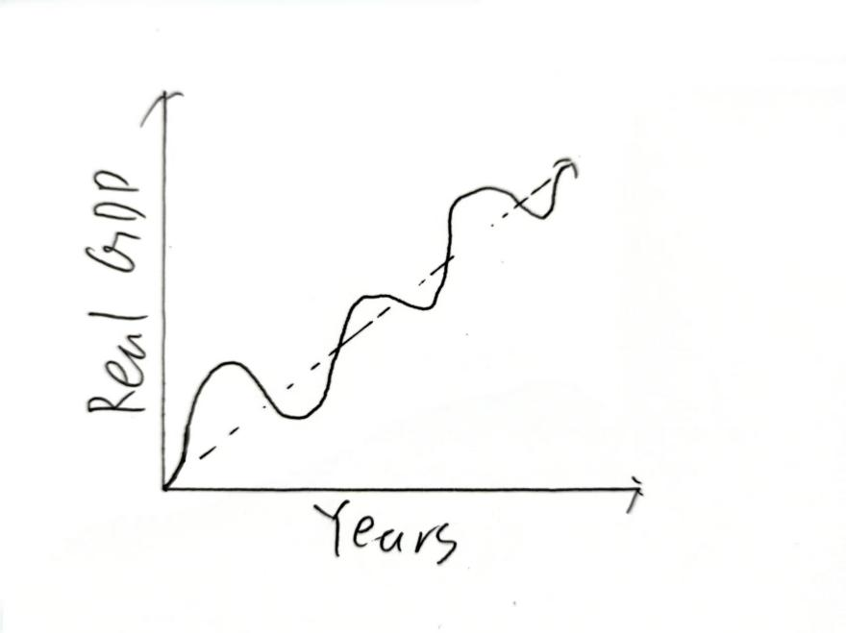
As on the PPC diagram shows, when AI is being used in production, the PPC curve shift out wards comparing to when there is only worker production, and the movement shows the ability of production is increasing due to AI. 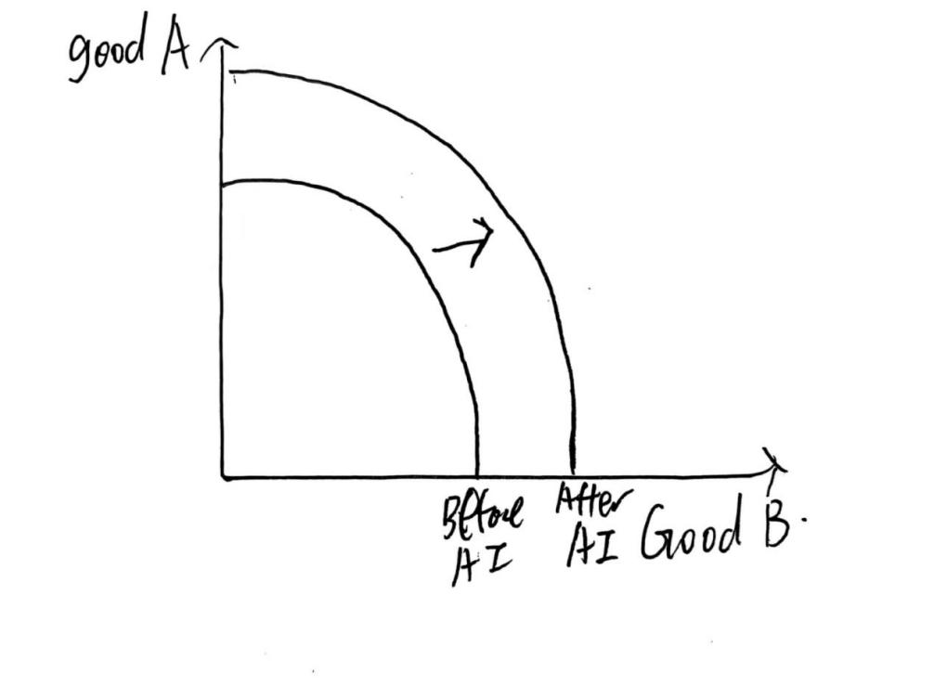
Also, the short term aggregate supply(SRAS) increases, so the profit being made by suppliers may also increases. As the diagram shows, the SRAS curve had shifted right and the market equilibrium had moved right and downwards, which shows the growth on quantity of production and the fall of price.
And also, due to the growth of AI, the growth of potential of ability of production can also be shown on an long term aggregate demand(LRAS) curve. Which on the diagram below, the LRAS curve had shift to the right which shows the increase of ability of production.
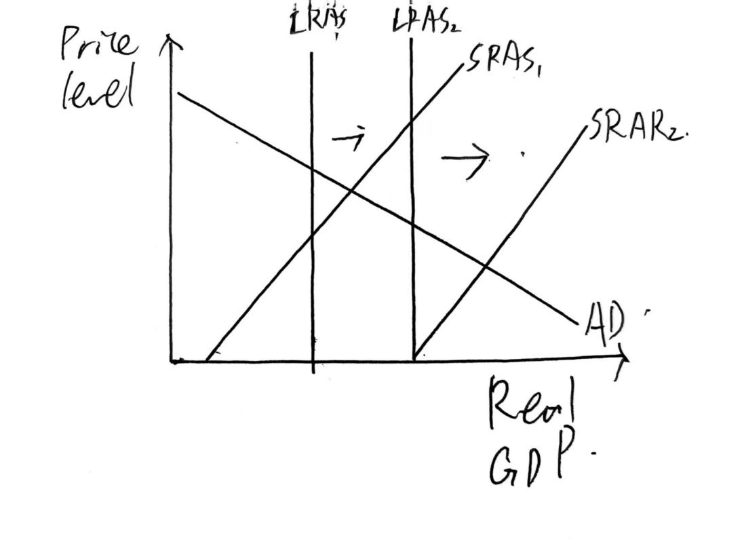

2.Concern of usage of AI
As the AI grows, the production is more depended towards AI. Which will have some concerns on usage. The concern is unlike frictional films that said AI is going to rule over human, instead, the concern is actually when we are too depended on AI, if some day AI breaks down, the economics might be soon affected hardly in a negative way, which will be a point that AI may not work good on. If we are in this situation, the existence of human worker will still be useful to entire economy.

3.The rising and falling industries due to AI
- How does AI leads to structural unemployment?
Structure unemployment is a type of unemployment that usually occurs when the demand of some skills of labour decreases. It often happens when a new type of technology of production comes up and becomes advanced.

Now a days, AI is being advanced and it is already being used to do many things. In sites of production, AI has an ability to produce more goods than workers, which may increase the ability of production.

By the same time, to maximize the profit being produced by the firm, the entrepreneur of the firm will prefer to use more AI than human workers due to the rise of AI, which might cause a structural unemployment due to the lack of use of certain skills.
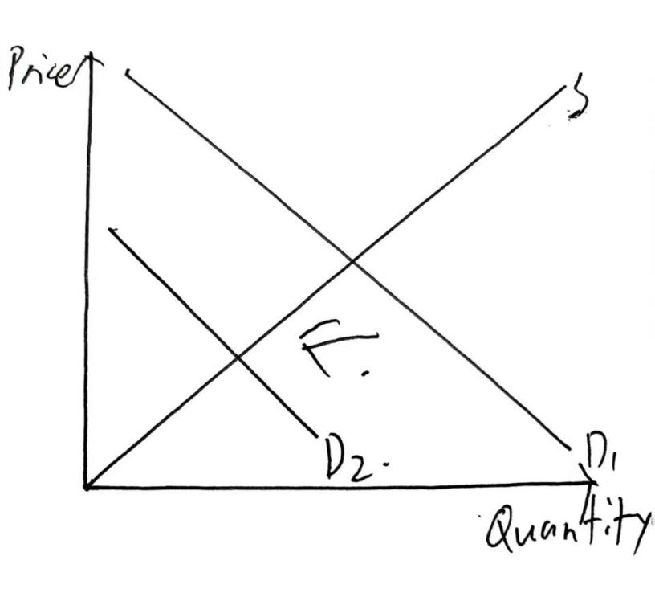

As the diagram shows, the demand curve of worker shifts to the left, which leads to the decrease of quantity of labour, which shows the fall of demand of human workers. As the demand of labour falls, the unemployment rate increases, which is a structural unemployment like.
- Rising
Manufacture, Internet, Finance, Education, Medical care: Become Automatic
Rise: AI, Automation, AI entertainment(social, gaming, Making pictures), Research

- Falling
传统制造业, Traditional medical, Education programs by real people...

- How AI affect consumer market?
Due to the growth of AI, there are many things can be change in consumer market. AI brings a lot of new product in consumer market. These are some of the AI products that had brought to the consumer market:

- Chatting and researching AIs
Many AI product for Chatting and researching like ChatGPT and Deepseek are coming to the consumer market. These AIs are most well known ones due to their usage of daily life. Now a days, people are using them to chat and get information.

Due to the existence of this type of AI, traditional researching engines like Google, Baidu, Bing may face a decrease on their users and may earn less profit. Google, the firm that had being accused for being a monopoly in researching engines market recently, may lose their row of monopoly due to the rise of ChatGPT and Deepseek.

- The autonomous car
Vehicles are nowadays becoming autonomous due to the existence of AI. Many car firm are now showing the ability of automatic driving system as a competitive point against their competitor. Autonomous Vehicles are going to be a trend in future market of vehicles.

This might affect the sales of traditional vehicles that have no ability to be autonomous in a negative way.

- Home use Robots
Robots for daily use is a new thing for consumer market after the growth of AI. It is now on a stage of development. It is helping people do works in home.

5.What human can do without concerning of AI replacement？(Especially feeling economics)
1. Complex Emotional Understanding and Interpersonal Relationships
One of the most significant limitations of AI is its inability to fully understand and react to the complex emotional dynamics and interpersonal relationships With in human. While AI has ability to analyze language and emotions to a certain extent, it has a lack towards the deep empathy, emotional intelligence. And also, cultural sensitivity required in roles like psychological healthcare, crisis intervention, and negotiation. These professions rely heavily on human’s thoughts, feeling, understanding, and the ability to adapt to ever-changing emotional landscapes. The slightly differences of human relationships, particularly in contexts of emotional distress or conflict, demand a level of empathy that AI has already achieved. Therefore, jobs requiring high emotional intelligence, such as psychologists, counselors, and mediators, are unlikely to be replaced by AI in the predictable future.
And also, emotions given by human can also affect the willing of consuming product. So promotion of good is going to be an important roll of economic activities in future.
2. Creativity and Artistic Creation
Another area where AI struggles is in the field of creativity and artistic expression. While AI is capable of generating music, art, and literature through past experiences, it often lacks the emotional depth, cultural context, and personal experience that humans bring to the creative process. Creativity involves not just technical skill but also an ability to reflect on personal experiences, societal issues, and cultural narratives—elements that AI cannot understand and make a creation with it. Humans have the ability to fill their work with meaning, symbols, and emotional understanding, which is why professions in the arts and humanities will remain critical. Writers, filmmakers, painters, musicians, and other creative professionals will continue to drive innovation and cultural progress, a task that AI will complement but not replace.
3. Complex Decision-Making and Ethical Judgments
AI is often limited by readied procedures and historical data, which makes it challenging for the technology to make complex ethical judgments or navigate morally blurry situations. In fields like law, healthcare, and policy-making, decisions often involve a huge number of factors, including social, cultural, and ethical considerations. Human judgment is necessary to weigh these factors and make decisions that supports societal values. AI may assist in data analysis and provide recommendations, but the final judgment will require human distinguishing and a deeper understanding of ethics. Professions that require fine decision-making, such as judges, doctors, and public policy experts, will continue to rely on human expertise.
4. Dynamic and Unpredictable Environments
In dynamic environments like emergency response, military operations, and disaster management, AI faces significant challenges. These fields often require quick, mind leading decisions in response to rapidly changing conditions that may not be easily predicted or modeled. AI systems rely on historical data and patterns, but they can struggle in situations where the data is incomplete or non-existent. Human beings, on the other hand, have the ability to adapt in real time, using their experience, creativity, and intuition to navigate uncertainty. This adaptability is critical in high-pressure, unpredictable environments where AI systems may be not advanced at. Thus, roles that demand rapid decision-making in unstable conditions will continue to require human leadership and expertise.
5. Leadership and High-Level Management
Although AI can analyze data, optimize processes, and enhance productivity, it lacks the human touch necessary for effective leadership and high-level management. Leadership is not just about making decisions; it involves motivating teams, understanding individual strengths and weaknesses, and cultivating a culture of trust and cooperation. Human leaders are able to inspire, empathize, and guide their teams through challenges in ways that AI cannot. The special things of human interaction, including body language, tone, and emotional undercurrents, are important in management roles. Therefore, professions that require leadership, team-building, and strategic decision-making will continue to be shaped by human abilities, not AI.
6. Innovative Scientific Research
While AI has proven invaluable in accelerating data analysis and automating experiments, it is still far from capable of generating groundbreaking scientific hypotheses or formulating innovative theories. Scientific research, particularly in fields like physics, biology, and chemistry, often requires human intuition, curiosity, and creativity. The process of discovery involves asking novel questions, exploring unexplored areas, and thinking something that haven’t existed before—tasks that AI, with its reliance on existing data, is not well-equipped to handle. Human researchers will continue to drive innovation in science and technology, with AI serving as a tool to enhance their work rather than replace them.
5.Conclusion
AI has their ability to increasing ability of production, which is able to increase firm’s revenue and decrease the market price being made. And also, it has ability to boost an economy’s situation. Even though it has concerns of causing structural unemployment, still there some growth on economy may be made.
As AI continues to evolve and automate various aspects of work, even though it might cause some unemployment, it is still clear that the future of human employment will center around areas where human qualities—such as emotional intelligence, creativity, ethical judgment, adaptability, leadership, and innovation—are essential for human to do. While AI can augment human capabilities and take over repetitive tasks, it is the uniquely human traits that will remain irreplaceable in many fields. Thus, the future of work is not one of replacement but of cooperation, with humans and AI working together to create a more efficient, creative, and ethically grounded world. The key to thriving in this future will be to focus on developing skills that influence human strengths and complement the capabilities of AI.

