**Exercise 1 : Using IF to calculate different voucher rates**

Download the file [here](https://github.com/devtlv/Datasets-DA-Bootcamp-2-/raw/refs/heads/main/Week%207%20-%20Analysing%20Web%20Data/W7D4%20-%20Python%20+%20Excel%20Advanced%20%231/qf-3725.zip)

We want to create a formula that uses =IF to display a test message about the length of each beetle in our field study of the school playing fields  
In cell C4, create a formula using =IF function to calculate the following:

* If the beetle length > average in cell B21, set the text message to LONG
* If length is shorter, set the text message to SHORT

Copy the formula down to the rest of column C to calculate all the other messages.  
Change the length of the sample in cell B4 to 50.2 (this would be an alien monster beetle!).  
This will pull the average up and change many messages to SHORT.

If you like a challenge, have a go at creating a formula using =IF in cell D4 to display a message that calculates how much longer than average the beetle is:

* If the beetle length is LONG your message should say This sample is x.xx longer than average
* The cell should be blank if the beetle length is not LONG.  
  Change the length of the sample in cell B4 to 20.7 to check that your =IF formula works

**Used formulas:**

=IF(B4>$B$21, "LONG", "SHORT")

=IF(B4>$B$21, "this sample is " & TEXT(B4-$B$21, "0.00") & " longer than average", "")

**Exercise 2 : Use MS Excel 2007 Pivot Tables to filter your data and generate statistics.**

Download the file [here](https://github.com/devtlv/Datasets-DA-Bootcamp-2-/raw/refs/heads/main/Week%207%20-%20Analysing%20Web%20Data/W7D4%20-%20Python%20+%20Excel%20Advanced%20%231/qf-3824.zip)

1. Create a pivot table from this data, then use the filters within to view the average prices of holidays that have a Travel Method of Plane and a Resort Name that begins with the letter S.

**For 1, create pivot table then “travel method” and “resort name” to filters area, then “price” to values.**

**Then travel filter set to plane, resort filter search for “s*” and select multiple.**

**Average of price=** £582

1. Confirm that there are 3 holidays in total, by using the drill-down feature. If you double-click on the grand total figure, you should see these 3 holidays.

**By adding ‘holliday id’ into the values field we see a total of 3 hollidays, by adding it (as count) to the rows, we see the holidays:**

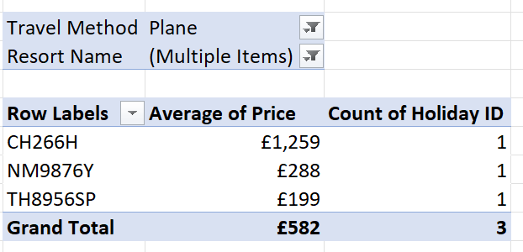

1. Choose the Save As … option to save your file in your new work folder, and then close it down.

**Exercise 3 : Show Oscar nominations by by certificate using a pivot chart and slicer**

Download the file [here](https://github.com/devtlv/Datasets-DA-Bootcamp-2-/raw/refs/heads/main/Week%207%20-%20Analysing%20Web%20Data/W7D4%20-%20Python%20+%20Excel%20Advanced%20%231/qf-3828.zip)

Open the workbook in the above folder, and create a pivot chart based upon the data showing the average number of Oscar nominations by certificate for any given genre

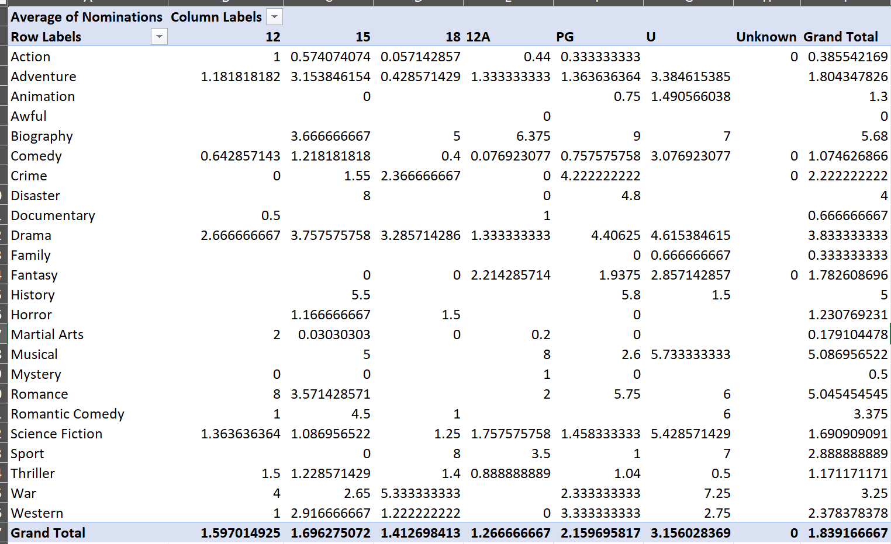

**Exercise 4 (Optinal) : Creating a pivot table to analyse the results of a house search**

Download the file [here](https://github.com/devtlv/Datasets-DA-Bootcamp-2-/raw/refs/heads/main/Week%207%20-%20Analysing%20Web%20Data/W7D4%20-%20Python%20+%20Excel%20Advanced%20%231/qf-3832.zip)

Within your pivot table create a calculated field called Total Rooms to equal the number of bedrooms, bathrooms and reception rooms combined  
Group the location into Urban (ie Town or Village) and Non-Urban (ie Countryside or Remote).  
Use this to show the percentage each garden size makes up of the total number of properties by each of your two types of location.

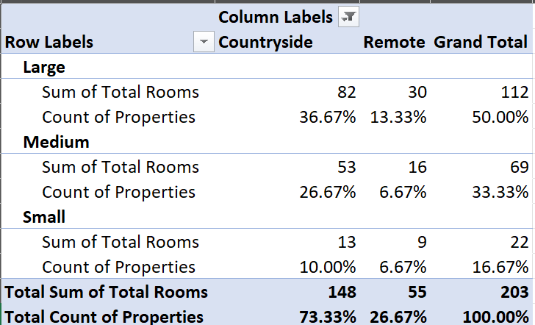

**Exercise 5 (Optinal) : Show film statistics by genre and certificate using a slicer**

Download the file [here](https://github.com/devtlv/Datasets-DA-Bootcamp-2-/raw/refs/heads/main/Week%207%20-%20Analysing%20Web%20Data/W7D4%20-%20Python%20+%20Excel%20Advanced%20%231/qf-3828.zip)

Remove the filter by country, and replace it with a slicer by country instead. Use this to show all Australasian films.

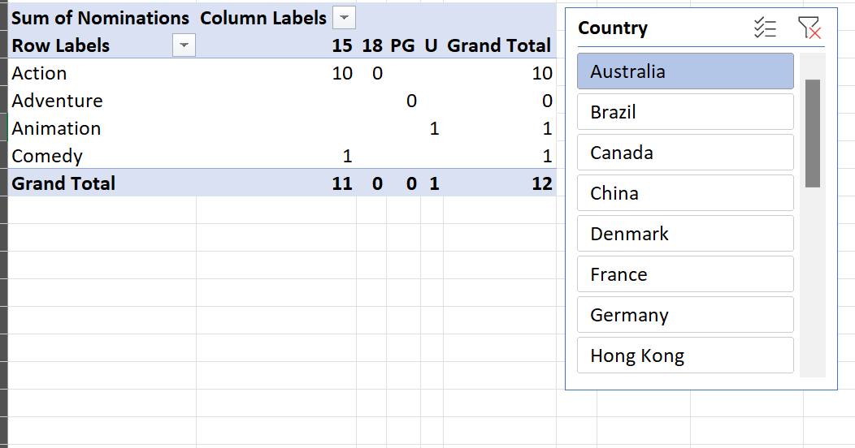

Create another pivot table (on a separate sheet) to show average Oscar wins by certificate. Apply the original slicer to this pivot table too to show this for Australia and New Zealand only.

Save this file as Filming over.xlsx, then close it down.

