SchemeStartDate | SchemeEndDate
01-05-2026 | 01-05-2030

MLI Name / MLI id
Valid

"{\"schemecode\":\"CAE\",\"borrowers\":[{\"MLIName\":\"Bank102\",\"MLIID\":\"60180\",\"ExporterName\":\"XYZ Exports Pvt Ltd\",\"ExporterITPAN\":\"OOIPP3467U\",\"IECCode\":\"3242342342\",\"UdyamRegistrationNumber\":\"UDYAM-UP-10-0000001\",\"UIN\":\"UIN123456\",\"Email\":\"xyz@exports.com\",\"MobileNumber\":\"9876543210\",\"Gender\":\"M\",\"Religion\":\"Hindu\",\"CasteCategory\":\"General\",\"ConstitutionType\":\"Partnership\",\"EntityType\":\"Micro\",\"AddressLine\":\"123 Industrial Area\",\"City\":\"Ghaziabad\",\"District\":\"519\",\"State\":\"27\",\"PinCode\":\"201001\",\"InterventionType\":\"OIE\",\"CustomerId\":\"CUST12345\",\"LoanAccountNumber\":\"LN000123456\",\"SanctionAmount\":\"5000000\",\"SanctionDate\":\"26-05-2026\",\"IndustryNature\":\"Textiles\",\"IndustrySector\":\"Cotton Textiles\",\"TenureOfLoan\":\"900\",\"IntrestRate\":\"8.5\",\"GuaranteeAmount\":\"4000000\"},{\"MLIName\":\"Bank102\",\"MLIID\":\"60181\",\"ExporterName\":\"ABC Global Traders\",\"ExporterITPAN\":\"ABCDE1234K\",\"IECCode\":\"9876543210\",\"UdyamRegistrationNumber\":\"UDYAM-DL-10-0000002\",\"UIN\":\"UIN654321\",\"Email\":\"abc@global.com\",\"MobileNumber\":\"9123456780\",\"Gender\":\"F\",\"Religion\":\"Hindu\",\"CasteCategory\":\"OBC\",\"ConstitutionType\":\"Company\",\"EntityType\":\"Small\",\"AddressLine\":\"45 Export Zone\",\"City\":\"Delhi\",\"District\":\"519\",\"State\":\"27\",\"PinCode\":\"110001\",\"InterventionType\":\"OIE\",\"CustomerId\":\"CUST54321\",\"LoanAccountNumber\":\"LN000654321\",\"SanctionAmount\":\"20000000\",\"SanctionDate\":\"15-04-2026\",\"IndustryNature\":\"Textiles\",\"IndustrySector\":\"Cotton Textiles\",\"TenureOfLoan\":\"60\",\"IntrestRate\":\"9.2\",\"GuaranteeAmount\":\"15000000\"},{\"MLIName\":\"Bank102\",\"MLIID\":\"60182\",\"ExporterName\":\"Global Ecom Solutions\",\"ExporterITPAN\":\"PQRSX6789L\",\"IECCode\":\"1122334455\",\"UdyamRegistrationNumber\":\"UDYAM-MH-10-0000003\",\"UIN\":\"UIN789123\",\"Email\":\"contact@ecom.com\",\"MobileNumber\":\"9988776655\",\"Gender\":\"M\",\"Religion\":\"Muslim\",\"CasteCategory\":\"General\",\"ConstitutionType\":\"LLP\",\"EntityType\":\"Medium\",\"AddressLine\":\"789 Tech Park\",\"City\":\"Mumbai\",\"District\":\"519\",\"State\":\"27\",\"PinCode\":\"400001\",\"InterventionType\":\"DEC\",\"CustomerId\":\"CUST67890\",\"LoanAccountNumber\":\"LN000789123\",\"SanctionAmount\":\"4500000\",\"SanctionDate\":\"10-06-2026\",\"IndustryNature\":\"Textiles\",\"IndustrySector\":\"Cotton Textiles\",\"TenureOfLoan\":\"36\",\"IntrestRate\":\"10.0\",\"GuaranteeAmount\":\"3000000\"}]}"

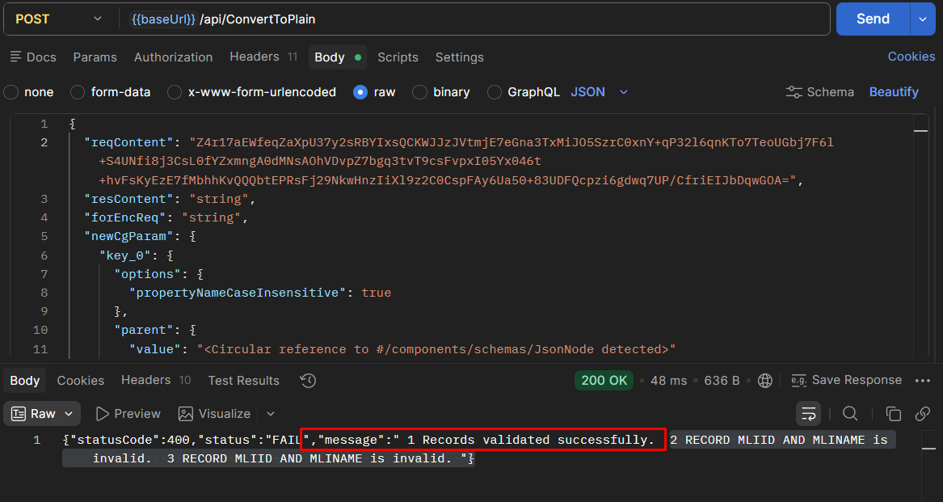

Invalid
"{\"schemecode\":\"CAE\",\"borrowers\":[{\"MLIName\":\"\",\"MLIID\":\"60180\",\"ExporterName\":\"XYZ Exports Pvt Ltd\",\"ExporterITPAN\":\"OOIPP3467U\",\"IECCode\":\"3242342342\",\"UdyamRegistrationNumber\":\"UDYAM-UP-10-0000001\",\"UIN\":\"UIN123456\",\"Email\":\"xyz@exports.com\",\"MobileNumber\":\"9876543210\",\"Gender\":\"M\",\"Religion\":\"Hindu\",\"CasteCategory\":\"General\",\"ConstitutionType\":\"Partnership\",\"EntityType\":\"Micro\",\"AddressLine\":\"123 Industrial Area\",\"City\":\"Ghaziabad\",\"District\":\"519\",\"State\":\"27\",\"PinCode\":\"201001\",\"InterventionType\":\"OIE\",\"CustomerId\":\"CUST12345\",\"LoanAccountNumber\":\"LN000123456\",\"SanctionAmount\":\"5000000\",\"SanctionDate\":\"26-05-2026\",\"IndustryNature\":\"Textiles\",\"IndustrySector\":\"Cotton Textiles\",\"TenureOfLoan\":\"900\",\"IntrestRate\":\"8.5\",\"GuaranteeAmount\":\"4000000\"},{\"MLIName\":\"Bank1034656455\",\"MLIID\":\"60181\",\"ExporterName\":\"ABC Global Traders\",\"ExporterITPAN\":\"ABCDE1234K\",\"IECCode\":\"9876543210\",\"UdyamRegistrationNumber\":\"UDYAM-DL-10-0000002\",\"UIN\":\"UIN654321\",\"Email\":\"abc@global.com\",\"MobileNumber\":\"9123456780\",\"Gender\":\"F\",\"Religion\":\"Hindu\",\"CasteCategory\":\"OBC\",\"ConstitutionType\":\"Company\",\"EntityType\":\"Small\",\"AddressLine\":\"45 Export Zone\",\"City\":\"Delhi\",\"District\":\"519\",\"State\":\"27\",\"PinCode\":\"110001\",\"InterventionType\":\"OIE\",\"CustomerId\":\"CUST54321\",\"LoanAccountNumber\":\"LN000654321\",\"SanctionAmount\":\"20000000\",\"SanctionDate\":\"15-04-2026\",\"IndustryNature\":\"Textiles\",\"IndustrySector\":\"Cotton Textiles\",\"TenureOfLoan\":\"60\",\"IntrestRate\":\"9.2\",\"GuaranteeAmount\":\"15000000\"},{\"MLIName\":\"B\",\"MLIID\":\"60182\",\"ExporterName\":\"Global Ecom Solutions\",\"ExporterITPAN\":\"PQRSX6789L\",\"IECCode\":\"1122334455\",\"UdyamRegistrationNumber\":\"UDYAM-MH-10-0000003\",\"UIN\":\"UIN789123\",\"Email\":\"contact@ecom.com\",\"MobileNumber\":\"9988776655\",\"Gender\":\"M\",\"Religion\":\"Muslim\",\"CasteCategory\":\"General\",\"ConstitutionType\":\"LLP\",\"EntityType\":\"Medium\",\"AddressLine\":\"789 Tech Park\",\"City\":\"Mumbai\",\"District\":\"519\",\"State\":\"27\",\"PinCode\":\"400001\",\"InterventionType\":\"DEC\",\"CustomerId\":\"CUST67890\",\"LoanAccountNumber\":\"LN000789123\",\"SanctionAmount\":\"4500000\",\"SanctionDate\":\"10-06-2026\",\"IndustryNature\":\"Textiles\",\"IndustrySector\":\"Cotton Textiles\",\"TenureOfLoan\":\"36\",\"IntrestRate\":\"10.0\",\"GuaranteeAmount\":\"3000000\"}]}"

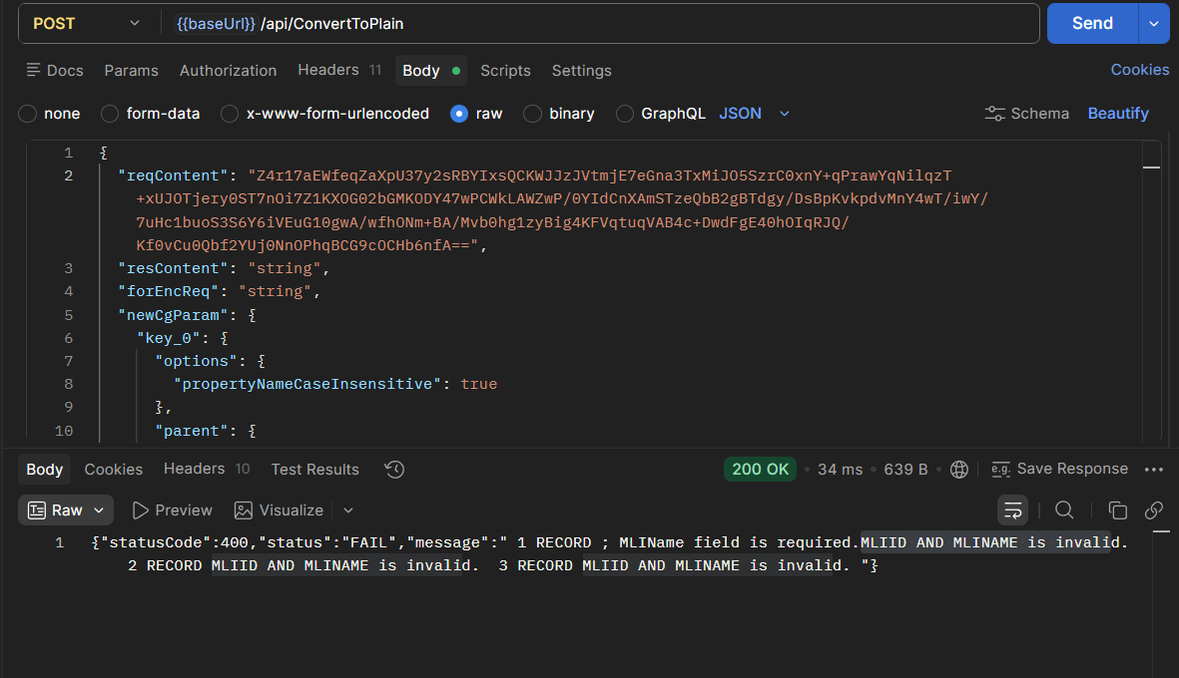

Name of the exporter

"{\"schemecode\":\"CAE\",\"borrowers\":[{\"MLIName\":\"Bank102\",\"MLIID\":\"60180\",\"ExporterName\":\"\",\"ExporterITPAN\":\"OOIPP3467U\",\"IECCode\":\"3242342342\",\"UdyamRegistrationNumber\":\"UDYAM-UP-12-1000001\",\"UIN\":\"UIN113451\",\"Email\":\"xyz@exports.com\",\"MobileNumber\":\"9876543210\",\"Gender\":\"M\",\"Religion\":\"Hindu\",\"CasteCategory\":\"General\",\"ConstitutionType\":\"Partnership\",\"EntityType\":\"Micro\",\"AddressLine\":\"123 Industrial Area\",\"City\":\"Ghaziabad\",\"District\":\"519\",\"State\":\"27\",\"PinCode\":\"201001\",\"InterventionType\":\"OIE\",\"CustomerId\":\"CUST12345\",\"LoanAccountNumber\":\"LN000123456\",\"SanctionAmount\":\"5000000\",\"SanctionDate\":\"26-05-2026\",\"IndustryNature\":\"Textiles\",\"IndustrySector\":\"Cotton Textiles\",\"TenureOfLoan\":\"900\",\"IntrestRate\":\"8.5\",\"GuaranteeAmount\":\"4000000\"},{\"MLIName\":\"Bank102\",\"MLIID\":\"60180\",\"ExporterName\":\"ABC 133345 Global Traders\",\"ExporterITPAN\":\"ABCDE1234K\",\"IECCode\":\"9876543210\",\"UdyamRegistrationNumber\":\"UDYAM-DL-11-1000002\",\"UIN\":\"UIN154322\",\"Email\":\"abc@global.com\",\"MobileNumber\":\"9123456780\",\"Gender\":\"F\",\"Religion\":\"Hindu\",\"CasteCategory\":\"OBC\",\"ConstitutionType\":\"Company\",\"EntityType\":\"Small\",\"AddressLine\":\"45 Export Zone\",\"City\":\"Delhi\",\"District\":\"519\",\"State\":\"27\",\"PinCode\":\"110001\",\"InterventionType\":\"OIE\",\"CustomerId\":\"CUST54321\",\"LoanAccountNumber\":\"LN000654321\",\"SanctionAmount\":\"2000\",\"SanctionDate\":\"15-04-2026\",\"IndustryNature\":\"Textiles\",\"IndustrySector\":\"Cotton Textiles\",\"TenureOfLoan\":\"60\",\"IntrestRate\":\"9.2\",\"GuaranteeAmount\":\"150\"},{\"MLIName\":\"Bank102\",\"MLIID\":\"60180\",\"ExporterName\":\"@#$<>%^&\",\"ExporterITPAN\":\"PQRSX6789L\",\"IECCode\":\"1122334455\",\"UdyamRegistrationNumber\":\"UDYAM-MH-11-1000003\",\"UIN\":\"UIN189123\",\"Email\":\"contact@ecom.com\",\"MobileNumber\":\"9988776655\",\"Gender\":\"M\",\"Religion\":\"Muslim\",\"CasteCategory\":\"General\",\"ConstitutionType\":\"LLP\",\"EntityType\":\"Medium\",\"AddressLine\":\"789 Tech Park\",\"City\":\"Mumbai\",\"District\":\"519\",\"State\":\"27\",\"PinCode\":\"400001\",\"InterventionType\":\"OIE\",\"CustomerId\":\"CUST67890\",\"LoanAccountNumber\":\"LN000789123\",\"SanctionAmount\":\"450\",\"SanctionDate\":\"10-06-2026\",\"IndustryNature\":\"Textiles\",\"IndustrySector\":\"Cotton Textiles\",\"TenureOfLoan\":\"36\",\"IntrestRate\":\"10.0\",\"GuaranteeAmount\":\"150\"}]}"

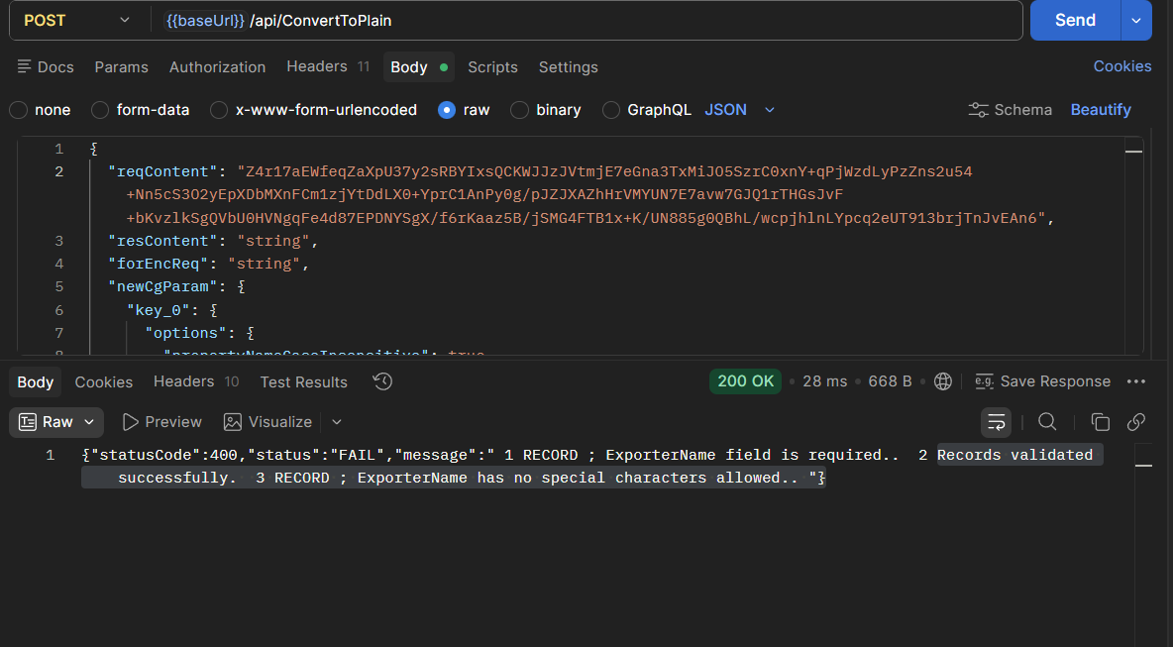

Exporter ITPAN | PAN of the exporter. Unique PAN validation to be included | Alphanumeric | Mandatory

"{\"schemecode\":\"CAE\",\"borrowers\":[{\"MLIName\":\"Bank102\",\"MLIID\":\"60180\",\"ExporterName\":\"Somesh01\",\"ExporterITPAN\":\"\",\"IECCode\":\"3242342342\",\"UdyamRegistrationNumber\":\"UDYAM-UP-12-1000002\",\"UIN\":\"UIN100001\",\"Email\":\"xyz@exports.com\",\"MobileNumber\":\"9876543210\",\"Gender\":\"M\",\"Religion\":\"Hindu\",\"CasteCategory\":\"General\",\"ConstitutionType\":\"Partnership\",\"EntityType\":\"Micro\",\"AddressLine\":\"123 Industrial Area\",\"City\":\"Ghaziabad\",\"District\":\"519\",\"State\":\"27\",\"PinCode\":\"201001\",\"InterventionType\":\"OIE\",\"CustomerId\":\"CUST12345\",\"LoanAccountNumber\":\"LN000123456\",\"SanctionAmount\":\"5000000\",\"SanctionDate\":\"26-05-2026\",\"IndustryNature\":\"Textiles\",\"IndustrySector\":\"Cotton Textiles\",\"TenureOfLoan\":\"900\",\"IntrestRate\":\"8.5\",\"GuaranteeAmount\":\"4000000\"},{\"MLIName\":\"Bank102\",\"MLIID\":\"60180\",\"ExporterName\":\"somesh02\",\"ExporterITPAN\":\"ABCDE1234K5\",\"IECCode\":\"9876543210\",\"UdyamRegistrationNumber\":\"UDYAM-DL-11-1000002\",\"UIN\":\"UIN200001\",\"Email\":\"abc@global.com\",\"MobileNumber\":\"9123456780\",\"Gender\":\"F\",\"Religion\":\"Hindu\",\"CasteCategory\":\"OBC\",\"ConstitutionType\":\"Company\",\"EntityType\":\"Small\",\"AddressLine\":\"45 Export Zone\",\"City\":\"Delhi\",\"District\":\"519\",\"State\":\"27\",\"PinCode\":\"110001\",\"InterventionType\":\"OIE\",\"CustomerId\":\"CUST54321\",\"LoanAccountNumber\":\"LN000654321\",\"SanctionAmount\":\"2000\",\"SanctionDate\":\"15-04-2026\",\"IndustryNature\":\"Textiles\",\"IndustrySector\":\"Cotton Textiles\",\"TenureOfLoan\":\"60\",\"IntrestRate\":\"9.2\",\"GuaranteeAmount\":\"150\"},{\"MLIName\":\"Bank102\",\"MLIID\":\"60180\",\"ExporterName\":\"somesh 03\",\"ExporterITPAN\":\"QRSX6789L\",\"IECCode\":\"1122334455\",\"UdyamRegistrationNumber\":\"UDYAM-MH-11-1000002\",\"UIN\":\"UIN300001\",\"Email\":\"contact@ecom.com\",\"MobileNumber\":\"9988776655\",\"Gender\":\"M\",\"Religion\":\"Muslim\",\"CasteCategory\":\"General\",\"ConstitutionType\":\"LLP\",\"EntityType\":\"Medium\",\"AddressLine\":\"789 Tech Park\",\"City\":\"Mumbai\",\"District\":\"519\",\"State\":\"27\",\"PinCode\":\"400001\",\"InterventionType\":\"OIE\",\"CustomerId\":\"CUST67890\",\"LoanAccountNumber\":\"LN000789123\",\"SanctionAmount\":\"450\",\"SanctionDate\":\"10-06-2026\",\"IndustryNature\":\"Textiles\",\"IndustrySector\":\"Cotton Textiles\",\"TenureOfLoan\":\"36\",\"IntrestRate\":\"10.0\",\"GuaranteeAmount\":\"150\"}]}"

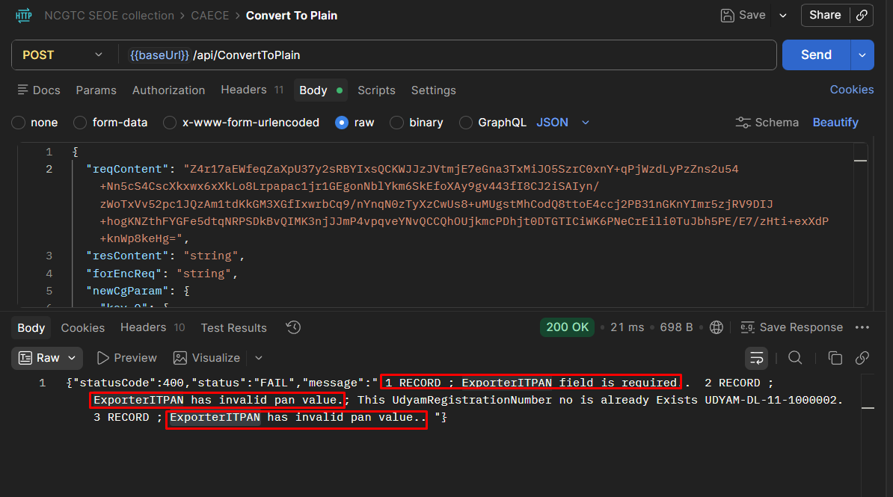

"{\"schemecode\":\"CAE\",\"borrowers\":[{\"MLIName\":\"Bank102\",\"MLIID\":\"60180\",\"ExporterName\":\"Somesh01\",\"ExporterITPAN\":\"AQPPL1101A\",\"IECCode\":\"A242342342\",\"UdyamRegistrationNumber\":\"UDYAM-UP-10-1000000\",\"UIN\":\"A1\",\"Email\":\"\",\"MobileNumber\":\"912345678565\",\"Gender\":\"T\",\"Religion\":\"1\",\"CasteCategory\":\"1\",\"ConstitutionType\":\"1\",\"EntityType\":\"1\",\"AddressLine\":\"123 Industrial Area\",\"City\":\"Ghaziabad\",\"District\":\"519\",\"State\":\"27\",\"PinCode\":\"123451\",\"InterventionType\":\"DEC\",\"CustomerId\":\"CUSTA05\",\"LoanAccountNumber\":\"loan01\",\"SanctionAmount\":\"1000000\",\"SanctionDate\":\"04-05-2026\",\"IndustryNature\":\"1\",\"IndustrySector\":\"1\",\"TenureOfLoan\":\"900\",\"IntrestRate\":\"8.5\",\"GuaranteeAmount\":\"40000\"},{\"MLIName\":\"Bank102\",\"MLIID\":\"60180\",\"ExporterName\":\"somesh02\",\"ExporterITPAN\":\"AQPPL1101A\",\"IECCode\":\"987654321A\",\"UdyamRegistrationNumber\":\"UDYAM-DL-11-1000000\",\"UIN\":\"B1\",\"Email\":\"cmcredit@wbgb.bank.in\",\"MobileNumber\":\"912345678565\",\"Gender\":\"F\",\"Religion\":\"1\",\"CasteCategory\":\"1\",\"ConstitutionType\":\"1\",\"EntityType\":\"1\",\"AddressLine\":\"45 Export Zone\",\"City\":\"Delhi\",\"District\":\"639\",\"State\":\"35\",\"PinCode\":\"110001\",\"InterventionType\":\"OIE\",\"CustomerId\":\"CUSTB05\",\"LoanAccountNumber\":\"Loan01\",\"SanctionAmount\":\"10000000\",\"SanctionDate\":\"03-06-2026\",\"IndustryNature\":\"1\",\"IndustrySector\":\"1\",\"TenureOfLoan\":\"60\",\"IntrestRate\":\"9.2\",\"GuaranteeAmount\":\"150\"}]}"

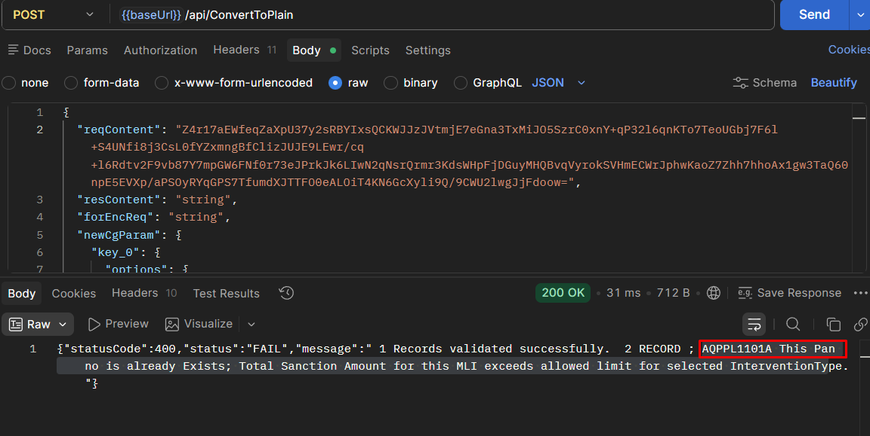

Importer Exporter Code (IEC) | Exporter’s (Importer Exporter Code) | 10-digit Alphanumeric | Mandatory

"{\"schemecode\":\"CAE\",\"borrowers\":[{\"MLIName\":\"Bank102\",\"MLIID\":\"60180\",\"ExporterName\":\"Somesh01\",\"ExporterITPAN\":\"AQPPL1001A\",\"IECCode\":\"A242342342\",\"UdyamRegistrationNumber\":\"UDYAM-UP-12-1100002\",\"UIN\":\"UIN110001\",\"Email\":\"xyz@exports.com\",\"MobileNumber\":\"9876543210\",\"Gender\":\"M\",\"Religion\":\"Hindu\",\"CasteCategory\":\"General\",\"ConstitutionType\":\"Partnership\",\"EntityType\":\"Micro\",\"AddressLine\":\"123 Industrial Area\",\"City\":\"Ghaziabad\",\"District\":\"519\",\"State\":\"27\",\"PinCode\":\"201001\",\"InterventionType\":\"OIE\",\"CustomerId\":\"CUST12345\",\"LoanAccountNumber\":\"LN000123456\",\"SanctionAmount\":\"5000000\",\"SanctionDate\":\"26-05-2026\",\"IndustryNature\":\"Textiles\",\"IndustrySector\":\"Cotton Textiles\",\"TenureOfLoan\":\"900\",\"IntrestRate\":\"8.5\",\"GuaranteeAmount\":\"4000000\"},{\"MLIName\":\"Bank102\",\"MLIID\":\"60180\",\"ExporterName\":\"somesh02\",\"ExporterITPAN\":\"AQPPL1002A\",\"IECCode\":\"98765432107\",\"UdyamRegistrationNumber\":\"UDYAM-DL-11-1100002\",\"UIN\":\"UIN220001\",\"Email\":\"abc@global.com\",\"MobileNumber\":\"9123456780\",\"Gender\":\"F\",\"Religion\":\"Hindu\",\"CasteCategory\":\"OBC\",\"ConstitutionType\":\"Company\",\"EntityType\":\"Small\",\"AddressLine\":\"45 Export Zone\",\"City\":\"Delhi\",\"District\":\"519\",\"State\":\"27\",\"PinCode\":\"110001\",\"InterventionType\":\"OIE\",\"CustomerId\":\"CUST54321\",\"LoanAccountNumber\":\"LN000654321\",\"SanctionAmount\":\"2000\",\"SanctionDate\":\"15-04-2026\",\"IndustryNature\":\"Textiles\",\"IndustrySector\":\"Cotton Textiles\",\"TenureOfLoan\":\"60\",\"IntrestRate\":\"9.2\",\"GuaranteeAmount\":\"150\"},{\"MLIName\":\"Bank102\",\"MLIID\":\"60180\",\"ExporterName\":\"somesh 03\",\"ExporterITPAN\":\"AQPPL1003A\",\"IECCode\":\"112233445\",\"UdyamRegistrationNumber\":\"UDYAM-MH-11-1100002\",\"UIN\":\"UIN330001\",\"Email\":\"contact@ecom.com\",\"MobileNumber\":\"9988776655\",\"Gender\":\"M\",\"Religion\":\"Muslim\",\"CasteCategory\":\"General\",\"ConstitutionType\":\"LLP\",\"EntityType\":\"Medium\",\"AddressLine\":\"789 Tech Park\",\"City\":\"Mumbai\",\"District\":\"519\",\"State\":\"27\",\"PinCode\":\"400001\",\"InterventionType\":\"OIE\",\"CustomerId\":\"CUST67890\",\"LoanAccountNumber\":\"LN000789123\",\"SanctionAmount\":\"450\",\"SanctionDate\":\"10-06-2026\",\"IndustryNature\":\"Textiles\",\"IndustrySector\":\"Cotton Textiles\",\"TenureOfLoan\":\"36\",\"IntrestRate\":\"10.0\",\"GuaranteeAmount\":\"150\"}]}"

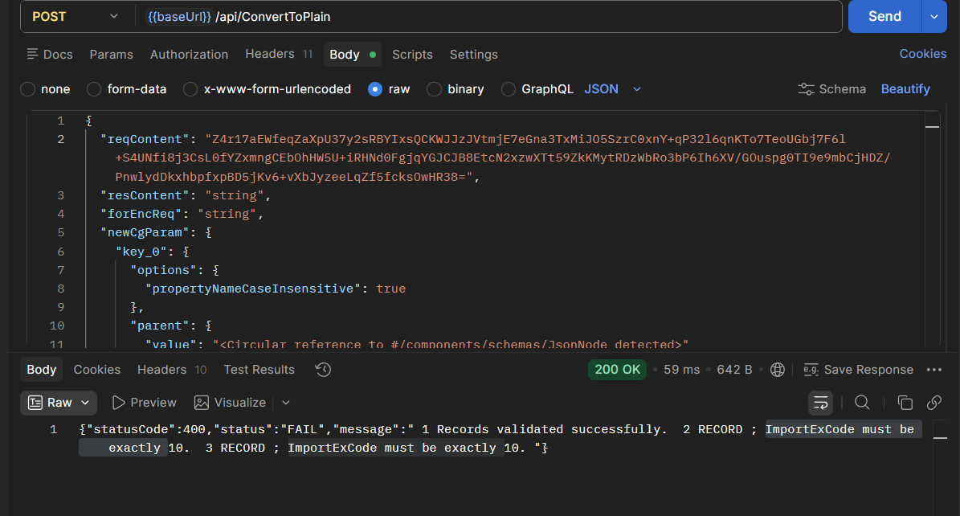

Udhyam Registration Number | 19 digit Udyam Registration Number (i.e. UDYAM-XX-00-0000000).E.G. UDYAM-GJ-21-0123456 | Number (Upto 19 digits) | Mandatory

"{\"schemecode\":\"CAE\",\"borrowers\":[{\"MLIName\":\"Bank102\",\"MLIID\":\"60180\",\"ExporterName\":\"Somesh01\",\"ExporterITPAN\":\"AQPPL1101A\",\"IECCode\":\"A242342342\",\"UdyamRegistrationNumber\":\"UDYAM-UP-12-1100003\",\"UIN\":\"UIN111101\",\"Email\":\"xyz@exports.com\",\"MobileNumber\":\"9876543210\",\"Gender\":\"M\",\"Religion\":\"Hindu\",\"CasteCategory\":\"General\",\"ConstitutionType\":\"Partnership\",\"EntityType\":\"Micro\",\"AddressLine\":\"123 Industrial Area\",\"City\":\"Ghaziabad\",\"District\":\"519\",\"State\":\"27\",\"PinCode\":\"201001\",\"InterventionType\":\"OIE\",\"CustomerId\":\"CUST12345\",\"LoanAccountNumber\":\"LN000123456\",\"SanctionAmount\":\"5000000\",\"SanctionDate\":\"26-05-2026\",\"IndustryNature\":\"Textiles\",\"IndustrySector\":\"Cotton Textiles\",\"TenureOfLoan\":\"900\",\"IntrestRate\":\"8.5\",\"GuaranteeAmount\":\"4000000\"},{\"MLIName\":\"Bank102\",\"MLIID\":\"60180\",\"ExporterName\":\"somesh02\",\"ExporterITPAN\":\"AQPPL1102A\",\"IECCode\":\"98765432107\",\"UdyamRegistrationNumber\":\"UDYAM-DL-11-110000\",\"UIN\":\"UIN222001\",\"Email\":\"abc@global.com\",\"MobileNumber\":\"9123456780\",\"Gender\":\"F\",\"Religion\":\"Hindu\",\"CasteCategory\":\"OBC\",\"ConstitutionType\":\"Company\",\"EntityType\":\"Small\",\"AddressLine\":\"45 Export Zone\",\"City\":\"Delhi\",\"District\":\"519\",\"State\":\"27\",\"PinCode\":\"110001\",\"InterventionType\":\"OIE\",\"CustomerId\":\"CUST54321\",\"LoanAccountNumber\":\"LN000654321\",\"SanctionAmount\":\"2000\",\"SanctionDate\":\"15-04-2026\",\"IndustryNature\":\"Textiles\",\"IndustrySector\":\"Cotton Textiles\",\"TenureOfLoan\":\"60\",\"IntrestRate\":\"9.2\",\"GuaranteeAmount\":\"150\"},{\"MLIName\":\"Bank102\",\"MLIID\":\"60180\",\"ExporterName\":\"somesh 03\",\"ExporterITPAN\":\"AQPPL1103A\",\"IECCode\":\"112233445\",\"UdyamRegistrationNumber\":\"\",\"UIN\":\"UIN333001\",\"Email\":\"contact@ecom.com\",\"MobileNumber\":\"9988776655\",\"Gender\":\"M\",\"Religion\":\"Muslim\",\"CasteCategory\":\"General\",\"ConstitutionType\":\"LLP\",\"EntityType\":\"Medium\",\"AddressLine\":\"789 Tech Park\",\"City\":\"Mumbai\",\"District\":\"519\",\"State\":\"27\",\"PinCode\":\"400001\",\"InterventionType\":\"OIE\",\"CustomerId\":\"CUST67890\",\"LoanAccountNumber\":\"LN000789123\",\"SanctionAmount\":\"450\",\"SanctionDate\":\"10-06-2026\",\"IndustryNature\":\"Textiles\",\"IndustrySector\":\"Cotton Textiles\",\"TenureOfLoan\":\"36\",\"IntrestRate\":\"10.0\",\"GuaranteeAmount\":\"150\"}]}"

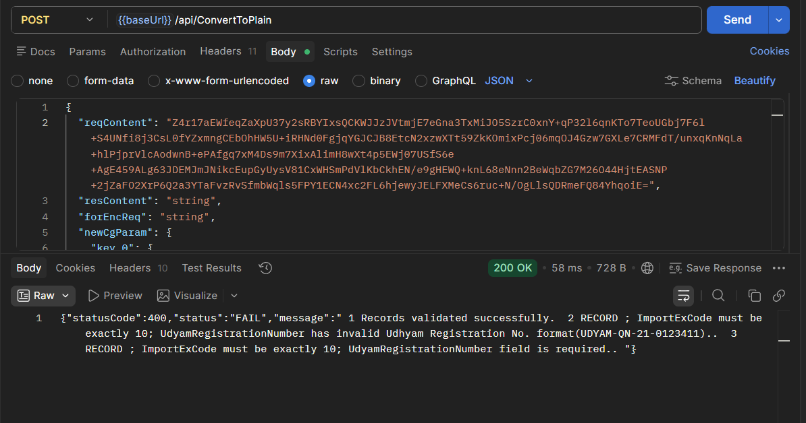

Unique Identification Number (UIN) | UIN issued on DGFT portal to exporter | Alphanumeric | Mandatory

"{\"schemecode\":\"CAE\",\"borrowers\":[{\"MLIName\":\"Bank102\",\"MLIID\":\"60180\",\"ExporterName\":\"Somesh01\",\"ExporterITPAN\":\"AQPPL1101A\",\"IECCode\":\"A242342342\",\"UdyamRegistrationNumber\":\"UDYAM-UP-12-1110003\",\"UIN\":\"\",\"Email\":\"xyz@exports.com\",\"MobileNumber\":\"9876543210\",\"Gender\":\"M\",\"Religion\":\"Hindu\",\"CasteCategory\":\"General\",\"ConstitutionType\":\"Partnership\",\"EntityType\":\"Micro\",\"AddressLine\":\"123 Industrial Area\",\"City\":\"Ghaziabad\",\"District\":\"519\",\"State\":\"27\",\"PinCode\":\"201001\",\"InterventionType\":\"OIE\",\"CustomerId\":\"CUST12345\",\"LoanAccountNumber\":\"LN000123456\",\"SanctionAmount\":\"5000000\",\"SanctionDate\":\"26-05-2026\",\"IndustryNature\":\"Textiles\",\"IndustrySector\":\"Cotton Textiles\",\"TenureOfLoan\":\"900\",\"IntrestRate\":\"8.5\",\"GuaranteeAmount\":\"4000000\"},{\"MLIName\":\"Bank102\",\"MLIID\":\"60180\",\"ExporterName\":\"somesh02\",\"ExporterITPAN\":\"AQPPL1102A\",\"IECCode\":\"987654321A\",\"UdyamRegistrationNumber\":\"UDYAM-DL-11-1110000\",\"UIN\":\"UIN222001!@#$%^&*\",\"Email\":\"abc@global.com\",\"MobileNumber\":\"9123456780\",\"Gender\":\"F\",\"Religion\":\"Hindu\",\"CasteCategory\":\"OBC\",\"ConstitutionType\":\"Company\",\"EntityType\":\"Small\",\"AddressLine\":\"45 Export Zone\",\"City\":\"Delhi\",\"District\":\"519\",\"State\":\"27\",\"PinCode\":\"110001\",\"InterventionType\":\"OIE\",\"CustomerId\":\"CUST54321\",\"LoanAccountNumber\":\"LN000654321\",\"SanctionAmount\":\"2000\",\"SanctionDate\":\"15-04-2026\",\"IndustryNature\":\"Textiles\",\"IndustrySector\":\"Cotton Textiles\",\"TenureOfLoan\":\"60\",\"IntrestRate\":\"9.2\",\"GuaranteeAmount\":\"150\"},{\"MLIName\":\"Bank102\",\"MLIID\":\"60180\",\"ExporterName\":\"somesh 03\",\"ExporterITPAN\":\"AQPPL1103A\",\"IECCode\":\"112A233445\",\"UdyamRegistrationNumber\":\"UDYAM-MH-11-1110000\",\"UIN\":\"UIN333001AAAAAAAAAAAAAAAAAAAAAAAAAAAAAAAAAAAAAAAAAAAAAAA\",\"Email\":\"contact@ecom.com\",\"MobileNumber\":\"9988776655\",\"Gender\":\"M\",\"Religion\":\"Muslim\",\"CasteCategory\":\"General\",\"ConstitutionType\":\"LLP\",\"EntityType\":\"Medium\",\"AddressLine\":\"789 Tech Park\",\"City\":\"Mumbai\",\"District\":\"519\",\"State\":\"27\",\"PinCode\":\"400001\",\"InterventionType\":\"OIE\",\"CustomerId\":\"CUST67890\",\"LoanAccountNumber\":\"LN000789123\",\"SanctionAmount\":\"450\",\"SanctionDate\":\"10-06-2026\",\"IndustryNature\":\"Textiles\",\"IndustrySector\":\"Cotton Textiles\",\"TenureOfLoan\":\"36\",\"IntrestRate\":\"10.0\",\"GuaranteeAmount\":\"150\"}]}"

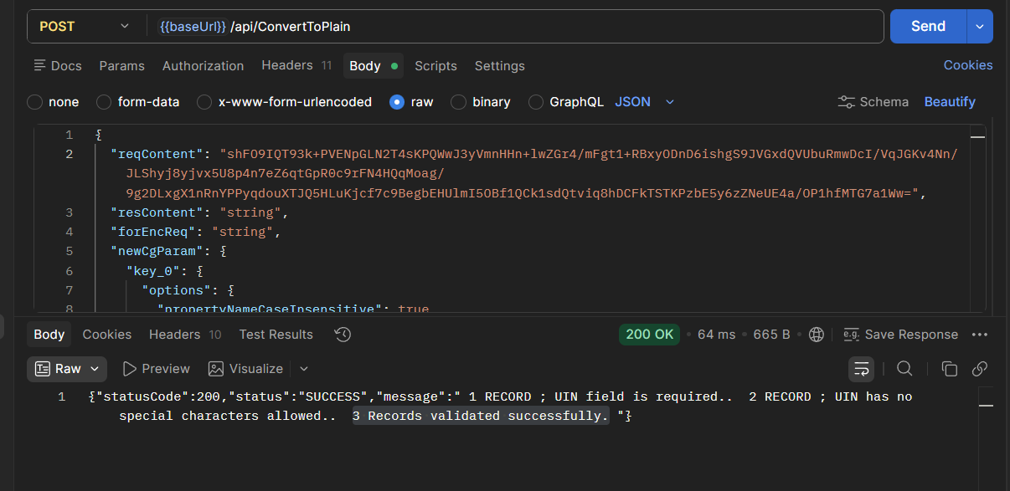

Email Id of Exporter | Official email ID of exporter | Alphanumeric following Standard Email Rules | Optional

"{\"schemecode\":\"CAE\",\"borrowers\":[{\"MLIName\":\"Bank102\",\"MLIID\":\"60180\",\"ExporterName\":\"Somesh01\",\"ExporterITPAN\":\"AQPPL1101A\",\"IECCode\":\"A242342342\",\"UdyamRegistrationNumber\":\"UDYAM-UP-12-1110003\",\"UIN\":\"A\",\"Email\":\"\",\"MobileNumber\":\"9876543210\",\"Gender\":\"M\",\"Religion\":\"Hindu\",\"CasteCategory\":\"General\",\"ConstitutionType\":\"Partnership\",\"EntityType\":\"Micro\",\"AddressLine\":\"123 Industrial Area\",\"City\":\"Ghaziabad\",\"District\":\"519\",\"State\":\"27\",\"PinCode\":\"201001\",\"InterventionType\":\"OIE\",\"CustomerId\":\"CUST12345\",\"LoanAccountNumber\":\"LN000123456\",\"SanctionAmount\":\"5000000\",\"SanctionDate\":\"26-05-2026\",\"IndustryNature\":\"Textiles\",\"IndustrySector\":\"Cotton Textiles\",\"TenureOfLoan\":\"900\",\"IntrestRate\":\"8.5\",\"GuaranteeAmount\":\"4000000\"},{\"MLIName\":\"Bank102\",\"MLIID\":\"60180\",\"ExporterName\":\"somesh02\",\"ExporterITPAN\":\"AQPPL1102A\",\"IECCode\":\"987654321A\",\"UdyamRegistrationNumber\":\"UDYAM-DL-11-1110000\",\"UIN\":\"UIN222001\",\"Email\":\"cmcredit@wbgb.bank.in\",\"MobileNumber\":\"9123456780\",\"Gender\":\"F\",\"Religion\":\"Hindu\",\"CasteCategory\":\"OBC\",\"ConstitutionType\":\"Company\",\"EntityType\":\"Small\",\"AddressLine\":\"45 Export Zone\",\"City\":\"Delhi\",\"District\":\"519\",\"State\":\"27\",\"PinCode\":\"110001\",\"InterventionType\":\"OIE\",\"CustomerId\":\"CUST54321\",\"LoanAccountNumber\":\"LN000654321\",\"SanctionAmount\":\"2000\",\"SanctionDate\":\"15-04-2026\",\"IndustryNature\":\"Textiles\",\"IndustrySector\":\"Cotton Textiles\",\"TenureOfLoan\":\"60\",\"IntrestRate\":\"9.2\",\"GuaranteeAmount\":\"150\"},{\"MLIName\":\"Bank102\",\"MLIID\":\"60180\",\"ExporterName\":\"somesh 03\",\"ExporterITPAN\":\"AQPPL1103A\",\"IECCode\":\"112A233445\",\"UdyamRegistrationNumber\":\"UDYAM-MH-11-1110000\",\"UIN\":\"UIN333001AAAAAAAAAAAAAAAAAAAAAAAAAAAAAAAAAAAAAAAAAAAAAAA\",\"Email\":\"contactecom.com\",\"MobileNumber\":\"9988776655\",\"Gender\":\"M\",\"Religion\":\"Muslim\",\"CasteCategory\":\"General\",\"ConstitutionType\":\"LLP\",\"EntityType\":\"Medium\",\"AddressLine\":\"789 Tech Park\",\"City\":\"Mumbai\",\"District\":\"519\",\"State\":\"27\",\"PinCode\":\"400001\",\"InterventionType\":\"OIE\",\"CustomerId\":\"CUST67890\",\"LoanAccountNumber\":\"LN000789123\",\"SanctionAmount\":\"450\",\"SanctionDate\":\"10-06-2026\",\"IndustryNature\":\"Textiles\",\"IndustrySector\":\"Cotton Textiles\",\"TenureOfLoan\":\"36\",\"IntrestRate\":\"10.0\",\"GuaranteeAmount\":\"150\"}]}"

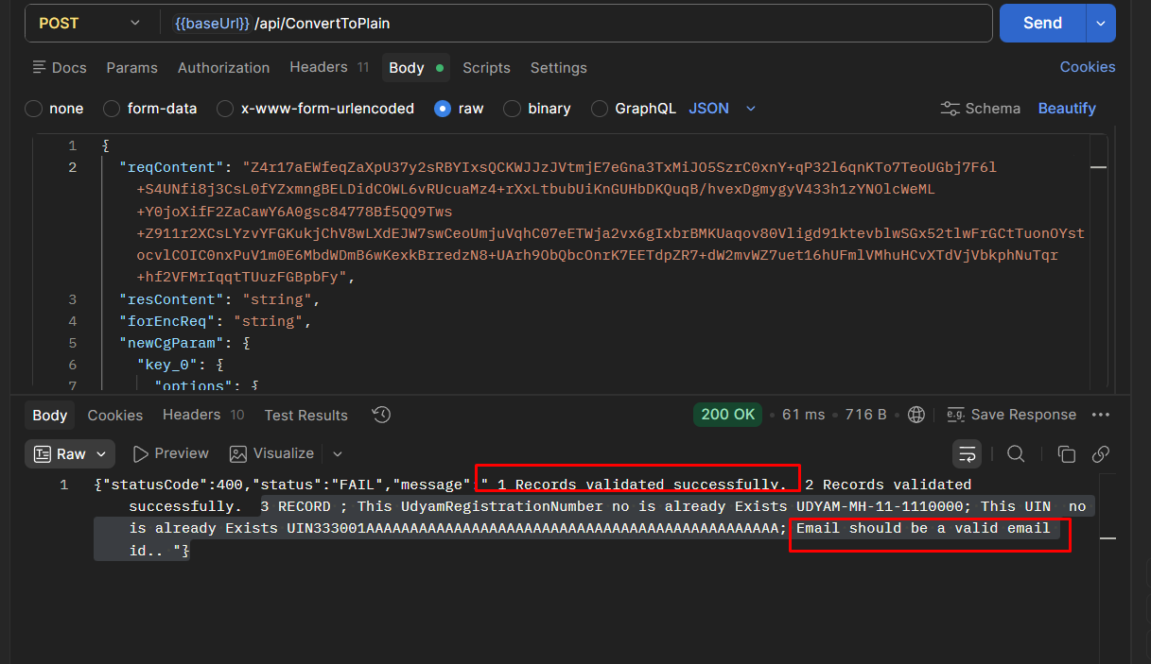

Mobile No. of Exporter | 10-digit mobile number of exporter | Number (Upto 12 digits) | Mandatory

"{\"schemecode\":\"CAE\",\"borrowers\":[{\"MLIName\":\"Bank102\",\"MLIID\":\"60180\",\"ExporterName\":\"Somesh01\",\"ExporterITPAN\":\"AQPPL1101A\",\"IECCode\":\"A242342342\",\"UdyamRegistrationNumber\":\"UDYAM-UP-12-1111003\",\"UIN\":\"A1\",\"Email\":\"\",\"MobileNumber\":\"\",\"Gender\":\"M\",\"Religion\":\"Hindu\",\"CasteCategory\":\"General\",\"ConstitutionType\":\"Partnership\",\"EntityType\":\"Micro\",\"AddressLine\":\"123 Industrial Area\",\"City\":\"Ghaziabad\",\"District\":\"519\",\"State\":\"27\",\"PinCode\":\"201001\",\"InterventionType\":\"OIE\",\"CustomerId\":\"CUST12345\",\"LoanAccountNumber\":\"LN000123456\",\"SanctionAmount\":\"5000000\",\"SanctionDate\":\"26-05-2026\",\"IndustryNature\":\"Textiles\",\"IndustrySector\":\"Cotton Textiles\",\"TenureOfLoan\":\"900\",\"IntrestRate\":\"8.5\",\"GuaranteeAmount\":\"4000000\"},{\"MLIName\":\"Bank102\",\"MLIID\":\"60180\",\"ExporterName\":\"somesh02\",\"ExporterITPAN\":\"AQPPL1102A\",\"IECCode\":\"987654321A\",\"UdyamRegistrationNumber\":\"UDYAM-DL-11-1111000\",\"UIN\":\"B2\",\"Email\":\"cmcredit@wbgb.bank.in\",\"MobileNumber\":\"9123456785659\",\"Gender\":\"F\",\"Religion\":\"Hindu\",\"CasteCategory\":\"OBC\",\"ConstitutionType\":\"Company\",\"EntityType\":\"Small\",\"AddressLine\":\"45 Export Zone\",\"City\":\"Delhi\",\"District\":\"519\",\"State\":\"27\",\"PinCode\":\"110001\",\"InterventionType\":\"OIE\",\"CustomerId\":\"CUST54321\",\"LoanAccountNumber\":\"LN000654321\",\"SanctionAmount\":\"2000\",\"SanctionDate\":\"15-04-2026\",\"IndustryNature\":\"Textiles\",\"IndustrySector\":\"Cotton Textiles\",\"TenureOfLoan\":\"60\",\"IntrestRate\":\"9.2\",\"GuaranteeAmount\":\"150\"},{\"MLIName\":\"Bank102\",\"MLIID\":\"60180\",\"ExporterName\":\"somesh 03\",\"ExporterITPAN\":\"AQPPL1103A\",\"IECCode\":\"112A233445\",\"UdyamRegistrationNumber\":\"UDYAM-MH-11-1111000\",\"UIN\":\"C1\",\"Email\":\"contacte@com.com\",\"MobileNumber\":\"998877665\",\"Gender\":\"M\",\"Religion\":\"Muslim\",\"CasteCategory\":\"General\",\"ConstitutionType\":\"LLP\",\"EntityType\":\"Medium\",\"AddressLine\":\"789 Tech Park\",\"City\":\"Mumbai\",\"District\":\"519\",\"State\":\"27\",\"PinCode\":\"400001\",\"InterventionType\":\"OIE\",\"CustomerId\":\"CUST67890\",\"LoanAccountNumber\":\"LN000789123\",\"SanctionAmount\":\"450\",\"SanctionDate\":\"10-06-2026\",\"IndustryNature\":\"Textiles\",\"IndustrySector\":\"Cotton Textiles\",\"TenureOfLoan\":\"36\",\"IntrestRate\":\"10.0\",\"GuaranteeAmount\":\"150\"}]}"

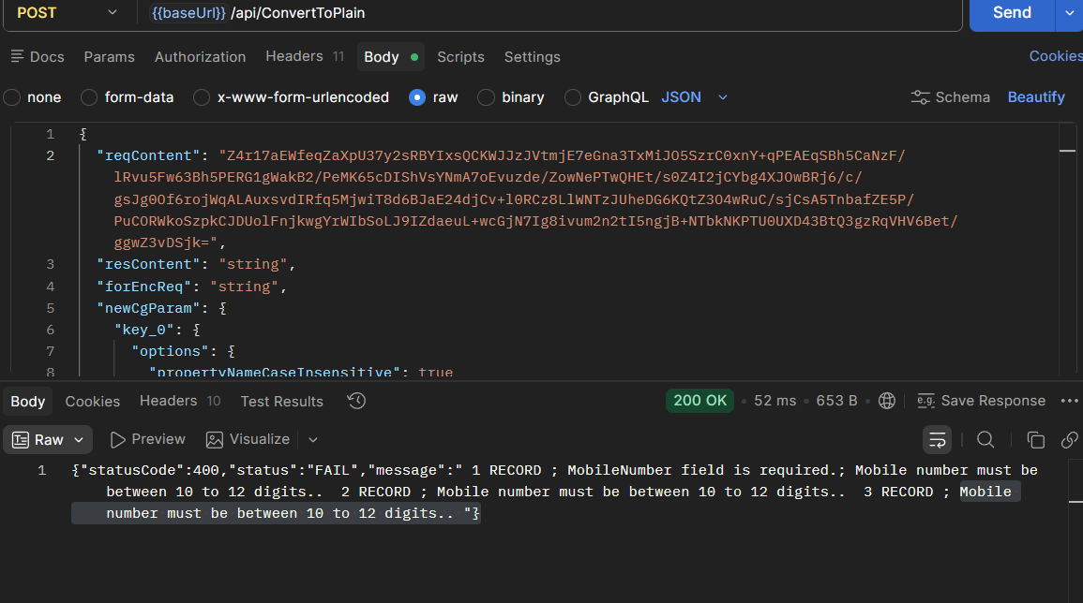

Chief Promoter Gender | Male/Female/Other | Text (List) | Mandatory

"{\"schemecode\":\"CAE\",\"borrowers\":[{\"MLIName\":\"Bank102\",\"MLIID\":\"60180\",\"ExporterName\":\"Somesh01\",\"ExporterITPAN\":\"AQPPL1101A\",\"IECCode\":\"A242342342\",\"UdyamRegistrationNumber\":\"UDYAM-UP-12-1111003\",\"UIN\":\"A1\",\"Email\":\"\",\"MobileNumber\":\"912345678565\",\"Gender\":\"\",\"Religion\":\"Hindu\",\"CasteCategory\":\"General\",\"ConstitutionType\":\"Partnership\",\"EntityType\":\"Micro\",\"AddressLine\":\"123 Industrial Area\",\"City\":\"Ghaziabad\",\"District\":\"519\",\"State\":\"27\",\"PinCode\":\"201001\",\"InterventionType\":\"OIE\",\"CustomerId\":\"CUST12345\",\"LoanAccountNumber\":\"LN000123456\",\"SanctionAmount\":\"5000000\",\"SanctionDate\":\"26-05-2026\",\"IndustryNature\":\"Textiles\",\"IndustrySector\":\"Cotton Textiles\",\"TenureOfLoan\":\"900\",\"IntrestRate\":\"8.5\",\"GuaranteeAmount\":\"4000000\"},{\"MLIName\":\"Bank102\",\"MLIID\":\"60180\",\"ExporterName\":\"somesh02\",\"ExporterITPAN\":\"AQPPL1102A\",\"IECCode\":\"987654321A\",\"UdyamRegistrationNumber\":\"UDYAM-DL-11-1111000\",\"UIN\":\"B2\",\"Email\":\"cmcredit@wbgb.bank.in\",\"MobileNumber\":\"912345678565\",\"Gender\":\"F\",\"Religion\":\"Hindu\",\"CasteCategory\":\"OBC\",\"ConstitutionType\":\"Company\",\"EntityType\":\"Small\",\"AddressLine\":\"45 Export Zone\",\"City\":\"Delhi\",\"District\":\"519\",\"State\":\"27\",\"PinCode\":\"110001\",\"InterventionType\":\"OIE\",\"CustomerId\":\"CUST54321\",\"LoanAccountNumber\":\"LN000654321\",\"SanctionAmount\":\"2000\",\"SanctionDate\":\"15-04-2026\",\"IndustryNature\":\"Textiles\",\"IndustrySector\":\"Cotton Textiles\",\"TenureOfLoan\":\"60\",\"IntrestRate\":\"9.2\",\"GuaranteeAmount\":\"150\"},{\"MLIName\":\"Bank102\",\"MLIID\":\"60180\",\"ExporterName\":\"somesh 03\",\"ExporterITPAN\":\"AQPPL1103A\",\"IECCode\":\"112A233445\",\"UdyamRegistrationNumber\":\"UDYAM-MH-11-1111000\",\"UIN\":\"C1\",\"Email\":\"contacte@com.com\",\"MobileNumber\":\"912345678565\",\"Gender\":\"A\",\"Religion\":\"Muslim\",\"CasteCategory\":\"General\",\"ConstitutionType\":\"LLP\",\"EntityType\":\"Medium\",\"AddressLine\":\"789 Tech Park\",\"City\":\"Mumbai\",\"District\":\"519\",\"State\":\"27\",\"PinCode\":\"400001\",\"InterventionType\":\"OIE\",\"CustomerId\":\"CUST67890\",\"LoanAccountNumber\":\"LN000789123\",\"SanctionAmount\":\"450\",\"SanctionDate\":\"10-06-2026\",\"IndustryNature\":\"Textiles\",\"IndustrySector\":\"Cotton Textiles\",\"TenureOfLoan\":\"36\",\"IntrestRate\":\"10.0\",\"GuaranteeAmount\":\"150\"}]}"

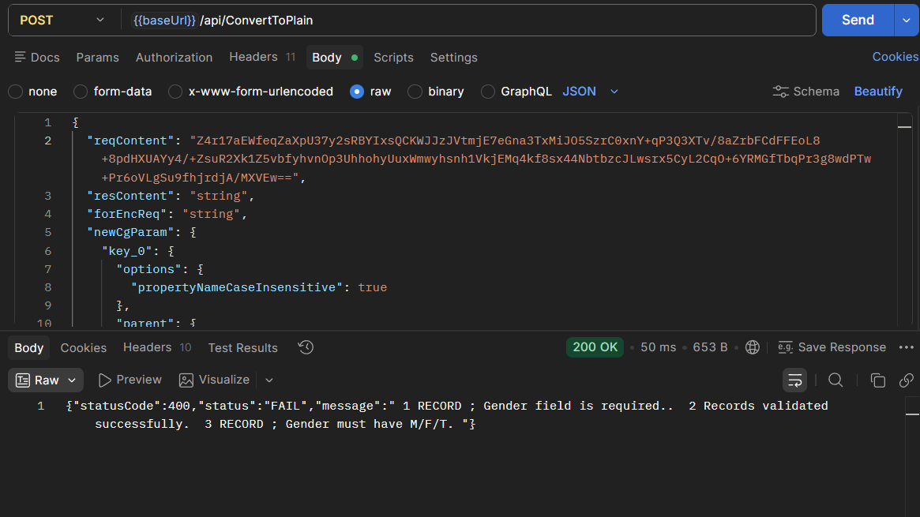

Religion of Chief Promoter | Religion of chief promoter | Text (List) | Mandatory
Caste Category of Chief Promoter | SC/ST/OBC/General/Other | Text (List) | Mandatory

Constitution Type | Proprietorship/Partnership/Company/LLP/ Other | Text (List) | Mandatory

Present – Address Line | Borrowers present address of residence – Room no. & Building | Alphnumeric | Mandatory
Present – City/Town/Village | Borrowers present address of residence – City/Town/Village | Alphnumeric | Mandatory

Present – District | Borrowers present address of residence – District | List – Available in surge Code | Mandatory
Present – State | Borrowers present address of residence – State | List – Available in surge Code | Mandatory

"{\"schemecode\":\"CAE\",\"borrowers\":[{\"MLIName\":\"Bank102\",\"MLIID\":\"60180\",\"ExporterName\":\"Somesh01\",\"ExporterITPAN\":\"AQPPL1101A\",\"IECCode\":\"A242342342\",\"UdyamRegistrationNumber\":\"UDYAM-UP-12-1111113\",\"UIN\":\"A4\",\"Email\":\"\",\"MobileNumber\":\"912345678565\",\"Gender\":\"T\",\"Religion\":\"Hindu\",\"CasteCategory\":\"OBC\",\"ConstitutionType\":\"Company\",\"EntityType\":\"Micro\",\"AddressLine\":\"123 Industrial Area\",\"City\":\"Ghaziabad\",\"District\":\"519\",\"State\":\"\",\"PinCode\":\"201001\",\"InterventionType\":\"OIE\",\"CustomerId\":\"CUST12345\",\"LoanAccountNumber\":\"LN000123456\",\"SanctionAmount\":\"5000000\",\"SanctionDate\":\"26-05-2026\",\"IndustryNature\":\"Textiles\",\"IndustrySector\":\"Cotton Textiles\",\"TenureOfLoan\":\"900\",\"IntrestRate\":\"8.5\",\"GuaranteeAmount\":\"4000000\"},{\"MLIName\":\"Bank102\",\"MLIID\":\"60180\",\"ExporterName\":\"somesh02\",\"ExporterITPAN\":\"AQPPL1102A\",\"IECCode\":\"987654321A\",\"UdyamRegistrationNumber\":\"UDYAM-DL-11-1111110\",\"UIN\":\"B4\",\"Email\":\"cmcredit@wbgb.bank.in\",\"MobileNumber\":\"912345678565\",\"Gender\":\"F\",\"Religion\":\"Hindu\",\"CasteCategory\":\"OBC\",\"ConstitutionType\":\"Company\",\"EntityType\":\"Micro\",\"AddressLine\":\"45 Export Zone\",\"City\":\"Delhi\",\"District\":\"519\",\"State\":\"35\",\"PinCode\":\"110001\",\"InterventionType\":\"OIE\",\"CustomerId\":\"CUST54321\",\"LoanAccountNumber\":\"LN000654321\",\"SanctionAmount\":\"2000\",\"SanctionDate\":\"15-04-2026\",\"IndustryNature\":\"Textiles\",\"IndustrySector\":\"Cotton Textiles\",\"TenureOfLoan\":\"60\",\"IntrestRate\":\"9.2\",\"GuaranteeAmount\":\"150\"},{\"MLIName\":\"Bank102\",\"MLIID\":\"60180\",\"ExporterName\":\"somesh 03\",\"ExporterITPAN\":\"AQPPL1103A\",\"IECCode\":\"112A233445\",\"UdyamRegistrationNumber\":\"UDYAM-MH-11-1111110\",\"UIN\":\"C4\",\"Email\":\"contacte@com.com\",\"MobileNumber\":\"912345678565\",\"Gender\":\"M\",\"Religion\":\"Muslim\",\"CasteCategory\":\"General\",\"ConstitutionType\":\"LLP\",\"EntityType\":\"Medium\",\"AddressLine\":\"789 Tech Park\",\"City\":\"Mumbai\",\"District\":\"\",\"State\":\"35\",\"PinCode\":\"400001\",\"InterventionType\":\"OIE\",\"CustomerId\":\"CUST67890\",\"LoanAccountNumber\":\"LN000789123\",\"SanctionAmount\":\"450\",\"SanctionDate\":\"10-06-2026\",\"IndustryNature\":\"Textiles\",\"IndustrySector\":\"Cotton Textiles\",\"TenureOfLoan\":\"36\",\"IntrestRate\":\"10.0\",\"GuaranteeAmount\":\"150\"}]}"

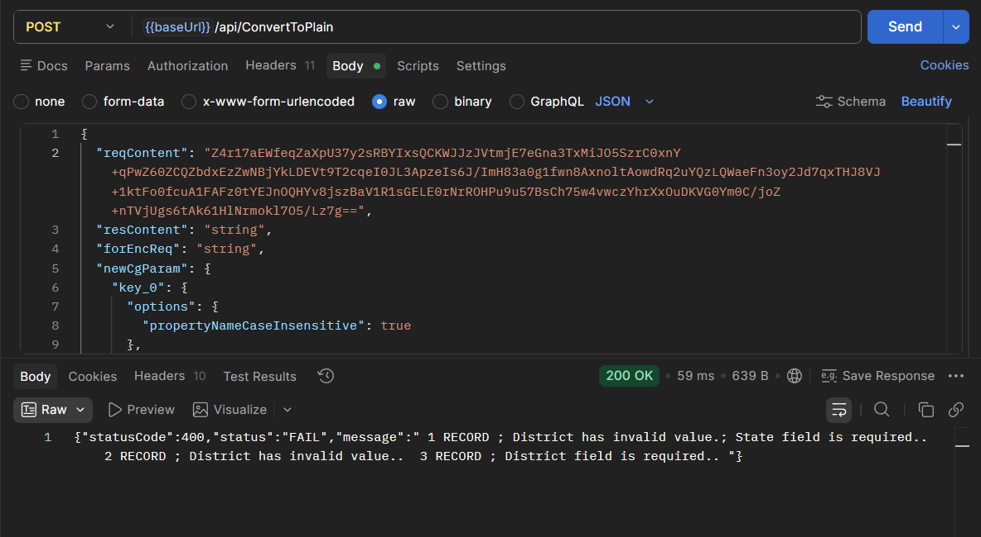

"{\"schemecode\":\"CAE\",\"borrowers\":[{\"MLIName\":\"Bank102\",\"MLIID\":\"60180\",\"ExporterName\":\"Somesh01\",\"ExporterITPAN\":\"AQPPL1101A\",\"IECCode\":\"A242342342\",\"UdyamRegistrationNumber\":\"UDYAM-UP-12-1111113\",\"UIN\":\"A4\",\"Email\":\"\",\"MobileNumber\":\"912345678565\",\"Gender\":\"T\",\"Religion\":\"Hindu\",\"CasteCategory\":\"OBC\",\"ConstitutionType\":\"Company\",\"EntityType\":\"Micro\",\"AddressLine\":\"123 Industrial Area\",\"City\":\"Ghaziabad\",\"District\":\"519\",\"State\":\"27\",\"PinCode\":\"201001\",\"InterventionType\":\"OIE\",\"CustomerId\":\"CUST12345\",\"LoanAccountNumber\":\"LN000123456\",\"SanctionAmount\":\"5000000\",\"SanctionDate\":\"26-05-2026\",\"IndustryNature\":\"Textiles\",\"IndustrySector\":\"Cotton Textiles\",\"TenureOfLoan\":\"900\",\"IntrestRate\":\"8.5\",\"GuaranteeAmount\":\"4000000\"},{\"MLIName\":\"Bank102\",\"MLIID\":\"60180\",\"ExporterName\":\"somesh02\",\"ExporterITPAN\":\"AQPPL1102A\",\"IECCode\":\"987654321A\",\"UdyamRegistrationNumber\":\"UDYAM-DL-11-1111110\",\"UIN\":\"B4\",\"Email\":\"cmcredit@wbgb.bank.in\",\"MobileNumber\":\"912345678565\",\"Gender\":\"F\",\"Religion\":\"Hindu\",\"CasteCategory\":\"OBC\",\"ConstitutionType\":\"Company\",\"EntityType\":\"Micro\",\"AddressLine\":\"45 Export Zone\",\"City\":\"Delhi\",\"District\":\"639\",\"State\":\"35\",\"PinCode\":\"110001\",\"InterventionType\":\"OIE\",\"CustomerId\":\"CUST54321\",\"LoanAccountNumber\":\"LN000654321\",\"SanctionAmount\":\"2000\",\"SanctionDate\":\"15-04-2026\",\"IndustryNature\":\"Textiles\",\"IndustrySector\":\"Cotton Textiles\",\"TenureOfLoan\":\"60\",\"IntrestRate\":\"9.2\",\"GuaranteeAmount\":\"150\"},{\"MLIName\":\"Bank102\",\"MLIID\":\"60180\",\"ExporterName\":\"somesh 03\",\"ExporterITPAN\":\"AQPPL1103A\",\"IECCode\":\"112A233445\",\"UdyamRegistrationNumber\":\"UDYAM-MH-11-1111110\",\"UIN\":\"C4\",\"Email\":\"contacte@com.com\",\"MobileNumber\":\"912345678565\",\"Gender\":\"M\",\"Religion\":\"Muslim\",\"CasteCategory\":\"General\",\"ConstitutionType\":\"LLP\",\"EntityType\":\"Medium\",\"AddressLine\":\"789 Tech Park\",\"City\":\"Mumbai\",\"District\":\"638\",\"State\":\"35\",\"PinCode\":\"400001\",\"InterventionType\":\"OIE\",\"CustomerId\":\"CUST67890\",\"LoanAccountNumber\":\"LN000789123\",\"SanctionAmount\":\"450\",\"SanctionDate\":\"10-06-2026\",\"IndustryNature\":\"Textiles\",\"IndustrySector\":\"Cotton Textiles\",\"TenureOfLoan\":\"36\",\"IntrestRate\":\"10.0\",\"GuaranteeAmount\":\"150\"}]}"

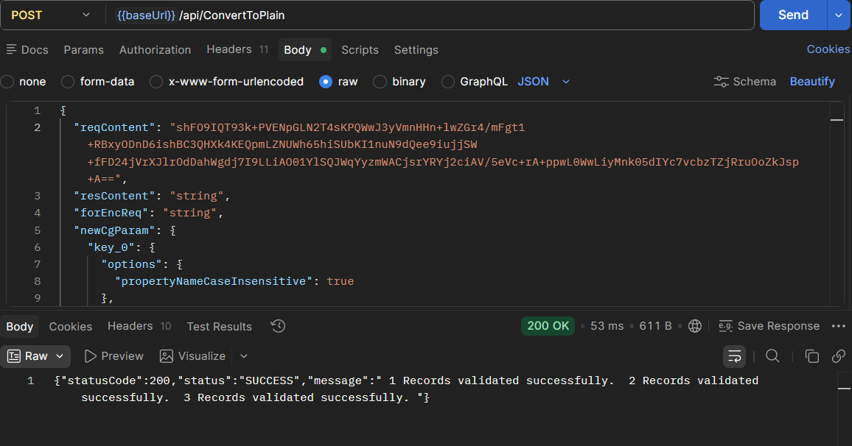

Present – Pin Code | Borrowers present address of residence – Pin Code | Number (Upto 6 digits) | Mandatory

"{\"schemecode\":\"CAE\",\"borrowers\":[{\"MLIName\":\"Bank102\",\"MLIID\":\"60180\",\"ExporterName\":\"Somesh01\",\"ExporterITPAN\":\"AQPPL1101A\",\"IECCode\":\"A242342342\",\"UdyamRegistrationNumber\":\"UDYAM-UP-12-1111111\",\"UIN\":\"A5\",\"Email\":\"\",\"MobileNumber\":\"912345678565\",\"Gender\":\"T\",\"Religion\":\"Hindu\",\"CasteCategory\":\"OBC\",\"ConstitutionType\":\"Company\",\"EntityType\":\"Micro\",\"AddressLine\":\"123 Industrial Area\",\"City\":\"Ghaziabad\",\"District\":\"519\",\"State\":\"27\",\"PinCode\":\"\",\"InterventionType\":\"OIE\",\"CustomerId\":\"CUST12345\",\"LoanAccountNumber\":\"LN000123456\",\"SanctionAmount\":\"5000000\",\"SanctionDate\":\"26-05-2026\",\"IndustryNature\":\"Textiles\",\"IndustrySector\":\"Cotton Textiles\",\"TenureOfLoan\":\"900\",\"IntrestRate\":\"8.5\",\"GuaranteeAmount\":\"4000000\"},{\"MLIName\":\"Bank102\",\"MLIID\":\"60180\",\"ExporterName\":\"somesh02\",\"ExporterITPAN\":\"AQPPL1102A\",\"IECCode\":\"987654321A\",\"UdyamRegistrationNumber\":\"UDYAM-DL-11-1111111\",\"UIN\":\"B5\",\"Email\":\"cmcredit@wbgb.bank.in\",\"MobileNumber\":\"912345678565\",\"Gender\":\"F\",\"Religion\":\"Hindu\",\"CasteCategory\":\"OBC\",\"ConstitutionType\":\"Company\",\"EntityType\":\"Micro\",\"AddressLine\":\"45 Export Zone\",\"City\":\"Delhi\",\"District\":\"639\",\"State\":\"35\",\"PinCode\":\"1100016\",\"InterventionType\":\"OIE\",\"CustomerId\":\"CUST54321\",\"LoanAccountNumber\":\"LN000654321\",\"SanctionAmount\":\"2000\",\"SanctionDate\":\"15-04-2026\",\"IndustryNature\":\"Textiles\",\"IndustrySector\":\"Cotton Textiles\",\"TenureOfLoan\":\"60\",\"IntrestRate\":\"9.2\",\"GuaranteeAmount\":\"150\"},{\"MLIName\":\"Bank102\",\"MLIID\":\"60180\",\"ExporterName\":\"somesh 03\",\"ExporterITPAN\":\"AQPPL1103A\",\"IECCode\":\"112A233445\",\"UdyamRegistrationNumber\":\"UDYAM-MH-11-1111111\",\"UIN\":\"C5\",\"Email\":\"contacte@com.com\",\"MobileNumber\":\"912345678565\",\"Gender\":\"M\",\"Religion\":\"Muslim\",\"CasteCategory\":\"General\",\"ConstitutionType\":\"LLP\",\"EntityType\":\"Medium\",\"AddressLine\":\"789 Tech Park\",\"City\":\"Mumbai\",\"District\":\"638\",\"State\":\"35\",\"PinCode\":\"40000\",\"InterventionType\":\"OIE\",\"CustomerId\":\"CUST67890\",\"LoanAccountNumber\":\"LN000789123\",\"SanctionAmount\":\"450\",\"SanctionDate\":\"10-06-2026\",\"IndustryNature\":\"Textiles\",\"IndustrySector\":\"Cotton Textiles\",\"TenureOfLoan\":\"36\",\"IntrestRate\":\"10.0\",\"GuaranteeAmount\":\"150\"}]}"

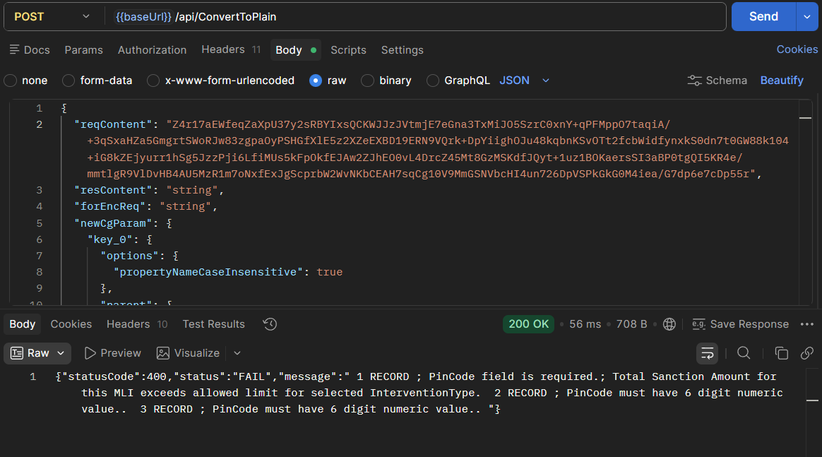

Intervention Type | Direct E-Commerce Credit Facility /Overseas Inventory E-Commerce Credit Facility | List | Mandatory  (CG FEE will decided based on this)

Record 1 -
DEC - 10L 1000000

OCC - 1cr 10000000

"{\"schemecode\":\"CAE\",\"borrowers\":[{\"MLIName\":\"Bank102\",\"MLIID\":\"60180\",\"ExporterName\":\"Somesh01\",\"ExporterITPAN\":\"AQPPL1110A\",\"IECCode\":\"A242342342\",\"UdyamRegistrationNumber\":\"UDYAM-UP-10-1111100\",\"UIN\":\"A1\",\"Email\":\"\",\"MobileNumber\":\"912345678565\",\"Gender\":\"T\",\"Religion\":\"1\",\"CasteCategory\":\"1\",\"ConstitutionType\":\"1\",\"EntityType\":\"1\",\"AddressLine\":\"123 Industrial Area\",\"City\":\"Ghaziabad\",\"District\":\"519\",\"State\":\"27\",\"PinCode\":\"123451\",\"InterventionType\":\"DEC\",\"CustomerId\":\"CUSTA09\",\"LoanAccountNumber\":\"loan01\",\"SanctionAmount\":\"1000000\",\"SanctionDate\":\"04-06-2026\",\"IndustryNature\":\"1\",\"IndustrySector\":\"1\",\"TenureOfLoan\":\"900\",\"IntrestRate\":\"8.5\",\"GuaranteeAmount\":\"10000\"},{\"MLIName\":\"Bank102\",\"MLIID\":\"60180\",\"ExporterName\":\"somesh02\",\"ExporterITPAN\":\"AQPPL1110B\",\"IECCode\":\"987654321A\",\"UdyamRegistrationNumber\":\"UDYAM-DL-11-1111100\",\"UIN\":\"B1\",\"Email\":\"cmcredit@wbgb.bank.in\",\"MobileNumber\":\"912345678565\",\"Gender\":\"F\",\"Religion\":\"1\",\"CasteCategory\":\"1\",\"ConstitutionType\":\"1\",\"EntityType\":\"1\",\"AddressLine\":\"45 Export Zone\",\"City\":\"Delhi\",\"District\":\"639\",\"State\":\"35\",\"PinCode\":\"110001\",\"InterventionType\":\"OIE\",\"CustomerId\":\"CUSTB09\",\"LoanAccountNumber\":\"Loan01\",\"SanctionAmount\":\"10000000\",\"SanctionDate\":\"03-06-2026\",\"IndustryNature\":\"1\",\"IndustrySector\":\"1\",\"TenureOfLoan\":\"60\",\"IntrestRate\":\"9.2\",\"GuaranteeAmount\":\"10000\"}]}"

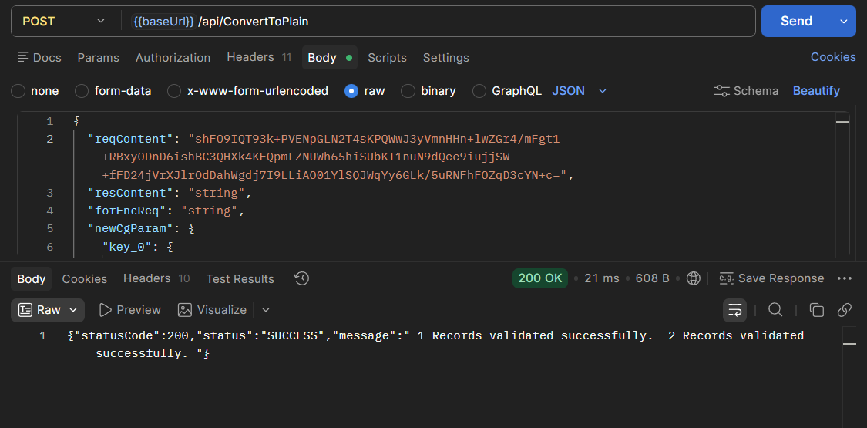

Record 2
DEC - 10L+10L=20CR 1000000 + 1000000

OCC - 1cr+1Cr=2Cr 10000000 + 10000000

"{\"schemecode\":\"CAE\",\"borrowers\":[{\"MLIName\":\"Bank102\",\"MLIID\":\"60180\",\"ExporterName\":\"Somesh01\",\"ExporterITPAN\":\"AQPPL1111A\",\"IECCode\":\"A242342342\",\"UdyamRegistrationNumber\":\"UDYAM-UP-10-1111110\",\"UIN\":\"A2\",\"Email\":\"\",\"MobileNumber\":\"912345678565\",\"Gender\":\"T\",\"Religion\":\"1\",\"CasteCategory\":\"1\",\"ConstitutionType\":\"1\",\"EntityType\":\"1\",\"AddressLine\":\"123 Industrial Area\",\"City\":\"Ghaziabad\",\"District\":\"519\",\"State\":\"27\",\"PinCode\":\"123451\",\"InterventionType\":\"DEC\",\"CustomerId\":\"CUSTA2\",\"LoanAccountNumber\":\"loan01\",\"SanctionAmount\":\"1000000\",\"SanctionDate\":\"04-06-2026\",\"IndustryNature\":\"1\",\"IndustrySector\":\"1\",\"TenureOfLoan\":\"900\",\"IntrestRate\":\"8.5\",\"GuaranteeAmount\":\"10000\"},{\"MLIName\":\"Bank102\",\"MLIID\":\"60180\",\"ExporterName\":\"somesh02\",\"ExporterITPAN\":\"AQPPL1111B\",\"IECCode\":\"987654321A\",\"UdyamRegistrationNumber\":\"UDYAM-DL-11-1111110\",\"UIN\":\"B2\",\"Email\":\"cmcredit@wbgb.bank.in\",\"MobileNumber\":\"912345678565\",\"Gender\":\"F\",\"Religion\":\"1\",\"CasteCategory\":\"1\",\"ConstitutionType\":\"1\",\"EntityType\":\"1\",\"AddressLine\":\"45 Export Zone\",\"City\":\"Delhi\",\"District\":\"639\",\"State\":\"35\",\"PinCode\":\"110001\",\"InterventionType\":\"OIE\",\"CustomerId\":\"CUSTB2\",\"LoanAccountNumber\":\"Loan01\",\"SanctionAmount\":\"10000000\",\"SanctionDate\":\"03-06-2026\",\"IndustryNature\":\"1\",\"IndustrySector\":\"1\",\"TenureOfLoan\":\"60\",\"IntrestRate\":\"9.2\",\"GuaranteeAmount\":\"10000\"}]}"

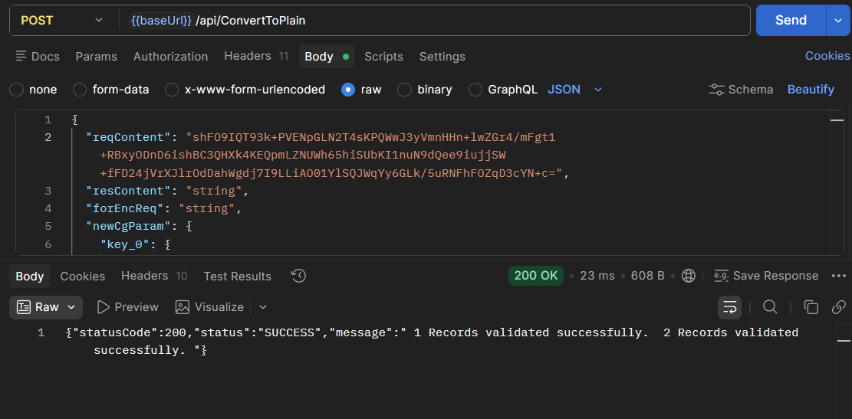

Record 3
DEC 1000000 + 1000000 + 1000000
OIE 10000000 + 10000000 + 10000000

"{\"schemecode\":\"CAE\",\"borrowers\":[{\"MLIName\":\"Bank102\",\"MLIID\":\"60180\",\"ExporterName\":\"Somesh01\",\"ExporterITPAN\":\"AQPPL0111A\",\"IECCode\":\"A242342342\",\"UdyamRegistrationNumber\":\"UDYAM-UP-10-1111111\",\"UIN\":\"A3\",\"Email\":\"\",\"MobileNumber\":\"912345678565\",\"Gender\":\"T\",\"Religion\":\"1\",\"CasteCategory\":\"1\",\"ConstitutionType\":\"1\",\"EntityType\":\"1\",\"AddressLine\":\"123 Industrial Area\",\"City\":\"Ghaziabad\",\"District\":\"519\",\"State\":\"27\",\"PinCode\":\"123451\",\"InterventionType\":\"DEC\",\"CustomerId\":\"CUSTA3\",\"LoanAccountNumber\":\"loan01\",\"SanctionAmount\":\"1000000\",\"SanctionDate\":\"04-06-2026\",\"IndustryNature\":\"1\",\"IndustrySector\":\"1\",\"TenureOfLoan\":\"90\",\"IntrestRate\":\"8.5\",\"GuaranteeAmount\":\"10000\"},{\"MLIName\":\"Bank102\",\"MLIID\":\"60180\",\"ExporterName\":\"somesh02\",\"ExporterITPAN\":\"AQPPL0111B\",\"IECCode\":\"987654321A\",\"UdyamRegistrationNumber\":\"UDYAM-DL-11-1111111\",\"UIN\":\"B3\",\"Email\":\"cmcredit@wbgb.bank.in\",\"MobileNumber\":\"912345678565\",\"Gender\":\"F\",\"Religion\":\"1\",\"CasteCategory\":\"1\",\"ConstitutionType\":\"1\",\"EntityType\":\"1\",\"AddressLine\":\"45 Export Zone\",\"City\":\"Delhi\",\"District\":\"639\",\"State\":\"35\",\"PinCode\":\"110001\",\"InterventionType\":\"OIE\",\"CustomerId\":\"CUSTB3\",\"LoanAccountNumber\":\"Loan01\",\"SanctionAmount\":\"10000000\",\"SanctionDate\":\"03-06-2026\",\"IndustryNature\":\"1\",\"IndustrySector\":\"1\",\"TenureOfLoan\":\"10\",\"IntrestRate\":\"9.2\",\"GuaranteeAmount\":\"10000\"}]}"

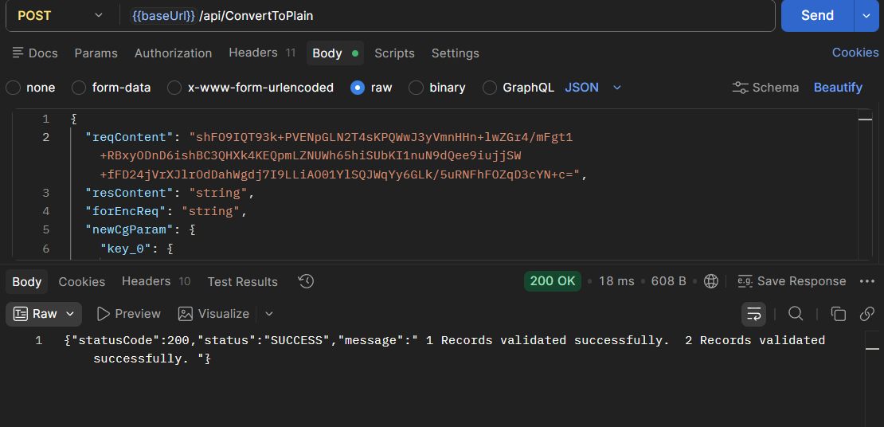

Record 4
DEC 1000000 + 1000000 + 1000000 + 1000000
OIE 10000000 + 10000000 + 10000000 + 10000000

"{\"schemecode\":\"CAE\",\"borrowers\":[{\"MLIName\":\"Bank102\",\"MLIID\":\"60180\",\"ExporterName\":\"Somesh01\",\"ExporterITPAN\":\"AQPPL0011A\",\"IECCode\":\"A242342342\",\"UdyamRegistrationNumber\":\"UDYAM-UP-10-0111111\",\"UIN\":\"A4\",\"Email\":\"\",\"MobileNumber\":\"912345678565\",\"Gender\":\"T\",\"Religion\":\"1\",\"CasteCategory\":\"1\",\"ConstitutionType\":\"1\",\"EntityType\":\"1\",\"AddressLine\":\"123 Industrial Area\",\"City\":\"Ghaziabad\",\"District\":\"519\",\"State\":\"27\",\"PinCode\":\"123451\",\"InterventionType\":\"DEC\",\"CustomerId\":\"CUSTA4\",\"LoanAccountNumber\":\"loan01\",\"SanctionAmount\":\"1000000\",\"SanctionDate\":\"04-06-2026\",\"IndustryNature\":\"1\",\"IndustrySector\":\"1\",\"TenureOfLoan\":\"90\",\"IntrestRate\":\"8.5\",\"GuaranteeAmount\":\"10000\"},{\"MLIName\":\"Bank102\",\"MLIID\":\"60180\",\"ExporterName\":\"somesh02\",\"ExporterITPAN\":\"AQPPL0011B\",\"IECCode\":\"987654321A\",\"UdyamRegistrationNumber\":\"UDYAM-DL-11-0111111\",\"UIN\":\"B4\",\"Email\":\"cmcredit@wbgb.bank.in\",\"MobileNumber\":\"912345678565\",\"Gender\":\"F\",\"Religion\":\"1\",\"CasteCategory\":\"1\",\"ConstitutionType\":\"1\",\"EntityType\":\"1\",\"AddressLine\":\"45 Export Zone\",\"City\":\"Delhi\",\"District\":\"639\",\"State\":\"35\",\"PinCode\":\"110001\",\"InterventionType\":\"OIE\",\"CustomerId\":\"CUSTB4\",\"LoanAccountNumber\":\"Loan01\",\"SanctionAmount\":\"10000000\",\"SanctionDate\":\"03-06-2026\",\"IndustryNature\":\"1\",\"IndustrySector\":\"1\",\"TenureOfLoan\":\"10\",\"IntrestRate\":\"9.2\",\"GuaranteeAmount\":\"10000\"}]}"

Record 5
DEC 1000000 + 1000000 + 1000000 + 1000000 + 100000.12
OIE 10000000 + 10000000 + 10000000 + 10000000 + 1000000.19

"{\"schemecode\":\"CAE\",\"borrowers\":[{\"MLIName\":\"Bank102\",\"MLIID\":\"60180\",\"ExporterName\":\"Somesh01\",\"ExporterITPAN\":\"AQPPL0001A\",\"IECCode\":\"A242342342\",\"UdyamRegistrationNumber\":\"UDYAM-UP-10-0011111\",\"UIN\":\"A5\",\"Email\":\"\",\"MobileNumber\":\"912345678565\",\"Gender\":\"T\",\"Religion\":\"1\",\"CasteCategory\":\"1\",\"ConstitutionType\":\"1\",\"EntityType\":\"1\",\"AddressLine\":\"123 Industrial Area\",\"City\":\"Ghaziabad\",\"District\":\"519\",\"State\":\"27\",\"PinCode\":\"123451\",\"InterventionType\":\"DEC\",\"CustomerId\":\"CUSTA5\",\"LoanAccountNumber\":\"loan01\",\"SanctionAmount\":\"100000.12\",\"SanctionDate\":\"04-06-2026\",\"IndustryNature\":\"1\",\"IndustrySector\":\"1\",\"TenureOfLoan\":\"90\",\"IntrestRate\":\"8.5\",\"GuaranteeAmount\":\"10000.01\"},{\"MLIName\":\"Bank102\",\"MLIID\":\"60180\",\"ExporterName\":\"somesh02\",\"ExporterITPAN\":\"AQPPL0001B\",\"IECCode\":\"987654321A\",\"UdyamRegistrationNumber\":\"UDYAM-DL-11-0011111\",\"UIN\":\"B5\",\"Email\":\"cmcredit@wbgb.bank.in\",\"MobileNumber\":\"912345678565\",\"Gender\":\"F\",\"Religion\":\"1\",\"CasteCategory\":\"1\",\"ConstitutionType\":\"1\",\"EntityType\":\"1\",\"AddressLine\":\"45 Export Zone\",\"City\":\"Delhi\",\"District\":\"639\",\"State\":\"35\",\"PinCode\":\"110001\",\"InterventionType\":\"OIE\",\"CustomerId\":\"CUSTB5\",\"LoanAccountNumber\":\"Loan01\",\"SanctionAmount\":\"1000000.19\",\"SanctionDate\":\"03-06-2026\",\"IndustryNature\":\"1\",\"IndustrySector\":\"1\",\"TenureOfLoan\":\"10\",\"IntrestRate\":\"9.2\",\"GuaranteeAmount\":\"10000.09\"}]}"

Record 6
DEC 1000000 + 1000000 + 1000000 + 1000000 + 100000.12 + 899999.89(failed)
OIE 10000000 + 10000000 + 10000000 + 10000000 + 1000000.12 + 8999999.89 (failed)

"{\"schemecode\":\"CAE\",\"borrowers\":[{\"MLIName\":\"Bank102\",\"MLIID\":\"60180\",\"ExporterName\":\"Somesh01\",\"ExporterITPAN\":\"AQPPL0000A\",\"IECCode\":\"A242342342\",\"UdyamRegistrationNumber\":\"UDYAM-UP-10-0001111\",\"UIN\":\"A6\",\"Email\":\"\",\"MobileNumber\":\"912345678565\",\"Gender\":\"T\",\"Religion\":\"1\",\"CasteCategory\":\"1\",\"ConstitutionType\":\"1\",\"EntityType\":\"1\",\"AddressLine\":\"123 Industrial Area\",\"City\":\"Ghaziabad\",\"District\":\"519\",\"State\":\"27\",\"PinCode\":\"123451\",\"InterventionType\":\"DEC\",\"CustomerId\":\"CUSTA6\",\"LoanAccountNumber\":\"loan01\",\"SanctionAmount\":\"899999.89\",\"SanctionDate\":\"04-06-2026\",\"IndustryNature\":\"1\",\"IndustrySector\":\"1\",\"TenureOfLoan\":\"90\",\"IntrestRate\":\"8.5\",\"GuaranteeAmount\":\"10000.01\"},{\"MLIName\":\"Bank102\",\"MLIID\":\"60180\",\"ExporterName\":\"somesh02\",\"ExporterITPAN\":\"AQPPL0000B\",\"IECCode\":\"987654321A\",\"UdyamRegistrationNumber\":\"UDYAM-DL-11-0001111\",\"UIN\":\"B6\",\"Email\":\"cmcredit@wbgb.bank.in\",\"MobileNumber\":\"912345678565\",\"Gender\":\"F\",\"Religion\":\"1\",\"CasteCategory\":\"1\",\"ConstitutionType\":\"1\",\"EntityType\":\"1\",\"AddressLine\":\"45 Export Zone\",\"City\":\"Delhi\",\"District\":\"639\",\"State\":\"35\",\"PinCode\":\"110001\",\"InterventionType\":\"OIE\",\"CustomerId\":\"CUSTB6\",\"LoanAccountNumber\":\"Loan01\",\"SanctionAmount\":\"8999999.89\",\"SanctionDate\":\"03-06-2026\",\"IndustryNature\":\"1\",\"IndustrySector\":\"1\",\"TenureOfLoan\":\"10\",\"IntrestRate\":\"9.2\",\"GuaranteeAmount\":\"10000.09\"}]}"

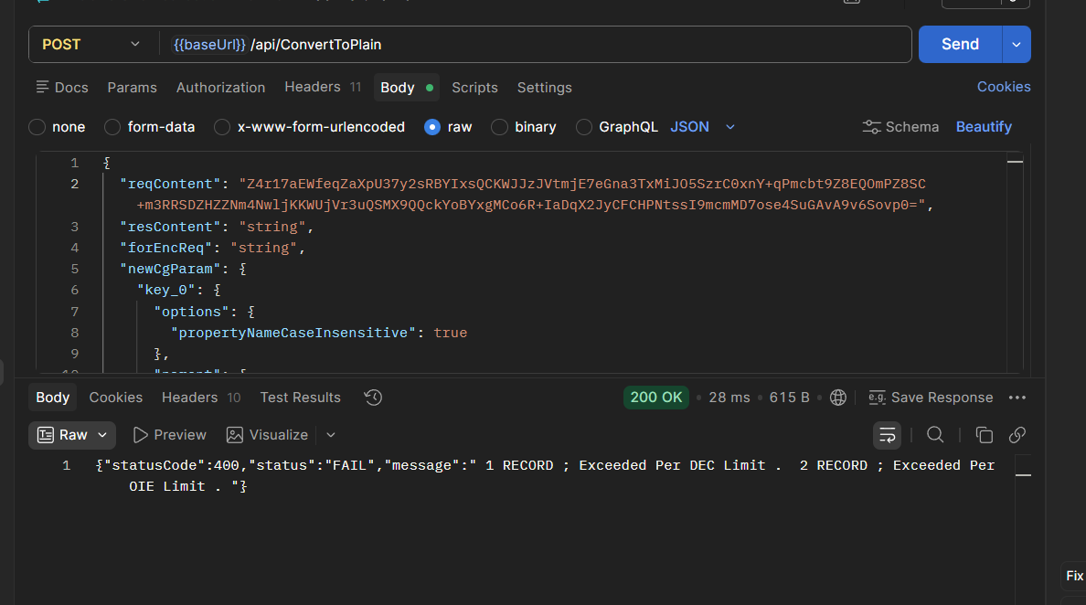

Record 7
DEC 1000000 + 1000000 + 1000000 + 1000000 + 100000.12 + 899999.88
OIE 10000000 + 10000000 + 10000000 + 10000000 + 1000000.12 +8999999.81

"{\"schemecode\":\"CAE\",\"borrowers\":[{\"MLIName\":\"Bank102\",\"MLIID\":\"60180\",\"ExporterName\":\"Somesh01\",\"ExporterITPAN\":\"AQPPL0000A\",\"IECCode\":\"A242342342\",\"UdyamRegistrationNumber\":\"UDYAM-UP-10-0001111\",\"UIN\":\"A6\",\"Email\":\"\",\"MobileNumber\":\"912345678565\",\"Gender\":\"T\",\"Religion\":\"1\",\"CasteCategory\":\"1\",\"ConstitutionType\":\"1\",\"EntityType\":\"1\",\"AddressLine\":\"123 Industrial Area\",\"City\":\"Ghaziabad\",\"District\":\"519\",\"State\":\"27\",\"PinCode\":\"123451\",\"InterventionType\":\"DEC\",\"CustomerId\":\"CUSTA6\",\"LoanAccountNumber\":\"loan01\",\"SanctionAmount\":\"899999.88\",\"SanctionDate\":\"04-06-2026\",\"IndustryNature\":\"1\",\"IndustrySector\":\"1\",\"TenureOfLoan\":\"3\",\"IntrestRate\":\"8.5\",\"GuaranteeAmount\":\"10000.01\"},{\"MLIName\":\"Bank102\",\"MLIID\":\"60180\",\"ExporterName\":\"somesh02\",\"ExporterITPAN\":\"AQPPL0000B\",\"IECCode\":\"987654321A\",\"UdyamRegistrationNumber\":\"UDYAM-DL-11-0001111\",\"UIN\":\"B6\",\"Email\":\"cmcredit@wbgb.bank.in\",\"MobileNumber\":\"912345678565\",\"Gender\":\"F\",\"Religion\":\"1\",\"CasteCategory\":\"1\",\"ConstitutionType\":\"1\",\"EntityType\":\"1\",\"AddressLine\":\"45 Export Zone\",\"City\":\"Delhi\",\"District\":\"639\",\"State\":\"35\",\"PinCode\":\"110001\",\"InterventionType\":\"OIE\",\"CustomerId\":\"CUSTB6\",\"LoanAccountNumber\":\"Loan01\",\"SanctionAmount\":\"8999999.81\",\"SanctionDate\":\"03-06-2026\",\"IndustryNature\":\"1\",\"IndustrySector\":\"1\",\"TenureOfLoan\":\"8\",\"IntrestRate\":\"9.2\",\"GuaranteeAmount\":\"10000.09\"}]}"

Customer ID | Unique Customer Id issued by the lending institution for the borrower | Alphanumeric | Mandatory

"{\"schemecode\":\"CAE\",\"borrowers\":[{\"MLIName\":\"Bank102\",\"MLIID\":\"60180\",\"ExporterName\":\"Somesh01\",\"ExporterITPAN\":\"AQPPL1102A\",\"IECCode\":\"A242342342\",\"UdyamRegistrationNumber\":\"UDYAM-UP-10-1100000\",\"UIN\":\"A2\",\"Email\":\"\",\"MobileNumber\":\"912345678565\",\"Gender\":\"T\",\"Religion\":\"1\",\"CasteCategory\":\"1\",\"ConstitutionType\":\"1\",\"EntityType\":\"1\",\"AddressLine\":\"123 Industrial Area\",\"City\":\"Ghaziabad\",\"District\":\"519\",\"State\":\"27\",\"PinCode\":\"123451\",\"InterventionType\":\"DEC\",\"CustomerId\":\"CUSTA05\",\"LoanAccountNumber\":\"loan01\",\"SanctionAmount\":\"1000000\",\"SanctionDate\":\"04-05-2026\",\"IndustryNature\":\"1\",\"IndustrySector\":\"1\",\"TenureOfLoan\":\"900\",\"IntrestRate\":\"8.5\",\"GuaranteeAmount\":\"40000\"},{\"MLIName\":\"Bank102\",\"MLIID\":\"60180\",\"ExporterName\":\"somesh02\",\"ExporterITPAN\":\"AQPPL1112B\",\"IECCode\":\"987654321A\",\"UdyamRegistrationNumber\":\"UDYAM-DL-11-1100000\",\"UIN\":\"B2\",\"Email\":\"cmcredit@wbgb.bank.in\",\"MobileNumber\":\"912345678565\",\"Gender\":\"F\",\"Religion\":\"1\",\"CasteCategory\":\"1\",\"ConstitutionType\":\"1\",\"EntityType\":\"1\",\"AddressLine\":\"45 Export Zone\",\"City\":\"Delhi\",\"District\":\"639\",\"State\":\"35\",\"PinCode\":\"110001\",\"InterventionType\":\"OIE\",\"CustomerId\":\"CUSTB05\",\"LoanAccountNumber\":\"Loan01\",\"SanctionAmount\":\"10000000\",\"SanctionDate\":\"03-06-2026\",\"IndustryNature\":\"1\",\"IndustrySector\":\"1\",\"TenureOfLoan\":\"60\",\"IntrestRate\":\"9.2\",\"GuaranteeAmount\":\"150\"}]}"

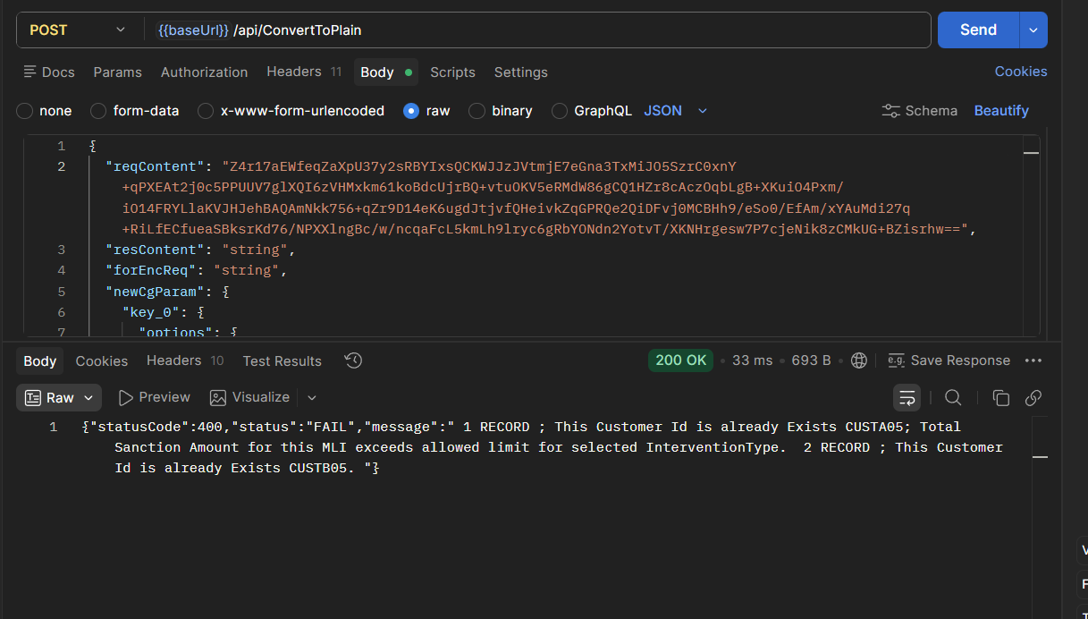

Loan Account Number | Numeric / Alpha Numeric | TEXT | Mandatory

"{\"schemecode\":\"CAE\",\"borrowers\":[{\"MLIName\":\"Bank102\",\"MLIID\":\"60180\",\"ExporterName\":\"Somesh01\",\"ExporterITPAN\":\"AQPPL1101A\",\"IECCode\":\"A242342342\",\"UdyamRegistrationNumber\":\"UDYAM-UP-12-0000011\",\"UIN\":\"A9\",\"Email\":\"\",\"MobileNumber\":\"912345678565\",\"Gender\":\"T\",\"Religion\":\"Hindu\",\"CasteCategory\":\"OBC\",\"ConstitutionType\":\"Company\",\"EntityType\":\"Micro\",\"AddressLine\":\"123 Industrial Area\",\"City\":\"Ghaziabad\",\"District\":\"519\",\"State\":\"27\",\"PinCode\":\"123451\",\"InterventionType\":\"OIE\",\"CustomerId\":\"CUST01\",\"LoanAccountNumber\":\"\",\"SanctionAmount\":\"500000\",\"SanctionDate\":\"26-05-2026\",\"IndustryNature\":\"Textiles\",\"IndustrySector\":\"Cotton Textiles\",\"TenureOfLoan\":\"900\",\"IntrestRate\":\"8.5\",\"GuaranteeAmount\":\"40000\"},{\"MLIName\":\"Bank102\",\"MLIID\":\"60180\",\"ExporterName\":\"somesh02\",\"ExporterITPAN\":\"AQPPL1102A\",\"IECCode\":\"987654321A\",\"UdyamRegistrationNumber\":\"UDYAM-DL-11-0000011\",\"UIN\":\"B9\",\"Email\":\"cmcredit@wbgb.bank.in\",\"MobileNumber\":\"912345678565\",\"Gender\":\"F\",\"Religion\":\"Hindu\",\"CasteCategory\":\"OBC\",\"ConstitutionType\":\"Company\",\"EntityType\":\"Micro\",\"AddressLine\":\"45 Export Zone\",\"City\":\"Delhi\",\"District\":\"639\",\"State\":\"35\",\"PinCode\":\"110001\",\"InterventionType\":\"OIE\",\"CustomerId\":\"CUST02\",\"LoanAccountNumber\":\"@#$%^&\",\"SanctionAmount\":\"2000\",\"SanctionDate\":\"15-04-2026\",\"IndustryNature\":\"Textiles\",\"IndustrySector\":\"Cotton Textiles\",\"TenureOfLoan\":\"60\",\"IntrestRate\":\"9.2\",\"GuaranteeAmount\":\"150\"},{\"MLIName\":\"Bank102\",\"MLIID\":\"60180\",\"ExporterName\":\"somesh 03\",\"ExporterITPAN\":\"AQPPL1103A\",\"IECCode\":\"112A233445\",\"UdyamRegistrationNumber\":\"UDYAM-MH-11-0000011\",\"UIN\":\"C9\",\"Email\":\"contacte@com.com\",\"MobileNumber\":\"912345678565\",\"Gender\":\"M\",\"Religion\":\"Muslim\",\"CasteCategory\":\"General\",\"ConstitutionType\":\"LLP\",\"EntityType\":\"Medium\",\"AddressLine\":\"789 Tech Park\",\"City\":\"Mumbai\",\"District\":\"638\",\"State\":\"35\",\"PinCode\":\"400004\",\"InterventionType\":\"OIE\",\"CustomerId\":\"CUST03\",\"LoanAccountNumber\":\"LN00012345660\",\"SanctionAmount\":\"450\",\"SanctionDate\":\"10-06-2026\",\"IndustryNature\":\"Textiles\",\"IndustrySector\":\"Cotton Textiles\",\"TenureOfLoan\":\"36\",\"IntrestRate\":\"10.0\",\"GuaranteeAmount\":\"150\"}]}"

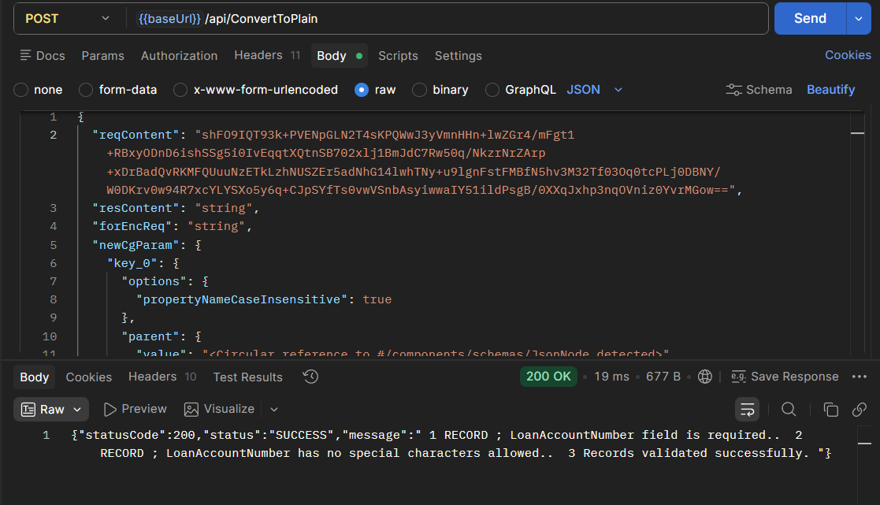

Sanction Amount | Total Loan amount sanctioned by MLI should be limited to Rs.50 lakhs for Direct E-Commerce Credit Facility and Rs. 5 cr for Overseas Inventory E-Commerce Credit Facility | Number With 2 Decimals | Mandatory

"{\"schemecode\":\"CAE\",\"borrowers\":[{\"MLIName\":\"Bank102\",\"MLIID\":\"60180\",\"ExporterName\":\"Somesh01\",\"ExporterITPAN\":\"AQPPL1101A\",\"IECCode\":\"A242342342\",\"UdyamRegistrationNumber\":\"UDYAM-UP-10-1000000\",\"UIN\":\"A1\",\"Email\":\"\",\"MobileNumber\":\"912345678565\",\"Gender\":\"T\",\"Religion\":\"1\",\"CasteCategory\":\"1\",\"ConstitutionType\":\"1\",\"EntityType\":\"1\",\"AddressLine\":\"123 Industrial Area\",\"City\":\"Ghaziabad\",\"District\":\"519\",\"State\":\"27\",\"PinCode\":\"123451\",\"InterventionType\":\"DEC\",\"CustomerId\":\"CUSTA05\",\"LoanAccountNumber\":\"loan01\",\"SanctionAmount\":\"5000001\",\"SanctionDate\":\"04-05-2026\",\"IndustryNature\":\"1\",\"IndustrySector\":\"1\",\"TenureOfLoan\":\"900\",\"IntrestRate\":\"8.5\",\"GuaranteeAmount\":\"40000\"},{\"MLIName\":\"Bank102\",\"MLIID\":\"60180\",\"ExporterName\":\"somesh02\",\"ExporterITPAN\":\"AQPPL1101A\",\"IECCode\":\"987654321A\",\"UdyamRegistrationNumber\":\"UDYAM-DL-11-1000000\",\"UIN\":\"B1\",\"Email\":\"cmcredit@wbgb.bank.in\",\"MobileNumber\":\"912345678565\",\"Gender\":\"F\",\"Religion\":\"1\",\"CasteCategory\":\"1\",\"ConstitutionType\":\"1\",\"EntityType\":\"1\",\"AddressLine\":\"45 Export Zone\",\"City\":\"Delhi\",\"District\":\"639\",\"State\":\"35\",\"PinCode\":\"110001\",\"InterventionType\":\"OIE\",\"CustomerId\":\"CUSTB05\",\"LoanAccountNumber\":\"Loan01\",\"SanctionAmount\":\"500000001\",\"SanctionDate\":\"03-06-2026\",\"IndustryNature\":\"1\",\"IndustrySector\":\"1\",\"TenureOfLoan\":\"60\",\"IntrestRate\":\"9.2\",\"GuaranteeAmount\":\"150\"}]}"

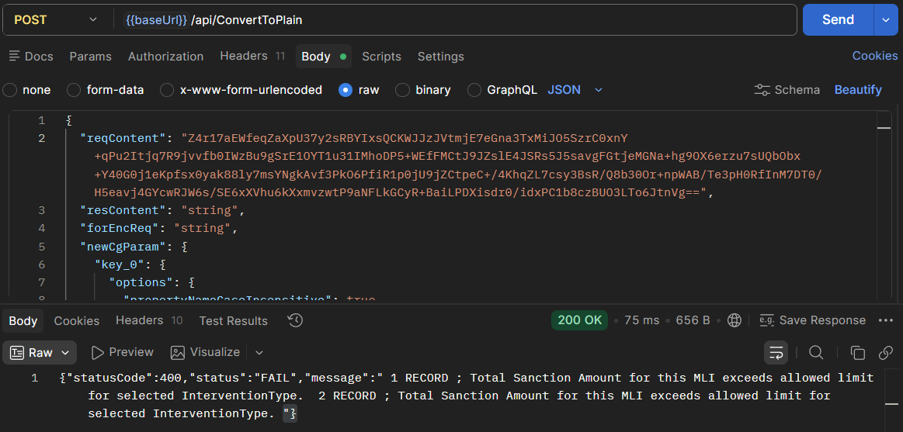

Sanction Date | Date of loan sanctioned by MLI as per scheme eligibility rules/guidance, from all the sanctions for this borrower. Sanction date >= scheme notification date, Sanction date <= system date, sanction date <= scheme close date | DD-MM-YYYY | Mandatory

SchemeStartDate | SchemeEndDate
01-05-2026 | 01-05-2030

Sanction date >= scheme notification date --> pass
Sanction date <= system date, --> pass
sanction date <= scheme close date --> pass

"{\"schemecode\":\"CAE\",\"borrowers\":[{\"MLIName\":\"Bank102\",\"MLIID\":\"60180\",\"ExporterName\":\"Somesh01\",\"ExporterITPAN\":\"AQPPL1101A\",\"IECCode\":\"A242342342\",\"UdyamRegistrationNumber\":\"UDYAM-UP-10-1000000\",\"UIN\":\"A1\",\"Email\":\"\",\"MobileNumber\":\"912345678565\",\"Gender\":\"T\",\"Religion\":\"1\",\"CasteCategory\":\"1\",\"ConstitutionType\":\"1\",\"EntityType\":\"1\",\"AddressLine\":\"123 Industrial Area\",\"City\":\"Ghaziabad\",\"District\":\"519\",\"State\":\"27\",\"PinCode\":\"123451\",\"InterventionType\":\"DEC\",\"CustomerId\":\"CUSTA05\",\"LoanAccountNumber\":\"loan01\",\"SanctionAmount\":\"50000000\",\"SanctionDate\":\"04-04-2026\",\"IndustryNature\":\"1\",\"IndustrySector\":\"1\",\"TenureOfLoan\":\"900\",\"IntrestRate\":\"8.5\",\"GuaranteeAmount\":\"40000\"},{\"MLIName\":\"Bank102\",\"MLIID\":\"60180\",\"ExporterName\":\"somesh02\",\"ExporterITPAN\":\"AQPPL1101A\",\"IECCode\":\"987654321A\",\"UdyamRegistrationNumber\":\"UDYAM-DL-11-1000000\",\"UIN\":\"B1\",\"Email\":\"cmcredit@wbgb.bank.in\",\"MobileNumber\":\"912345678565\",\"Gender\":\"F\",\"Religion\":\"1\",\"CasteCategory\":\"1\",\"ConstitutionType\":\"1\",\"EntityType\":\"1\",\"AddressLine\":\"45 Export Zone\",\"City\":\"Delhi\",\"District\":\"639\",\"State\":\"35\",\"PinCode\":\"110001\",\"InterventionType\":\"OIE\",\"CustomerId\":\"CUSTB05\",\"LoanAccountNumber\":\"Loan01\",\"SanctionAmount\":\"500000000\",\"SanctionDate\":\"01-06-2030\",\"IndustryNature\":\"1\",\"IndustrySector\":\"1\",\"TenureOfLoan\":\"60\",\"IntrestRate\":\"9.2\",\"GuaranteeAmount\":\"150\"}]}"

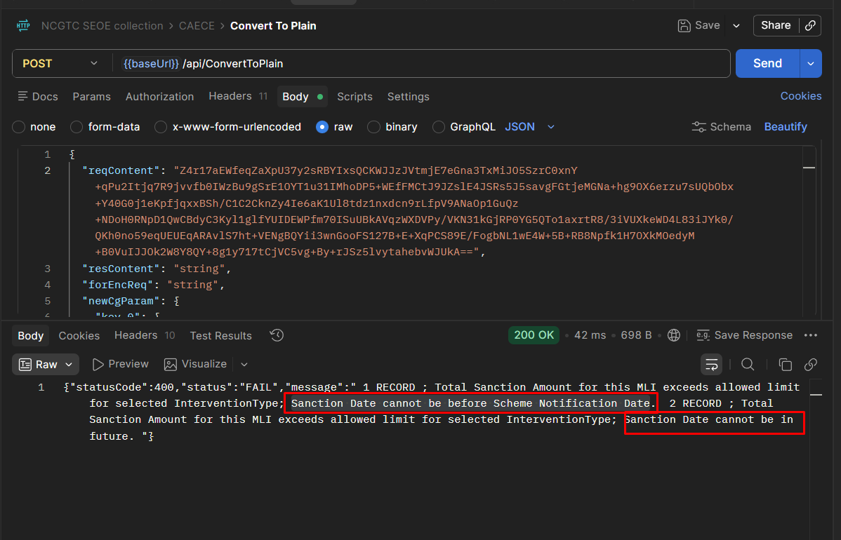

Industry Nature | Copy the required value From Given List only | TEXT | Mandatory
Industry Sector | Copy the required value From Given List only | TEXT | Mandatory

Failed - not accepting special charactor

"{\"schemecode\":\"CAE\",\"borrowers\":[{\"MLIName\":\"Bank102\",\"MLIID\":\"60180\",\"ExporterName\":\"Somesh01\",\"ExporterITPAN\":\"AQPPL1101A\",\"IECCode\":\"A242342342\",\"UdyamRegistrationNumber\":\"UDYAM-UP-12-1000000\",\"UIN\":\"A12\",\"Email\":\"\",\"MobileNumber\":\"912345678565\",\"Gender\":\"T\",\"Religion\":\"Hindu\",\"CasteCategory\":\"OBC\",\"ConstitutionType\":\"Company\",\"EntityType\":\"Micro\",\"AddressLine\":\"123 Industrial Area\",\"City\":\"Ghaziabad\",\"District\":\"519\",\"State\":\"27\",\"PinCode\":\"123451\",\"InterventionType\":\"OIE\",\"CustomerId\":\"CUSTA05\",\"LoanAccountNumber\":\"loan01\",\"SanctionAmount\":\"500000\",\"SanctionDate\":\"04-04-2026\",\"IndustryNature\":\"Mining & Quarrying (incl. Coal)\",\"IndustrySector\":\"Mining & Quarrying (incl. Coal)\",\"TenureOfLoan\":\"900\",\"IntrestRate\":\"8.5\",\"GuaranteeAmount\":\"40000\"},{\"MLIName\":\"Bank102\",\"MLIID\":\"60180\",\"ExporterName\":\"somesh02\",\"ExporterITPAN\":\"AQPPL1102A\",\"IECCode\":\"987654321A\",\"UdyamRegistrationNumber\":\"UDYAM-DL-11-1000000\",\"UIN\":\"B12\",\"Email\":\"cmcredit@wbgb.bank.in\",\"MobileNumber\":\"912345678565\",\"Gender\":\"F\",\"Religion\":\"Hindu\",\"CasteCategory\":\"OBC\",\"ConstitutionType\":\"Company\",\"EntityType\":\"Micro\",\"AddressLine\":\"45 Export Zone\",\"City\":\"Delhi\",\"District\":\"639\",\"State\":\"35\",\"PinCode\":\"110001\",\"InterventionType\":\"OIE\",\"CustomerId\":\"CUSTB05\",\"LoanAccountNumber\":\"Loan01\",\"SanctionAmount\":\"2000\",\"SanctionDate\":\"15-04-2026\",\"IndustryNature\":\"Food Processing\",\"IndustrySector\":\"Sugar\",\"TenureOfLoan\":\"60\",\"IntrestRate\":\"9.2\",\"GuaranteeAmount\":\"150\"},{\"MLIName\":\"Bank102\",\"MLIID\":\"60180\",\"ExporterName\":\"somesh 03\",\"ExporterITPAN\":\"AQPPL1103A\",\"IECCode\":\"112A233445\",\"UdyamRegistrationNumber\":\"UDYAM-MH-11-1000000\",\"UIN\":\"C12\",\"Email\":\"contacte@com.com\",\"MobileNumber\":\"912345678565\",\"Gender\":\"M\",\"Religion\":\"Muslim\",\"CasteCategory\":\"General\",\"ConstitutionType\":\"LLP\",\"EntityType\":\"Medium\",\"AddressLine\":\"789 Tech Park\",\"City\":\"Mumbai\",\"District\":\"638\",\"State\":\"35\",\"PinCode\":\"400004\",\"InterventionType\":\"OIE\",\"CustomerId\":\"CUSTC05\",\"LoanAccountNumber\":\"LN00012345660\",\"SanctionAmount\":\"450\",\"SanctionDate\":\"30-05-2026\",\"IndustryNature\":\"Food Processing\",\"IndustrySector\":\"Others\",\"TenureOfLoan\":\"36\",\"IntrestRate\":\"10.0\",\"GuaranteeAmount\":\"150\"}]}"

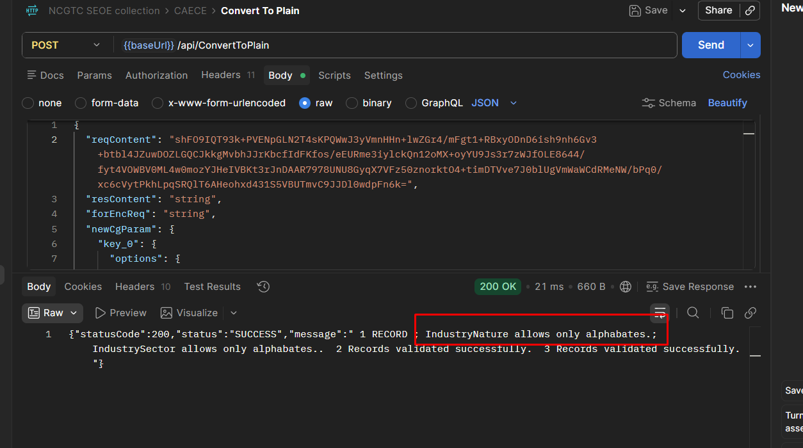

Canara bank
"{\"schemecode\":\"CAE\",\"borrowers\":[{\"MLIName\":\"Canara Bank\",\"MLIID\":\"1\",\"ExporterName\":\"Somesh01\",\"ExporterITPAN\":\"CBKCA1010A\",\"IECCode\":\"1234567890\",\"UdyamRegistrationNumber\":\"UDYAM-KA-10-1111100\",\"UIN\":\"uinC1\",\"Email\":\"\",\"MobileNumber\":\"9123456781\",\"Gender\":\"M\",\"Religion\":\"1\",\"CasteCategory\":\"4\",\"ConstitutionType\":\"2\",\"EntityType\":\"1\",\"AddressLine\":\"Industrial Area\",\"City\":\"Vijayawada\",\"District\":\"743\",\"State\":\"28\",\"PinCode\":\"500001\",\"InterventionType\":\"DEC\",\"CustomerId\":\"canara101\",\"LoanAccountNumber\":\"loan101\",\"SanctionAmount\":\"2000000\",\"SanctionDate\":\"03-05-2026\",\"IndustryNature\":\"2\",\"IndustrySector\":\"2\",\"TenureOfLoan\":\"11\",\"IntrestRate\":\"8.5\",\"GuaranteeAmount\":\"2000000\"},{\"MLIName\":\"Canara Bank\",\"MLIID\":\"1\",\"ExporterName\":\"Somesh02\",\"ExporterITPAN\":\"CBKCA1011A\",\"IECCode\":\"1234567891\",\"UdyamRegistrationNumber\":\"UDYAM-KA-10-1111101\",\"UIN\":\"uinC2\",\"Email\":\"\",\"MobileNumber\":\"9123456782\",\"Gender\":\"F\",\"Religion\":\"2\",\"CasteCategory\":\"3\",\"ConstitutionType\":\"3\",\"EntityType\":\"2\",\"AddressLine\":\"Industrial Area\",\"City\":\"Guntur\",\"District\":\"748\",\"State\":\"28\",\"PinCode\":\"500002\",\"InterventionType\":\"DEC\",\"CustomerId\":\"canara102\",\"LoanAccountNumber\":\"loan102\",\"SanctionAmount\":\"1500000\",\"SanctionDate\":\"15-05-2026\",\"IndustryNature\":\"4\",\"IndustrySector\":\"7\",\"TenureOfLoan\":\"11\",\"IntrestRate\":\"8.5\",\"GuaranteeAmount\":\"1500000\"},{\"MLIName\":\"Canara Bank\",\"MLIID\":\"1\",\"ExporterName\":\"Somesh03\",\"ExporterITPAN\":\"CBKCA1012A\",\"IECCode\":\"1234567892\",\"UdyamRegistrationNumber\":\"UDYAM-KA-10-1111102\",\"UIN\":\"uinC3\",\"Email\":\"\",\"MobileNumber\":\"9123456783\",\"Gender\":\"T\",\"Religion\":\"3\",\"CasteCategory\":\"1\",\"ConstitutionType\":\"1\",\"EntityType\":\"3\",\"AddressLine\":\"Industrial Area\",\"City\":\"Nellore\",\"District\":\"546\",\"State\":\"28\",\"PinCode\":\"500003\",\"InterventionType\":\"DEC\",\"CustomerId\":\"canara103\",\"LoanAccountNumber\":\"loan103\",\"SanctionAmount\":\"1500000\",\"SanctionDate\":\"28-05-2026\",\"IndustryNature\":\"9\",\"IndustrySector\":\"15\",\"TenureOfLoan\":\"11\",\"IntrestRate\":\"8.5\",\"GuaranteeAmount\":\"1500000\"},{\"MLIName\":\"Canara Bank\",\"MLIID\":\"1\",\"ExporterName\":\"Somesh04\",\"ExporterITPAN\":\"CBKBA2010B\",\"IECCode\":\"9876543210\",\"UdyamRegistrationNumber\":\"UDYAM-KA-12-1111200\",\"UIN\":\"uinC4\",\"Email\":\"credit@canara.com\",\"MobileNumber\":\"9234567891\",\"Gender\":\"M\",\"Religion\":\"4\",\"CasteCategory\":\"2\",\"ConstitutionType\":\"4\",\"EntityType\":\"2\",\"AddressLine\":\"Export Zone\",\"City\":\"Kakinada\",\"District\":\"547\",\"State\":\"28\",\"PinCode\":\"500004\",\"InterventionType\":\"OIE\",\"CustomerId\":\"canara201\",\"LoanAccountNumber\":\"loan201\",\"SanctionAmount\":\"20000000\",\"SanctionDate\":\"05-06-2026\",\"IndustryNature\":\"13\",\"IndustrySector\":\"22\",\"TenureOfLoan\":\"5\",\"IntrestRate\":\"9.2\",\"GuaranteeAmount\":\"20000000\"},{\"MLIName\":\"Canara Bank\",\"MLIID\":\"1\",\"ExporterName\":\"Somesh05\",\"ExporterITPAN\":\"CBKBA2011B\",\"IECCode\":\"9876543211\",\"UdyamRegistrationNumber\":\"UDYAM-KA-12-1111201\",\"UIN\":\"uinC5\",\"Email\":\"credit@canara.com\",\"MobileNumber\":\"9234567892\",\"Gender\":\"F\",\"Religion\":\"5\",\"CasteCategory\":\"4\",\"ConstitutionType\":\"5\",\"EntityType\":\"1\",\"AddressLine\":\"Export Zone\",\"City\":\"Tirupati\",\"District\":\"550\",\"State\":\"28\",\"PinCode\":\"500005\",\"InterventionType\":\"OIE\",\"CustomerId\":\"canara202\",\"LoanAccountNumber\":\"loan202\",\"SanctionAmount\":\"15000000\",\"SanctionDate\":\"09-06-2026\",\"IndustryNature\":\"18\",\"IndustrySector\":\"29\",\"TenureOfLoan\":\"5\",\"IntrestRate\":\"9.2\",\"GuaranteeAmount\":\"15000000\"},{\"MLIName\":\"Canara Bank\",\"MLIID\":\"1\",\"ExporterName\":\"Somesh06\",\"ExporterITPAN\":\"CBKBA2012B\",\"IECCode\":\"9876543212\",\"UdyamRegistrationNumber\":\"UDYAM-KA-12-1111202\",\"UIN\":\"uinC6\",\"Email\":\"credit@canara.com\",\"MobileNumber\":\"9234567893\",\"Gender\":\"T\",\"Religion\":\"6\",\"CasteCategory\":\"3\",\"ConstitutionType\":\"2\",\"EntityType\":\"3\",\"AddressLine\":\"Export Zone\",\"City\":\"Kadapa\",\"District\":\"551\",\"State\":\"28\",\"PinCode\":\"500006\",\"InterventionType\":\"OIE\",\"CustomerId\":\"canara203\",\"LoanAccountNumber\":\"loan203\",\"SanctionAmount\":\"15000000\",\"SanctionDate\":\"11-06-2026\",\"IndustryNature\":\"20\",\"IndustrySector\":\"34\",\"TenureOfLoan\":\"5\",\"IntrestRate\":\"9.2\",\"GuaranteeAmount\":\"15000000\"},{\"MLIName\":\"Canara Bank\",\"MLIID\":\"1\",\"ExporterName\":\"FAILCASE\",\"ExporterITPAN\":\"CBKZZ9999Z\",\"IECCode\":\"9999999999\",\"UdyamRegistrationNumber\":\"UDYAM-KA-99-9999999\",\"UIN\":\"uinFAIL\",\"Email\":\"fail@test.com\",\"MobileNumber\":\"9999999999\",\"Gender\":\"M\",\"Religion\":\"1\",\"CasteCategory\":\"4\",\"ConstitutionType\":\"1\",\"EntityType\":\"1\",\"AddressLine\":\"Test\",\"City\":\"TestCity\",\"District\":\"743\",\"State\":\"28\",\"PinCode\":\"500007\",\"InterventionType\":\"DEC\",\"CustomerId\":\"canarafail\",\"LoanAccountNumber\":\"loanfail\",\"SanctionAmount\":\"1\",\"SanctionDate\":\"10-06-2026\",\"IndustryNature\":\"2\",\"IndustrySector\":\"2\",\"TenureOfLoan\":\"1\",\"IntrestRate\":\"8.5\",\"GuaranteeAmount\":\"1\"}]}"

Bank102

"{\"schemecode\":\"CAE\",\"borrowers\":[{\"MLIName\":\"Bank102\",\"MLIID\":\"60180\",\"ExporterName\":\"DEC01\",\"ExporterITPAN\":\"BNKCA1101A\",\"IECCode\":\"1111111111\",\"UdyamRegistrationNumber\":\"UDYAM-AP-10-1100001\",\"UIN\":\"uinX1\",\"Email\":\"\",\"MobileNumber\":\"9000000101\",\"Gender\":\"M\",\"Religion\":\"1\",\"CasteCategory\":\"4\",\"ConstitutionType\":\"2\",\"EntityType\":\"1\",\"AddressLine\":\"Area\",\"City\":\"Guntur\",\"District\":\"748\",\"State\":\"28\",\"PinCode\":\"500001\",\"InterventionType\":\"DEC\",\"CustomerId\":\"bank10201\",\"LoanAccountNumber\":\"loan301\",\"SanctionAmount\":\"800000\",\"SanctionDate\":\"02-05-2026\",\"IndustryNature\":\"2\",\"IndustrySector\":\"2\",\"TenureOfLoan\":\"10\",\"IntrestRate\":\"8.5\",\"GuaranteeAmount\":\"800000\"},{\"MLIName\":\"Bank102\",\"MLIID\":\"60180\",\"ExporterName\":\"DEC02\",\"ExporterITPAN\":\"BNKCA1102A\",\"IECCode\":\"1111111112\",\"UdyamRegistrationNumber\":\"UDYAM-AP-10-1100002\",\"UIN\":\"uinX2\",\"Email\":\"\",\"MobileNumber\":\"9000000102\",\"Gender\":\"F\",\"Religion\":\"2\",\"CasteCategory\":\"3\",\"ConstitutionType\":\"3\",\"EntityType\":\"2\",\"AddressLine\":\"Area\",\"City\":\"Kakinada\",\"District\":\"748\",\"State\":\"28\",\"PinCode\":\"500002\",\"InterventionType\":\"DEC\",\"CustomerId\":\"bank10202\",\"LoanAccountNumber\":\"loan302\",\"SanctionAmount\":\"600000\",\"SanctionDate\":\"04-05-2026\",\"IndustryNature\":\"4\",\"IndustrySector\":\"7\",\"TenureOfLoan\":\"10\",\"IntrestRate\":\"8.5\",\"GuaranteeAmount\":\"600000\"},{\"MLIName\":\"Bank102\",\"MLIID\":\"60180\",\"ExporterName\":\"DEC03\",\"ExporterITPAN\":\"BNKCA1103A\",\"IECCode\":\"1111111113\",\"UdyamRegistrationNumber\":\"UDYAM-AP-10-1100003\",\"UIN\":\"uinX3\",\"Email\":\"\",\"MobileNumber\":\"9000000103\",\"Gender\":\"T\",\"Religion\":\"3\",\"CasteCategory\":\"1\",\"ConstitutionType\":\"1\",\"EntityType\":\"3\",\"AddressLine\":\"Area\",\"City\":\"Nellore\",\"District\":\"550\",\"State\":\"28\",\"PinCode\":\"500003\",\"InterventionType\":\"DEC\",\"CustomerId\":\"bank10203\",\"LoanAccountNumber\":\"loan303\",\"SanctionAmount\":\"700000\",\"SanctionDate\":\"06-05-2026\",\"IndustryNature\":\"9\",\"IndustrySector\":\"15\",\"TenureOfLoan\":\"10\",\"IntrestRate\":\"8.5\",\"GuaranteeAmount\":\"700000\"},{\"MLIName\":\"Bank102\",\"MLIID\":\"60180\",\"ExporterName\":\"OIE01\",\"ExporterITPAN\":\"BNKBA2101B\",\"IECCode\":\"2222222221\",\"UdyamRegistrationNumber\":\"UDYAM-AP-12-2100001\",\"UIN\":\"uinY1\",\"Email\":\"test@bank.com\",\"MobileNumber\":\"9111111101\",\"Gender\":\"M\",\"Religion\":\"1\",\"CasteCategory\":\"4\",\"ConstitutionType\":\"2\",\"EntityType\":\"1\",\"AddressLine\":\"Zone\",\"City\":\"Kadapa\",\"District\":\"551\",\"State\":\"28\",\"PinCode\":\"500011\",\"InterventionType\":\"OIE\",\"CustomerId\":\"bank10211\",\"LoanAccountNumber\":\"loan311\",\"SanctionAmount\":\"8000000\",\"SanctionDate\":\"10-06-2026\",\"IndustryNature\":\"13\",\"IndustrySector\":\"22\",\"TenureOfLoan\":\"5\",\"IntrestRate\":\"9.2\",\"GuaranteeAmount\":\"8000000\"},{\"MLIName\":\"Bank102\",\"MLIID\":\"60180\",\"ExporterName\":\"OIE02\",\"ExporterITPAN\":\"BNKBA2102B\",\"IECCode\":\"2222222222\",\"UdyamRegistrationNumber\":\"UDYAM-AP-12-2100002\",\"UIN\":\"uinY2\",\"Email\":\"test@bank.com\",\"MobileNumber\":\"9111111102\",\"Gender\":\"F\",\"Religion\":\"2\",\"CasteCategory\":\"3\",\"ConstitutionType\":\"3\",\"EntityType\":\"2\",\"AddressLine\":\"Zone\",\"City\":\"Guntur\",\"District\":\"748\",\"State\":\"28\",\"PinCode\":\"500012\",\"InterventionType\":\"OIE\",\"CustomerId\":\"bank10212\",\"LoanAccountNumber\":\"loan312\",\"SanctionAmount\":\"6000000\",\"SanctionDate\":\"12-06-2026\",\"IndustryNature\":\"18\",\"IndustrySector\":\"29\",\"TenureOfLoan\":\"5\",\"IntrestRate\":\"9.2\",\"GuaranteeAmount\":\"6000000\"},{\"MLIName\":\"Bank102\",\"MLIID\":\"60180\",\"ExporterName\":\"FAIL\",\"ExporterITPAN\":\"FAIL0000Z\",\"IECCode\":\"9999999999\",\"UdyamRegistrationNumber\":\"UDYAM-AP-99-9999999\",\"UIN\":\"uinFAIL\",\"Email\":\"fail@test.com\",\"MobileNumber\":\"9999999999\",\"Gender\":\"M\",\"Religion\":\"1\",\"CasteCategory\":\"4\",\"ConstitutionType\":\"1\",\"EntityType\":\"1\",\"AddressLine\":\"Test\",\"City\":\"Guntur\",\"District\":\"748\",\"State\":\"28\",\"PinCode\":\"500099\",\"InterventionType\":\"DEC\",\"CustomerId\":\"bankfail\",\"LoanAccountNumber\":\"loanfail\",\"SanctionAmount\":\"1\",\"SanctionDate\":\"25-05-2026\",\"IndustryNature\":\"2\",\"IndustrySector\":\"2\",\"TenureOfLoan\":\"1\",\"IntrestRate\":\"8.5\",\"GuaranteeAmount\":\"1\"}]}"

Both MLI data
"{\"schemecode\":\"CAE\",\"borrowers\":[{\"MLIName\":\"Canara Bank\",\"MLIID\":\"1\",\"ExporterName\":\"SomeshA\",\"ExporterITPAN\":\"CBKCA2010A\",\"IECCode\":\"1234567890\",\"UdyamRegistrationNumber\":\"UDYAM-KA-10-2111100\",\"UIN\":\"uinC101\",\"Email\":\"\",\"MobileNumber\":\"9123456781\",\"Gender\":\"M\",\"Religion\":\"1\",\"CasteCategory\":\"4\",\"ConstitutionType\":\"2\",\"EntityType\":\"1\",\"AddressLine\":\"Industrial Area\",\"City\":\"Vijayawada\",\"District\":\"743\",\"State\":\"28\",\"PinCode\":\"500001\",\"InterventionType\":\"DEC\",\"CustomerId\":\"CAN101\",\"LoanAccountNumber\":\"LN101\",\"SanctionAmount\":\"2000000\",\"SanctionDate\":\"03-05-2026\",\"IndustryNature\":\"2\",\"IndustrySector\":\"2\",\"TenureOfLoan\":\"11\",\"IntrestRate\":\"8.5\",\"GuaranteeAmount\":\"2000000\"},{\"MLIName\":\"Canara Bank\",\"MLIID\":\"1\",\"ExporterName\":\"SomeshB\",\"ExporterITPAN\":\"CBKCA2011A\",\"IECCode\":\"1234567891\",\"UdyamRegistrationNumber\":\"UDYAM-KA-10-2111101\",\"UIN\":\"uinC102\",\"Email\":\"\",\"MobileNumber\":\"9123456782\",\"Gender\":\"F\",\"Religion\":\"2\",\"CasteCategory\":\"3\",\"ConstitutionType\":\"3\",\"EntityType\":\"2\",\"AddressLine\":\"Industrial Area\",\"City\":\"Guntur\",\"District\":\"748\",\"State\":\"28\",\"PinCode\":\"500002\",\"InterventionType\":\"DEC\",\"CustomerId\":\"CAN102\",\"LoanAccountNumber\":\"LN102\",\"SanctionAmount\":\"1500000\",\"SanctionDate\":\"15-05-2026\",\"IndustryNature\":\"4\",\"IndustrySector\":\"7\",\"TenureOfLoan\":\"11\",\"IntrestRate\":\"8.5\",\"GuaranteeAmount\":\"1500000\"},{\"MLIName\":\"Canara Bank\",\"MLIID\":\"1\",\"ExporterName\":\"SomeshC\",\"ExporterITPAN\":\"CBKCA2012A\",\"IECCode\":\"1234567892\",\"UdyamRegistrationNumber\":\"UDYAM-KA-10-2111102\",\"UIN\":\"uinC103\",\"Email\":\"\",\"MobileNumber\":\"9123456783\",\"Gender\":\"T\",\"Religion\":\"3\",\"CasteCategory\":\"1\",\"ConstitutionType\":\"1\",\"EntityType\":\"3\",\"AddressLine\":\"Industrial Area\",\"City\":\"Nellore\",\"District\":\"546\",\"State\":\"28\",\"PinCode\":\"500003\",\"InterventionType\":\"DEC\",\"CustomerId\":\"CAN103\",\"LoanAccountNumber\":\"LN103\",\"SanctionAmount\":\"1500000\",\"SanctionDate\":\"28-05-2026\",\"IndustryNature\":\"9\",\"IndustrySector\":\"15\",\"TenureOfLoan\":\"11\",\"IntrestRate\":\"8.5\",\"GuaranteeAmount\":\"1500000\"},{\"MLIName\":\"Canara Bank\",\"MLIID\":\"1\",\"ExporterName\":\"SomeshD\",\"ExporterITPAN\":\"CBKBA3010B\",\"IECCode\":\"9876543210\",\"UdyamRegistrationNumber\":\"UDYAM-KA-12-3111200\",\"UIN\":\"uinC104\",\"Email\":\"credit@canara.com\",\"MobileNumber\":\"9234567891\",\"Gender\":\"M\",\"Religion\":\"4\",\"CasteCategory\":\"2\",\"ConstitutionType\":\"4\",\"EntityType\":\"2\",\"AddressLine\":\"Export Zone\",\"City\":\"Kakinada\",\"District\":\"547\",\"State\":\"28\",\"PinCode\":\"500004\",\"InterventionType\":\"OIE\",\"CustomerId\":\"CAN201\",\"LoanAccountNumber\":\"LN201\",\"SanctionAmount\":\"20000000\",\"SanctionDate\":\"05-06-2026\",\"IndustryNature\":\"13\",\"IndustrySector\":\"22\",\"TenureOfLoan\":\"5\",\"IntrestRate\":\"9.2\",\"GuaranteeAmount\":\"20000000\"},{\"MLIName\":\"Canara Bank\",\"MLIID\":\"1\",\"ExporterName\":\"SomeshE\",\"ExporterITPAN\":\"CBKBA3011B\",\"IECCode\":\"9876543211\",\"UdyamRegistrationNumber\":\"UDYAM-KA-12-3111201\",\"UIN\":\"uinC105\",\"Email\":\"credit@canara.com\",\"MobileNumber\":\"9234567892\",\"Gender\":\"F\",\"Religion\":\"5\",\"CasteCategory\":\"4\",\"ConstitutionType\":\"5\",\"EntityType\":\"1\",\"AddressLine\":\"Export Zone\",\"City\":\"Tirupati\",\"District\":\"550\",\"State\":\"28\",\"PinCode\":\"500005\",\"InterventionType\":\"OIE\",\"CustomerId\":\"CAN202\",\"LoanAccountNumber\":\"LN202\",\"SanctionAmount\":\"15000000\",\"SanctionDate\":\"09-06-2026\",\"IndustryNature\":\"18\",\"IndustrySector\":\"29\",\"TenureOfLoan\":\"5\",\"IntrestRate\":\"9.2\",\"GuaranteeAmount\":\"15000000\"},{\"MLIName\":\"Canara Bank\",\"MLIID\":\"1\",\"ExporterName\":\"SomeshF\",\"ExporterITPAN\":\"CBKBA3012B\",\"IECCode\":\"9876543212\",\"UdyamRegistrationNumber\":\"UDYAM-KA-12-3111202\",\"UIN\":\"uinC106\",\"Email\":\"credit@canara.com\",\"MobileNumber\":\"9234567893\",\"Gender\":\"T\",\"Religion\":\"6\",\"CasteCategory\":\"3\",\"ConstitutionType\":\"2\",\"EntityType\":\"3\",\"AddressLine\":\"Export Zone\",\"City\":\"Kadapa\",\"District\":\"551\",\"State\":\"28\",\"PinCode\":\"500006\",\"InterventionType\":\"OIE\",\"CustomerId\":\"CAN203\",\"LoanAccountNumber\":\"LN203\",\"SanctionAmount\":\"15000000\",\"SanctionDate\":\"11-06-2026\",\"IndustryNature\":\"20\",\"IndustrySector\":\"34\",\"TenureOfLoan\":\"5\",\"IntrestRate\":\"9.2\",\"GuaranteeAmount\":\"15000000\"},{\"MLIName\":\"Bank102\",\"MLIID\":\"60180\",\"ExporterName\":\"ClientA\",\"ExporterITPAN\":\"BNKCA3101A\",\"IECCode\":\"1111111111\",\"UdyamRegistrationNumber\":\"UDYAM-AP-10-3100001\",\"UIN\":\"uinX201\",\"Email\":\"\",\"MobileNumber\":\"9000000101\",\"Gender\":\"M\",\"Religion\":\"1\",\"CasteCategory\":\"4\",\"ConstitutionType\":\"2\",\"EntityType\":\"1\",\"AddressLine\":\"Area\",\"City\":\"Guntur\",\"District\":\"748\",\"State\":\"28\",\"PinCode\":\"500011\",\"InterventionType\":\"DEC\",\"CustomerId\":\"BNK101\",\"LoanAccountNumber\":\"BNKLN101\",\"SanctionAmount\":\"800000\",\"SanctionDate\":\"02-05-2026\",\"IndustryNature\":\"2\",\"IndustrySector\":\"2\",\"TenureOfLoan\":\"10\",\"IntrestRate\":\"8.5\",\"GuaranteeAmount\":\"800000\"},{\"MLIName\":\"Bank102\",\"MLIID\":\"60180\",\"ExporterName\":\"ClientB\",\"ExporterITPAN\":\"BNKBA4101B\",\"IECCode\":\"2222222221\",\"UdyamRegistrationNumber\":\"UDYAM-AP-12-4100001\",\"UIN\":\"uinX202\",\"Email\":\"test@bank.com\",\"MobileNumber\":\"9111111101\",\"Gender\":\"M\",\"Religion\":\"1\",\"CasteCategory\":\"4\",\"ConstitutionType\":\"2\",\"EntityType\":\"1\",\"AddressLine\":\"Zone\",\"City\":\"Kadapa\",\"District\":\"551\",\"State\":\"28\",\"PinCode\":\"500012\",\"InterventionType\":\"OIE\",\"CustomerId\":\"BNK201\",\"LoanAccountNumber\":\"BNKLN201\",\"SanctionAmount\":\"8000000\",\"SanctionDate\":\"10-06-2026\",\"IndustryNature\":\"13\",\"IndustrySector\":\"22\",\"TenureOfLoan\":\"5\",\"IntrestRate\":\"9.2\",\"GuaranteeAmount\":\"8000000\"}]}"

