50.007 Machine Learning — Homework 1
Report
Name: Somesh Agrawal Student ID: ____________________

Q1 — Perceptron (Linear Classification)
We implement the perceptron with an offset and train on train_1_5.csv (columns: symmetry, intensity, label), evaluating on test_1_5.csv. As required, the data is NOT shuffled — instances are visited sequentially. A point is misclassified when:
yᵢ (θ · xᵢ + θ₀) ≤ 0
and on each misclassification we update:
θ ← θ + yᵢ xᵢ , θ₀ ← θ₀ + yᵢ

Q1(a) — 1 epoch (one pass over the training set)
theta = [-2.4483233, -5.88190688]
offset = 0.0
test accuracy = 0.9671
After a single pass, θ = [-2.4483, -5.8819], offset = 0, and the test accuracy is 96.71%.

Q1(b) — 5 epochs
theta = [-2.05895878, -8.83521606]
offset = 1.0
test accuracy = 0.9671
After 5 epochs, θ = [-2.0590, -8.8352], offset = 1, and the test accuracy is still 96.71%. The data is close to linearly separable, so even one pass classifies ~97% of the test set correctly; extra epochs change the weights but not the test accuracy here.

Q1(c) — How to run
The submitted notebook FirstName_LastName_HW1.ipynb contains the code under the "Q1" heading. Run from the project folder (which contains HW1_data/) and execute the cells top to bottom. perceptron(X_train, y_train, epochs) returns (theta, offset); accuracy(X_test, y_test, theta, offset) returns the test accuracy. Data is read from HW1_data/1/.

Q2 — Linear and Polynomial Regression
Inputs hw1x.dat, targets hw1y.dat. Training error is reported as the empirical risk (mean squared error):
R(θ) = (1/n) Σᵢ (xᵢᵀθ − yᵢ)²

Q2(a) — Closed-form linear regression
We prepend a column of 1s (bias) and solve the normal equations:
θ = (XᵀX)⁻¹ XᵀY
theta (bias, slope): [3.2447, 1.7816]
training MSE : 1.1625
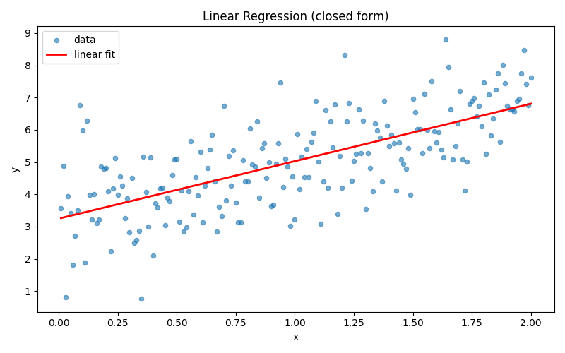
Q2(a): data with the closed-form linear fit.

Q2(b) — Gradient descent and stochastic gradient descent
Both use learning rate η = 0.01 for 5 epochs. Batch GD makes one update per epoch using the full-data gradient; SGD makes one update per data point (shuffling each epoch, seeded for reproducibility).
Batch GD final theta: [0.2413, 0.2703] min training MSE: 22.3745
SGD final theta: [3.0091, 1.9637] min training MSE: 1.1763
With only 5 epochs and this small step size, batch GD (5 updates total) barely moves from zero, so its error is still large. SGD makes 200 updates per epoch, so it reaches close to the closed-form solution (θ ≈ [3.24, 1.78], MSE ≈ 1.16) in the same 5 epochs.
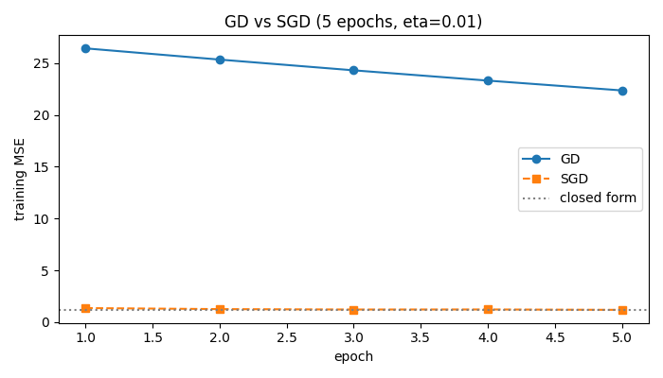
Q2(b): training MSE per epoch for GD vs SGD (dotted = closed form).

Q2(c) — Polynomial regression
PolyRegress(x, y, d) builds the design matrix [1, x, x², …, xᵈ] and solves it with the same closed form as part (a).
Quadratic (degree-2) fit:
degree-2 theta: [3.5808, 0.7834, 0.4966]
degree-2 MSE : 1.1406
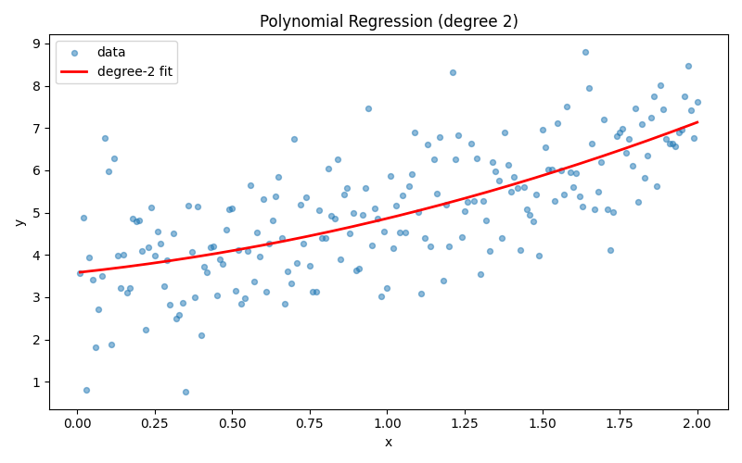
Q2(c): degree-2 polynomial fit.
Training error for degrees 1–15:
d 1 -> 1.1625 d 6 -> 1.1227 d 11 -> 1.4402
d 2 -> 1.1406 d 7 -> 1.1125 d 12 -> 6.4399
d 3 -> 1.1402 d 8 -> 1.1076 d 13 -> 9.3212
d 4 -> 1.1292 d 9 -> 1.1058 d 14 -> 5.7676
d 5 -> 1.1278 d 10 -> 1.1052 d 15 -> 100.5221
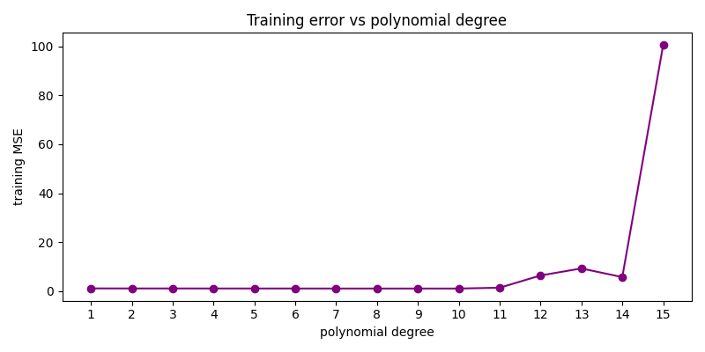
Q2(c): training MSE vs polynomial degree.
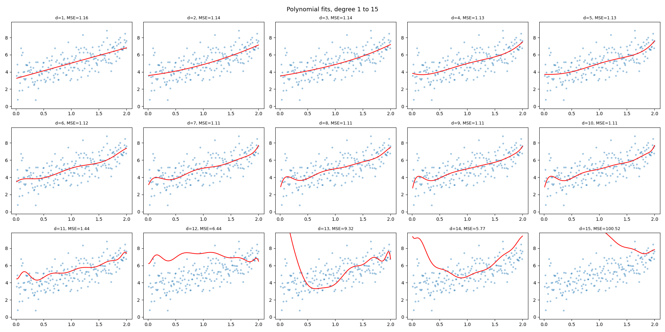
Q2(c): polynomial fits for degrees 1–15.
After which order does the error get worse? The error decreases up to degree 10, then increases starting at degree 11 (1.1052 → 1.4402). In theory training error can never increase with more terms; here it does only for numerical reasons: the columns x, x², …, x¹⁵ become almost collinear, so XᵀX is nearly singular (ill-conditioned) and np.linalg.inv loses accuracy. Using np.linalg.lstsq or np.linalg.pinv would keep the error flat.

Q3 — Ridge Regression
Inputs hw1_ridge_x.dat (already include a column of 1s), targets hw1_ridge_y.dat. The first 10 rows are the validation set, the last 40 are the training set. The closed-form ridge solution is:
θ̂ = (n λ I + XᵀX)⁻¹ XᵀY
where n = 40 (number of training points).

Q3(a) — θ for λ = 0.15
theta = [-0.57939825, 1.15033028, 0.04934122, -1.59867896]

Q3(b) — Choosing λ with the validation set
We sweep λ on a log scale (log₁₀λ from 0 down to −4.9, the grid given in the question) and plot training vs validation loss. The chosen λ minimises the validation loss.
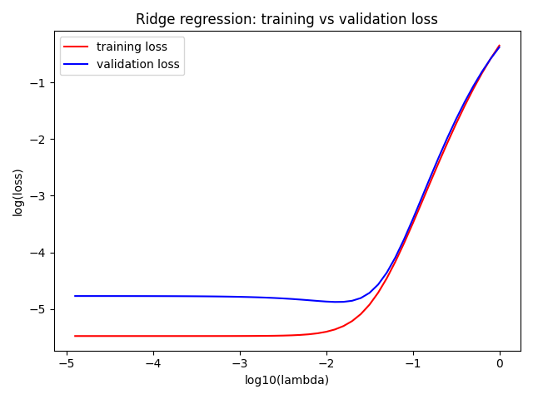
Q3(b): log training loss (red) and log validation loss (blue) vs log₁₀λ.
lambda minimising validation loss = 0.012589 (≈ 10^-1.9)
The training loss rises monotonically with λ, while the validation loss dips to a minimum near λ ≈ 0.0126 and then rises again — that minimum is the λ we pick.

Q4 — K-Means on an Image
kmeans-image.txt holds one RGB vector per pixel (516×407 image). We run our own K-Means with K = 8, the given initial centroids, and squared Euclidean distance. Each iteration assigns every pixel to its nearest centroid and recomputes each centroid as the mean of its pixels, stopping when the assignments stop changing.
Convergence:
The algorithm converged after 48 iterations. The total within-cluster squared error drops fast at first — from ≈ 1.29×10⁹ at iteration 1 to ≈ 1.18×10⁸ — and then flattens out (full per-iteration error is printed in the notebook).
Final centroids and pixel counts:
k R G B pixels
0 241.23 238.63 233.86 4930
1 194.41 136.33 90.94 15190
2 136.27 61.09 10.10 52535
3 0.00 255.00 0.00 0
4 157.29 97.59 51.43 22075
5 0.00 0.00 255.00 0
6 78.93 37.11 13.07 40365
7 25.98 23.24 23.61 74917
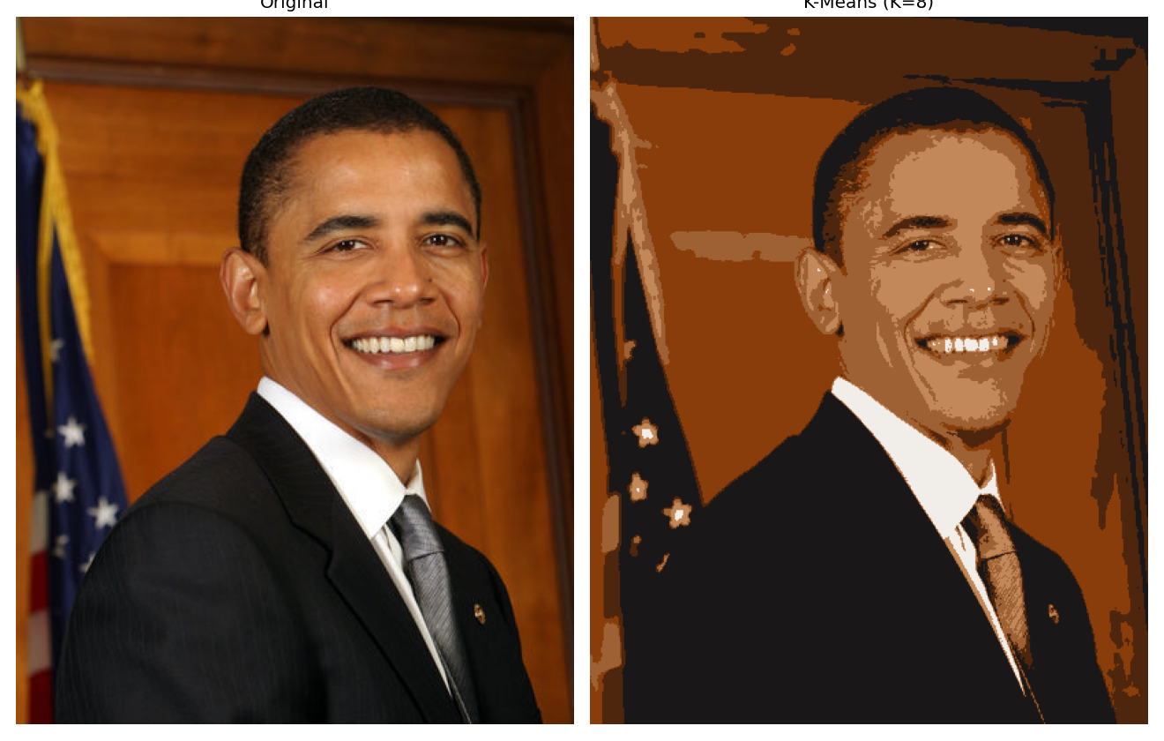
Q4: original image (left) vs K-Means 8-colour quantised image (right).
Clusters 3 (pure green) and 5 (pure blue) end up with 0 pixels. The image is a portrait with warm skin tones, a dark suit and a light background, so there are no pure-green or pure-blue pixels for those centroids to attract — they stay at their initial positions. The other 6 centroids cover the real colours of the image.

