1. **[What is stress?](https://www.who.int//news-room/questions-and-answers/item/stress/?gclid=EAIaIQobChMI_qHiub2lgQMVsNdMAh1VkgLaEAAYASAAEgIJLPD_BwE)**

Stress can be defined as a state of worry or mental tension caused by a difficult situation. Stress is a natural human response that prompts us to address challenges and threats in our lives. Everyone experiences stress to some degree

### What Are the Symptoms of Stress?

Emotional symptoms of stress include:

* Becoming easily agitated, frustrated, and moody
* Feeling overwhelmed, as if you are losing control or need to take control
* Having a hard time relaxing and quieting your mind

Physical symptoms of stress include:

* Low energy
* [Headaches](https://www.webmd.com/migraines-headaches/migraines-headaches-migraines)
* [Upset stomach](https://www.webmd.com/digestive-disorders/digestive-diseases-nausea-vomiting), including [diarrhea](https://www.webmd.com/digestive-disorders/digestive-diseases-diarrhea), [constipation](https://www.webmd.com/digestive-disorders/digestive-diseases-constipation), and [nausea](https://www.webmd.com/children/ss/nausea-vomiting-remedies-treatment)
* Aches, pains, and tense muscles
* [Chest pain](https://www.webmd.com/pain-management/whats-causing-my-chest-pain) and rapid heartbeat
* [Insomnia](https://www.webmd.com/sleep-disorders/insomnia-symptoms-and-causes)
* Frequent [colds](https://www.webmd.com/balance/stress-management/stress-symptoms-effects_of-stress-on-the-body) and infections
* Loss of sexual desire and/or ability

Behavioral symptoms of stress include:

* Changes in appetite -- either not eating or eating too much
* Procrastinating and avoiding responsibilities
* More use of alcohol, drugs, or cigarettes

# Stress in academic years nowadays in stundets.

There are several reason why a student suffer from the mental stress

1. Stress in various academic years.

Overall, 88 percent of college students reported their school life to be stressful. Education and medical majors reported the highest levels of stress, though, followed by psychology, arts, and the sciences. The biggest stressor for students was exams (89 percent)

As you can see the following graph

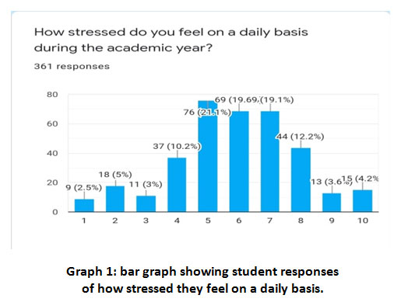



1. Different level of stress experienced by a collage students

# 2-Overall-Level-of-Stress-Experienced-Among-College-Students

# Levels of stress reported by full- time office workers

