**Assignment 2**

1. Write Regular expression for the following L = { an bm : m, n are even} or L = { an, bm: m>=2, n>=2}
2. Define regular expression and write regular expression for the following language: L={a2nb2m+1: m≥0,n≥0}
3. Obtain the RE for the following
4. To accept odd number 0’s and 1’s.
5. To accept even number of a’s and b’s.
6. write regular expression for the following language L={The set of all strings over Ʃ = {a,b,c} contains at least one a & at least one b.}
7. Explain the equivalence relation between Finite automata and regular Expression.
8. Write the NFA which accepts L( r ) where r = ( a + bb)*ba*
9. Convert the regular expression (0+1)*10(0+1) to an ε-NFA.
10. Convert the regular expression (10+1)*101(0+1)* to an ε-NFA.
11. 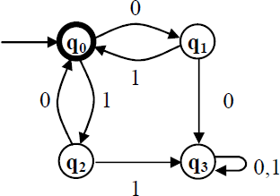Obtain a regular expression for the FA shown below:
12. Consider the DFA given below. Give all the regular expressions Rij(2).

|  |  |  |
| --- | --- | --- |
| ᵟ | 0 | 1 |
| ->A | B | A |
| B | B | C |
| *C | C | B |

1. State and prove pumping lemma for regular language.
2. Prove that L={w|w is a palindrome on {a,b}*} is not regular. i.e., L={aabaa, aba,abbbba,…
3. Write down the closure properties of regular languages
4. Consider the DFA given by the transition table.

|  |  |  |
| --- | --- | --- |
| ᵟ | 0 | 1 |
| ->A | B | C |
| B | C | E |
| *C | D | C |
| D | C | E |
| *E | B | E |

Construct the minimum state equivalent DFA.

1. Apply pumping lemma for the following language and prove that it is not regular. L = {0n | n is prime}