**PIZZA SALES SQL QUERIES**

KPI (Key Performance Indicator)

1. **TOTAL REVENUE**

select sum(total_price) as Total_Revenue from pizza;



1. **AVERAGE ORDER VALUE**

select sum(total_price) / count (distinct order_id) as Avg_Order_value from pizza;

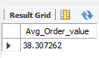

1. **TOTAL PIZZA SOLD**

select sum(quantity) as Total_pizza_sold from pizza;

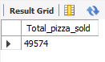

1. **TOTAL ORDERS**

select count (distinct order_id) as Total_orders from pizza;

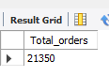

1. **AVERAGE PIZZAS PER ORDER**

select sum(quantity) / count (distinct order_id) as Avg_pizza_per_oder from pizza;

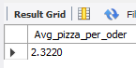

B. HOURLY TREND FOR TOTAL PIZZA SOLD

select hour(order_time) as order_hour, sum(quantity) as total_pizza_sold from pizza

group by order_hour

order by order_hour;

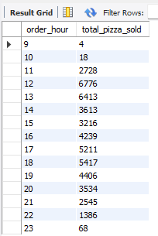

**WEEKLY TREND FOR TOTAL ORDERS**

select week (order_date, 3) as week_number, year(order_date) as order_years, count (distinct order_id) as total_orders

from pizza

group by week_number, order_years

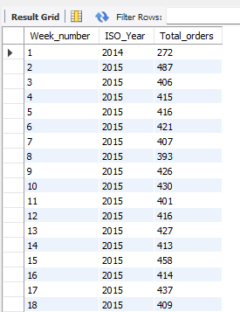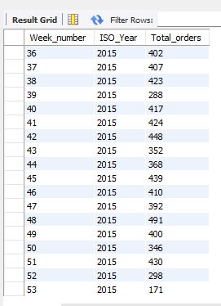order by week_number, order_years;

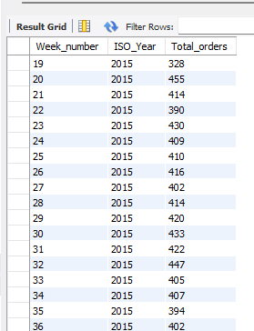

**PERCENTAGE OF SALES BY PIZZA CATEGORY:**

select pizza_category, sum(total_price) as total_price, (sum(total_price) / (select sum(total_price) from pizza)) * 100 as category_percentage from pizza group by pizza_category;

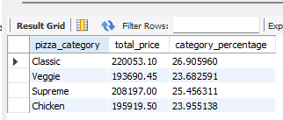

**Percentage of month wise (Extra Point)**

select pizza_category, sum(total_price) as total_price, (sum(total_price) / (select sum(total_price) from pizza where month(order_date) = 1)) * 100 as category_percentage from pizza where month(order_date) = group by pizza_category

PERCENTAGE OF SALES BY PIZZA SIZE

select pizza_size, sum(total_price) as total_price, cast((sum(total_price) / (select sum(total_price) from pizza)) * 100 as decimal (10,2)) as category_percentage from pizza group by pizza_size;

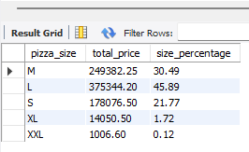

PERCENTAGE OF SALES BY PIZZA SIZE QUARTER WISE

select pizza_size, sum(total_price) as total_price, (sum(total_price) / (select sum(total_price) from pizza where quarter(order_date) = 1)) * 100 as category_percentage from pizza where quarter(order_date) = 1 group by pizza_size;

**TOP 5 PIZZA NAMES**

select pizza_name, sum(total_price) as Total_revenue from pizza group by pizza_name order by total_revenue desc limit 5;

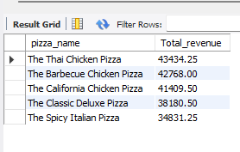

**BOTTOM 5 PIZZA NAMES**

select pizza_name, sum(total_price) as Total_revenue from pizza group by pizza_name order by total_revenue limit 5;

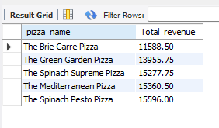

**TOP 5 PIZZA QUANTITY**

select pizza_name, sum(quantity) as Total_quantity from pizza group by pizza_name order by total_quantity desc limit 5 ;

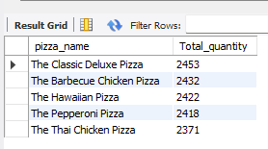

**BOTTOM 5 QUANTITY**

select pizza_name, sum(quantity) as Total_quantity from pizza group by pizza_name order by total_quantity limit 5;

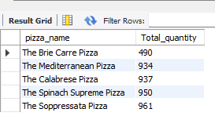

**TOP 5 PIZZA ORDER**

select pizza_name, count (distinct order_id) as Total_orders from pizza group by pizza_name order by total_orders desc limit 5;

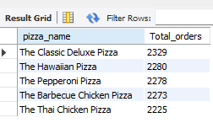

**BOTTOM 5 PIZZA ORDERS**

select pizza_name, count (distinct order_id) as Total_orders from pizza group by pizza_name order by total_orders limit 5;

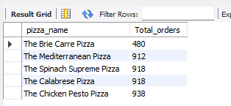

***NOTE***

If you want to apply the pizza_category or pizza_size filters to the above queries you can use where clause. follow some of below examples

select top 5 pizza_name, count(distinct order_id) as total_orders

from pizza_sales

where pizza_category = 'classic'

group by pizza_name

order by total_orders asc;