F1Next
Machine Learning-Based Formula 1 Race and Championship Prediction

Machine Learning Project Report
Review 1 - Regression and Classification Part A

1. Project Overview
F1Next is a machine learning project designed to predict Formula 1 race performance using historical race results, qualifying performance, driver statistics, and constructor statistics. The project explores regression models for predicting finishing position and classification models for predicting whether a driver finishes on the podium.

2. Project Objectives
- Predict a driver's finishing position using historical F1 data.
- Classify whether a driver achieves a podium finish.
- Compare multiple regression and classification algorithms.
- Evaluate models using appropriate performance metrics.
- Identify features that contribute to predicted race performance.

3. Dataset Description
The dataset contains Formula 1 race and qualifying records from 2010 to 2025. Race results and qualifying data were merged using season, round, and driver ID.
Total records: 6,911
Total columns in the final dataset: 35

4. Data Preprocessing
- Combined race results and qualifying datasets.
- Checked dataset shape, column types, missing values, and duplicate records.
- Handled missing qualifying positions using the starting grid position.
- Sorted records chronologically by season, round, and date.
- Created historical driver performance features using previous race data.
- Created season-to-date driver and constructor statistics.
- Created career experience features.
- Created the binary podium target: 1 for a top-three finish, otherwise 0.
- Checked feature outliers using the IQR method and retained valid F1 extremes.
- Applied StandardScaler, fitting it only on the training data.

5. Feature Engineering
The project uses qualifying position, grid position, previous finishing results, historical averages, recent five-race performance, season-to-date statistics, constructor performance, and driver career experience.
Historical features were shifted to use information from previous races rather than the current race outcome. This helps prevent target leakage.

6. Dataset Split
Dataset | Seasons | Records
Training | 2010–2023 | 5953
Validation | 2024 | 479
Testing | 2025 | 479
Future prediction | 2026 | Not included in training/testing

A chronological split was used to reflect the forecasting task: older seasons are used for training, followed by validation on 2024 and testing on 2025.

7. Exploratory Data Analysis (EDA)
EDA was performed to understand the distribution of race results, feature values, class balance, and relationships between variables.
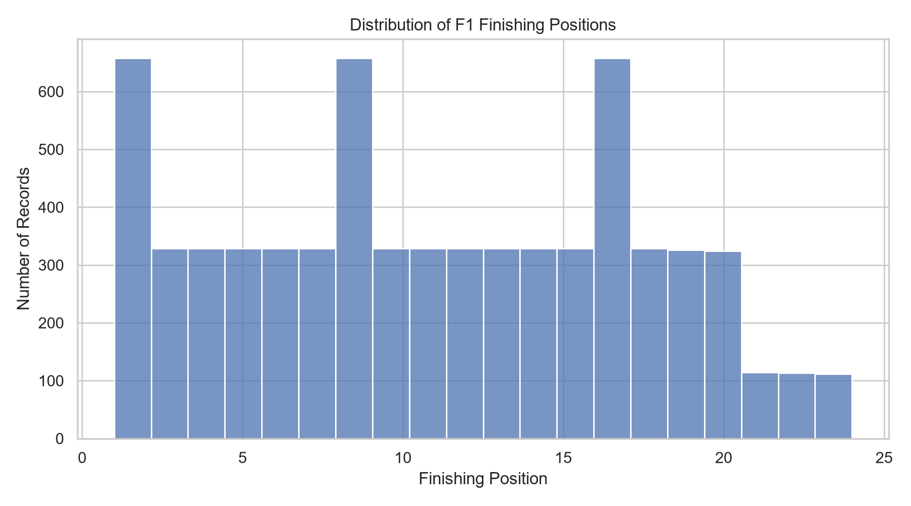
Figure 1. Distribution of finishing positions.
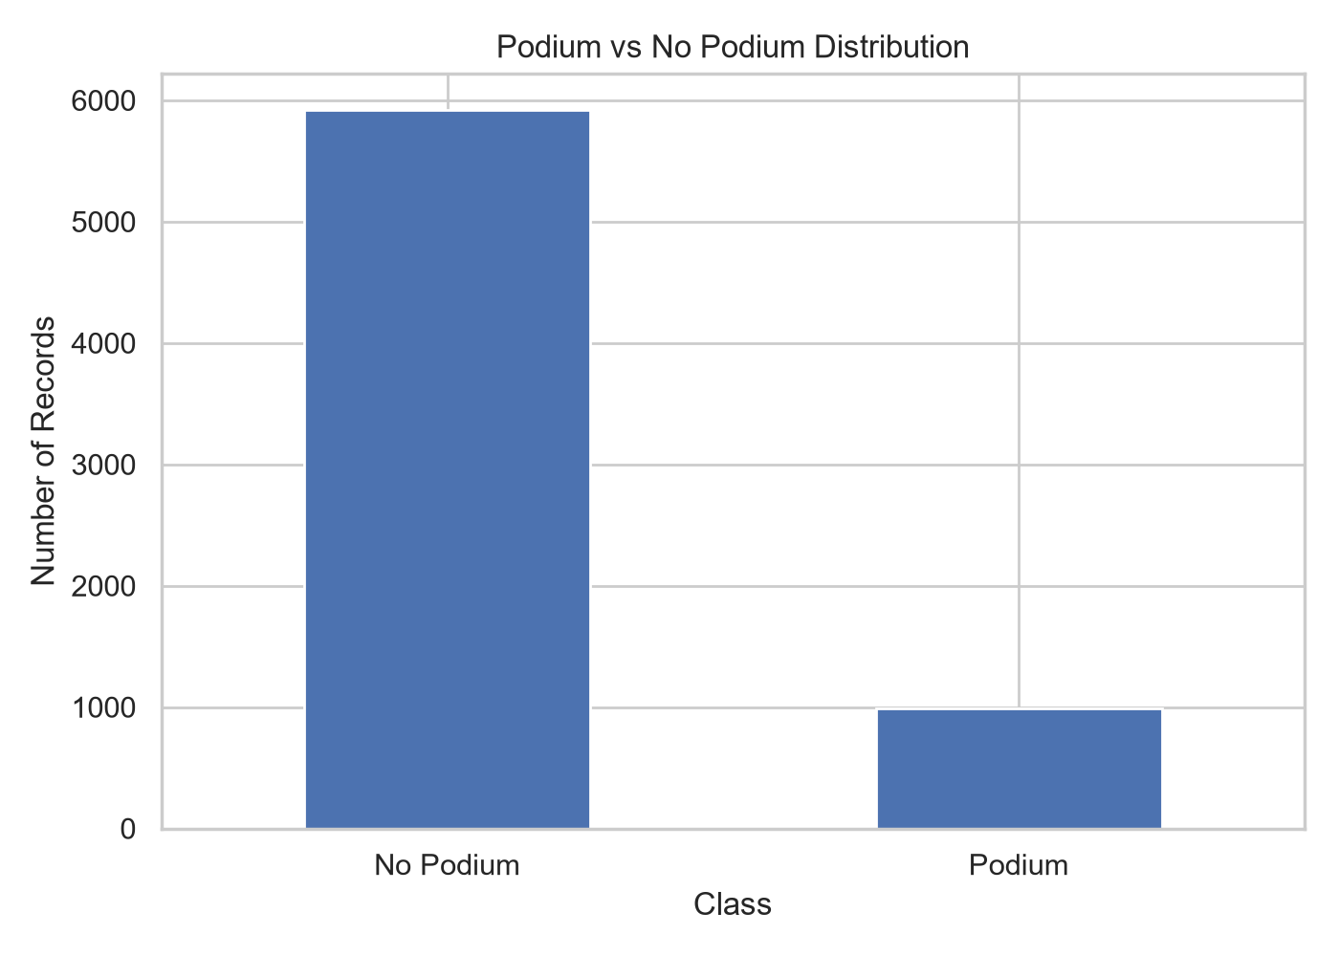
Figure 2. Distribution of podium and non-podium outcomes.
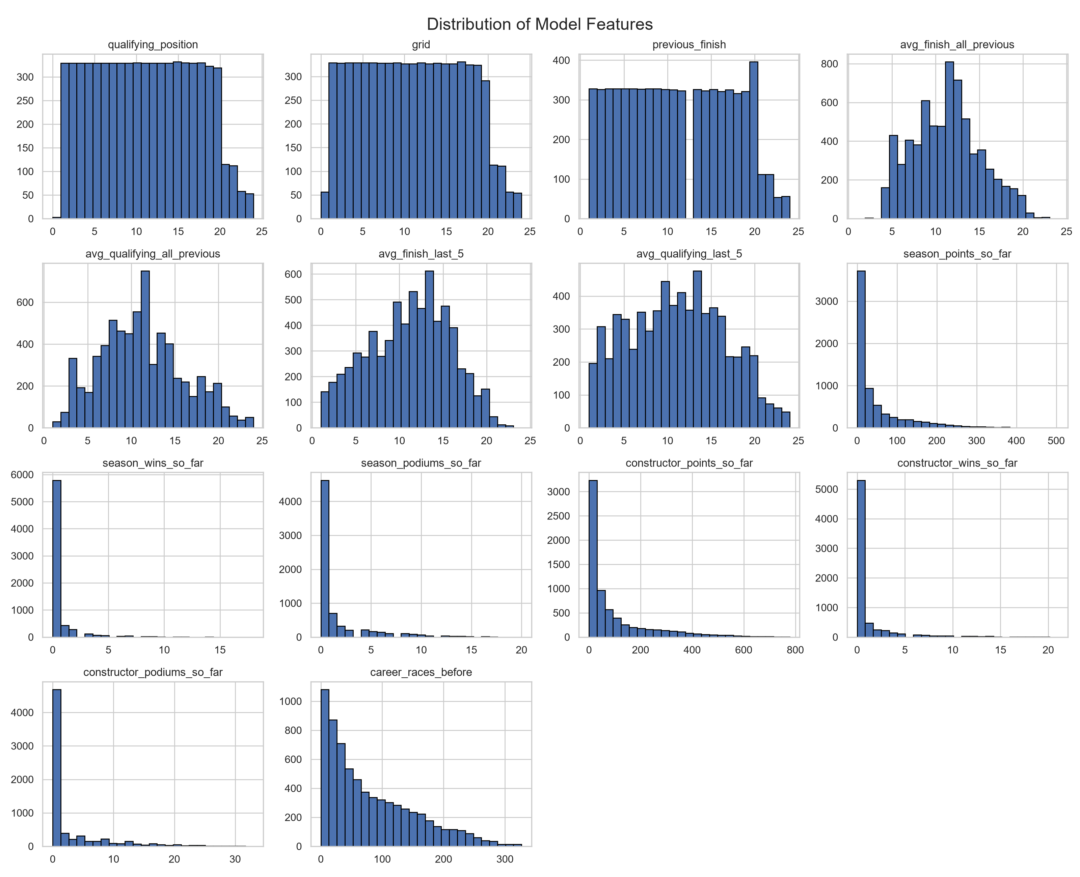
Figure 3. Distributions of the numerical model features.
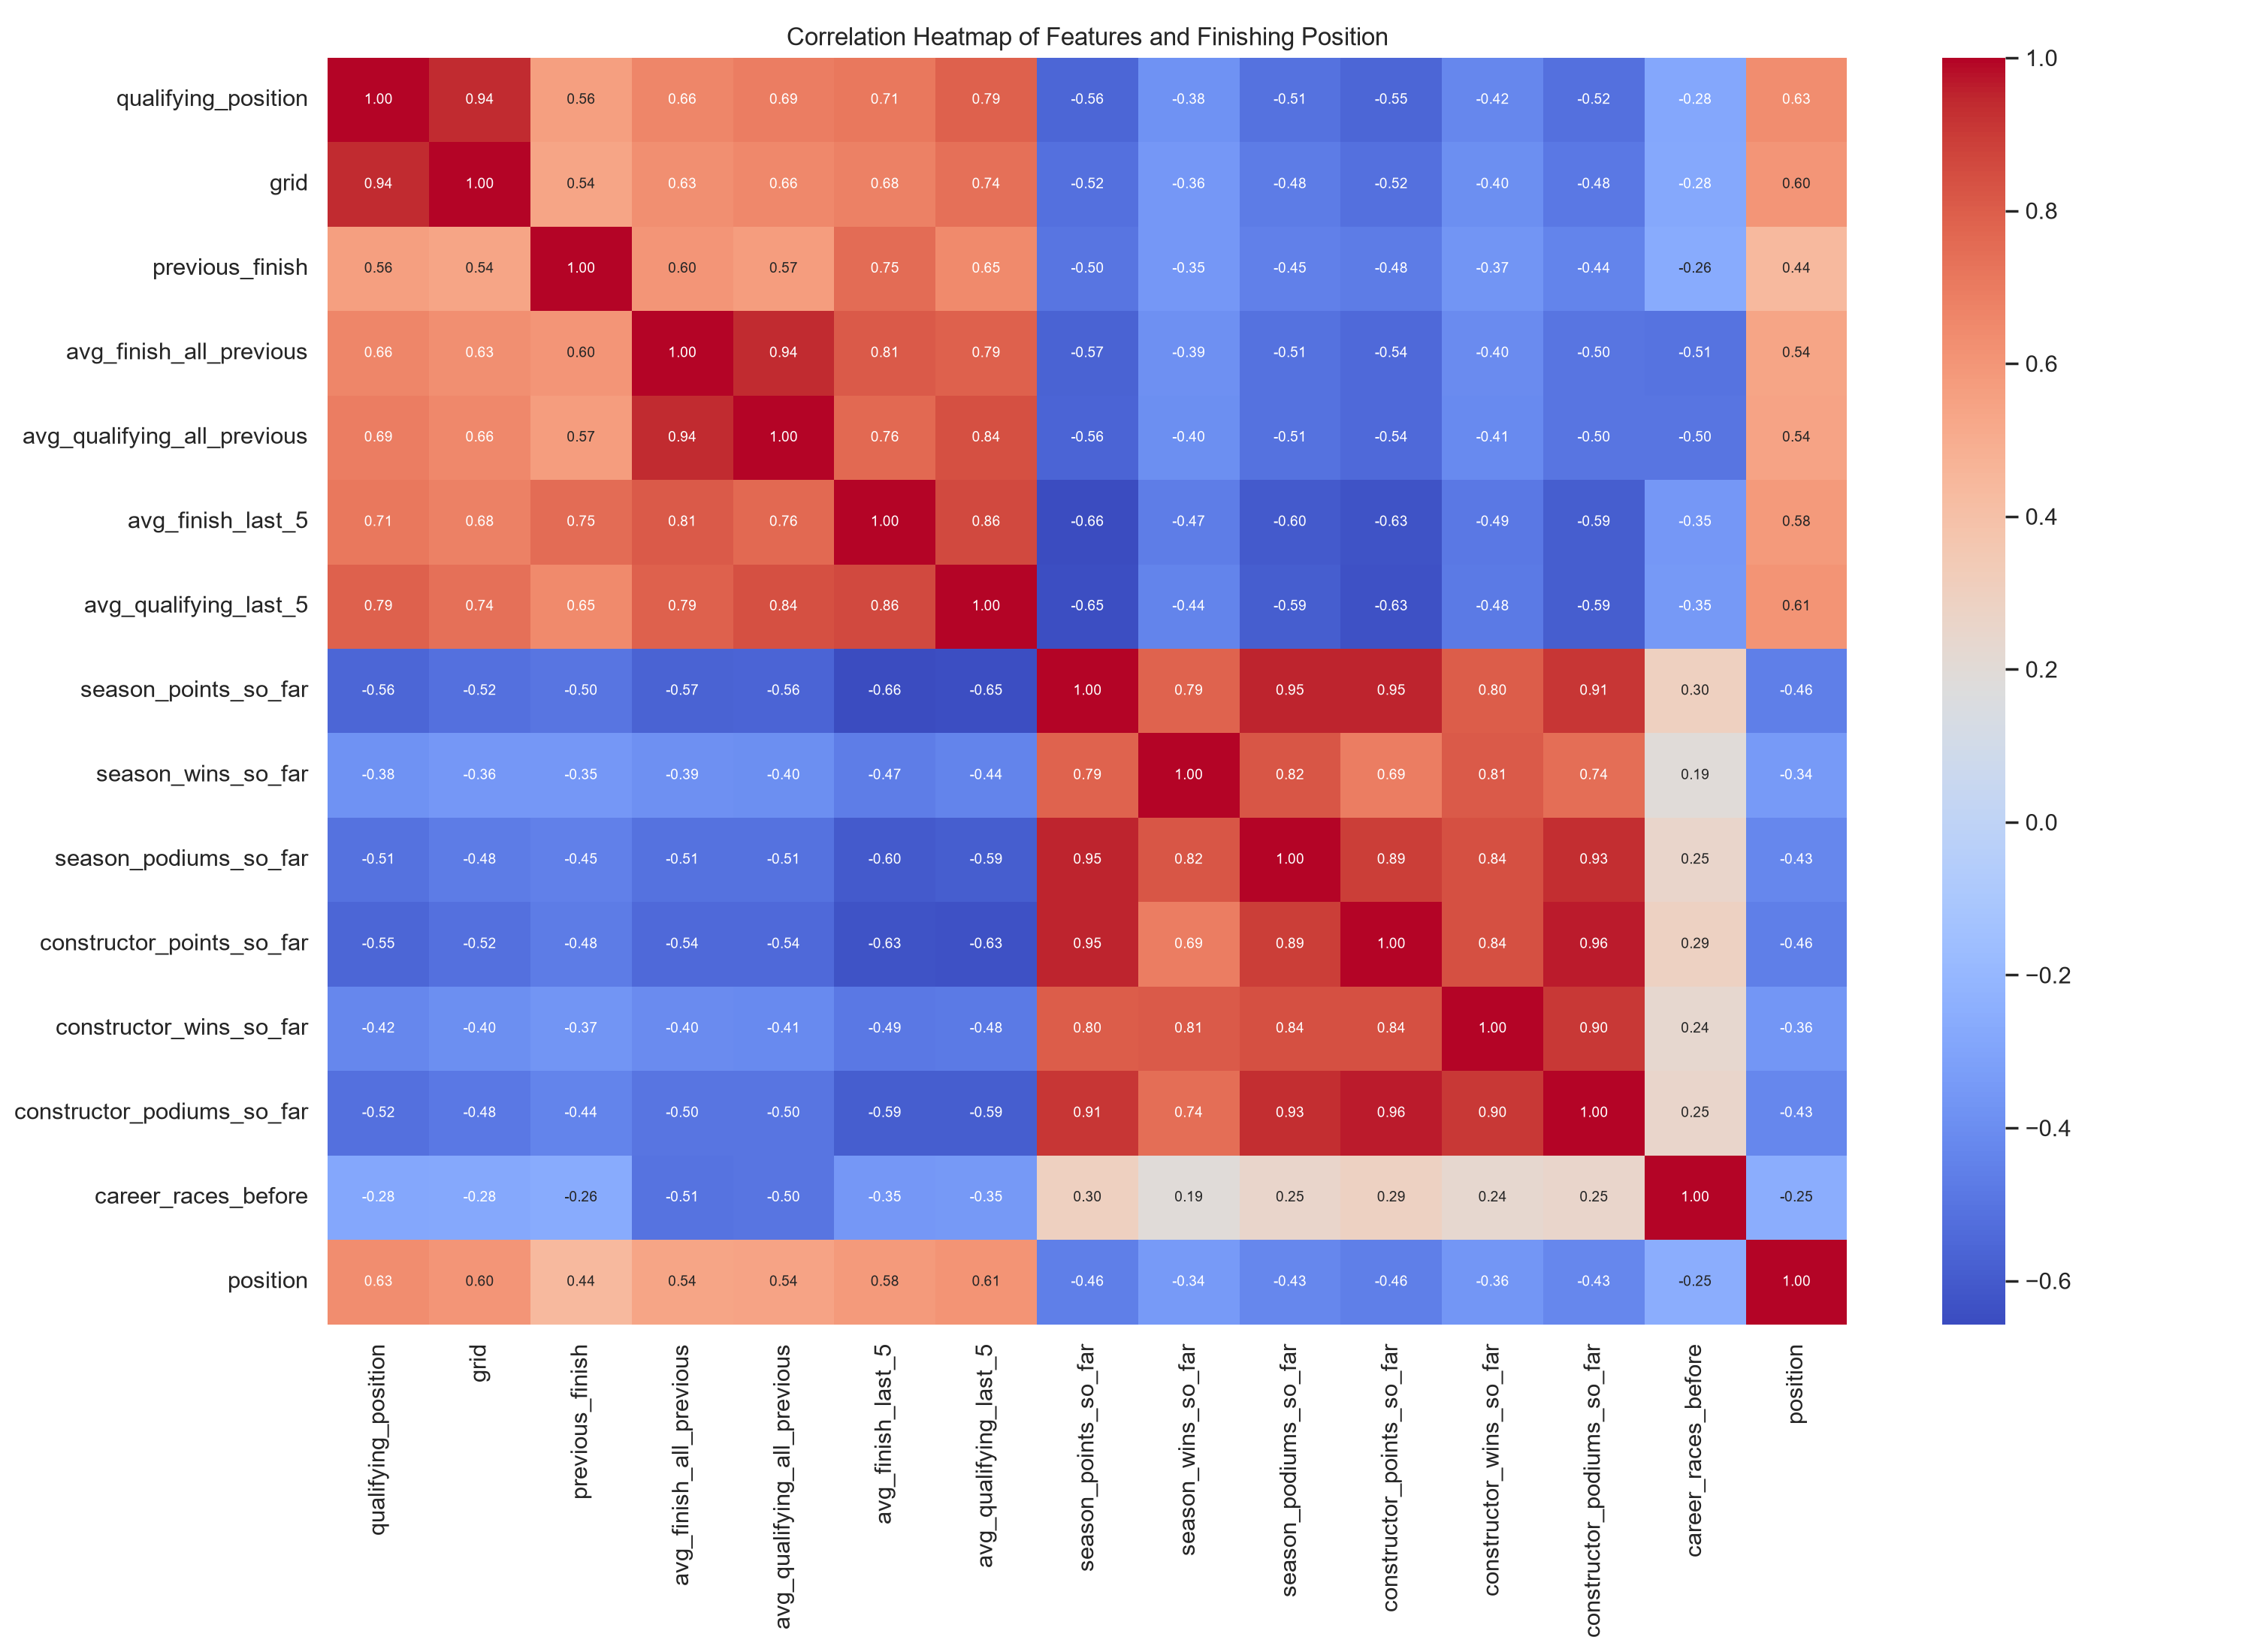
Figure 4. Correlation heatmap of model features and finishing position.
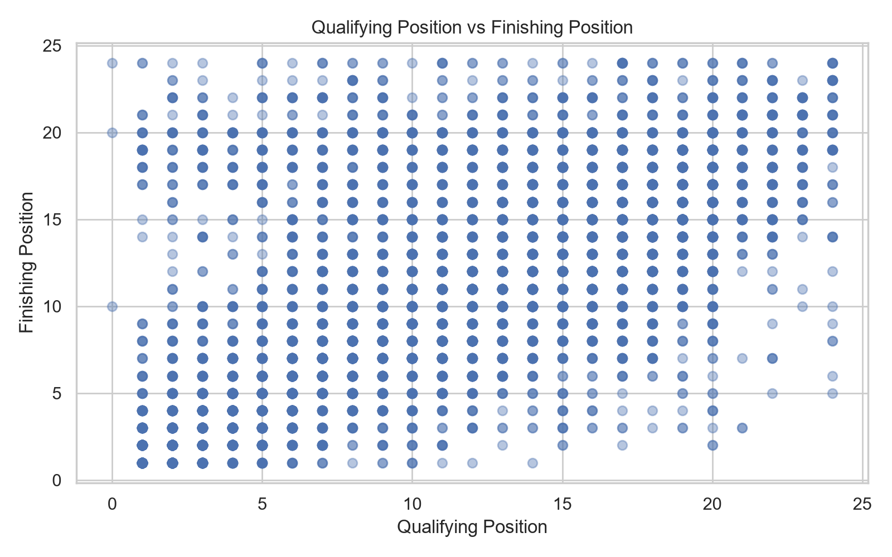
Figure 5. Relationship between qualifying position and finishing position.
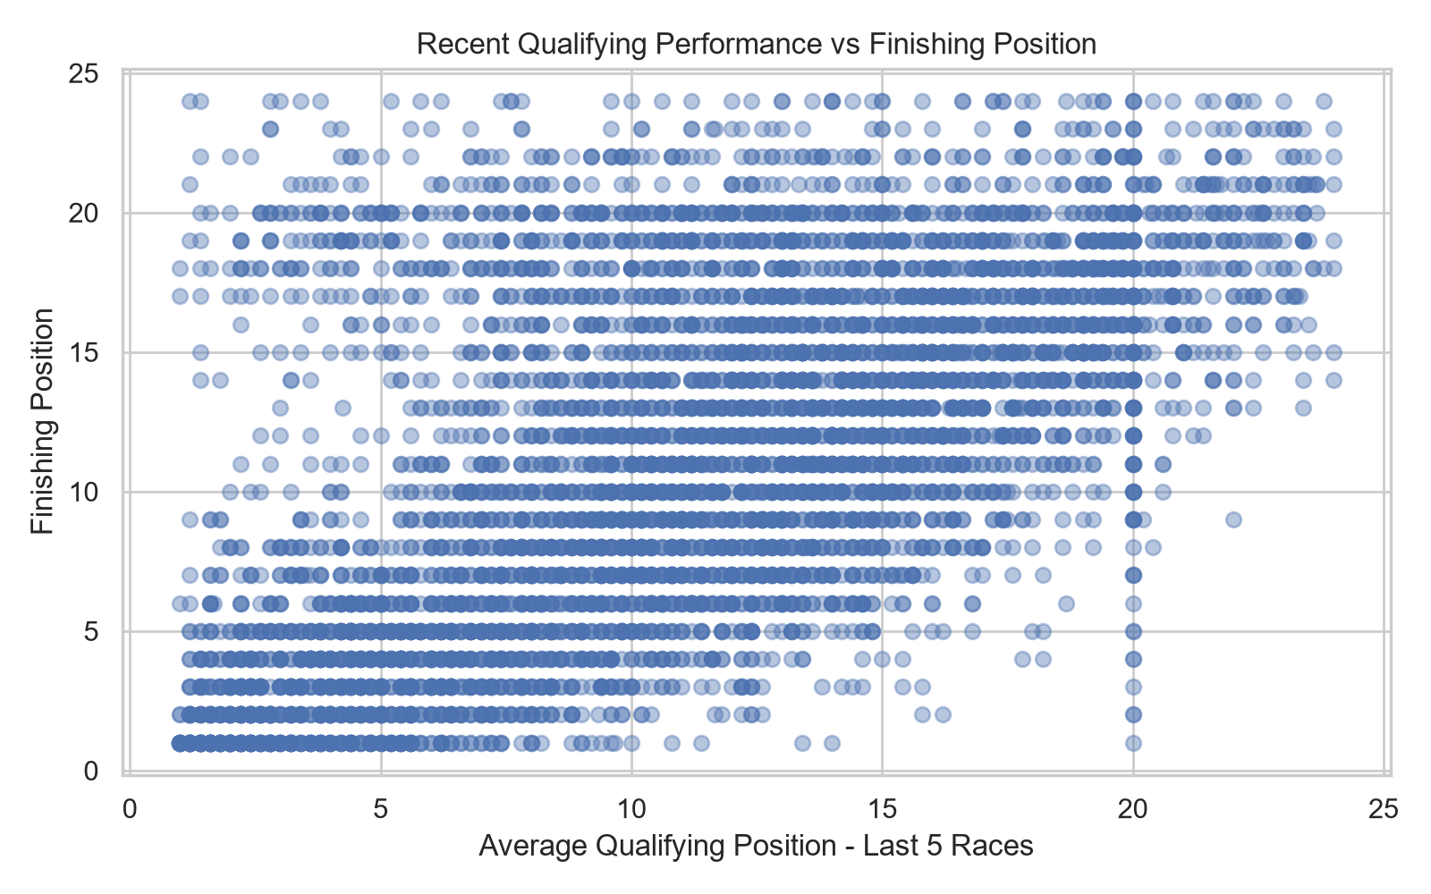
Figure 6. Relationship between recent qualifying performance and finishing position.

8. Regression Models
Ten regression algorithms were trained using the 2010–2023 training data. Their initial comparison was performed using the 2024 validation dataset. The evaluation metrics were R², RMSE, and MAE.
Model | R2 | RMSE | MAE
Lasso Regression | 0.5670 | 3.7874 | 2.9472
ElasticNet Regression | 0.5668 | 3.7886 | 2.9439
Ridge Regression | 0.5658 | 3.7928 | 2.9368
Linear Regression | 0.5657 | 3.7931 | 2.9368
Polynomial Regression | 0.5538 | 3.8449 | 3.0167
Gradient Boosting | 0.5317 | 3.9389 | 3.0900
Random Forest | 0.5095 | 4.0311 | 3.1600
KNN Regressor | 0.4362 | 4.3218 | 3.3712
SVR | 0.4312 | 4.3410 | 3.1816
Decision Tree | -0.2615 | 6.6494 | 4.8343

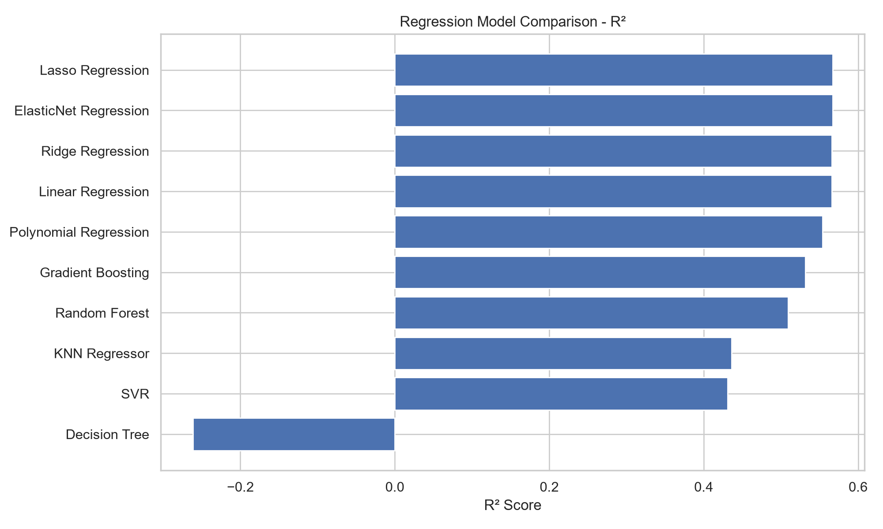
Figure 7. R² comparison across regression models.
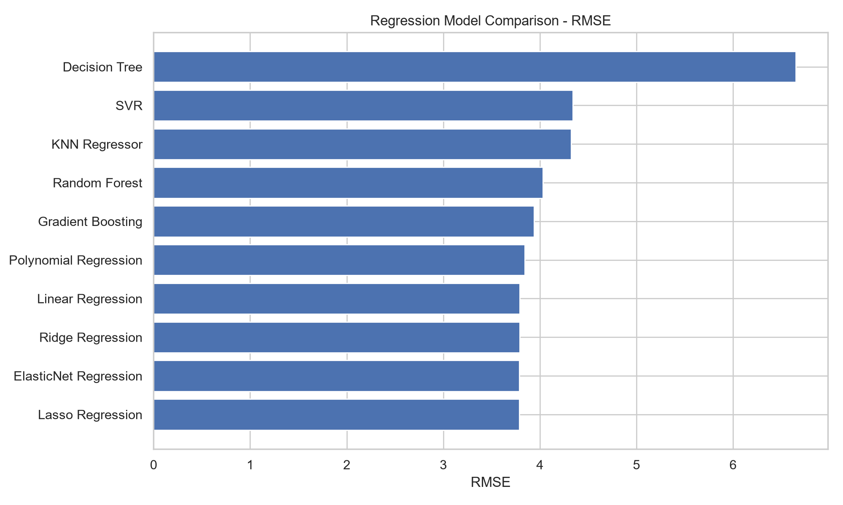
Figure 8. RMSE comparison across regression models.

9. Cross-Validation and Hyperparameter Tuning
Five-fold cross-validation was conducted for Lasso and ElasticNet. Hyperparameter tuning was performed using GridSearchCV.

Cross-validation results
Model | Mean CV R²
Lasso | 0.4122
ElasticNet | 0.4133

Best hyperparameters
Model | Best Parameters | Best CV R²
Lasso | alpha = 0.05 | 0.4150
ElasticNet | alpha = 0.05, l1_ratio = 0.9 | 0.4150

Tuned model validation results
Model | R² | RMSE | MAE
Tuned Lasso | 0.5676 | 3.7849 | 2.9587
Tuned ElasticNet | 0.5675 | 3.7856 | 2.9582

10. Regression Final Test Result
Model | R² | RMSE | MAE
Tuned Lasso | 0.4518 | 4.2618 | 3.1280

The final test result shown above is from the 2025 test dataset. The tuned Lasso model achieved an R² of 0.4518, RMSE of 4.2618, and MAE of 3.1280.

11. Feature Importance
Random Forest feature importance was used to examine which input features contributed most to the model's predictions. Qualifying position had the largest reported importance.
Feature | Importance
qualifying_position | 0.3567
avg_qualifying_last_5 | 0.1248
avg_finish_all_previous | 0.0775
avg_finish_last_5 | 0.0708
avg_qualifying_all_previous | 0.0693
career_races_before | 0.0641
constructor_points_so_far | 0.0608
previous_finish | 0.0469
season_points_so_far | 0.0418
grid | 0.0396
constructor_podiums_so_far | 0.0180
season_podiums_so_far | 0.0130
constructor_wins_so_far | 0.0092
season_wins_so_far | 0.0073

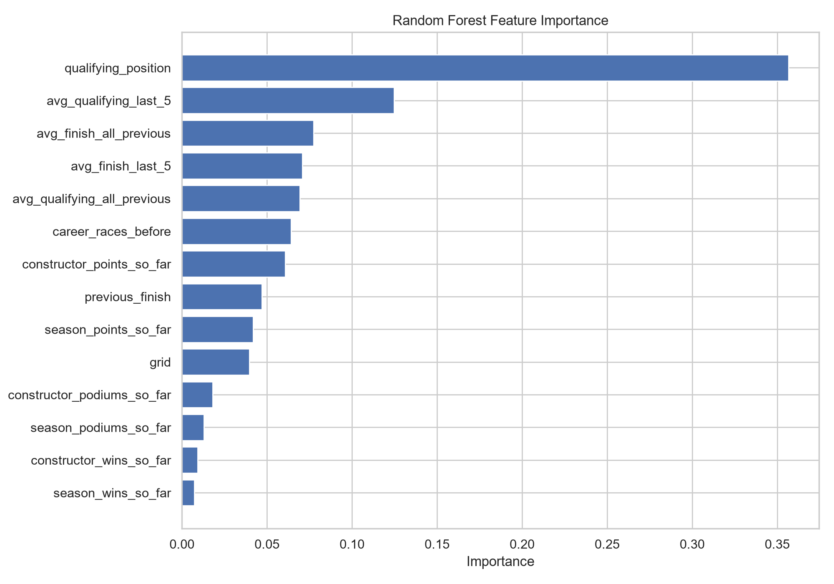
Figure 9. Random Forest feature importance.

12. Classification Models
The classification task predicts whether a driver finishes in the top three. The target is 1 for a podium finish and 0 otherwise.
Five algorithms were evaluated: Logistic Regression, K-Nearest Neighbors, Gaussian Naive Bayes, Decision Tree, and Support Vector Classifier. Metrics include Accuracy, Weighted F1, and ROC-AUC.
Model | Accuracy | Weighted F1 | ROC-AUC
Logistic Regression | 0.8310 | 0.8760 | 0.9210
SVC | 0.8310 | 0.8810 | 0.9280
KNN | 0.8430 | 0.8620 | 0.8690
Gaussian Naive Bayes | 0.8058 | 0.8260 | 0.8260
Decision Tree | 0.8539 | 0.8577 | 0.7425

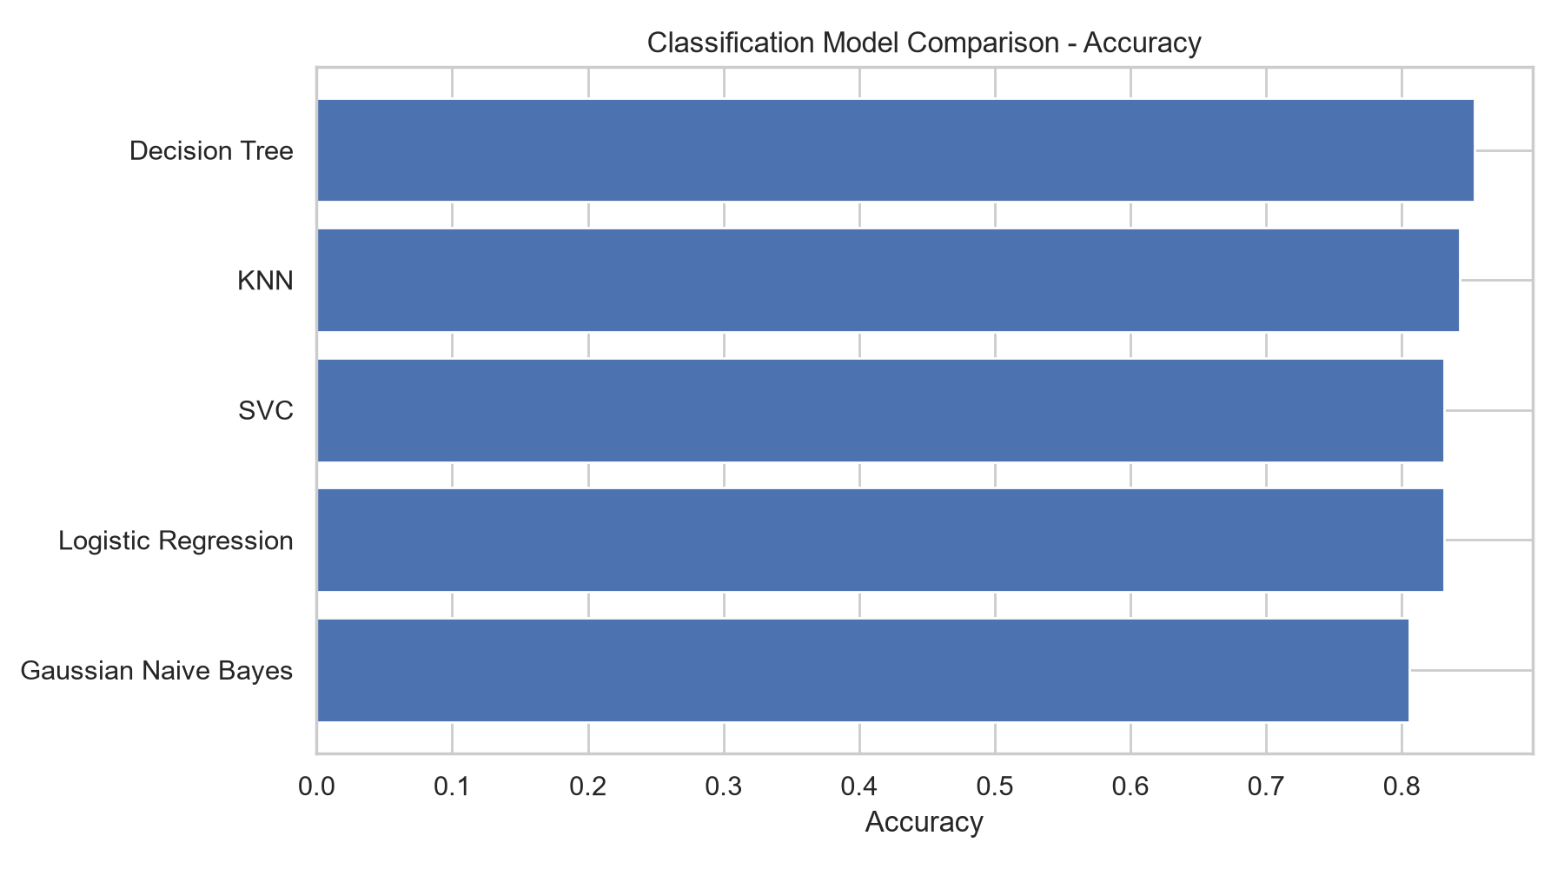
Figure 10. Classification model accuracy comparison.

13. Model Selection Summary
For regression, Lasso and ElasticNet were among the strongest models in the initial 2024 validation comparison and were selected for cross-validation and hyperparameter tuning. Tuned Lasso was evaluated on the 2025 test dataset.
For classification, all five required algorithms were compared using Accuracy, Weighted F1, and ROC-AUC. The model selection should consider the podium class imbalance and the project's evaluation requirements.

14. Conclusion
F1Next combines historical race results, qualifying information, and driver and constructor performance statistics to predict Formula 1 finishing positions and podium outcomes. The project completed data preprocessing, feature engineering, exploratory data analysis, regression model comparison, classification model comparison, and initial model tuning. Further work can include the remaining classification algorithms and clustering tasks required for the next review.

15. Tools and Technologies
- Python
- Pandas and NumPy
- Matplotlib and Seaborn
- Scikit-learn
- Jupyter Notebook
- Microsoft Word document generation using python-docx

