AGRIMARKET DDL STATEMENTS
MIS : 111803136
Name : Siddhika Santoshkumar Bejekar
College of Engineering, Pune

Agrimarket Database Tables:
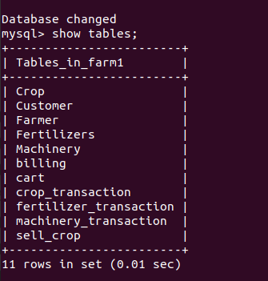

1) Farmer Table
create table Farmer
(Farmer_ID varchar(7),
Farmer_name varchar(20) not null,
Mobile_no numeric(10,0),
Email_ID varchar(20),
City varchar(10),
Password varchar(20),
primary key (Farmer_ID));
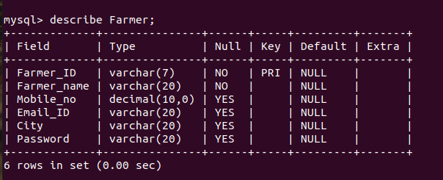

2) Customer Table
create table Customer
(Customer_ID varchar(7),
Customer_name varchar(20) not null,
Mobile_no numeric(10,0),
Email_ID varchar(20),
City varchar(10),
Password varchar(20),
primary key (Customer_ID));
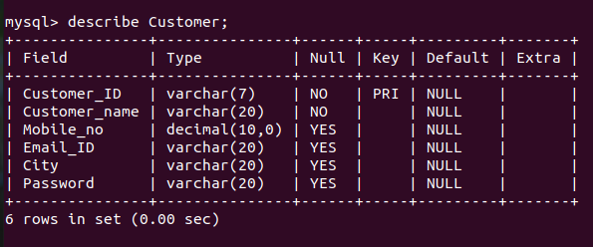

3)Crops Table

create table Crop
(Crop_ID varchar(7),
Crop_name varchar(20) not null,
Quantity numeric(3,2),
Primary key (Crop_ID));
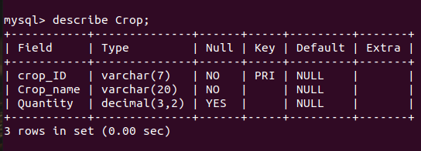

4)Crop sell table
create table sell_crop
(Crop_ID varchar(7),
Farmer_ID varchar(7),
Price numeric(5,2),
primary key (Crop_ID, Farmer_ID),
foreign key (Crop_ID) references Crop(Crop_ID) on delete cascade,
foreign key (Farmer_ID) references Farmer(Farmer_ID) on delete cascade);
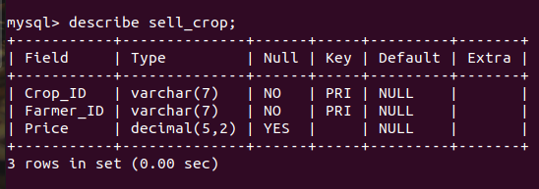

5) Machinery Table
create table Machinery
(Machine_ID varchar(7),
Machine_name varchar(10),
Company varchar(15),
Price numeric(7,2),
primary key (Machine_ID));
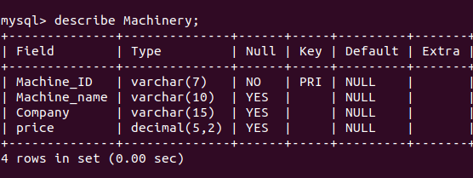

6) Fertilizer table
create table Fertilizer
(Fertilizer_ID varchar(7),
Fertilizer_name varchar(20) not null,
Component varchar(10),
Price numeric(7,2),
primary key (fertilizer_ID));
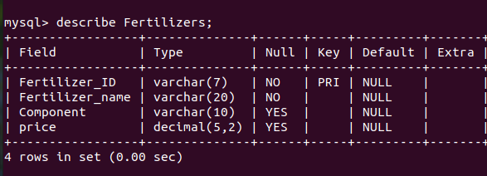

7) Crop_Transaction table
create table crop_transaction
(trans_IDc varchar(7),
Customer_ID varchar(7),
Crop_ID varchar(7),
Farmer_ID varchar(7),
primary key (trans_IDc),
foreign key (Customer_ID) references Customer(Customer_ID) on delete cascade,
foreign key (Crop_ID) references Crop(Crop_ID) on delete cascade,
foreign key (Farmer_ID) references Farmer(Farmer_ID) on delete cascade);
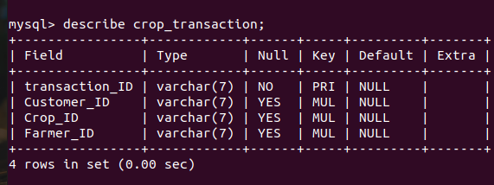

7)Machinery_Transaction table
create table machinery_transaction
(trans_Idm varchar(7),
Machine_ID varchar(7),
Customer_ID varchar(7),
primary key (trans_IDm),
foreign key(Machine_ID) references Machinery(Machine_ID) on delete cascade,
foreign key(Customer_ID) references Customer(Customer_ID) on delete cascade);
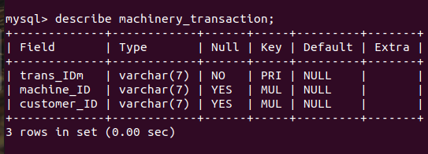

8)Fertilizer_Transaction table
create table fertilizer_transaction
(trans_Idf varchar(7),
Fertilizer_ID varchar(7),
Customer_ID varchar(7),
primary key (trans_IDf),
foreign key (Fertilizer_ID) references Fertilizer(Fertilizer_ID) on delete cascade,
foreign key(Customer_ID) references Customer(Customer_ID) on delete cascade);
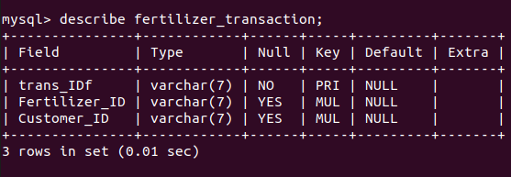

9)Cart Table
create table cart
(bill_ID varchar(7),
transaction_ID varchar(7),
amount numeric(5,2),
primary key (bill_ID, transaction_ID));
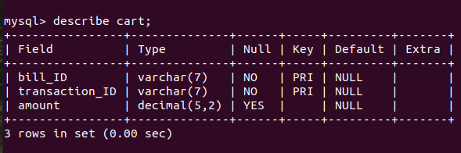

10)Billing Table
create table billing
(bill_ID varchar(7),
Customer_ID varchar(7),
Amount numeric(7,2),
Card_no int,
Card_name varchar(20),
Expiry int,
CVV numeric(3,0),
primary key(bill_ID),
foreign key(bill_ID) references cart(bill_ID) on delete cascade,
foreign key(Customer_ID) references Customer(Customer_ID) on delete cascade);
