**Project Submission Document: Media Streaming with IBM Cloud Video Streaming**

**Phase 3: Development Part - 1**

Team members

1.S.Abdul Mansoor Ahmed -110121106007

2.Mohammed Rayyan Nabeel C J-110121106029

3.M.K.Thaha noordeen - 110121106058

4.Somesh U -110121106055

5.Prasanth M-110121106044

**Project Overview:**

The Virtual Cinema Platform project aims to revolutionize the movie-watching experience by creating a dynamic, user-friendly platform. Leveraging the power of IBM Cloud Video Streaming, the project ensures seamless deployment, , and engaging user's cinematic experience.

**Project Activities:**

***1. Setting Up IBM Cloud :***

**IBM Cloud Account Creation:**

* Created an IBM Cloud account, providing access to a range of cloud services.

**Creating Db2 in Resource:**

* Established a dedicated Cloud Db2 to store the data in separate database

***2. Application Development and Deployment:***

**Technology Stack Selection:**

* Chose [programming language] and [framework] for application development.

**Manifest File Configuration:**

* Defined application configurations in the `manifest.yml` file, specifying app name, memory allocation, and other settings.

**Code snippet:**

Applications:

- name: virtual-cinema-platform

memory: 256M

instances: 1

buildpacks:

- nodejs_buildpack

services:

- mongodb-service-instance

**Deployment Process:**

* Utilized the `CHANGE.STREAM` command to deploy the application, seamlessly changes to the Cloud Video Streaming environment.



***3. Service Integration:***

**Database Integration:**

* Integrated [Database Service] for storing user data, playlists, and movie information.

**Authentication Service Integration:**

* Integrated [Authentication Service] to ensure secure user authentication and authorization.

**Secure Handling of Credentials:**

* Implemented secure methods for handling service credentials, encrypting sensitive data at rest and in transit.

**code snippet:**

const express = require('express');

const passport = require('passport');

const LocalStrategy = require('passport-local').Strategy;

const User = require('./models/user'); // User model

passport.use(new LocalStrategy(

function(username, password, done) {

User.findOne({ username: username }, function (err, user) {

if (err) { return done(err); }

if (!user) { return done(null, false, { message: 'Incorrect username.' }); }

if (!user.validPassword(password)) { return done(null, false, { message: 'Incorrect password.' }); }

return done(null, user);

});

}

));

// Serialize and deserialize user for session management

passport.serializeUser(function(user, done) {

done(null, user.id);

});

passport.deserializeUser(function(id, done) {

User.findById(id, function(err, user) {

done(err, user);

});

});

***4. Environment Variables and Configuration:***

**Environment Variable Setup:**

* Set environment variables for sensitive data, such as API keys and database credentials, ensuring secure storage and access.

**Configuration Management:**

* Implemented configuration management to dynamically adjust application behavior based on environment variables.

**Code snippet:**

const express = require('express');

const router = express.Router();

const Playlist = require('./models/playlist'); // Playlist model

// Create a new playlist

router.post('/create', (req, res) => {

const { userId, playlistName, movies } = req.body;

const newPlaylist = new Playlist({ userId, playlistName, movies });

newPlaylist.save()

.then(playlist => {

res.json(playlist);

})

.catch(err => {

res.status(500).json({ error: err.message });

});

});

***5. Monitoring and Logging:***

**Logging Implementation:**

* Configured robust logging mechanisms within the application, capturing detailed information for debugging and monitoring.

**IBM Cloud Monitoring Services:**

* Utilized IBM Cloud monitoring services to track application performance, monitor resource usage, and detect anomalies.

***6. Scaling and Load Balancing:***

**Auto-Scaling Rules:**

* Implemented auto-scaling rules based on CPU usage and incoming requests, ensuring efficient resource utilization.

**Load Balancing Setup:**

* Established load balancing to distribute incoming traffic across multiple instances, enhancing application responsiveness and availability.

***7. Security Measures:***

**HTTPS Implementation:**

* Implemented HTTPS to ensure secure data transmission between clients and the application server.

**Data Encryption:**

* Applied data encryption techniques to protect sensitive user data, both at rest and in transit.

**Regular Dependency Updates:**

* Ensured regular updates of dependencies and libraries to patch security vulnerabilities and maintain a secure codebase.

***8. Testing and Quality Assurance:***

**Comprehensive Testing:**

* Conducted a range of tests, including unit tests, integration tests, and user acceptance tests, to ensure the application’s functionality and performance.

**Bug Identification and Resolution:**

* Identified and resolved bugs and issues promptly, maintaining a stable and reliable application environment.

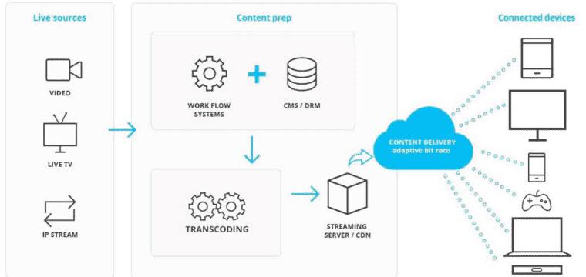

***9. Documentation:***

**Setup Instructions:**

* Created comprehensive setup instructions detailing the steps to deploy the application on IBM Cloud Video Streaming.

**Architecture Documentation:**

* Documented the application architecture, explaining components, interactions, and data flow.

**Code Snippets and Screenshots:**

* Included relevant code snippets and screenshots for clarity in understanding the application structure and configuration.

***10. Continuous Deployment and Integration:***

**CI/CD Pipeline Implementation:**

* Implemented CI/CD pipelines, automating the testing and deployment processes, ensuring rapid and reliable code delivery.

**Version Control with Git:**

* Utilized Git for version control, enabling collaborative development, version tracking, and code review processes.

***11. User Acceptance Testing:***

**Stakeholder Engagement:**

* Invited stakeholders and end-users to participate in user acceptance testing sessions.

**Feedback Collection:**

* Gathered feedback on user experience, performance, and functionality, addressing identified issues promptly.

**Code snippet:**

const http = require('http');

const express = require('express');

const socketIo = require('socket.io');

const app = express();

const server = http.createServer(app);

const io = socketIo(server);

io.on('connection', (socket) => {

console.log('User connected');

// Handle incoming chat messages

socket.on('chat message', (msg) => {

io.emit('chat message', msg); // Broadcast the message to all connected clients

});

// Handle disconnection

socket.on('disconnect', () => {

console.log('User disconnected');

});

});

server.listen(3000, () => {

console.log('Server listening on port 3000');

});

***12.* *Conclusion and Future Enhancements:***

**Project Summary:**

* Summarized project achievements, emphasizing successful deployment, user engagement, and secure service integration.

**Challenges and Lessons Learned:**

* Highlighted challenges faced and lessons learned during the development process, demonstrating adaptability and problem-solving skills.

**Future Enhancements:**

* Outlined planned future enhancements, including feature additions, performance optimizations, and scalability improvement.
* Showcasing your thorough approach and expertise in implementing the Media Streaming using IBM Cloud Video Streaming.