Prompt Analytics

1. Overview & Purpose
The Prompt Analytics Viewer provides request-level transparency into every AI interaction that goes through the platform. While the Observability Dashboard shows aggregate cost totals rolled up by model, user, or department, Prompt Analytics goes deeper — it records and displays every individual prompt, the response it generated, the exact cost of that single call, the response latency, and whether any safety issues were flagged.

This module answers questions that aggregate dashboards cannot:
- Which specific prompt caused a $0.05 charge on a day that was otherwise averaging $0.002 per call?
- Is a particular model's response time degrading over time?
- Which users are sending the longest prompts?
- Are there any failed or errored calls in the last 24 hours?
- What does a specific user's actual prompt and response look like?
- How does model A compare to model B in terms of tokens consumed per call and cost per call?

The Prompt Analytics Viewer is therefore both a cost investigation tool and a quality monitoring tool — the two dimensions are closely linked because expensive calls are often the ones with unusually long prompts or responses.

2. How Data Gets Into the System
Every time a user sends a message through the AI Playground, the backend writes a complete log entry to the prompt_logs MongoDB collection. This happens automatically — the user does not need to take any action to enable logging.

Each log entry captures:
What is captured | Why it matters
The full prompt text | Allows investigation of exactly what was sent
The full response text | Allows review of what the model returned
Token counts (input + output) | Enables cost calculation
Cost in USD for that single call | Direct cost audit at the request level
Response latency in milliseconds | Performance monitoring
User identity (email + persona) | Attribution and accountability
Model name + provider | Model comparison and cost attribution
Timestamp | Time-based trend analysis
Error field | Detects failed, timed-out, or blocked requests

The prompt_logs collection is separate from usage_records and usage_daily. Those two collections store aggregated token totals for the Observability Dashboard. The prompt_logs collection stores one document per individual API call and is the sole data source for Prompt Analytics.

2.1 How Logging Works — Data Capture Flow
Every log entry in prompt_logs is created by the playground_chat endpoint in playground_routes.py. The logging is automatic and happens for every request — successful or failed.

The write to prompt_logs is the last step in the request lifecycle:

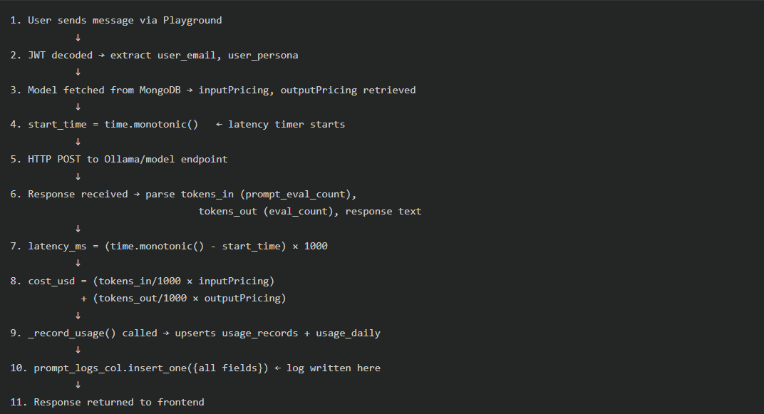

3. Page Layout & Navigation
The Prompt Analytics page uses the standard Admin layout — the AdminSidebar on the left and AdminHeader at the top, consistent with the rest of the admin interface.

All data across all tabs is fetched simultaneously from four backend endpoints when the page loads. When either the day range filter or the model search filter changes, all four data sets are re-fetched in parallel.

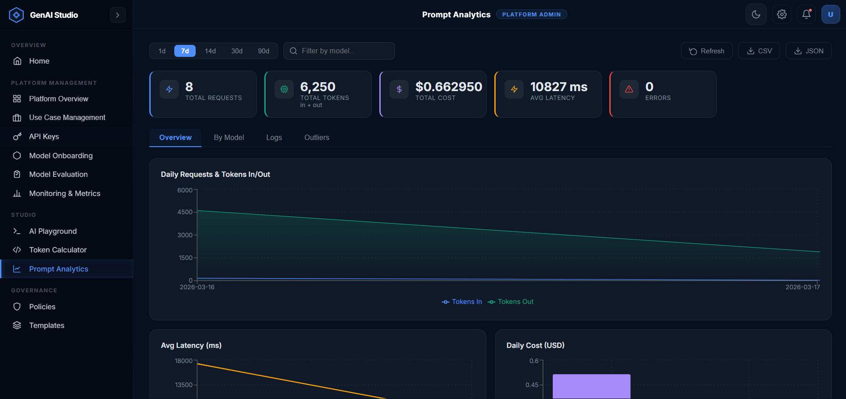

4. KPI Summary Cards
Five metric summary cards are displayed in a row below the top filter bar. These cards aggregate data from all prompt_logs records that fall within the selected time window.

The values in these cards are derived client-side by summing up the daily trend data returned from the /api/analytics/trends endpoint.

Card 1: Total Requests
- Icon: Lightning bolt
- Value: Total count of API calls recorded in the selected period
- Format: Integer with comma separators (e.g., 1,482)
- Color accent: Blue (#4E8EFF)
- Meaning: The total volume of LLM interactions processed through the Playground for the selected time range

Card 2: Total Tokens
- Icon: CPU chip
- Value: Combined total of all tokens_in + tokens_out across all log entries
- Format: Integer with comma separators (e.g., 284,610)
- Sub-label: "in + out" displayed below the value
- Color accent: Green (#10A37F)
- Meaning: The total token throughput — directly proportional to total cost

Card 3: Total Cost
- Icon: Dollar sign
- Value: Sum of cost_usd field across all log entries in the selected period
- Format: $ prefix with 6 decimal places (e.g., $0.284610)
- Color accent: Purple (#a78bfa)
- Meaning: The actual monetary cost of every Playground API call in the selected period, summed to a single dollar figure. This is cost stored at the time of the call (not recomputed from current pricing) — making it a true point-in-time cost record.

Card 4: Avg Latency
- Icon: Lightning bolt
- Value: Average of avg_latency_ms values across all trend data points
- Format: Integer milliseconds (e.g., 843 ms)
- Color accent: Amber (#f59e0b)
- Meaning: The average response time for API calls. This is an average-of-averages (daily avg latency averaged across selected days), giving a general sense of model responsiveness. Spikes in this value indicate model performance issues.

Card 5: Errors
- Icon: Alert triangle (⚠)
- Value: Total count of log entries where the error field is not null
- Format: Integer (e.g., 3)
- Color accent: Red (#ef4444)
- Meaning: The count of failed, timeout, or guardrail-blocked requests. Any non-zero value warrants investigation via the Logs or Outliers tab.

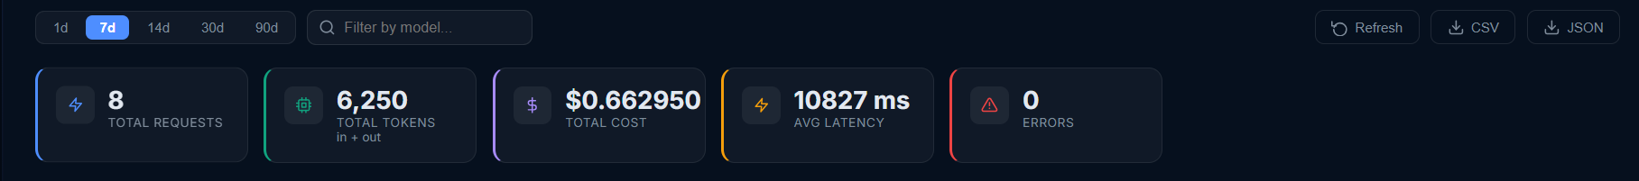

5. Filters & Search Controls
Located in the Top Bar section above the KPI cards. These controls scope all data across the entire page.

5.1 Model Search / Filter
A search input box to the right of the day buttons. Contains a search icon in the left side of the input.
- Placeholder text: "Filter by model..."
- Behavior: Filters the Logs table and the By Model table client-side (no new API call) by matching the search string against model_name (case-insensitive substring match)
- Also used: When a model name is entered and the Refresh button is clicked, the backend API calls include &model=<n> as a query parameter, which filters the trends and outliers data at the database level

5.2 Action Buttons (Top Right)
Three buttons in the top-right corner of the top bar:
Button | Action
Refresh | Re-fetches all data from all four backend endpoints using the current filter values
CSV | Opens a new browser tab that triggers the backend /api/analytics/export?format=csv download
JSON | Opens a new browser tab that triggers the backend /api/analytics/export?format=json download

6. Tab 1 — Overview
The Overview tab is the default tab shown when the page loads. It presents four charts in a 2-column grid, giving a visual summary of activity over the selected time period.

All four charts use the trends data — the daily aggregate returned by /api/analytics/trends. Each data point in these charts represents one calendar day.

6.1 Chart 1: Daily Requests & Tokens In/Out (Area Chart)
Position: Top-left, spans the full width (wide card)

What it shows: Daily volume of token consumption, split between input tokens and output tokens, plotted as stacked area curves over time.

Chart configuration:
- Chart type: Area chart (Recharts AreaChart)
- X-axis: Date (YYYY-MM-DD), one point per day
- Y-axis: Token count
- Series 1 — Tokens In: Blue line (#4E8EFF) with a blue gradient fill (30% opacity at top, fading to 0% at bottom)
- Series 2 — Tokens Out: Green line (#10A37F) with a green gradient fill (same fade pattern)
- Legend: "Tokens In" and "Tokens Out" labels shown below the chart
- Height: 220px

How to read it:
- A wide gap between the Tokens In and Tokens Out lines means prompts are much longer than responses — typical for document summarization or analysis tasks
- If Tokens Out consistently exceeds Tokens In, the model is generating very long responses to short prompts — which may indicate inefficient system prompts or overly verbose model behavior
- Spikes on specific dates correlate directly with cost spikes visible in Chart 3

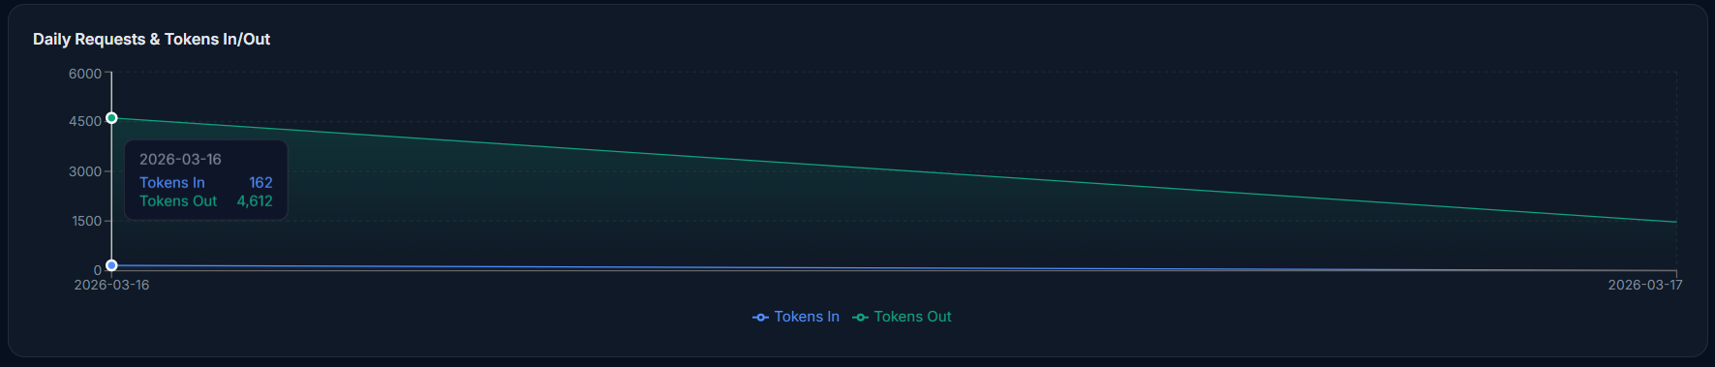

6.2 Chart 2: Avg Latency (Line Chart)
Position: Top-right

What it shows: The average response latency (in milliseconds) per day, plotted as a line.

Chart configuration:
- Chart type: Line chart (Recharts LineChart)
- X-axis: Date
- Y-axis: Milliseconds
- Line color: Amber (#f59e0b)
- Stroke width: 2px, no dots on data points
- Height: 220px

How to read it:
- A steady flat line indicates consistent model performance
- A rising trend indicates model degradation — possibly the model endpoint is being overloaded or the model server has a resource issue
- A sudden spike on one day may indicate a network issue or a particularly large request that inflated the average for that day
- Comparing latency trends across different selected time ranges helps identify whether a problem is recent or chronic

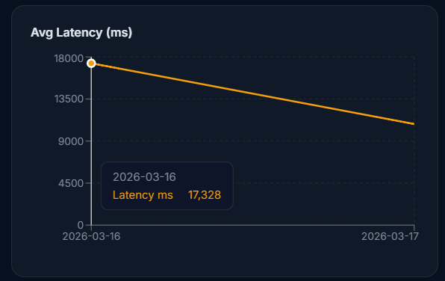

6.3 Chart 3: Daily Cost (Bar Chart)
Position: Bottom-left

What it shows: The total cost_usd charged across all requests on each calendar day, shown as vertical bars.

Chart configuration:
- Chart type: Bar chart (Recharts BarChart)
- X-axis: Date
- Y-axis: USD cost
- Bar color: Purple (#a78bfa) with rounded top corners (radius 3px)
- Height: 220px

How to read it:
- Each bar represents the actual monetary charge incurred on that specific day
- This chart is the most directly actionable for cost management — unusually tall bars on specific dates should be investigated using the Logs tab, where those dates can be filtered to find the specific expensive calls
- A consistently rising trend in bar heights indicates growing usage costs that may require budget intervention

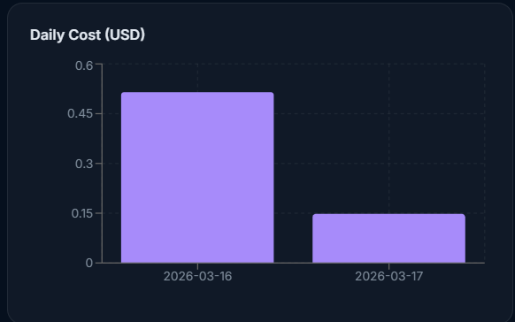

6.4 Chart 4: Requests by Model (Pie Chart)
Position: Bottom-right

What it shows: The proportional share of API call volume between different models, as a pie chart.

Chart configuration:
- Chart type: Pie chart (Recharts PieChart)
- Data key: requests (count of API calls per model)
- Name key: model_name
- Position: cx 50%, cy 50%, outer radius 80px
- Colors: Cycled from a fixed palette: Blue, Green, Orange, Purple, Amber, Pink (#4E8EFF, #10A37F, #D97757, #a78bfa, #f59e0b, #ec4899)
- Labels: Each slice is labelled with the model name (truncated to 12 characters) and its percentage of total requests
- Tooltip: Shows model name and exact request count on hover

How to read it:
- The largest slice is the most-used model by request volume
- Note: request volume share is not the same as cost share. A model with a small slice may still dominate cost if it is more expensive per token. Cross-reference with the By Model tab for cost comparison.

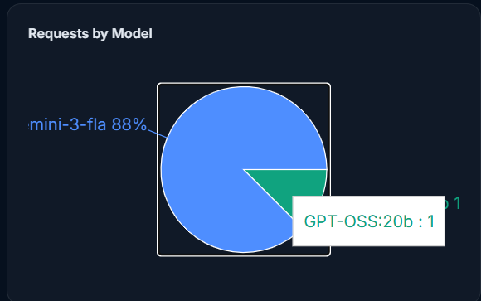

7. Tab 2 — By Model
The By Model tab presents a detailed comparison table of every model that was called during the selected time period. This is the primary tool for understanding cost and performance differences between models.

7.1 Search Filter
The model search box in the top bar filters this table client-side. Typing a partial model name immediately narrows the rows shown without a page reload.

7.2 Model Comparison Table
A full-width scrollable table with one row per model.
Columns:
Column | Source Field | Description
Model | model_name | Full model name as stored in the log. Displayed as the primary identifier cell, often styled distinctly for readability
Provider | provider | Provider name displayed as a small badge (e.g., "ollama", "openai"). The badge styling distinguishes providers visually
Requests | requests | Total number of API calls made to this model in the selected period
Tokens In | tokens_in | Total input tokens sent to this model across all calls
Tokens Out | tokens_out | Total output tokens generated by this model across all calls
Avg Latency | avg_latency_ms | Average response time in milliseconds across all calls to this model
Total Cost | total_cost | Sum of cost_usd stored in prompt_logs for all calls to this model — displayed in USD with 6 decimal places
Errors | errors | Count of errored/failed/blocked calls. Displayed as a red badge if greater than zero; a dash (—) if zero

Empty state: If no data matches the current filter, a single row spanning all columns shows "No data for selected range."
Sorting: The table is returned pre-sorted by request count descending from the backend (most-used models appear first).

Cost column meaning: The Total Cost shown here is the sum of cost_usd values stored in prompt_logs at the time each request was made. This is different from the Observability Dashboard cost, which is recomputed from current pricing. The Prompt Analytics cost is the point-in-time recorded cost — useful for precise billing audit.

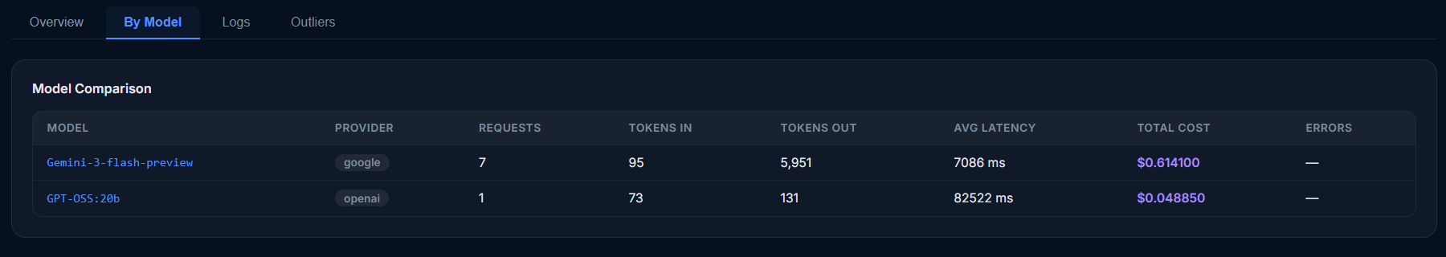

8. Tab 3 — Logs
The Logs tab is the most detailed view in Prompt Analytics — it shows individual request records. Administrators can see exactly who sent what, when, to which model, at what cost, and whether it succeeded.

8.1 Logs Table
Displays up to 100 log entries (the most recent within the selected time range). The table is scrollable vertically and horizontally.

Table header: Shows the title "Prompt Logs" followed by the count of displayed records in a small badge (e.g., "Prompt Logs 47").

Columns:
Column | Source Field | Description
Timestamp | timestamp | Date and time of the API call, formatted as YYYY-MM-DD HH:MM:SS (truncated from ISO string). No timezone conversion — shown as stored UTC
Model | model_name | Model that was called. Displayed in the model cell style (distinct from other text)
User | user_email | Email address of the user who made the call. Shows "—" if the user was anonymous or the JWT was not present
Tokens In | tokens_in | Number of input tokens for this specific call
Tokens Out | tokens_out | Number of output tokens returned
Latency | latency_ms | Response time for this call in milliseconds (e.g., "342 ms")
Cost | cost_usd | USD cost recorded for this specific single call, to 6 decimal places (e.g., "$0.000142"). This is the cost that was stored at call time.
Status | error | "OK" shown as a small green badge for successful calls; "Error" shown as a red badge for failed or blocked calls. The error badge text is always "Error" regardless of the specific error type — click the row's View button to see the full error message
View | — | An eye icon button (👁) that opens the full Drill-Down Modal for that specific log entry

Row highlighting: Rows where error is not null are highlighted in a light red background color to make them immediately visible when scanning the table.

Empty state: If no logs match the current filters, a single full-width row shows "No logs found."

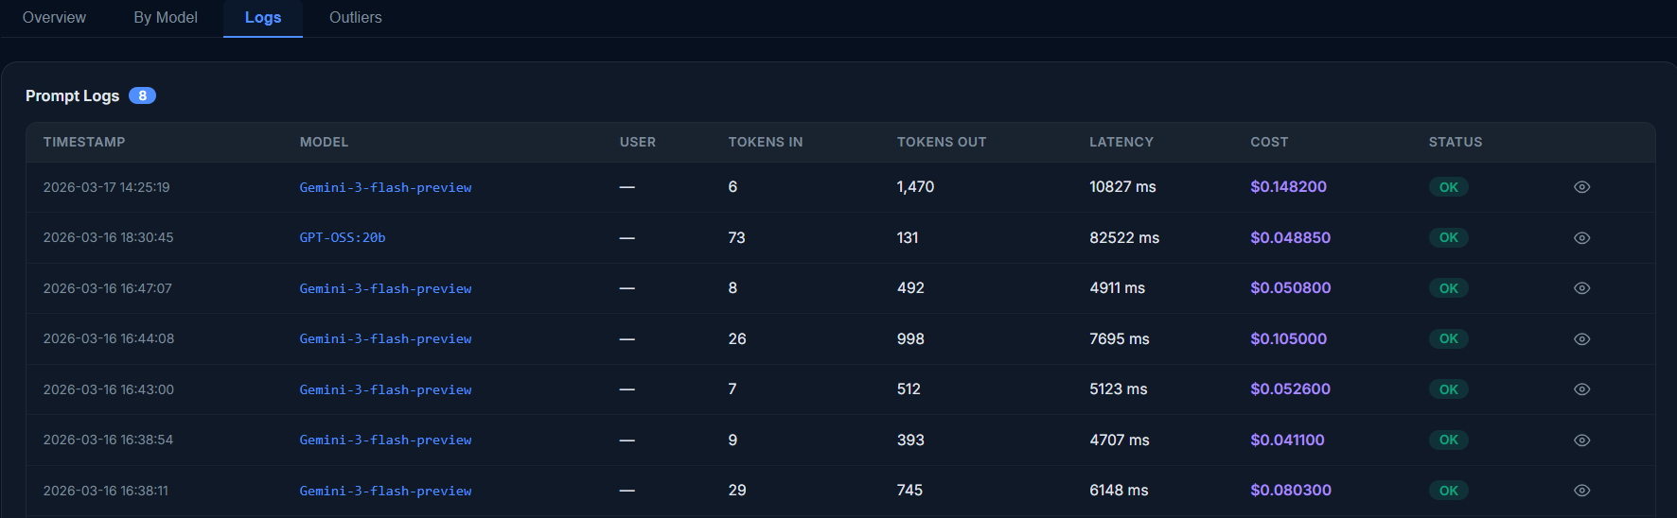

8.2 Reading Cost in the Logs Table
The Cost column in the Logs table represents the cost_usd value that was computed and stored at the exact moment the request was processed by the backend. This is calculated as:
cost_usd = (tokens_in / 1000) × inputPricing
+ (tokens_out / 1000) × outputPricing

Where inputPricing and outputPricing are the values that were stored in the models collection at the time of the call. This means:
- The same model call made last week may show a different cost than it would today if the pricing was updated since then
- This provides an accurate historical billing record — what was actually charged at the time
- Zero cost entries ($0.000000) typically indicate a request that was blocked before reaching the model (e.g., a guardrail-blocked call returns 0 tokens and 0 cost)

9. Tab 4 — Outliers
The Outliers tab automatically flags API calls that exceeded predefined thresholds, making it easy to identify the requests that are causing disproportionate cost or performance impact.

9.1 What Qualifies as an Outlier
A log entry is included in the Outliers list if it meets any one of the following three conditions:
Condition | Default Threshold | Configurable?
Response latency exceeds threshold | > 5,000 ms (5 seconds) | Yes — via ?latency_threshold=N query parameter
Total tokens (in + out) exceeds threshold | > 2,000 tokens | Yes — via ?tokens_threshold=N query parameter
The error field is not null | Any error present | No — all errors are always included

These three criteria catch the three most common types of problematic requests:
- High latency: The model took too long — a user experience problem and potentially a sign of an overloaded model endpoint
- High token usage: A single call consumed far more tokens than typical — likely a very long document being processed, which drives cost
- Error: The request failed completely — the cost was either 0 (blocked before model) or may have been partially charged (timeout after model started processing)

9.2 Outliers Table
Results are sorted by latency_ms descending — the slowest calls appear first.

Columns:
Column | Description
Timestamp | Date and time of the call (YYYY-MM-DD HH:MM:SS)
Model | Model name that was called
User | User email, or "—" if anonymous
Tokens In | Input token count for this call
Tokens Out | Output token count for this call
Latency | Response time displayed as an amber badge (e.g., "6,241 ms") — amber indicates this is an outlier value
Error | "Yes" in a red badge if an error is present; "—" if no error (the entry may still be listed because of high latency or high tokens)
View | Eye icon (👁) to open the Drill-Down Modal for this entry

Row styling: All rows in the Outliers table are highlighted in amber/yellow background to visually distinguish them from the normal log rows on the Logs tab.

Maximum results: The backend returns up to 100 outlier records per query.

Empty state: "No outliers detected." is shown if no records meet any of the three threshold conditions.

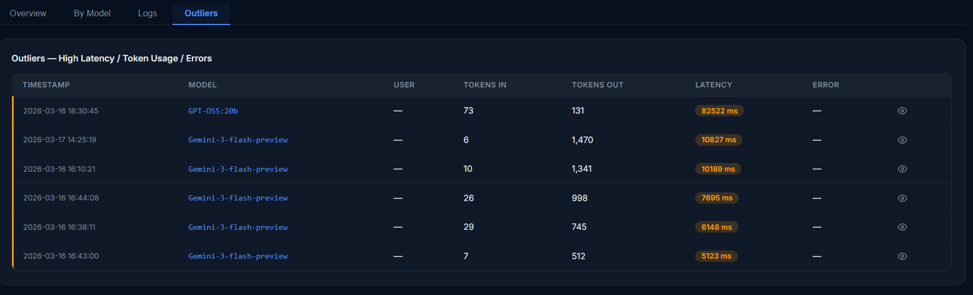

9.3 Using Outliers for Cost Investigation
The Outliers tab is particularly useful for cost spikes. When the Total Cost on a given day appears much higher than usual in the Observability Dashboard or the Overview tab's Cost chart, the recommended workflow is:
- Navigate to Prompt Analytics → set the day range to focus on the spike period
- Go to the Outliers tab
- Look for entries with high token counts — these are the most likely cause of a cost spike
- Click the View button on the highest-token entries to read the actual prompt and response
- Identify whether the spike was caused by a legitimate large document or by a runaway/malformed prompt

10. Drill-Down Modal
The Drill-Down Modal is accessible from both the Logs tab and the Outliers tab by clicking the eye icon on any row. It opens as an overlay panel on top of the page and allows administrators to inspect the full details of a specific API call.

10.1 Triggering the Modal
Clicking the eye icon sets the selected log entry as the component's selected state. The modal renders while selected is not null. Clicking outside the modal (on the dark overlay) or clicking the close (✕) button sets selected back to null, dismissing the modal.

10.2 Modal Header
Title: "Prompt Detail"
Close button: ✕ icon in the top-right corner

10.3 Metadata Badges Row
Immediately below the header, a horizontal row of small informational badges displays the key metrics of the selected call at a glance:
Badge | Value shown
Model badge | Model name
Provider badge | Provider name
Tokens In badge | "Tokens In: N" (green badge)
Tokens Out badge | "Tokens Out: N" (green badge)
Latency badge | "X ms" (neutral badge)
Cost badge | "$0.XXXXXX" (distinct cost-colored badge)

This allows quick comparison of the call's characteristics without reading the full text bodies.

10.4 Prompt Section
Section title: "Prompt" (smaller label above the content)

Content: The full text of the user's prompt stored in the prompt field of the log entry, displayed in a monospace <pre> block with word-wrap. If the prompt was a combined text + PDF call, the entire combined text (prompt + extracted PDF content) is shown, which may be very long.

If no prompt was captured for this entry, the text "(no prompt captured)" is shown.

10.5 Response Section
Section title: "Response"

Content: The full assistant response text stored in the response field, displayed in the same monospace <pre> block style.

If no response was captured: "(no response captured)" is shown.

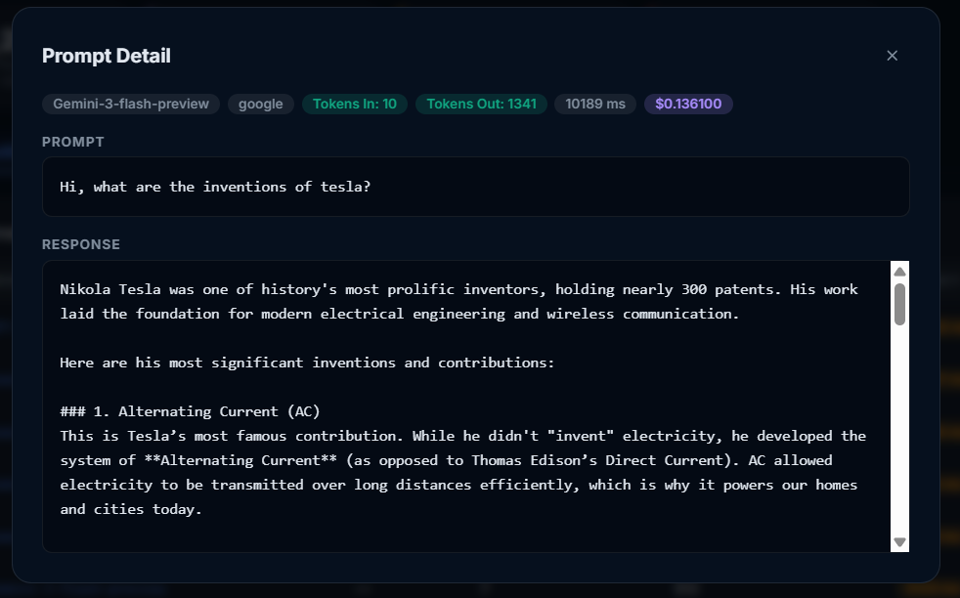

10.6 Error Section (Conditional)
Only visible if the selected log entry has a non-null error field.

Section title: "Error" (displayed in the danger/red color to draw immediate attention)

Content: The error message string stored in the error field, displayed in a red-tinted monospace code block.

Common error values:
- "Blocked by Guardrails" — the request was intercepted before reaching the model
- "Failed to connect to model endpoint: ..." — the Ollama server was unreachable
- "Model endpoint returned error: ..." — the model returned a non-200 HTTP status

11. Data Export
Two export formats are available for the prompt log data, both accessible from the action buttons in the top bar of the Prompt Analytics page.

11.1 CSV Export
Trigger: Clicking the "CSV" button in the top bar
Action: Opens a new browser tab which immediately triggers a file download
Backend endpoint: GET /api/analytics/export?format=csv&days=N[&model=name]
Filename: prompt_logs.csv
Maximum records: 5,000 per export
Scope: All prompt_log records within the selected time range (and model filter, if active)
Sort order: Newest records first (timestamp descending)

Exported columns:
Column | Source Field | Notes
timestamp | timestamp | ISO format datetime string
model_name | model_name | Full model name
provider | provider | Provider name
user_email | user_email | User's email address
tokens_in | tokens_in | Input token count
tokens_out | tokens_out | Output token count
latency_ms | latency_ms | Response latency in ms
cost_usd | cost_usd | Per-call cost in USD (up to 8 decimal places)
error | error | Error string or empty

Note: The CSV export does NOT include the full prompt text or response text in order to keep file sizes manageable and protect sensitive data. To view prompt/response content, use the Drill-Down Modal in the UI.

11.2 JSON Export
Trigger: Clicking the "JSON" button in the top bar
Backend endpoint: GET /api/analytics/export?format=json&days=N[&model=name]
Filename: prompt_logs.json
Maximum records: 5,000 per export
The JSON export contains the full document for each log entry as it appears in MongoDB (after ID serialization). This includes all fields — including prompt text, response text, guardrail_hits array, and error field — making it suitable for programmatic analysis or ingestion into external analytics tools.

Format is a JSON array of objects:
[
{
"_id": "65f3a2b1c4e...",
"timestamp": "2026-03-15T10:42:18.123000",
"model_name": "llama3.2",
"provider": "ollama",
"user_email": "alice@company.com",
"user_persona": "consumer",
"prompt": "Summarize the following document...",
"response": "The document describes...",
"tokens_in": 842,
"tokens_out": 213,
"latency_ms": 1842.3,
"cost_usd": 0.00018462,
"guardrail_hits": [],
"error": null
},
...
]

12. Backend API Reference
All endpoints reside under the /api/analytics prefix and are defined in analytics_routes.py. The base URL used by the frontend is http://localhost:8000/api/analytics.

12.1 GET /api/analytics/trends
Purpose: Returns daily aggregated metrics from the prompt_logs collection. This is the primary data source for the Overview tab charts and the KPI card calculations.

Query parameters:
Parameter | Type | Default | Description
days | integer | 30 | Number of past days to include
model | string | (none) | Optional — filter by model name substring (case-insensitive regex)

How it works:
- Calculates the cutoff datetime as now() − days
- Builds a $match filter: {timestamp: {$gte: cutoff}} plus optional model name regex
- Groups all matching documents by calendar date using $dateToString with %Y-%m-%d format
- For each date group, computes: sum of requests, sum of tokens_in, sum of tokens_out, sum of total_tokens, average latency, sum of cost_usd, and error count
- Sorts results by date ascending (oldest first, so charts display left-to-right chronologically)

Response — array of objects, one per day:
Field | Type | Description
date | string | YYYY-MM-DD
requests | integer | Number of API calls on this date
tokens_in | integer | Total input tokens on this date
tokens_out | integer | Total output tokens on this date
total_tokens | integer | tokens_in + tokens_out
avg_latency_ms | float | Average latency across all calls on this date (rounded to 1 decimal)
total_cost | float | Sum of cost_usd for all calls on this date (rounded to 6 decimal places)
errors | integer | Count of calls with a non-null error field on this date

Example response:
[
{
"date": "2026-03-10",
"requests": 42,
"tokens_in": 18420,
"tokens_out": 9840,
"total_tokens": 28260,
"avg_latency_ms": 834.2,
"total_cost": 0.028460,
"errors": 1
},
{
"date": "2026-03-11",
"requests": 65,
...
}
]

12.2 GET /api/analytics/by-model
Purpose: Returns per-model aggregate statistics from the prompt_logs collection. Powers the By Model tab comparison table and the Requests by Model pie chart.

Query parameters:
Parameter | Type | Default | Description
days | integer | 30 | Number of past days to include

How it works:
- Matches all documents with timestamp >= cutoff
- Groups by model_name field
- For each model group: counts requests, sums tokens_in and tokens_out, averages latency, sums cost_usd, counts errors, and captures provider (using $first — takes the provider from the first document in the group)
- Sorts by request count descending (most-used models first)

Response — array of objects, one per model:
Field | Type | Description
model_name | string | Full model name
provider | string | Provider name (from first log entry for this model)
requests | integer | Total API call count
tokens_in | integer | Total input tokens
tokens_out | integer | Total output tokens
avg_latency_ms | float | Average latency in ms (rounded to 1 decimal)
total_cost | float | Sum of cost_usd (rounded to 6 decimal places)
errors | integer | Count of errored calls

12.3 GET /api/analytics/logs
Purpose: Returns raw, individual prompt_log documents for display in the Logs tab table.

Query parameters:
Parameter | Type | Default | Description
days | integer | 7 | Number of past days to include
model | string | (none) | Optional — filter by model name substring
user_email | string | (none) | Optional — filter to a specific user
has_error | boolean | (none) | Optional — if true, returns only errored records
limit | integer | 200 | Maximum number of records to return
skip | integer | 0 | Number of records to skip (for pagination)

How it works:
- Builds a query filter with timestamp >= cutoff
- Appends optional filters: model name regex, exact user_email match, error existence check
- Queries prompt_logs collection sorted by timestamp descending (newest first)
- Applies skip and limit for pagination
- Serializes each document: converts _id ObjectId to string, converts timestamp datetime to ISO string

Frontend usage: The Prompt Analytics page fetches with limit=100 to show the 100 most recent logs. The model search box then filters this result client-side, making the search feel instant without additional API calls.

12.4 GET /api/analytics/outliers
Purpose: Returns prompt_log entries that qualify as outliers based on configurable thresholds. Powers the Outliers tab.

Query parameters:
Parameter | Type | Default | Description
days | integer | 30 | Number of past days to include
latency_threshold | float | 5000 | ms above which a call is flagged as a latency outlier
tokens_threshold | integer | 2000 | total token count above which a call is flagged

How it works:
- Matches documents with timestamp >= cutoff
- Uses a MongoDB $or query to find documents meeting any of these conditions: latency_ms > latency_threshold; (tokens_in + tokens_out) > tokens_threshold (evaluated using $expr and $add); error field exists and is not null
- Sorts by latency_ms descending (slowest calls first)
- Returns up to 100 results

Response: Array of full prompt_log document objects (same format as the logs endpoint).

12.5 GET /api/analytics/export
Purpose: Streams the log data as a downloadable file in either CSV or JSON format.

Query parameters:
Parameter | Type | Default | Description
format | string | csv | csv or json
days | integer | 7 | Number of past days to include
model | string | (none) | Optional model name filter

How it works:
- Fetches up to 5,000 documents (newest first) matching the filter
- For csv: uses Python's csv.DictWriter with a fixed set of column headers, writes to a StringIO buffer, then streams as a text/csv response with a Content-Disposition: attachment header
- For json: uses json.dumps(docs, indent=2) and streams as application/json

CSV column headers: timestamp, model_name, provider, user_email, tokens_in, tokens_out, latency_ms, cost_usd, error

Note: The CSV format uses extrasaction="ignore" — fields in the document that are not in the column headers (such as prompt, response, guardrail_hits) are silently excluded from the CSV output.

12.6 POST /api/analytics/log
Purpose: Accepts a new prompt log entry and inserts it directly into the prompt_logs collection. Used for any external logging that bypasses the Playground.

Request body: A JSON object containing any combination of prompt log fields.

How it works: The timestamp field is always overwritten with the current UTC datetime server-side, regardless of any timestamp provided in the request body. Returns {"id": "<inserted_objectid>"}.

13. Database Schema — prompt_logs Collection
Every document in the prompt_logs collection represents one individual API call made through the Playground.

Collection name: prompt_logs

13.1 Field Definitions
Field | Type | Required | Description
_id | ObjectId | Auto | MongoDB auto-generated document ID
timestamp | datetime | Yes | UTC datetime of the API call. Set server-side — not trusted from client
model_name | string | Yes | The human-readable name of the model that was called (e.g., "llama3.2", "mistral")
model_db_id | string | Yes | The MongoDB ObjectId string of the model document in the models collection. Used to cross-reference pricing
provider | string | Yes | The provider name (e.g., "ollama", "openai", "anthropic", "google")
user_email | string | Conditional | Email of the authenticated user extracted from the JWT. Empty string if the request had no valid JWT
user_persona | string | Conditional | The user's persona/role from the JWT (e.g., "admin", "consumer"). Empty string if anonymous
prompt | string | Yes | The full text of the user's message that was sent to the model. If the user attached files, the extracted file text is included and can make this field very large
response | string | Yes | The full text of the model's response. If the request was blocked, this contains the block message
tokens_in | integer | Yes | The number of input tokens counted by the model for this call (from prompt_eval_count in the Ollama response). Set to 0 for blocked calls
tokens_out | integer | Yes | The number of output tokens generated by the model (from eval_count in the Ollama response). Set to 0 for blocked calls
latency_ms | float | Yes | Wall-clock time in milliseconds from the moment the HTTP request was sent to the model endpoint until the response was fully received. Measured using time.monotonic(). Set to 0 for calls blocked before the model is called
cost_usd | float | Yes | The computed cost for this single call: (tokens_in/1000 × inputPricing) + (tokens_out/1000 × outputPricing). Rounded to 8 decimal places. Stored at call time using the pricing active at that moment. Set to 0 for blocked calls
guardrail_hits | array of strings | Yes | List of safety category names that were flagged by the guardrail model (e.g., ["HATE_SPEECH"]). Empty array [] for calls with no guardrail configured or calls that passed the safety check
error | string or null | Yes | null for successful calls. Contains an error description string for failed or blocked calls

13.2 Cost Calculation at Write Time
Unlike the usage_records collection (which stores only token counts and computes cost at query time), the prompt_logs collection stores the cost at write time. This is intentional:
- Provides an immutable point-in-time cost record for each call
- Enables the Prompt Analytics cost figures to reflect what was actually billed at the moment each call was made
- Makes it possible to detect if pricing changes would have affected historical calls

The formula used when writing to prompt_logs:
cost_usd = round(
(prompt_tokens / 1000) × float(model.inputPricing)
+ (completion_tokens / 1000) × float(model.outputPricing),
8
)

13.3 Example Document
{
"_id": "65f3a2b1c4e8f1234567890a",
"timestamp": "2026-03-15T10:42:18.123000+00:00",
"model_name": "llama3.2",
"model_db_id": "65e2b1a0c3d7f0987654321b",
"provider": "ollama",
"user_email": "alice@company.com",
"user_persona": "consumer",
"prompt": "Please summarize the following quarterly report in 3 bullet points:\n\n[Attached File: Q1_Report.pdf]\nPage 1\nThis quarter saw a 14% increase in revenue...",
"response": "Here are the 3 key highlights from the Q1 report:\n• Revenue grew 14% year-over-year\n• Operating margin improved to 22%\n• New customer acquisition increased by 31%",
"tokens_in": 842,
"tokens_out": 87,
"latency_ms": 1842.3,
"cost_usd": 0.00018462,
"guardrail_hits": [],
"error": null
}

13.4 Recommended MongoDB Indexes
For optimal query performance at scale, the following indexes are recommended on the prompt_logs collection:
Index | Fields | Purpose
Primary | timestamp (descending) | Supports all time-range queries efficiently
Compound | timestamp + model_name | Supports trends filtered by model
Single | user_email | Supports per-user log filtering
Single | error | Supports has_error filter and outlier detection
Compound | latency_ms + timestamp | Supports outlier queries sorted by latency

