LLM Gateway — Cost Tracking & Estimation

1. Introduction & Purpose
This document describes the cost tracking and cost estimation capabilities of the LLM Gateway platform. The platform provides organizations with full visibility into their Large Language Model (LLM) spending — both actual costs incurred from real API usage and estimated costs before making API calls.

1.1 Why Cost Tracking Matters
LLM APIs from providers like OpenAI, Google (Gemini), and Anthropic (Claude) charge per token consumed. Without proper tracking, organizations risk:
- Uncontrolled spending across teams and departments
- No visibility into which models or users are most expensive
- Inability to budget accurately for AI workloads
- No audit trail for compliance or chargebacks

1.2 Cost Visibility
The platform addresses cost tracking through three interconnected modules:

Module | Purpose
Monitoring & Metrics (Observability Dashboard) | Real-time cost reporting on actual API usage aggregated by model, provider, user, and department
Token Calculator | Pre-call cost estimation by counting tokens in a given prompt or PDF document
AI Playground | Interactive chat interface with live per-request cost capture and prompt audit logging

2. System Architecture Overview

2.1 Technology Stack

Component | Details
PDF Extraction | A custom PDFExtractor class handles all document ingestion. It supports three extraction modes simultaneously: (1) native text extraction from digital PDFs using PyMuPDF, (2) table detection — tables are detected and formatted as pipe-separated rows to preserve structure, (3) OCR via Tesseract for pages that are image-only or scanned documents. The extractor saves each extracted page's text sequentially, preserving document order. When both a text prompt and a PDF are submitted together in the Token Calculator, the PDF text is appended after the prompt text before token counting begins. In the Playground, uploaded PDFs and TXT files are extracted server-side and the plain text is returned to the frontend to be embedded into the next chat message as context.
Token Counting | Three separate counting strategies are used depending on the provider: (1) Google Gemini — uses the official google-generativeai SDK's count_tokens() API call, which returns exact token counts; (2) OpenAI — uses the tiktoken library with model-specific BPE encoding (e.g., cl100k_base for GPT-4, o200k_base for newer models), giving exact counts matching the API billing; (3) Anthropic Claude — uses cl100k_base encoding as an offline approximation (±1–5% of actual Claude tokens), since Anthropic does not provide a public token-counting SDK; the response includes a note about this approximation.

3. Module 1: Monitoring & Metrics (Observability Dashboard)

3.1 Overview
The Observability Dashboard is the primary cost monitoring interface for platform administrators. It aggregates all token usage data recorded from real API calls and presents it as interactive charts, KPI cards, and exportable tables.

The dashboard answers key questions:
- How much has the organization spent on LLMs in the last N days?
- Which models, providers, users, or departments are driving costs?
- What is the daily cost trend over time?
- How are input vs. output costs split across the organization?

All data is fetched in parallel on page load and on every filter change, ensuring the dashboard always shows a consistent, time-scoped snapshot.

3.2 Filter Bar
Located at the top of the dashboard. All data on the entire page — KPI cards, detail cards, and all charts — updates immediately when any filter changes.

View Selector Pills (4 options):
Pill | Effect
Providers | Groups all data by AI provider (OpenAI, Google, Anthropic, Ollama, etc.)
Models | Groups data per individual model endpoint
Users | Groups data per user email address
Departments | Groups data per organizational department

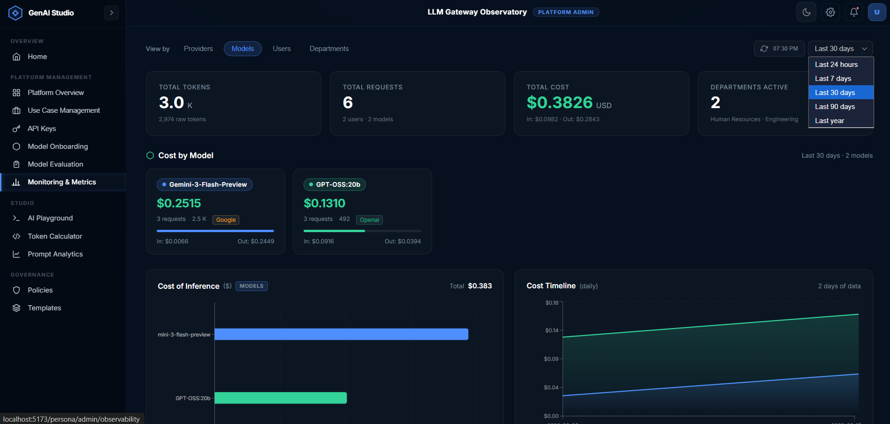

3.3 KPI Summary Cards
Four large metric cards displayed in a horizontal grid directly below the filter bar. All values are scoped to the selected time range.

Card 1: Total Tokens
Displays the grand total of all tokens consumed (input + output combined) across all users, models, and providers in the selected period.
- Primary value: Displayed in a human-readable abbreviated format — for example, 2.3 M for 2.3 million tokens, 1.1 B for over a billion tokens.
- Unit label: The unit suffix (M, K, B) is displayed in a smaller muted style next to the number.
- Subtitle: Shows the exact raw integer count (e.g., "2,341,892 raw tokens") for precision.
- Loading state: An animated shimmer bar replaces the value while data is loading.

Card 2: Total Requests
Displays the total number of individual API calls made to any model in the selected period.
- Primary value: Formatted with comma separators (e.g., 14,832).
- Subtitle: Shows "X users · Y models" — the count of unique users who made calls and the count of distinct models used, giving a sense of breadth of platform adoption.

Card 3: Total Cost (USD)
The most important card for cost governance. Shows the total monetary spend in US dollars.
- Primary value: Displayed to 4 decimal places (e.g., $4.2381) with a USD unit label.
- Color accent: The cost value is highlighted in a distinct color to draw immediate attention.
- Subtitle: Shows the input/output cost breakdown — e.g., "In: $2.1190 · Out: $2.1191" — allowing administrators to see whether input or output tokens dominate spending.

Card 4: Departments Active
Shows how many distinct organizational departments have recorded any API usage in the selected period.
- Primary value: A simple integer (e.g., 5).
- Subtitle: Lists the names of the top 3 most active departments by token usage, separated by dots — e.g., "Engineering · Marketing · Legal".

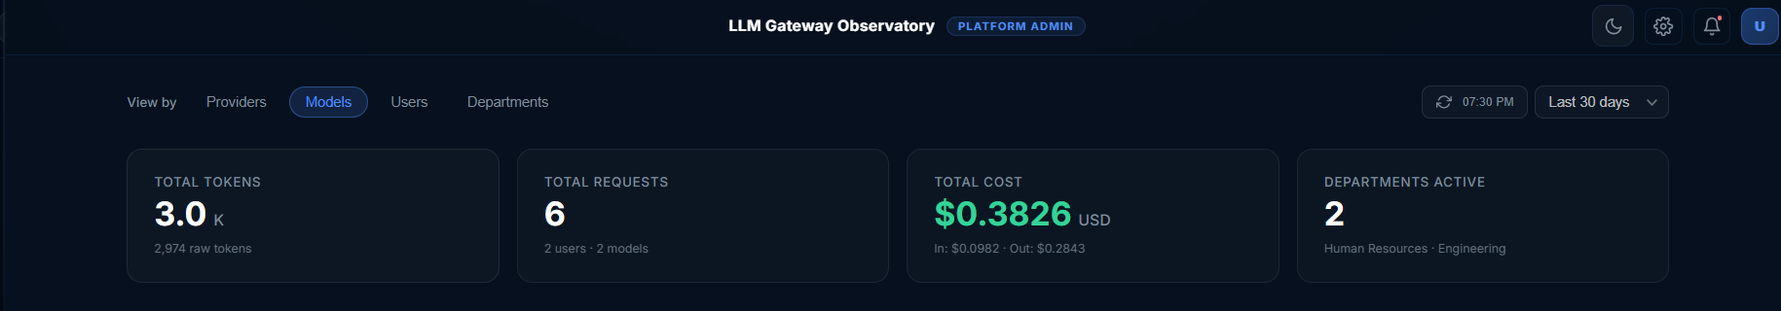

3.4 Context-Sensitive Detail Cards
Immediately below the KPI row, a section of individual entity cards appears. The content of this section changes based on the active View pill.

Models View — "Cost by Model" Cards
A responsive grid of cards, one per model. Cards are sorted by total cost descending (most expensive model first).

Each card contains:
- Model name displayed in a colored badge (color is consistent per model across all views)
- Total cost in USD to 4 decimal places as the hero value (e.g., $1.2043)
- Usage stats row: request count · total tokens · provider tag (color-coded by provider: green for OpenAI, purple for Anthropic, blue for Google/Gemini, blue for Ollama)
- Horizontal progress bar: Width represents this model's cost relative to the highest-cost model
- Input / Output cost split: "In: $0.6021 · Out: $0.6022" at the bottom of the card

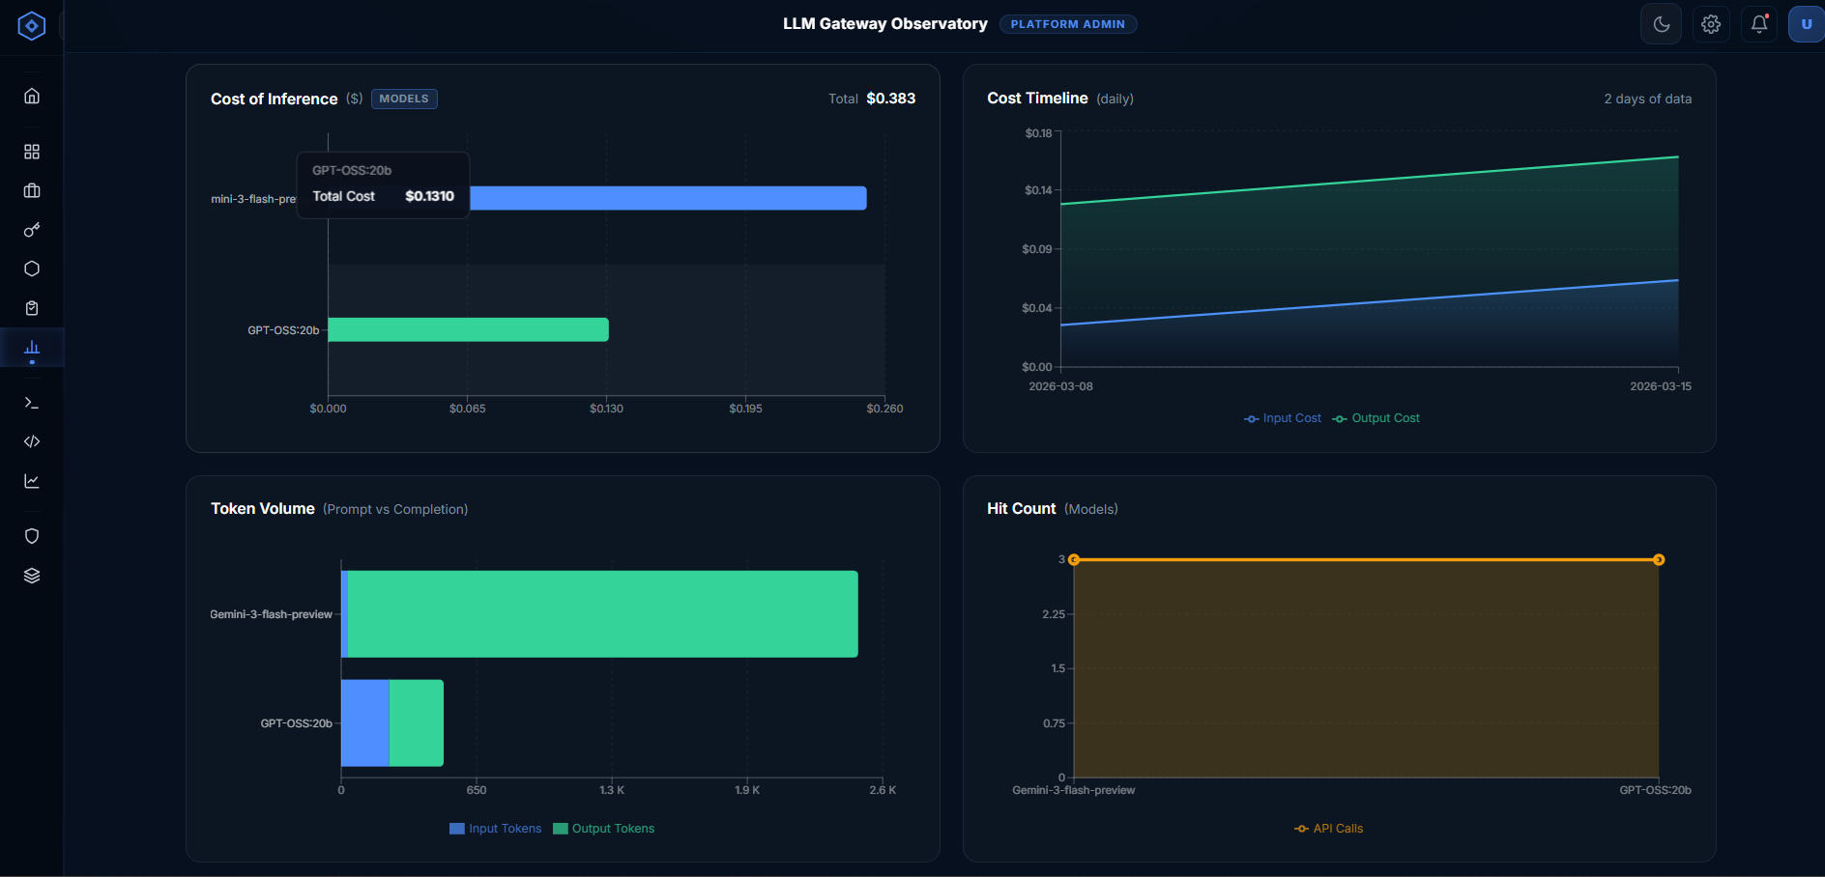

Providers View — "Cost by Provider" Cards
One card per active provider. Cards show:
- Provider name with a colored dot badge (each provider has a fixed color: OpenAI = green, Anthropic = purple, Google = amber, Ollama = blue)
- Percentage share of the total organizational spend (e.g., 43.2%) displayed top-right
- Total cost as the hero value
- Stats row: request count · total tokens · number of distinct models used
- Horizontal progress bar: Width represents percentage share of total spend
- Input / Output cost split

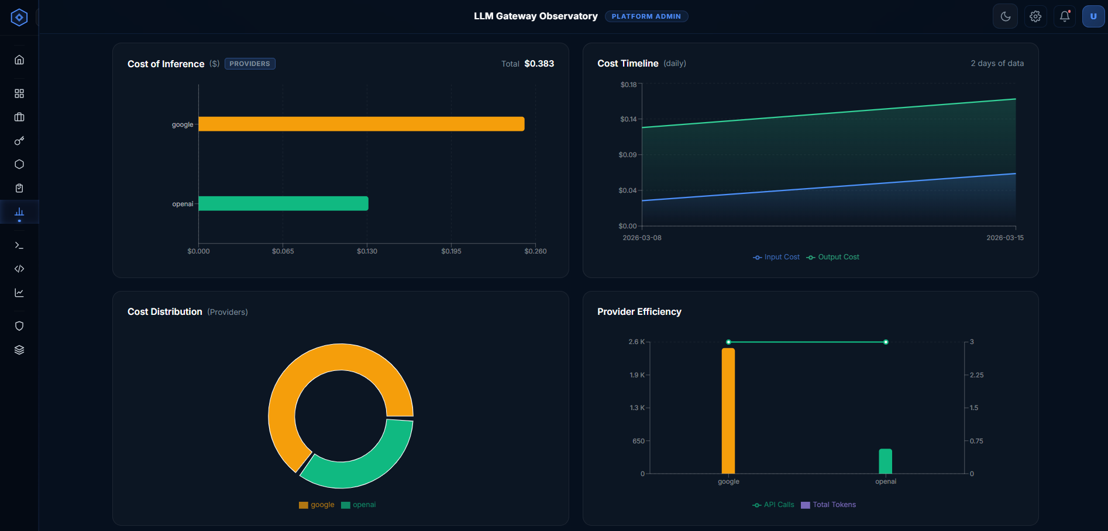

Users View — "Cost by User" Cards
One card per user who made any API calls in the period. Sorted by total cost descending.

Each card contains:
- User avatar — a small circle with the first letter of the user's email, colored uniquely per user
- Username — the email address prefix (before the "@" symbol) to keep cards compact
- Total cost as the hero value
- Stats row: request count · total tokens · number of distinct models used
- Horizontal progress bar: Width relative to the highest-spending user
- Input / Output cost split

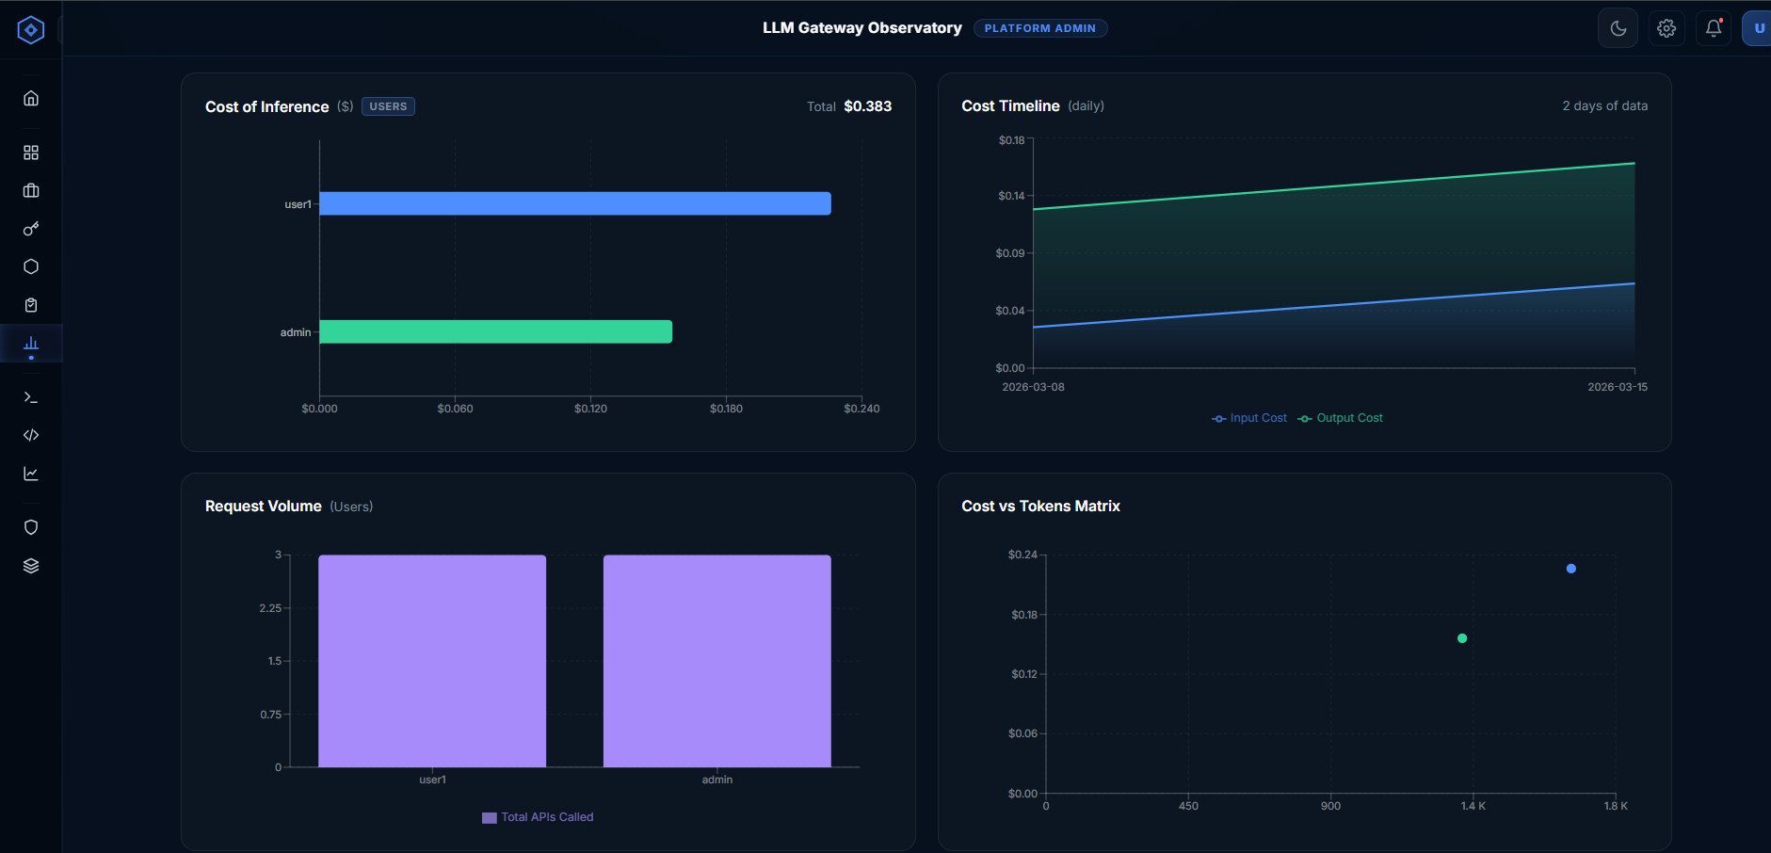

Departments View — "Cost by Department" Cards
One card per department. Department names are resolved from the user profile at query time, so users without a department are grouped as "Unassigned".

Each card contains:
- Department name with a colored dot badge
- Percentage share of total organizational spend
- Total cost as the hero value
- Stats row: request count · total tokens · unique users count · unique models count
- Horizontal progress bar: Width proportional to percentage share of total spend
- Input / Output cost split

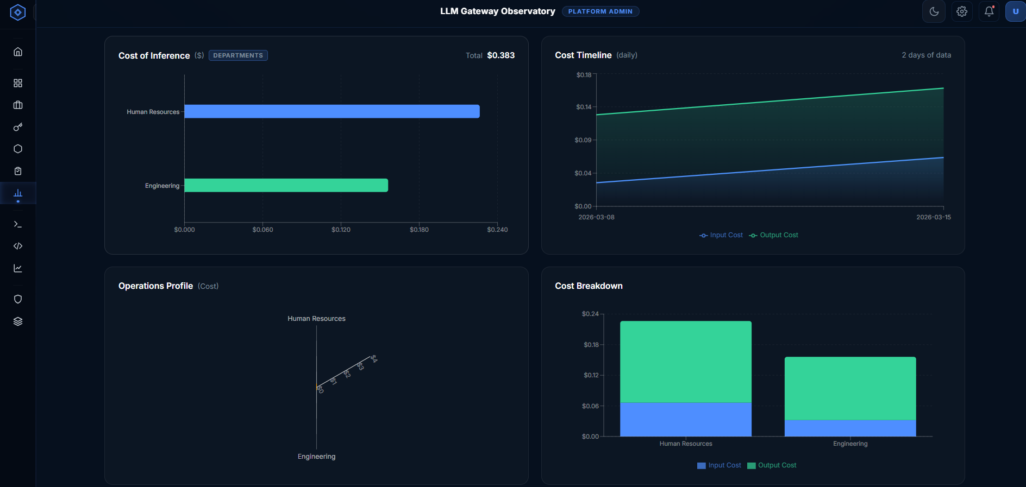

3.5 Charts Grid
A two-column responsive chart grid located below the detail cards section. The first two charts are always visible regardless of the active view tab. The third and fourth charts are context-sensitive and change based on the selected view.

Chart 1: Cost of Inference (Horizontal Bar Chart) — Always Visible
Shows cost per entity as a horizontal bar chart. The entity type (model / provider / user / department) matches the active view tab.
- Layout: Horizontal bars (entities on Y-axis, cost in USD on X-axis)
- Colors: Each bar uses a unique color per entity, matching the color assigned in the detail cards above
- Tooltip: Hovering any bar shows the entity name and exact cost (e.g., "gemini-2.0-flash · $1.2043")
- X-axis labels: Formatted as $0.001, $0.010, etc.
- Badge: The active view tab name is shown as a small badge in the chart title
- Metadata: Shows the total cost across all entities as a summary stat in the chart header

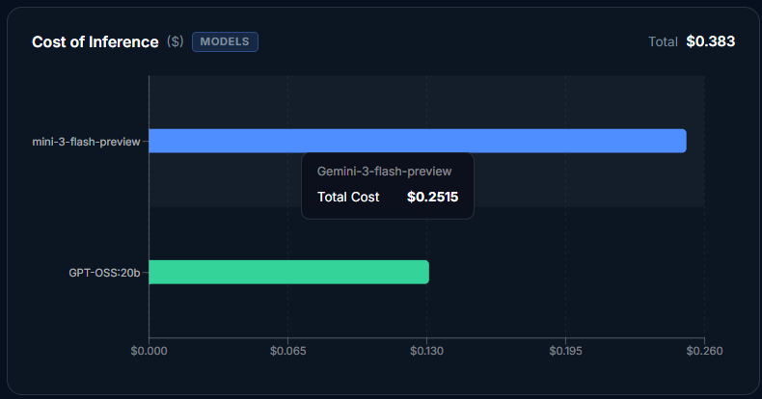

Chart 2: Cost Timeline (Stacked Area Chart) — Always Visible
Shows how the daily cost has evolved over the selected time range. Reads from the usage_daily collection (daily pre-aggregated data).
- Layout: Area chart with the date on the X-axis and USD cost on the Y-axis
- Two series: Input Cost — blue (#4E8EFF) with a blue gradient fill; Output Cost — green (#34D399) with a green gradient fill
- Tooltip: Hovering any point shows the date and exact input/output cost for that day
- Legend: Shows "Input Cost" and "Output Cost" labels in the chart footer
- Metadata: Shows the number of days of data available (e.g., "30 days of data")
- Purpose: Allows administrators to identify spending spikes, spot trends, and correlate cost increases with specific dates / events
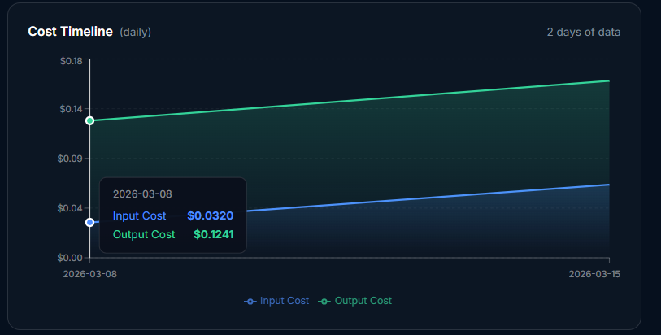

Charts 3 & 4: Context-Sensitive Analytics
These two charts adapt based on the active view tab, providing additional analytical depth for the selected dimension.

When "Models" tab is active:
Token Volume Chart (Stacked Horizontal Bar Chart)
- Shows prompt tokens (input) stacked against completion tokens (output) per model
- Blue bars = input tokens, green bars = output tokens, stacked horizontally
- Allows immediate visual comparison of whether a model is token-heavy on input or output
- X-axis formatted in abbreviated form: 1K, 10K, 1M
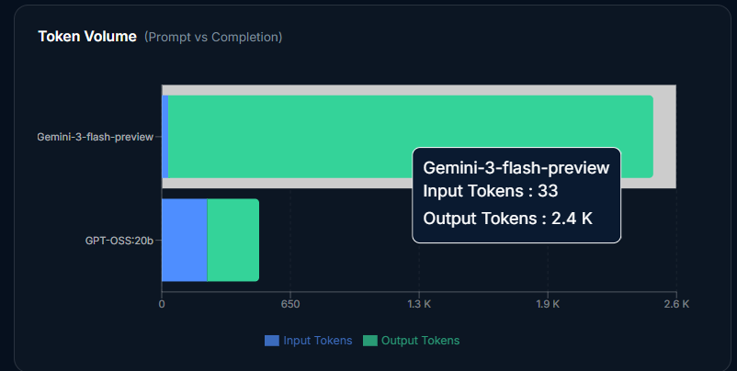
Hit Count Chart (Area Chart)
- Shows the number of API calls (request_count) per model
- Amber/yellow area curve (#F59E0B) with dots on each data point
- Highlights which models are being called most frequently
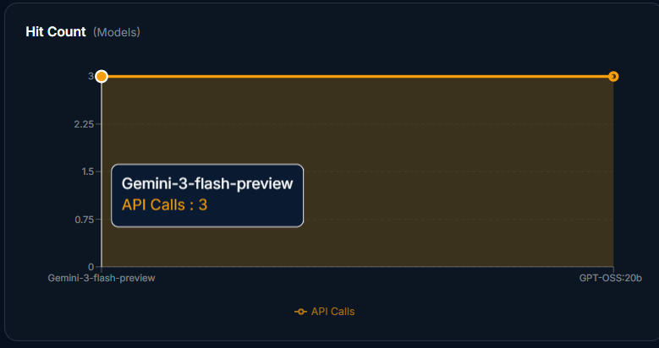
When "Providers" tab is active:
Cost Distribution Chart (Donut / Pie Chart)
- A donut pie chart showing proportional cost share per provider
- Each slice uses the provider's fixed color
- Labels show provider name and percentage
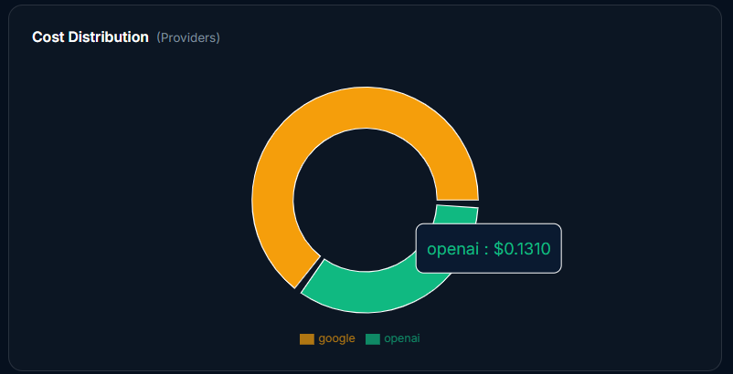
Provider Efficiency Chart (Composed Chart — Bar + Line)
- Left Y-axis (bars): Total tokens per provider
- Right Y-axis (line): API call count per provider — shown as a green line with dots
- This reveals efficiency: a provider with a high token bar but low request line means each call is token-heavy
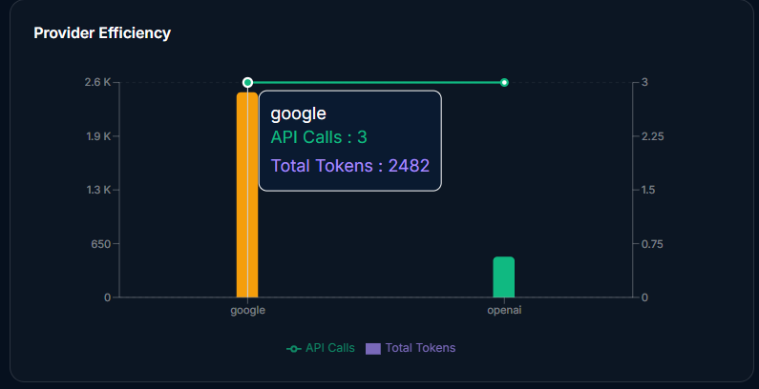
When "Users" tab is active:
Request Volume Chart (Vertical Bar Chart)
- One bar per user (top 10 highest-spending users shown)
- X-axis: username (email prefix); Y-axis: request count
- Color: purple (#A78BFA) bars with rounded top corners
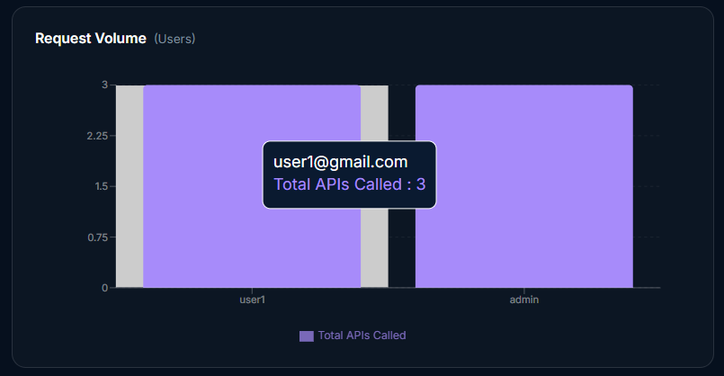

Cost vs. Tokens Matrix (Scatter Chart)
- Each dot represents a user; X-axis: total tokens consumed; Y-axis: total cost in USD
- Users near the top-right corner are the most expensive and highest token consumers
- Users in the bottom-right (high tokens, low cost) are efficient — likely using cheaper models
- Users in the top-left (low tokens, high cost) may be using premium models with short prompts
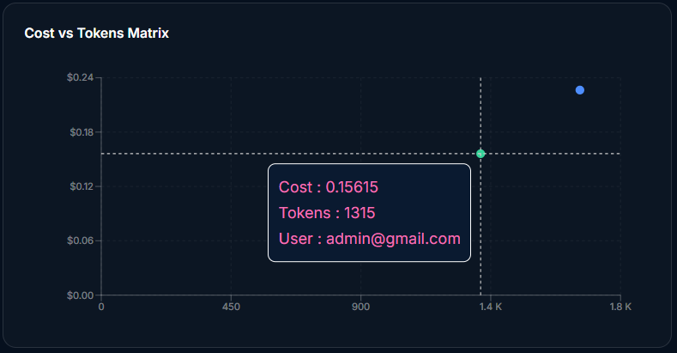
When "Departments" tab is active:
Operations Profile Chart (Radar / Spider Chart)
- A radar chart showing up to 6 departments on the axes
- Each axis represents a department; distance from center represents total cost
- Filled amber area with 50% opacity

Cost Breakdown Chart (Stacked Vertical Bar Chart)
- One bar group per department
- Blue segment = Input cost (prompt tokens); Green segment = Output cost (completion tokens)
- Allows comparison of whether departments drive cost primarily through long inputs vs. long outputs
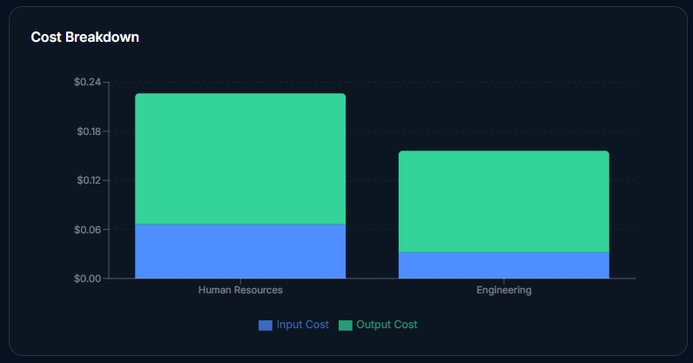

3.6 Raw Telemetry Table
Located at the very bottom of the dashboard. Provides the most granular view — one row per unique (user + model) combination for the selected time range. The table can have many rows and is scrollable horizontally.

Table columns:
Column | Description
Username | Full email address of the user
Department | Department resolved from the user's profile
Model | Full model name (e.g., gemini-2.0-flash-exp)
Provider | Provider name
Persona | User role/persona assigned at registration
Requests | Total number of API calls for this user-model pair
Input Tokens | Cumulative input tokens
Output Tokens | Cumulative output tokens
Input Cost | Computed input token cost in USD
Output Cost | Computed output token cost in USD
Total Cost | Combined cost in USD
Last Used | Timestamp of the most recent API call

- Row count indicator: Shows "X records · last N days" above the table
- Loading state: Five shimmer skeleton rows are shown while data loads
- Empty state: Displays "No records for selected time range" if no data exists
- Download CSV Button: Located in the table header. Exports all visible rows as a .csv file named cost-metrics-{N}d.csv

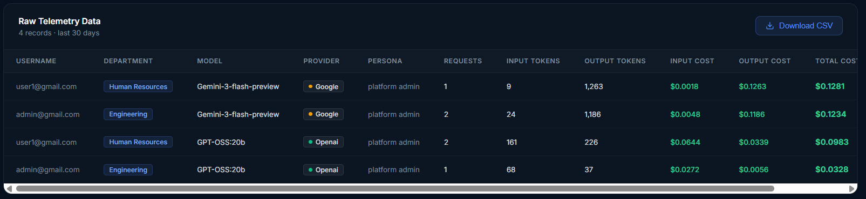

4. Module 2: Token Calculator

4.1 Overview
The Token Calculator allows users to estimate the cost of a prompt before sending it to an LLM. It is a pre-flight tool: users paste text or upload a PDF, select a provider and model, and immediately see how many tokens their content will consume and what that costs.

The calculator has two operating modes:
Mode | Purpose
Token Analyzer | Count tokens in actual text or PDF content for a specific model; shows a running session history
Pricing Estimator | Compare costs across all onboarded models given hypothetical input/output volumes and call counts

4.2 Frontend: Token Analyzer Mode

Step 1: Select AI Model
Provider buttons at the top of the left panel:
Button | Color
Google (Gemini) | Blue accent
OpenAI (GPT) | Green accent
Anthropic (Claude) | Orange accent

Selecting a provider immediately updates the model dropdown below it to show only models belonging to that provider (fetched from the /api/models endpoint on page load).

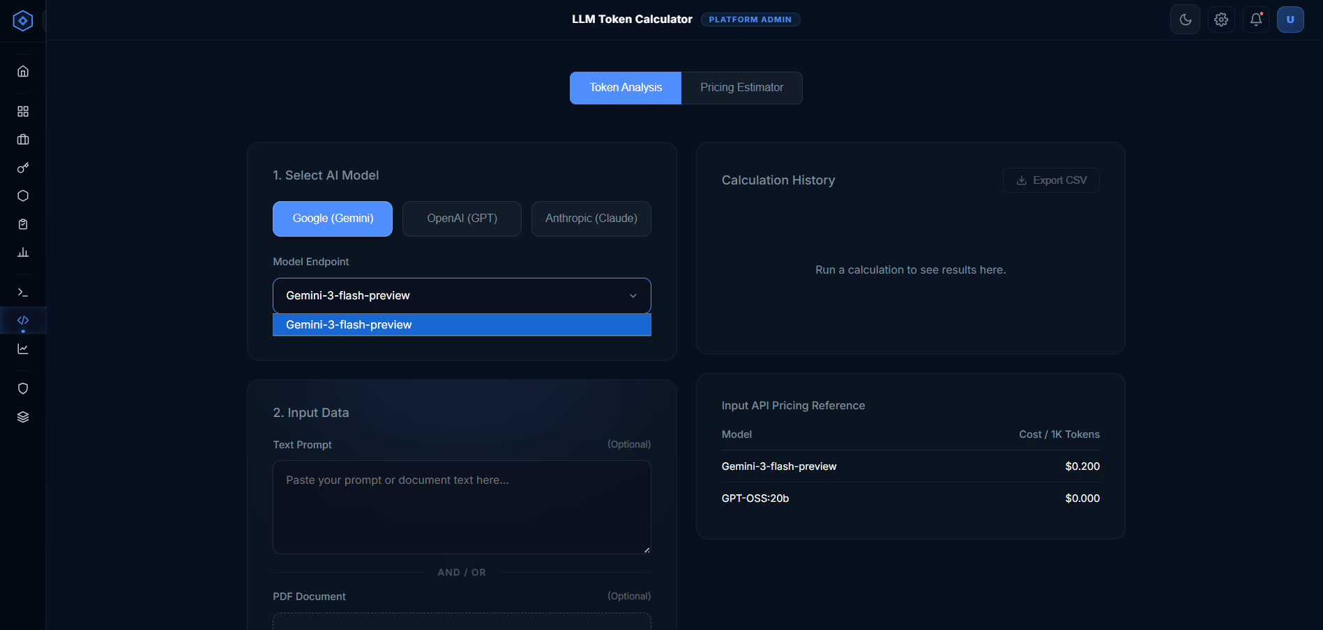

Step 2: Input Data
Two optional input methods are available. At least one must be provided before the Calculate button can be used.
- Text Prompt (textarea): A multi-line text area where users paste any content — a prompt, a document excerpt, a system message, or any combination. Supports unlimited text length.
- PDF Document (upload zone): A drag-and-drop area that accepts .pdf files only. Before upload: Shows an upload icon and the instruction "Click to upload or drag and drop · .pdf format only". After upload: The dropzone is replaced by a compact file badge showing a green checkmark, the filename, and a ✕ remove button.

The PDF is sent to the backend where text is extracted (including OCR for scanned pages). The extracted text is combined with the prompt text (if any) before token counting.

Calculate Button: "⚡ Calculate Tokens & Cost"
- Shows a spinner and "Parsing Tokens..." text while the API call is in progress
- Disabled while loading
- On success, adds a new entry to the calculation history on the right panel
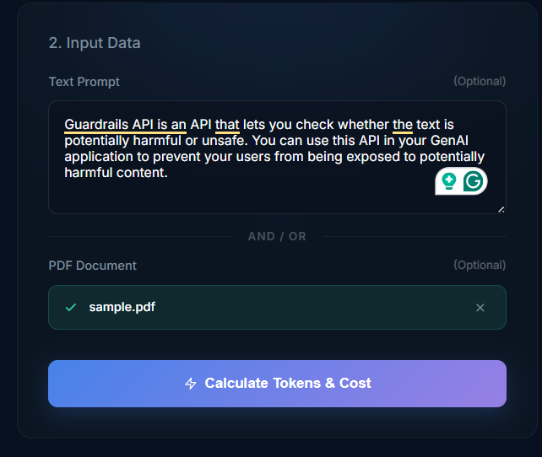

Step 3: Calculation History
Every successful calculation is prepended to the history list on the right panel (newest at the top). History exists for the current session only — it is not saved to the database.

Each history entry shows:
- Model name — the selected model
- Method badge — "Text Only", "PDF Only", or "Text + PDF" depending on what was submitted
- Token count — the exact number of tokens (formatted with commas)
- Estimated cost — in USD to 6 decimal places (e.g., $0.000042)

Empty state: Before the first calculation, shows a pulsing placeholder dot with the message "Run a calculation to see results here."

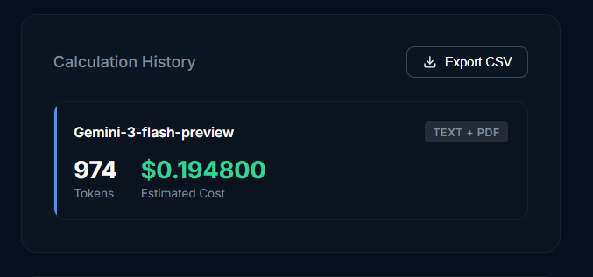
Export CSV button: Located in the top-right of the history panel. Downloads all history entries as llm-cost-calculations-{timestamp}.csv. Disabled when history is empty.

Input API Pricing Reference Table
Below the history panel, a compact table shows all onboarded models with their input pricing as a quick reference. This lets users compare pricing at a glance without needing to run a calculation.
Columns: Model Name | Cost / 1K Tokens

4.3 Frontend: Pricing Estimator Mode
Accessed via the "Pricing Estimator" toggle at the top of the page. A bulk cost estimation tool — users enter hypothetical usage volumes and see a live cost comparison table across all onboarded models simultaneously.

Control Inputs
Input | Description
Input tokens / words / characters | Volume of input content per API call
Output tokens / words / characters | Expected output volume per API call
API Calls | Number of calls to simulate in total

Calculate By toggle (3 options):
Mode | Conversion applied
Tokens | 1:1 (no conversion)
Words | × 1.33 (approx. 1.33 tokens per word)
Characters | × 0.25 (approx. 4 characters per token)

Model Type Tabs
Three tabs filter which models appear in the cost table:
- Chat / Completion — standard generation models (default tab)
- Fine-tuning — fine-tuned or specialized models
- Embedding — embedding / vector models

A search box in the top-right of the table filters models by name or provider substring in real time.

Results Table
Column | Description
Provider | Provider name
Model | Model name
Context | Max context window size (e.g., 128k, 1M)
Input / 1k Tokens | Price per 1,000 input tokens
Output / 1k Tokens | Price per 1,000 output tokens
Per Call | (Input volume × input rate) + (Output volume × output rate) for one call
Total | Per call cost × number of API calls — highlighted as the primary cost figure

All Per Call and Total values update instantly as the user changes any of the input controls — no submit button needed.

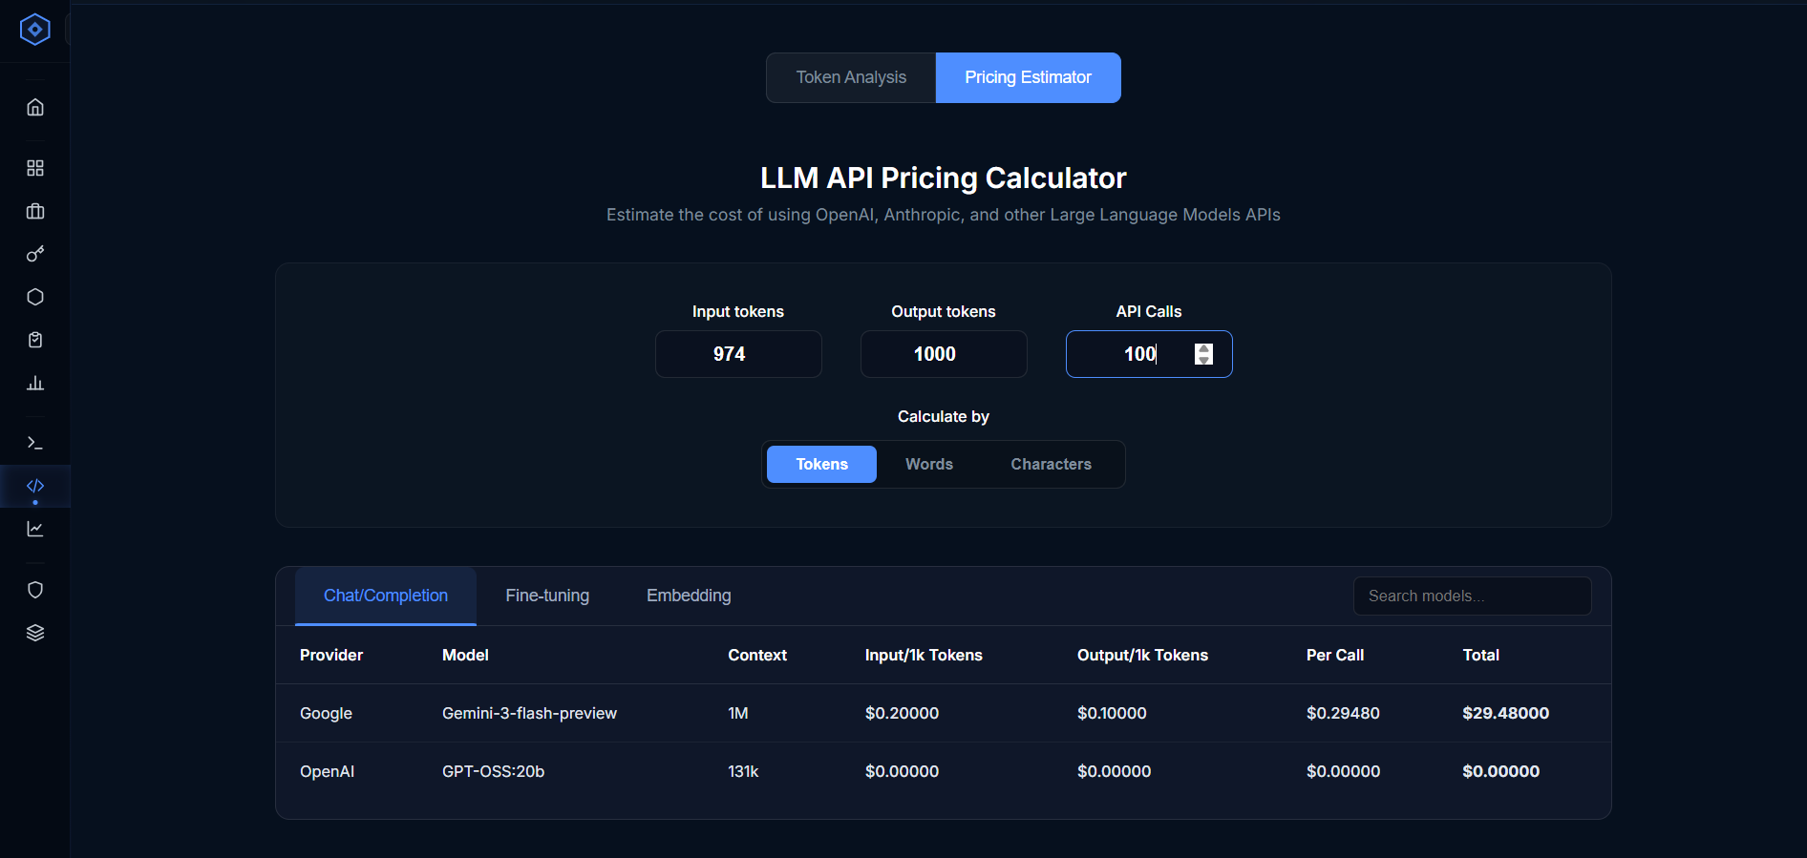

4.4 Backend: Token Counting (POST /count_tokens_unified)
Content-Type: multipart/form-data

Form Field | Type | Notes
provider | string | google, openai, or claude
model | string | Model identifier (e.g., gemini-2.0-flash, gpt-4o)
prompt | string (optional) | Text prompt. Optional if file is provided
file | file (optional) | PDF file. Optional if prompt is provided

At least one of prompt or file must be present, otherwise a 422 error is returned.

Processing:
- If prompt is provided, it is added to the combined text
- If file is provided, PDFExtractor saves it to a temp file, extracts all text (native + OCR), then deletes the temp file
- If both are provided, the PDF text is appended to the prompt text with a double newline separator
- The combined text is dispatched to the provider-specific token counter

Response:
Field | Description
provider | Provider echoed back
model | Model echoed back
token_count | Integer token count
note | Optional accuracy note (used for Claude approximation)

Frontend cost calculation:
estimated_cost = (token_count / 1000) × model.input_cost_per_1k_tokens

5. Module 3: AI Playground (Cost Tracking)

5.1 Overview
The AI Playground is an interactive chat interface for testing onboarded LLM models. Every message sent through the Playground is automatically:
- Forwarded to the configured model endpoint
- Token counts captured from the model's response metadata
- Recorded into the usage database — contributes directly to the Observability Dashboard
- Written to the prompt log — a full record of the prompt, response, latency, and per-call cost

This means the Playground is both a model testing tool and a cost capture mechanism — all Playground usage is visible in the Observability Dashboard alongside any other API usage.

5.2 Frontend: Page Layout
The Playground uses a split-pane layout: a narrow settings panel on the left and a full-height chat interface on the right.

Left Panel: Model Settings
Active Model Dropdown: Lists all onboarded models with status active or pending. Format: "Model Name (provider)". Switching models loads the new model's hyperparameter configuration automatically.

System Instructions (textarea): An optional system prompt. If provided, it is prepended to the message array as a {role: "system"} message on the very first user turn only.

Advanced Settings (Hyperparameters): Dynamically rendered based on the selected model's configuration. Supported parameter types:
- Float / Integer parameters — rendered as a range slider with a live value readout (e.g., Temperature: 0.72)
- Text parameters — rendered as a text input field

Examples of common hyperparameters: temperature, top_p, seed, num_ctx (context window size).

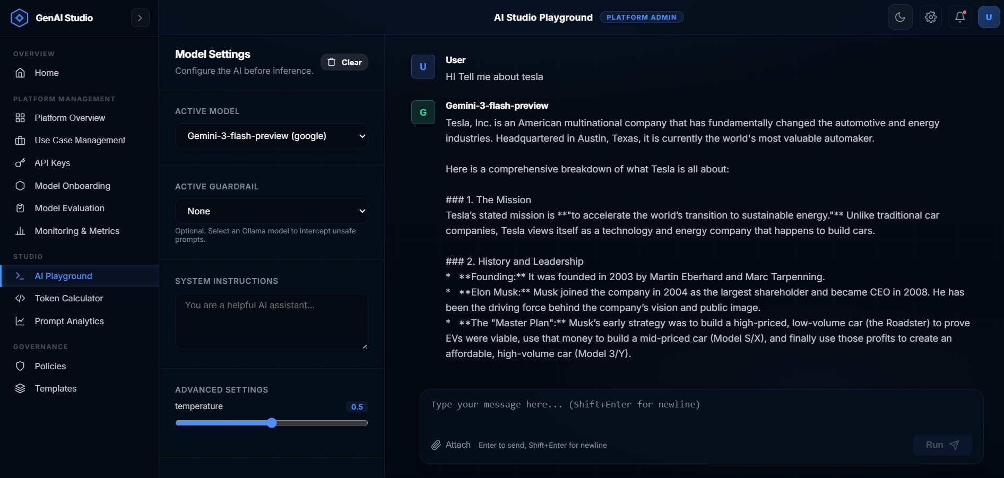

Right Panel: Chat Interface
Conversation thread: Messages are displayed in alternating bubbles. Each bubble shows:
- Avatar circle — first letter of the model name (for assistant messages) or "U" (for user messages)
- Role label — "User" or the model's name
- Message body — full text content

User messages appear immediately when submitted (optimistic UI) — the backend response is added once it arrives.

Loading indicator: While the model is generating a response, a "typing" animation of three animated bouncing dots appears in an assistant message bubble.

Clear Chat button: Located in the left panel header. Clears the entire conversation after a browser confirmation dialog.

Message Input Area
Fixed at the bottom of the right panel.
- Attached Files Strip: When files have been staged (uploaded but not yet sent), they appear as compact badges above the textarea. Each badge shows the filename with a ✕ remove button.
- Textarea: Auto-resizes from a single line up to 200px height as text is typed. Enter — sends the message; Shift + Enter — inserts a newline without sending.
- Attach Button: Opens a native file picker for .pdf or .txt files. The selected file is uploaded immediately to /api/playground/upload_context. While uploading, the button shows "Extracting..." and is disabled. On success, the extracted text is stored in memory client-side, ready to be prepended to the next message.
- Run Button: Submits the message. Disabled when: no text and no attached files, no model selected, or a request is in progress.

6. Backend Database Schema
MongoDB database with the following collections relevant to cost tracking:

Collection: usage_records
Field | Type | Description
_id | ObjectId | Auto-generated
user_email | string | User's email
user_persona | string | User role
user_department | string | Organizational department
model_db_id | string | ObjectId ref to models collection
model_name | string | Human-readable model name
model_id | string | API model identifier
provider | string | Provider name
prompt_tokens | int | Lifetime total input tokens (accumulated via $inc)
completion_tokens | int | Lifetime total output tokens
total_tokens | int | Combined lifetime tokens
request_count | int | Lifetime API call count
last_used | datetime | Most recent call timestamp
first_used | datetime | First ever call timestamp

Collection: usage_daily
Field | Type | Description
user_email | string | User's email
model_db_id | string | Model reference
date | string | YYYY-MM-DD
prompt_tokens | int | Daily accumulated input tokens
completion_tokens | int | Daily accumulated output tokens
total_tokens | int | Daily combined tokens
request_count | int | API calls on this date
model_name | string | Model name
provider | string | Provider
user_persona | string | Persona
user_department | string | Department
created_at | datetime | First record for this date

Collection: prompt_logs
Field | Type | Description
timestamp | datetime | UTC timestamp
model_name | string | Model name
model_db_id | string | Model ObjectId
provider | string | Provider
user_email | string | User email
user_persona | string | Persona
prompt | string | Full user prompt text
response | string | Full assistant response
tokens_in | int | Input token count
tokens_out | int | Output token count
latency_ms | float | Response latency in milliseconds
cost_usd | float | Per-request cost (8 decimal places)
guardrail_hits | array | Triggered safety categories (usually empty)
error | string / null | Error message or null

Collection: models (Pricing Source)
Field | Type | Description
name | string | Human-readable model name
modelId | string | API model identifier
provider | string | Provider name
modelLink | string | API endpoint URL
inputPricing | float | USD per 1,000 input tokens
outputPricing | float | USD per 1,000 output tokens
maxTokens | string | Max context window (e.g., "128000")
status | string | active / pending / inactive
hyperparams | array | Hyperparameter definitions

7. Cost Calculation Logic

Formula
All cost calculations across the platform use the same formula:
input_cost_usd = (prompt_tokens / 1000) × inputPricing
output_cost_usd = (completion_tokens / 1000) × outputPricing
total_cost_usd = input_cost_usd + output_cost_usd

Pricing is always USD per 1,000 tokens as stored in the models collection.

Where Cost is Computed
Module | When | Where
AI Playground | At the time of each chat API call | playground_routes.py — stored in prompt_logs.cost_usd
Observability Dashboard | At query time for all dashboard API calls | usage_routes.py → _calc_cost() function
Token Calculator Analyzer | Client-side after token count API response | TokenCalculator.jsx — session only
Token Calculator Estimator | Fully client-side, no API call | TokenCalculator.jsx — session only

Cost Precision by Display Context
Context | Precision | Example
Stored in prompt_logs | 8 decimal places | 0.00004219
Observability Dashboard display | 4 decimal places | $0.0042
Observability Dashboard chart tooltip | 4 decimal places | $0.0042
Token Calculator estimated cost | 6 decimal places | $0.000042

Dynamic Pricing Design
The usage_records and usage_daily collections deliberately store only token counts, never costs. This architectural decision means:
- If a model's pricing is updated in the models collection, all historical dashboard figures immediately reflect the new rate
- No batch migration or recalculation job is needed when pricing changes
- The _get_pricing_map() helper function fetches current pricing from models at the start of every usage query, ensuring all reports are always priced with the latest rates

8. Data Export & Reporting

8.1 Observability Dashboard CSV Export
Property | Value
Location | Raw Telemetry Table → "Download CSV" button
Filename | cost-metrics-{N}d.csv
Scope | All usage_records for the currently selected time range
Columns | Username, Department, Model, Provider, Persona, Requests, Input Tokens, Output Tokens, Total Tokens, Input Cost (USD), Output Cost (USD), Total Cost (USD), Last Used
Generated by | Frontend JavaScript using Blob API — no backend call

8.2 Token Calculator Session Export
Property | Value
Location | Calculation History panel → "Export CSV" button
Filename | llm-cost-calculations-{timestamp}.csv
Scope | All calculations performed in the current browser session
Columns | Date, Provider, Model, Input Method, Tokens, Estimated Cost (USD)
Generated by | Frontend JavaScript — session data only

