Certain investigation on fingerprint matching for Forensic
Subtitle as needed (paper subtitle)

Authors Name/s per 1st Affiliation (Author)
line 1 (of Affiliation): dept. name of organization
line 2-name of organization, acronyms acceptable
line 3-City, Country
line 4-e-mail address if desired
Authors Name/s per 2nd Affiliation (Author)
line 1 (of Affiliation): dept. name of organization
line 2-name of organization, acronyms acceptable
line 3-City, Country
line 4-e-mail address if desired

Abstract—This electronic document is a “live” template and already defines the components of your paper [title, text, heads, etc.] in its style sheet. *CRITICAL: Do Not Use Symbols, Special Characters, or Math in Paper Title or Abstract. (Abstract)
Keywords : Cloud Computing ,Image processing ,Web application ,SIFT

Introduction
Fingerprints are the unique pattern to identify the particular among the numerus amount of people in the world .Among the all biometrics fingerprints are the most widely used as parameter for the identification. Fingerprint matching is commonly employed in forensic science to aid criminal investigation .To searching of fingerprints among the scattered fingerprints all over the nation is very difficult but it is achieved easy through the cloud computing and web application. Cloud computing[1] is a complete new technology .It is based on the development of parallel computing , distributed computing , grid computing and is the total combination and the evolution of the Virtualization , Utility computing , including with Software-as-a-Service (SasS), Infrastructure-as-a-Service (IaaS), and Platform-as-a-service(PaaS). Cloud is a technical term to describe web as a space where computing has been per installed software and exist as a service ; operating system, data, storage, applications and processing power exist on the web ready to be share to the users .This shared IT resources can be access through the internet. Where the IT resources includes this all network, server, storage, application , service and so on etc. and they can be easily deployed with much quick manner and it need least management and also interactions with service providers is very easy.

ARCHITECTURAL COMPONENTS OF CLOUD COMPUTING
The following figure used to easily under stand the architectural components od the cloud computing .

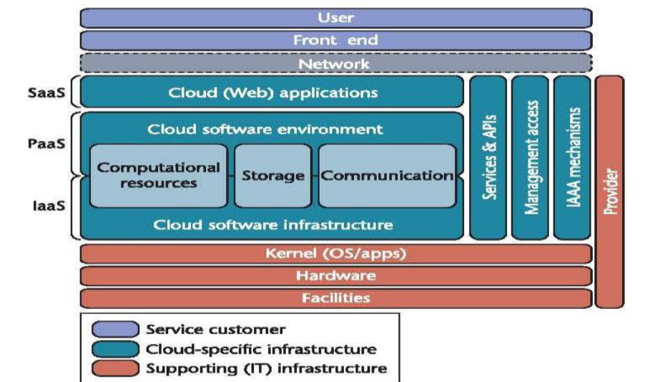

Fig 1. The cloud Computing reference architecture.
In above figure the separate division for the software services , platform services and Infrastructure services ; this are perform properly their work as per the ethics of computer science without any logical and security issues.
The remaining sections of the paper will discuss about the working functionality of the image processing algorithm to match the fingerprints in cloud and the data shared within the private network under the government of the nation.

Proposed system
The Fingerprint matching system under the cloud computing based on the image processing .In the department forensic they can match the fingerprint with the image taken from the crime incident place . The entire system is based on the two tire authentication .
Authentication Process:
The state level forensic or cyber crime department officer who that have position to process the verification part can have the rights access the national level Bio-Metric database , that person must give request to access the database and done the fingerprint verification process.
The national level Bio-metric database administrator who have the rights to authenticate the request from the lower level officer. That person must verify the request person is details to grant the access for the national level bio-metric database and fingerprint verification tool.

Fingerprint Matching
In the web server has full back end processing for fingerprint detecting (matching) , the fingerprint matching is fully processed by the image processing algorithm and the following algorithms are Histogram Equalization, Edge Detection , SIFT(Scale Invariant Feature Transform).
In our process of preparing the image to match the given image . Before the image process it has been cropped for certain size because , we must focusing the particular image location. we must first equalize the image color contraction , the image color equalization has been processed by the algorithm is called Histogram equalization .
Histogram Equalization is used to enhance the contrast of the colour image. It is one of the
simplest and less complex methods for enhancing the quality of the colour image. It distributes the pixels of the image on the dynamic range for enhancing the contrast of the image. It is the process that remaps the pixels of the image. Due this process the image has been converted in to grey scale image. [#2]

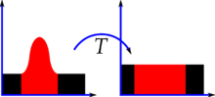
Fig 2. Histogram of an image before and after equalization .
The image of the fingerprint gone under this process is given below .
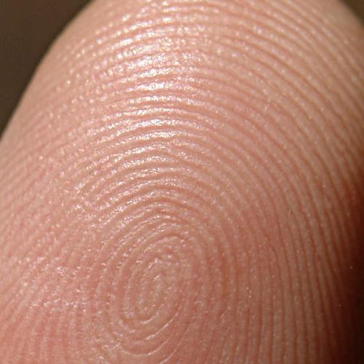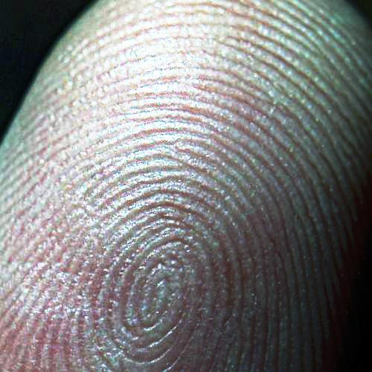
Fig 3. This is fingerprint image before the histogram equalization process and after the process .
Edge Detection
Edge detection includes a variety of mathematical methods that aim at identifying points in a digital image at which the image brightness changes sharply or, more formally, has discontinuities. In an image a set of continues and discontinues curved line segments are termed as edges. Edge detection is a fundamental tool in image processing, machine vision and computer vision, particularly in the areas of feature detection and feature extraction.^{[1]}
Edge detection techniques to perform the transform images to edge image benefiting from the changes of the grey scale tones in the images. Edges are the sign of lack of continuity and ending in the image . As per the result of this transformation ,image is obtained with there edges and without encountering any changes in the physical qualities of the main images[11][25]. Objects in the images consist of numerous parts of different color levels. An image in different grey levels, according to the change in the different levels of grey images had different types of edges that can be distinguished in below Figure.[]

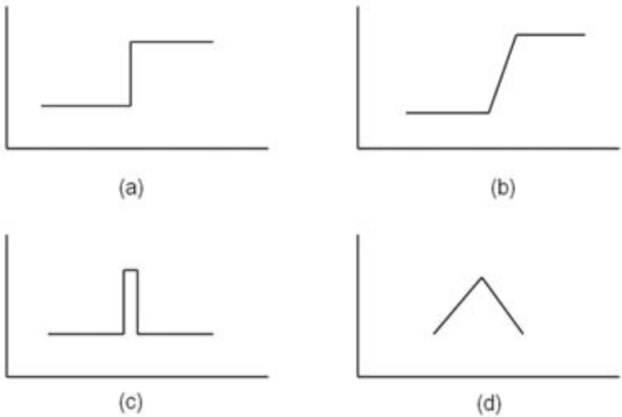
Type of Edges (a)Step Edge (b) Ramp Edge (c) Line Edge (d) Roof Edge
After performing the Edge Detection the image has been changed into edge obtained image of the original image that we had given the histogram equalized image , that processed image we can easily identify the edge .
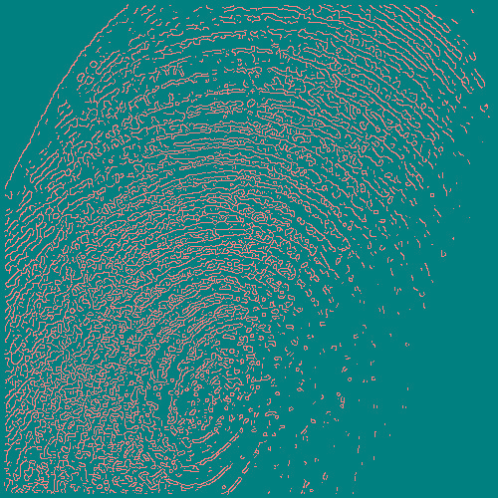
Fig . Edge Detected Fingerprint Image
Above image was the processed image of fingerprint who’s already processed under the Histogram Equalization , the fingerprint image was clearly showed the edge in above image and the other places were color changed for highlighting the edge point in the image .

Image Matching
After that all preprocessed the image has going to match with the given image captured from the crime place through the image processing algorithm called SIFT (Scale Invariant Feature Transform ).Below that we have going to see the process of the SIFT algorithm works .
We are going to use the OpenCV (open Computer Vision) for the SIFT image matching , because the image is going to match by the object recognition methodology . basically SIFT have the process of there algorithms following are Scale-space Extrema Detection, key point Localization, Orientation Assignment , Key point Descriptor, finally Key point Matching . we are going see one by one .

1. Scale-space Extrema Detection
From the image above, it is obvious that we can’t use the same window to detect keypoints with different scale. It is OK with small corner. But to detect larger corners we need larger windows. For this, scale-space filtering is used. In it, Laplacian of Gaussian is found for the image with various values. LoG acts as a blob detector which detects blobs in various sizes due to change in . In short, acts as a scaling parameter. For eg, in the above image, gaussian kernel with low gives high value for small corner while guassian kernel with high fits well for larger corner. So, we can find the local maxima across the scale and space which gives us a list of values which means there is a potential keypoint at (x,y) at scale.
But this LoG is a little costly, so SIFT algorithm uses Difference of Gaussians which is an approximation of LoG. Difference of Gaussian is obtained as the difference of Gaussian blurring of an image with two different , let it be and . This process is done for different octaves of the image in Gaussian Pyramid. It is represented in below image:
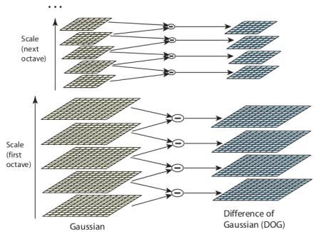
Once this DoG are found, images are searched for local extrema over scale and space. For eg, one pixel in an image is compared with its 8 neighbours as well as 9 pixels in next scale and 9 pixels in previous scales. If it is a local extrema, it is a potential keypoint. It basically means that keypoint is best represented in that scale. It is shown in below image:
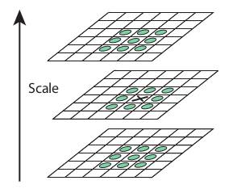
Regarding different parameters, the paper gives some empirical data which can be summarized as, number of octaves = 4, number of scale levels = 5, initial , etc as optimal values.

2. Keypoint Localization
Once potential keypoints locations are found, they have to be refined to get more accurate results. They used Taylor series expansion of scale space to get more accurate location of extrema, and if the intensity at this extrema is less than a threshold value (0.03 as per the paper), it is rejected. This threshold is called contrastThreshold in OpenCV
DoG has higher response for edges, so edges also need to be removed. For this, a concept similar to Harris corner detector is used. They used a 2x2 Hessian matrix (H) to compute the pricipal curvature. We know from Harris corner detector that for edges, one eigen value is larger than the other. So here they used a simple function,
If this ratio is greater than a threshold, called edgeThreshold in OpenCV, that keypoint is discarded. It is given as 10 in paper.
So it eliminates any low-contrast keypoints and edge keypoints and what remains is strong interest points.

3. Orientation Assignment
Now an orientation is assigned to each keypoint to achieve invariance to image rotation. A neigbourhood is taken around the keypoint location depending on the scale, and the gradient magnitude and direction is calculated in that region. An orientation histogram with 36 bins covering 360 degrees is created. (It is weighted by gradient magnitude and gaussian-weighted circular window with equal to 1.5 times the scale of keypoint. The highest peak in the histogram is taken and any peak above 80% of it is also considered to calculate the orientation. It creates keypoints with same location and scale, but different directions. It contribute to stability of matching.

4. Keypoint Descriptor
Now keypoint descriptor is created. A 16x16 neighbourhood around the keypoint is taken. It is devided into 16 sub-blocks of 4x4 size. For each sub-block, 8 bin orientation histogram is created. So a total of 128 bin values are available. It is represented as a vector to form keypoint descriptor. In addition to this, several measures are taken to achieve robustness against illumination changes, rotation etc.

5. Keypoint Matching
Keypoints between two images are matched by identifying their nearest neighbours. But in some cases, the second closest-match may be very near to the first. It may happen due to noise or some other reasons. In that case, ratio of closest-distance to second-closest distance is taken. If it is greater than 0.8, they are rejected. It eliminaters around 90% of false matches while discards only 5% correct matches, as per the paper.
So this is a summary of SIFT algorithm. For more details and understanding, reading the original paper is highly recommended. Remember one thing, this algorithm is patented. So this algorithm is included in Non-free module in OpenCV.[ijo04]

For author/s of only one affiliation (Heading 3): To change the default, adjust the template as follows.

Selection (Heading 4): Highlight all author and affiliation lines.

Change number of columns: Select the Columns icon from the MS Word Standard toolbar and then select “1 Column” from the selection palette.

Deletion: Delete the author and affiliation lines for the second affiliation.

For author/s of more than two affiliations: To change the default, adjust the template as follows.

Selection: Highlight all author and affiliation lines.

Change number of columns: Select the “Columns” icon from the MS Word Standard toolbar and then select “1 Column” from the selection palette.

Highlight author and affiliation lines of affiliation 1 and copy this selection.

Formatting: Insert one hard return immediately after the last character of the last affiliation line. Then paste down the copy of affiliation 1. Repeat as necessary for each additional affiliation.

Reassign number of columns: Place your cursor to the right of the last character of the last affiliation line of an even numbered affiliation (e.g., if there are five affiliations, place your cursor at end of fourth affiliation). Drag the cursor up to highlight all of the above author and affiliation lines. Go to Column icon and select “2 Columns”. If you have an odd number of affiliations, the final affiliation will be centered on the page; all previous will be in two columns.

Identify the Headings
Headings, or heads, are organizational devices that guide the reader through your paper. There are two types: component heads and text heads.
Component heads identify the different components of your paper and are not topically subordinate to each other. Examples include ACKNOWLEDGMENTS and REFERENCES, and for these, the correct style to use is “Heading 5.” Use “figure caption” for your Figure captions, and “table head” for your table title. Run-in heads, such as “Abstract,” will require you to apply a style (in this case, italic) in addition to the style provided by the drop down menu to differentiate the head from the text.
Text heads organize the topics on a relational, hierarchical basis. For example, the paper title is the primary text head because all subsequent material relates and elaborates on this one topic. If there are two or more sub-topics, the next level head (uppercase Roman numerals) should be used and, conversely, if there are not at least two sub-topics, then no subheads should be introduced. Styles named “Heading 1,” “Heading 2,” “Heading 3,” and “Heading 4” are prescribed.

Figures and Tables

Positioning Figures and Tables: Place figures and tables at the top and bottom of columns. Avoid placing them in the middle of columns. Large figures and tables may span across both columns. Figure captions should be below the figures; table heads should appear above the tables. Insert figures and tables after they are cited in the text. Use the abbreviation “Fig. 1,” even at the beginning of a sentence.
- Table Styles
Table Head | Table Column Head
Table Head | Table column subhead | Subhead | Subhead
copy | More table copyª
- Sample of a Table footnote. (Table footnote)

- Example of a figure caption. (figure caption)
Figure Labels: Use 8 point Times New Roman for Figure labels. Use words rather than symbols or abbreviations when writing Figure axis labels to avoid confusing the reader. As an example, write the quantity “Magnetization,” or “Magnetization, M,” not just “M.” If including units in the label, present them within parentheses. Do not label axes only with units. In the example, write “Magnetization (A/m)” or “Magnetization (A ( m(1),” not just “A/m.” Do not label axes with a ratio of quantities and units. For example, write “Temperature (K),” not “Temperature/K.”

Acknowledgment (Heading 5)
The preferred spelling of the word “acknowledgment” in America is without an “e” after the “g.” Avoid the stilted expression “one of us (R. B. G.) thanks ...”. Instead, try “R. B. G. thanks...”. Put sponsor acknowledgments in the unnumbered footnote on the first page.

References
The template will number citations consecutively within brackets [1]. The sentence punctuation follows the bracket [2]. Refer simply to the reference number, as in [3]—do not use “Ref. [3]” or “reference [3]” except at the beginning of a sentence: “Reference [3] was the first ...”
Number footnotes separately in superscripts. Place the actual footnote at the bottom of the column in which it was cited. Do not put footnotes in the reference list. Use letters for table footnotes.
Unless there are six authors or more give all authors’ names; do not use “et al.”. Papers that have not been published, even if they have been submitted for publication, should be cited as “unpublished” [4]. Papers that have been accepted for publication should be cited as “in press” [5]. Capitalize only the first word in a paper title, except for proper nouns and element symbols.
For papers published in translation journals, please give the English citation first, followed by the original foreign-language citation [6].

- G. Eason, B. Noble, and I.N. Sneddon, “On certain integrals of Lipschitz-Hankel type involving products of Bessel functions,” Phil. Trans. Roy. Soc. London, vol. A247, pp. 529-551, April 1955. (references)
We suggest that you use a text box to insert a graphic (which is ideally a 300 dpi resolution TIFF or EPS file with all fonts embedded) because this method is somewhat more stable than directly inserting a picture.
To have non-visible rules on your frame, use the MSWord “Format” pull-down menu, select Text Box > Colors and Lines to choose No Fill and No Line.
- J. Clerk Maxwell, A Treatise on Electricity and Magnetism, 3rd ed., vol. 2. Oxford: Clarendon, 1892, pp.68-73.
- I.S. Jacobs and C.P. Bean, “Fine particles, thin films and exchange anisotropy,” in Magnetism, vol. III, G.T. Rado and H. Suhl, Eds. New York: Academic, 1963, pp. 271-350.
- K. Elissa, “Title of paper if known,” unpublished.
- R. Nicole, “Title of paper with only first word capitalized,” J. Name Stand. Abbrev., in press.
- Y. Yorozu, M. Hirano, K. Oka, and Y. Tagawa, “Electron spectroscopy studies on magneto-optical media and plastic substrate interface,” IEEE Transl. J. Magn. Japan, vol. 2, pp. 740-741, August 1987 [Digests 9th Annual Conf. Magnetics Japan, p. 301, 1982].
- M. Young, The Technical Writer’s Handbook. Mill Valley, CA: University Science, 1989.

