**Assignment-2**

**Name: G.Somesh**

**1)create,update, delete comands in my sql**

**Creating Table**

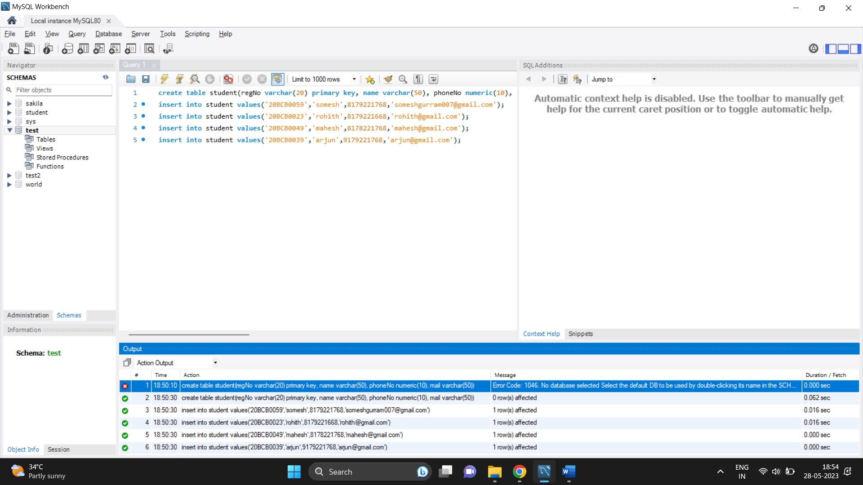

**Updating**

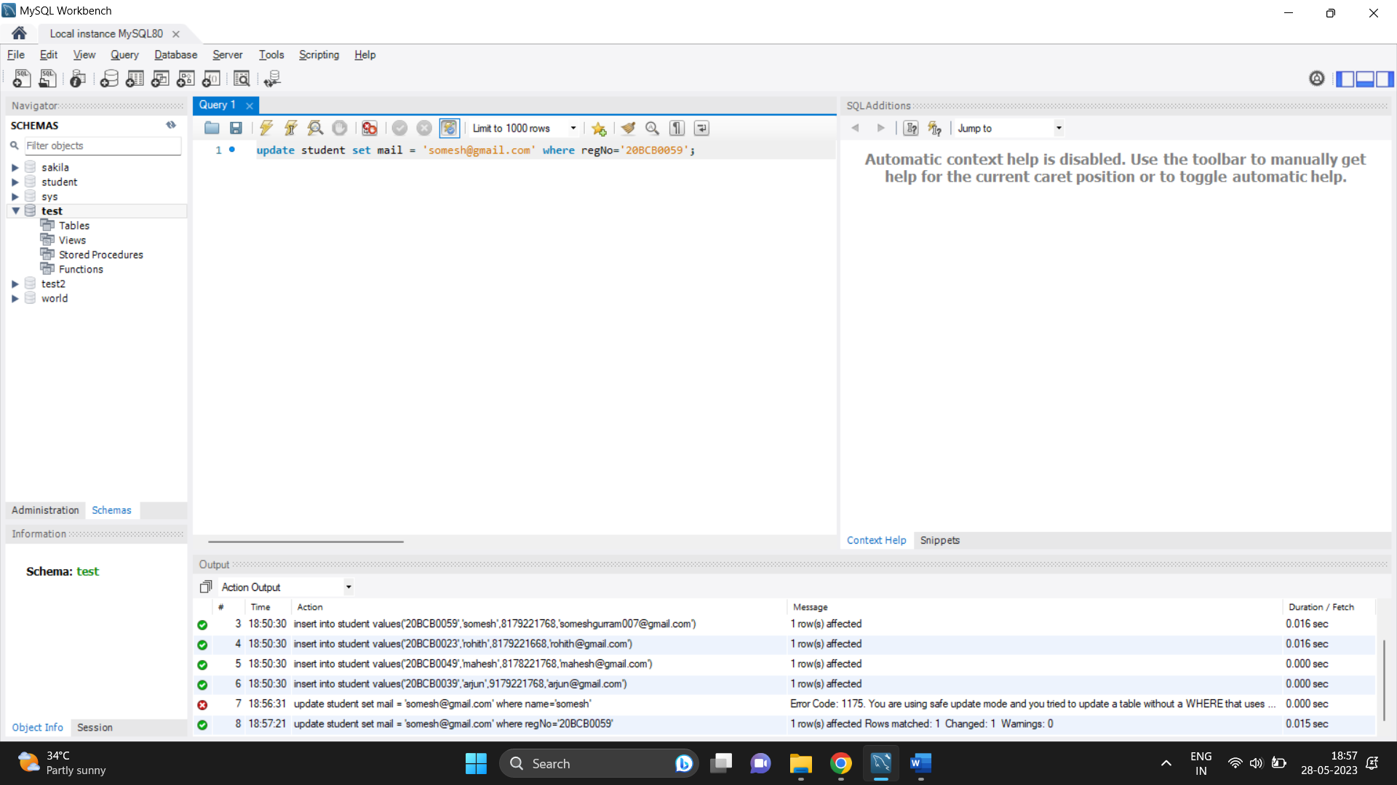

**Deleting**

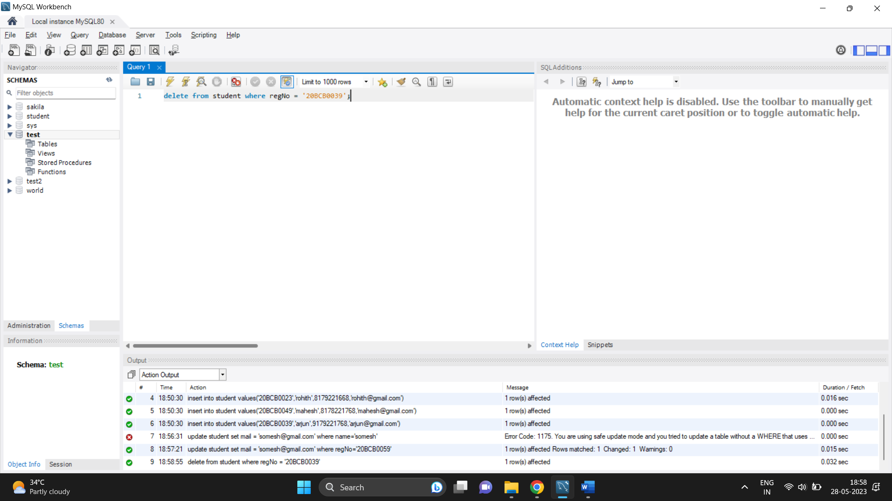

**2)create tables and perform joins**

**Creating required tables**



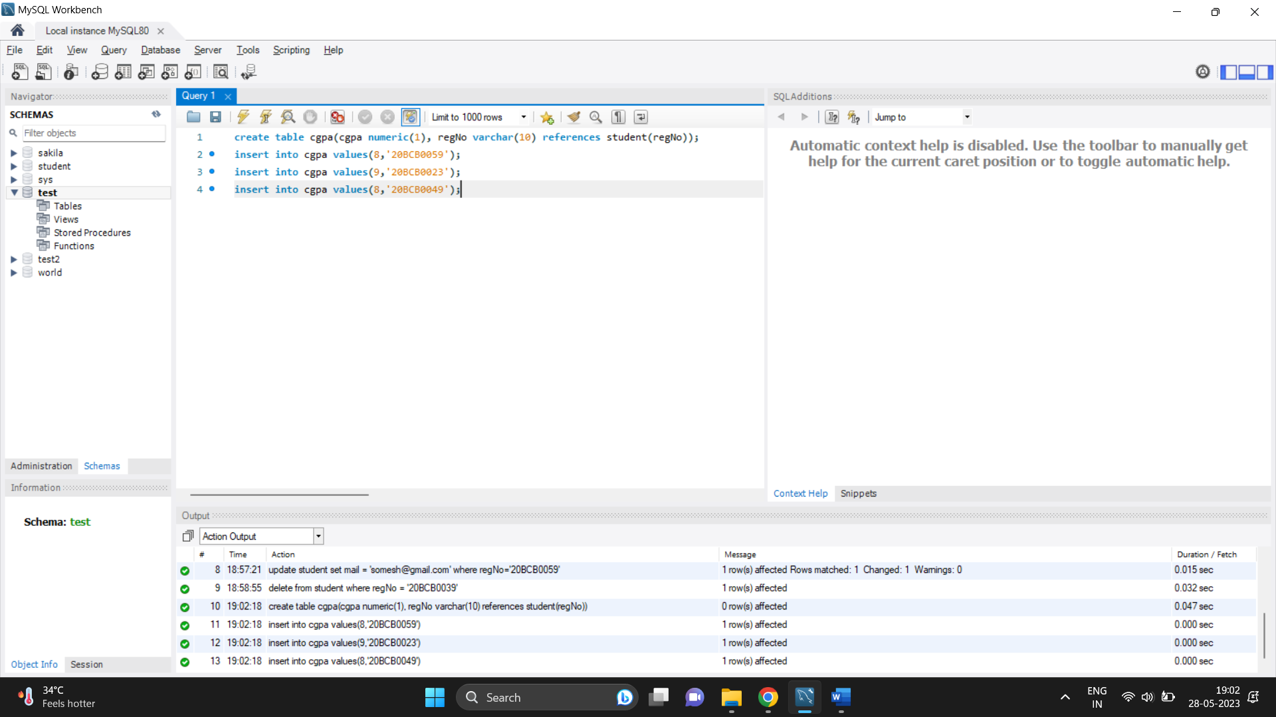

**Performing inner join**

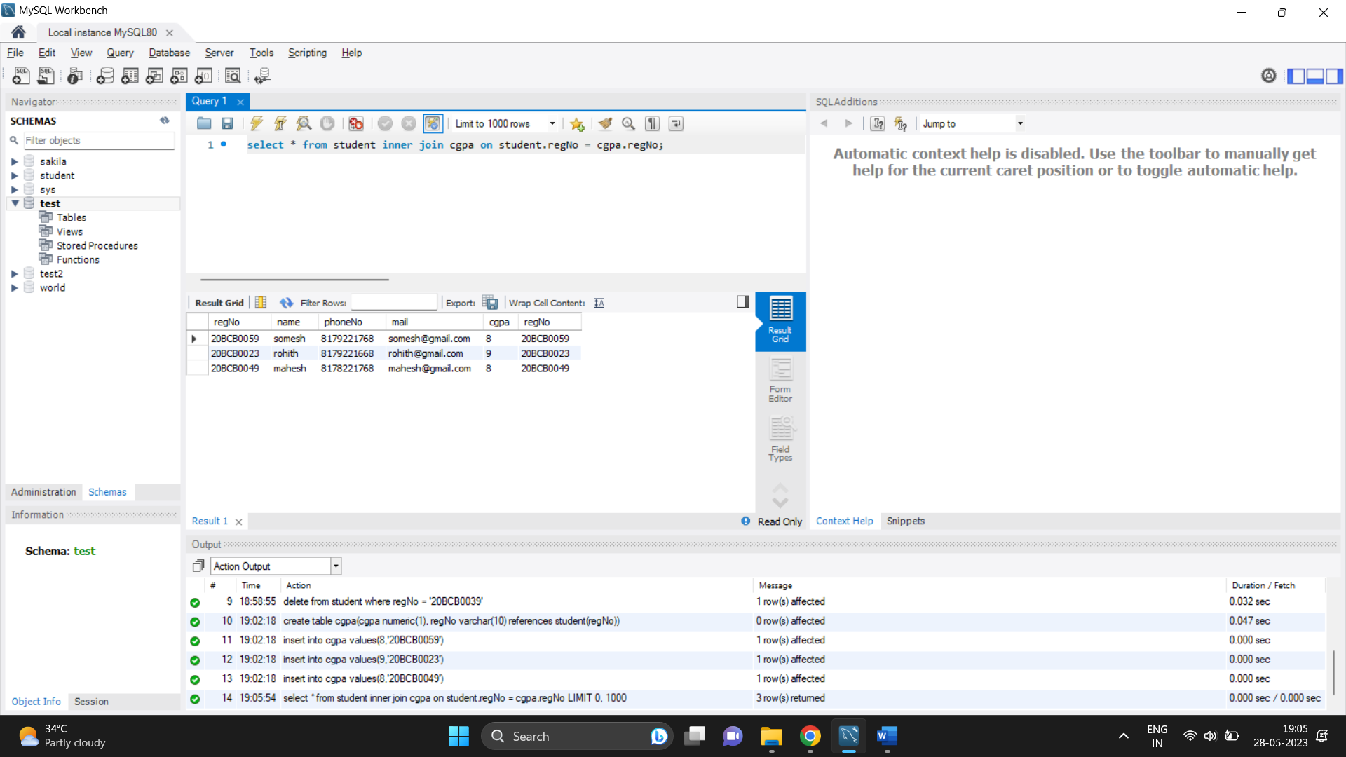

**Performing left join:**

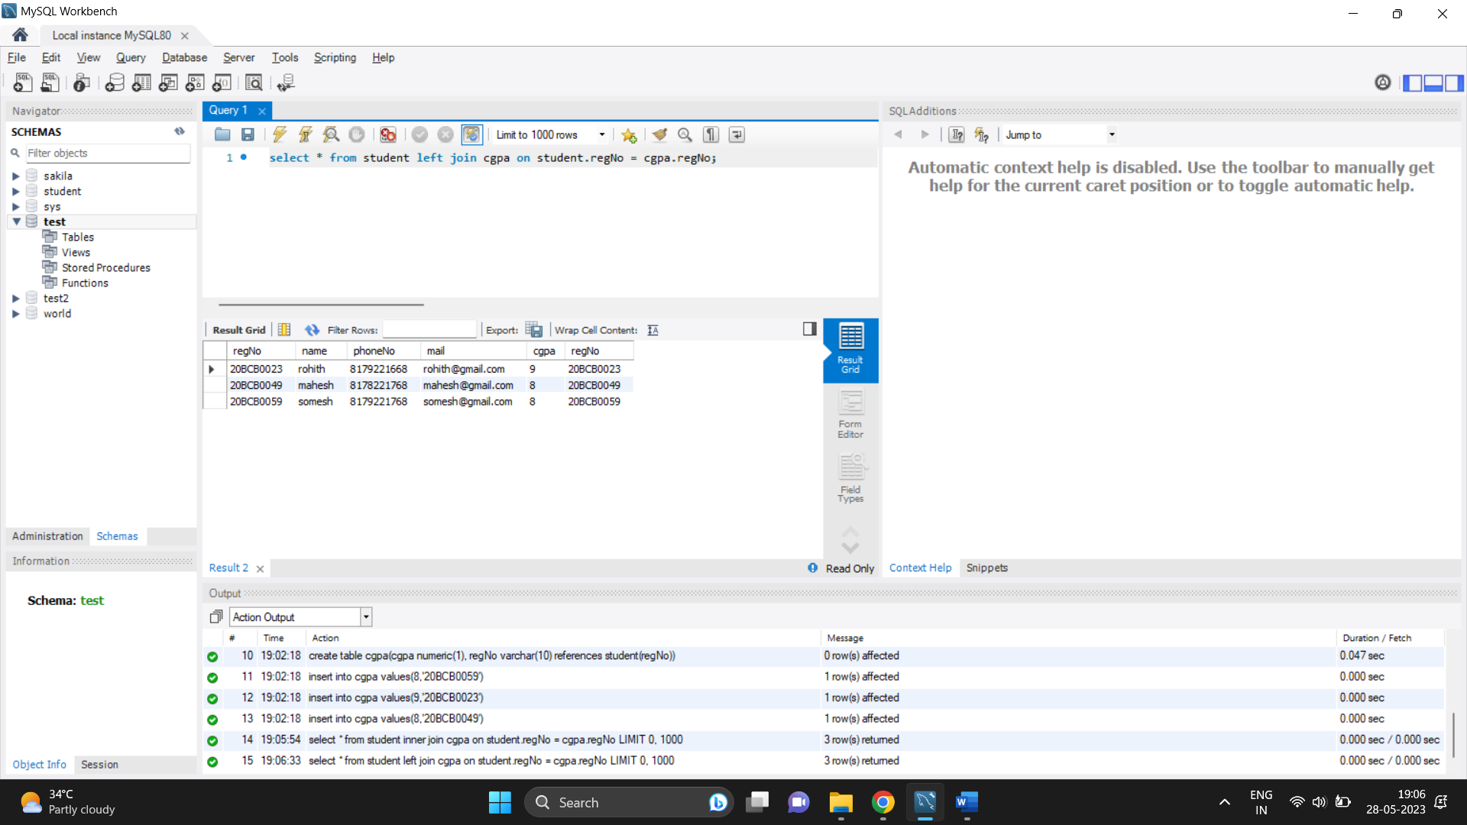

**Performing right join:**

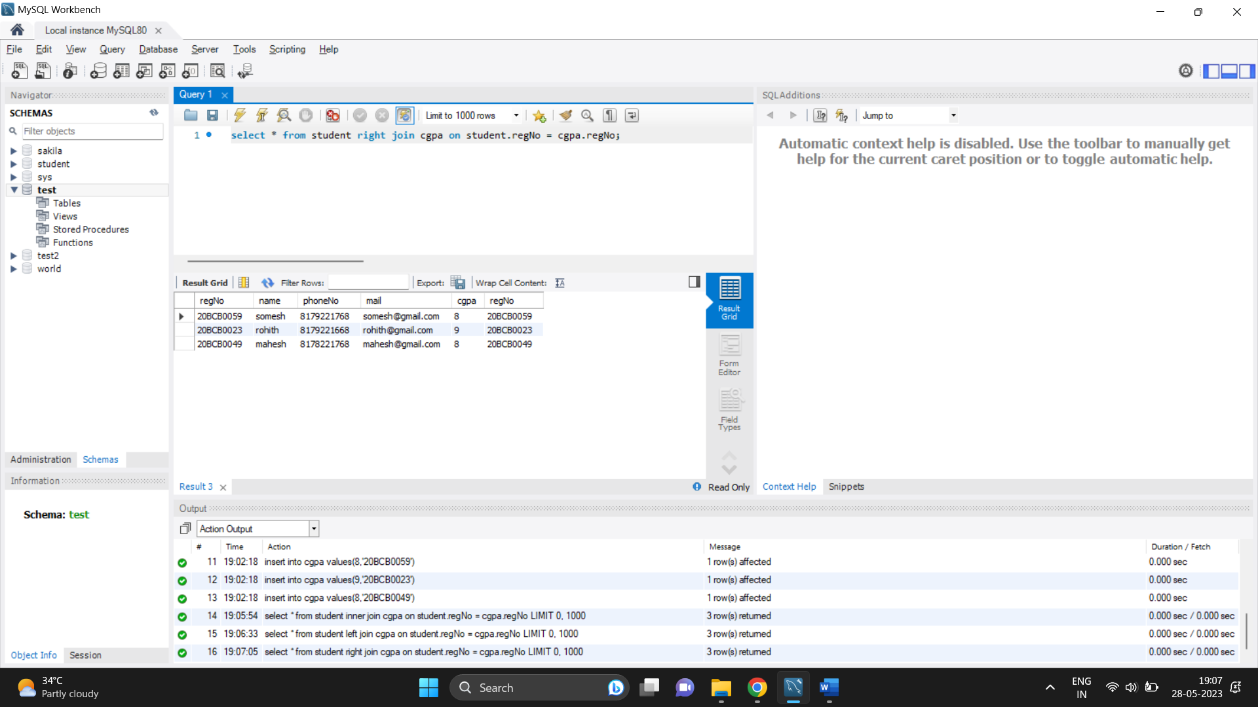

**3)create,update,delete comand in mongoDB**

**Create**

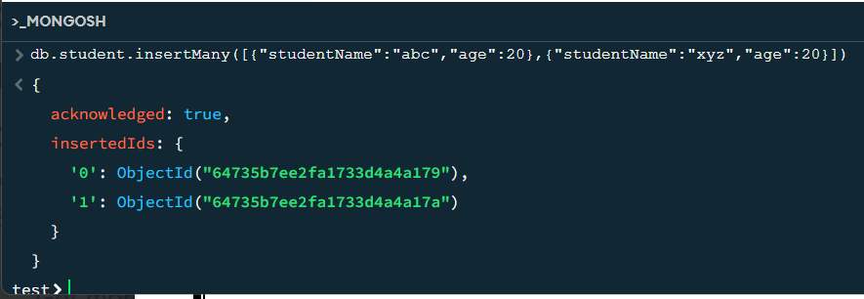

**Update**

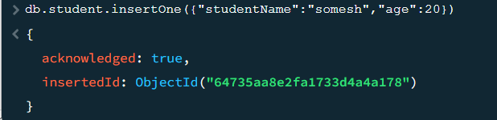

**Delete**

