**DropBears**

**Overview:**

Our Team has decided to do a turn-based tactical strategy game. We came up with DropBears, where you play as a squad of different colored bears that each have their own unique abilities fighting for justice and honey.

**Gameplay:**

The objective of the game is simple, defeat the enemy team before your team is wiped out.

**Battle Menu:**

|  |  |  |  |
| --- | --- | --- | --- |
| Character  Icon | Battle Menu and  ATTACK Submenu | Attack  Information | Character  Statuses |
| This panel will display the selected character. | This panel will display the gameplay options. (Explained Below) | This panel will display the information of the different attack option in the submenu. | This panel displays the current health of the player characters and has indicators to show if the abilities are usable. |

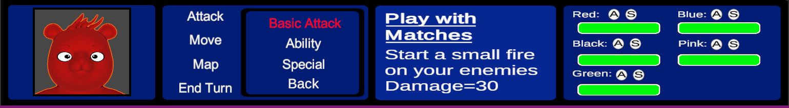

**Instructions/Controls:**

**Navigating the Menu:**

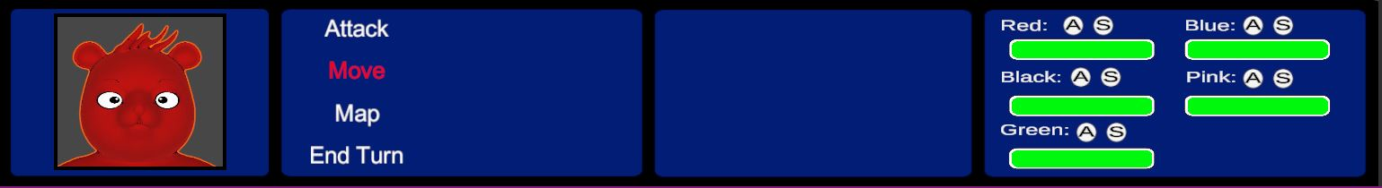

Layout - Keyboard/XBOX/PS4:

AD/D-PAD – Switch characters.

WS/D-PAD –Navigate up or down in the Menu.

Spacebar/A/X – Confirm the Selection.

Esc/B/O – Return to previous menu

Esc/Start/Options – Pause the game.

**Attack:**

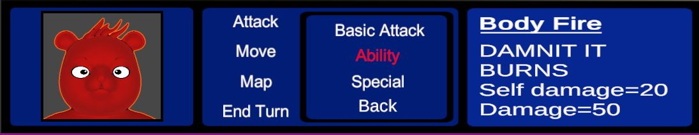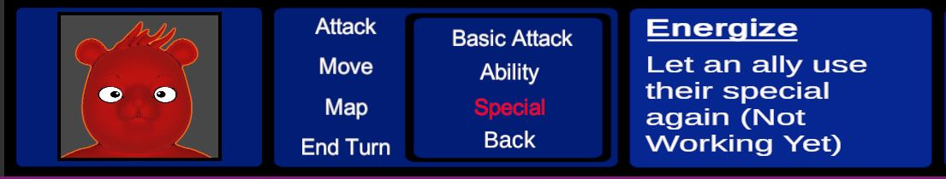

The attack option brings up a submenu with the specific bears different abilities:

* Basic Attack - Deals regular damage which is based on the bears attack strength.
* Ability - Each Bear has an ability that can deal extra damage to an enemy or buff one of the stats of itself or another bear. (Once used it has a 3 turn cooldown)
* Special - Same as ability but stronger. (Can only be used once per battle).

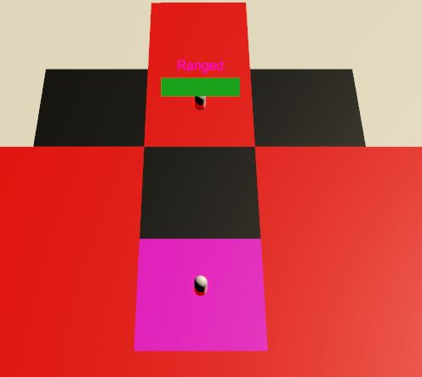Once an option has been selected you will be moved to the map and the range of the attack will be displayed in red.

Controls:

WASD/Arrow Keys/D-PAD – Navigate the cursor (Pink Square) and select a tile with an enemy.

SpaceBar/A or X – Confirm Selection

**Move:**

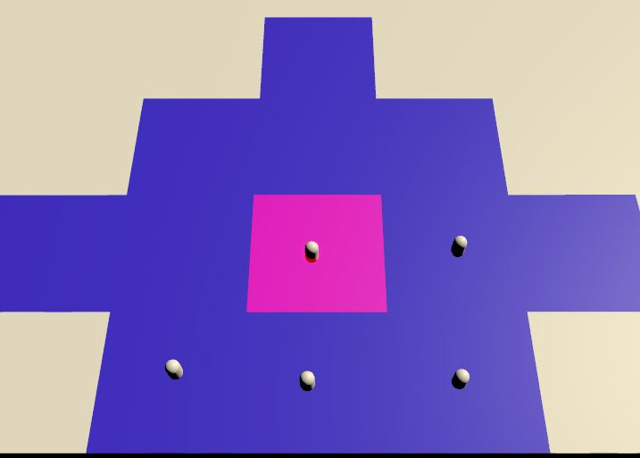Once move has been selected you will be moved to the map and the range of your movement will be displayed in blue.

Controls:

WASD/Arrow Keys/D-PAD – Navigate the cursor (Pink Square) and select a tile to move too.

SpaceBar/A or X – Confirm Selection

**Map:**

This option will allow the player to look around the battle arena and check the status of any enemy/player the cursor is on.

**End Turn:**

Once the player is finished with a character, they can end the turn anytime. However, the character will end its turn automatically after it has moved and attacked.

**Resources:**

**Models:**

**Bear Model** - 3D cartoon bear by visnum - <https://www.turbosquid.com/3d-models/3d-bear-cartoon-1240541>

**Black Bear Boss** - HybridCreature BlackBear V2 by printable_models - <https://free3d.com/3d-model/hybridcreature-blackbear-v2--749600.html>

**Polar Bear Boss** - HybridCreature PolarBear V2 by printable_models - <https://free3d.com/3d-model/hybridcreature-polarbear-v2--960655.html>

**Buck Enemies** - HybridCreature DeerBuck V2 by printable_models -

<https://free3d.com/3d-model/hybridcreature-deerbuck-v2--973911.html>

**Ram Enemies** - HybridCreature BigHornedRam V2 by printable_models -

<https://free3d.com/3d-model/hybridcreature-bighornedram-v1--496882.html>

**Lion Enemies** - HybridCreature Lion V2 by printable_models -

<https://free3d.com/3d-model/hybridcreature-lion-v1--83341.html>

**Asset Packs:**

8K Skybox Pack Free by BG Studio

Campfire Pack by DreamDev

LowPoly Water by Ebru Dogan

Neon Shapers by MAD Entertainment

POLYGON – Knight Pack by Synty Studios

POLYGON – Samurai Pack by Synty Studios

POLYGON – SCI-FI City Pack by Synty Studios

POLYGON – Vikings Pack by Synty Studios

**Pictures:**

**Eyes:**

Cartoon Eye PNG - [https://flyclipart.com/eye-graphic-png-cartoon-eyes-googly-eyes-png-825640#](https://flyclipart.com/eye-graphic-png-cartoon-eyes-googly-eyes-png-825640)

Owl Eyes Icons Png - <http://getdrawings.com/get-silhouette#eyes-silhouette-21.png>

Panda Eyes by inabox - <https://www.songkick.com/images/37025287>

Angry Eyes - <https://www.pinclipart.com/maxpin/bTmhRh/>

**Symbols:**

White Lightning by Y4K - <https://www.redbubble.com/fr/people/-y4k-/works/29638178-foudre-blanche>

Hermes Logo by Edga - <https://www.cleanpng.com/png-caduceus-as-a-symbol-of-medicine-caduceus-as-a-sym-176344/>

Bomb PNG Picture - <http://www.pngmart.com/image/110146>

Algiz Norse Rune - <https://symbolikon.com/downloads/algiz-norse-runes/>

Uruz Norse Rune - <https://thewickedgriffin.com/elder-futhark-rune-meanings/>

Fist Transparent Background - <http://clipart-library.com/clip-art/fist-transparent-background-10.htm>

Fiery Comet Fireball PNG by Ahkâm - <https://www.freeiconspng.com/img/48503>

Medic Free Icon - <https://www.onlinewebfonts.com/icon/491107>

**Tattoos:**

Tribal Chest Tattoo Png - <https://www.pngkit.com/bigpic/u2t4o0i1o0o0r5o0/>

Gothic Tattoo - <http://pluspng.com/gothic-tattoos-png-526.html>

Tribal Bear Tattoo by Raposakitsune - <https://www.deviantart.com/raposakitsune/art/Tribal-bear-possibly-the-next-tattoo-442156150>

Wrist Tribal Tattoo - <http://clipart-library.com/clip-art/tribal-tattoo-transparent-background-7.htm>

Tribal Sun Tattoo - <http://www.freetattoodesigns.org/sun-tattoos.html>

**Images:**

Happy Birthday Bear - <https://bestwishes4birthday.com/happy-birthday-bear-meme/>

Sad Bear - <https://www.pinterest.ca/pin/8514686774558150/>

Brown Bear - <https://www.publicdomainpictures.net/en/view-image.php?image=214013&picture=brown-bear>

Rounded Square Icon - <https://icons8.com/icon/4knsel5keE42/rounded-square>

LaSalle Logo Provided by Marc-Andre Larouche

**Fonts:**

Edmund by Typodermic Fonts - <https://www.dafont.com/edmunds.font>

**Music/Sound:**

Music Tracks done by Derek Roberts using Novation Launchpad App

Sound Clips recorded by Zachary Bolduc-Adolph

**Animations:**

All animations are from Mixamo