# School of Computing

# Assignment 1

# CA169 – Networks & Internet

# Dr. Mohammed Amine Togou

# TA: Aadarsh Balraj

# 20th February 2023

|  |  |
| --- | --- |
| STUDENT NAME: | Jack Egan |
| STUDENT NUMBER: | 22404362 |
| DEGREE:  [CA EC ECSA PSSD] | CA1 |
|  |  |

|  |
| --- |
| **Declaration**  ***In submitting this project, I declare that the project material, which I now submit, is my own work. Any assistance received by way of borrowing from the work of others has been cited and acknowledged within the work. I make this declaration in the knowledge that a breach of the rules pertaining to project submission may carry serious consequences.*** |

***P.S. Before submitting, change the document name to: yourlastname_CA1***

# Exercise 1

1. Using the ipconfig (Windows)/ifconfig (Mac) command, answer the following (**3 marks**):

|  |  |
| --- | --- |
| Your MAC address | F8-B5-4D-63-66-95 |
| Your IP address | 192.168.1.11 |
| The broadcast address | 192.168.1.255 |
| The subnet mask | 255.255.255 |
| The default gateway IP address | 192.168.1.1 |
| The network interface having this configuration | Wireless LAN adapter Wifi |

# See the ipconfig command manual[1] for more info on which option(s) to use to get all the above.

# For Mac users, use route command to get some of the requested information. See the manual[2] for more info on which option(s) to use.

# IP addresses/subnet mask should be expressed in decimal representation.

# Paste a screenshot of the output of the ipconfig/ifconfig command here showing all the above.

# Using your IP address, answer the followings (1.5 marks):

# Class of your IP address: C

# Netid of your IP address: 192.168.1

# Hostid of your IP address: 11

# How many devices can be connected to your network (show how you got the answer) (2 marks)?

My subnet mask is 255.

This means that I can have networks 0-255

This means I can have 256 devices connected to my network.

# 

# In your own words, what does “default gateway” mean (mark 1)?

The default gateway is a network device that acts as both an entry and exit point for traffic between various networks.

It is an essential part of the TCP/IP protocol suite that enables communication between devices on local networks and other networks, like the internet.

**Exercise 2**

1. Open the terminal and run the following command:

**ping www.dcu.ie**

# For Mac users, use control + c keys to stop the ping command once 5-6 entries are displayed. Paste a screenshot of the output of the ping command here.

# Describe all the information returned (redundant info should be described once only) (5 marks).

|  |  |
| --- | --- |
| Attribute | Description |
| Ip address | The IP address of DCU which is: 99.80.221.0 |
| Amount received | The number of packets received from DCU: 4 |
| Amount sent | The number of packets sent to DCU: 4 |
| Max Time | The longest time it took for a packet to send: 10ms |
| Min Time | The shortest time it took for a packet to send: 9ms |
| Average Time | The average time it took for the packets to send: 9ms |
| TTL | The time within if it doesn’t respond it will assume its lost: 50ms |
| Lost | The amount of packets lost: 0 |
|  |  |
|  |  |

1. Open the terminal and run the following command:

**ping localhost**

# In your own words, what does “localhost” mean and what is it used for? What is it IP address (1 marks)?

IP : 127.0.0.1

The local computer you are currently using is referred to as "localhost" and is also known as the loopback address.

Through the loopback network interface, it is used to access the network services that are active on the host.

1. Open the terminal and run the following command:

**ping** [**www.bonkers.ie**](http://www.bonkers.ie)

Paste a screenshot of the output here.

* What does “Request timed out” (Windows)/ “Request timeout” (Mac) mean (**1 marks**)?

"Request timed out" is an error message that can appear when a network connection attempt fails to receive a response within a certain amount of time.

1. Open a web browser and type in the IP address of [www.bonkers.ie](http://www.bonkers.ie) and hit Enter. Paste a screenshot of what is displayed.

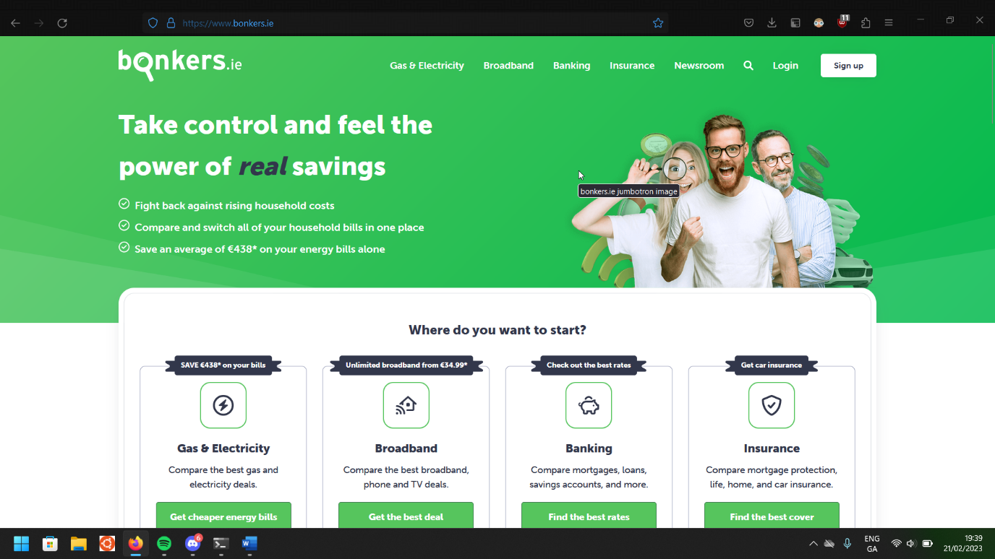

* What does this mean (**1.5 marks**)?

This means this IP Address is for the website www.bonkers.ie

* Why did the ping command not work (**1.5 marks**)?

The IP Address is secured and did not receive the data sent to it from the localhost due to the Firewall. This meant that the request timed out.

**Exercise 3**

Using the netstat command, answer the following (**2.5 marks**):

|  |  |  |
| --- | --- | --- |
| **Protocols** | **Attributes** | **Values** |
| **UDP** | Datagrams received | 2612653 |
| **IPv4** | Packets received | 3338719 |
| Packets sent | 3348061 |
| **ICMPv4** | Destination Unreachable (sent & received) | Sent:  1838  Received:  88 |
| Echo (sent & received) | Sent:  32  Received:  0 |

See the **netstat** command manual (Windows[3], Mac[4]) for more info on which option(s) to use to get all the above.

Paste a screenshot showing the UDP statistics here.

Paste a screenshot showing the IPv4 statistics here.

Paste a screenshot showing the ICMPv4 statistics here.

1. <https://learn.microsoft.com/en-us/windows-server/administration/windows-commands/ipconfig>
2. <https://www.manpagez.com/man/8/route/>
3. <https://learn.microsoft.com/en-us/windows-server/administration/windows-commands/netstat>
4. <https://www.oreilly.com/library/view/mac-os-x/0596003706/re307.html>