**The requirements that have been covered on the design of this controller are:**

* The user can input the cooking time by using the left button, it increases by 10 seconds and it varies from 10 to 60. The CPL is changed by clicking the right button. The previous inputs are initialized to 0 and null resp. The start and stop button are controlled by the sensor number 12 and it is initialized to 0.
* The door sensor is controlled by the controller’s switch. A variable DS is associated to the switch so that when microwave is cooking, the door is locked and even if the switch is positive it doesn’t make the door is opened.
* The bulb is showed by the LED 2 and 7, it is always ON except when the door is closed and no cooking.
* At the start the controller is asleep, the door sensor signifies that the door is closed, the cooking status is 0, the cooking time is 0, the cooking power level is undefined,
* When the cooking power lever and the cooking time are selected the cooking can start after pressing the start/stop sensor. If any of them is not selected, the cooking cannot start, and a message is displayed on the screen telling that the inputs are needed.
* When the cooking starts, the Fan is turned ON, the door is locked, the turntable starts turning and the magnetron is turned ON as well. However, the LED lights associated are turned ON. LED 0 and 1 are associated with the FAN. LED 3 and 4 are ON when the door is locked. LED 5 and 6 are linked to the turntable. LED 8 and 9 are ON when the magnetron is ON.
* During the cooking, the fan, the turntable and the magnetron are turned ON and the door is locked. when the door’s switch is moved, the door will not be opened, and a message will be displayed showing that the door is locked. The temperature is increased according to the time and the cooking power level. When the cooking power level is low the temperature increases by 2degrees Celsius every one second. If the level is medium, the temperature increases by 3 degrees Celsius every 1 second. If it is high, it increases by 5 degrees every 1 second. When the temperature gets to 100 the magnetron is turned off and the cooking continues.
* While cooking, if the stop button is pressed, the cooking stops, the magnetron and the turntable are turned OFF, the door is unlocked, and the fan stays ON for extra 10 seconds. A buzzer will go ON until 20 seconds passes or until the door is opened.
* When the cooking time is finished the fan stays ON for extra 10 seconds and the controller sounds buzzer for 20 seconds or until the door is opened.

**The safety cases:**

* The controller cannot start until both CPL and CT are given
* The door cannot be opened during the cooking time until the stop button is pressed, or the cooking time is over
* The magnetron is turned OFF for the rest of the cooking time when its temperature sensor is more than 100.
* After pressing the stop button, the fan continues working for extra 10 seconds after all the other components are turned OFF

**ASM:**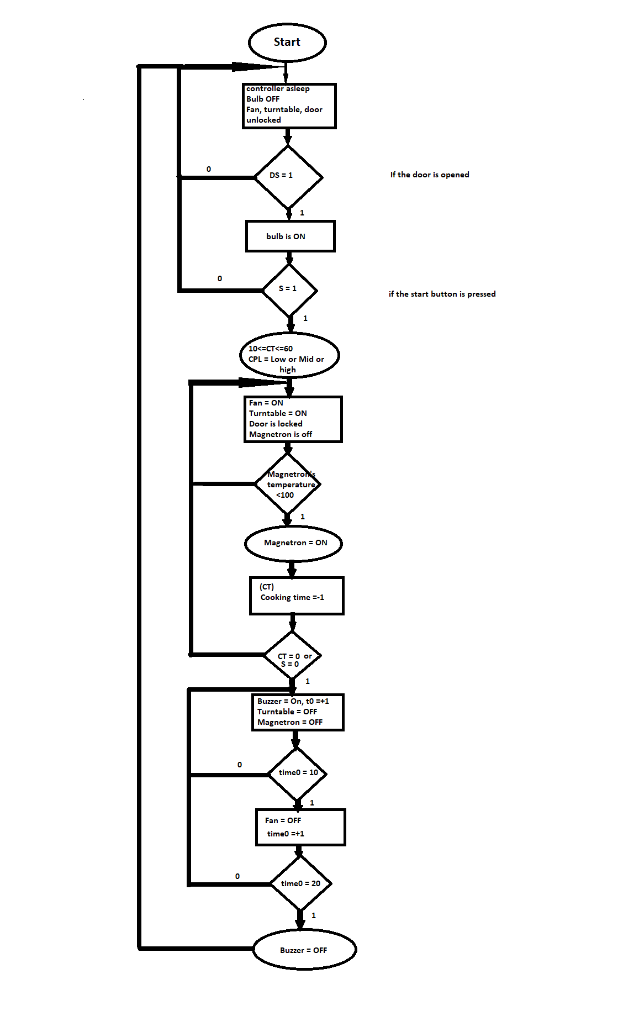

**The sensors used in the design:**

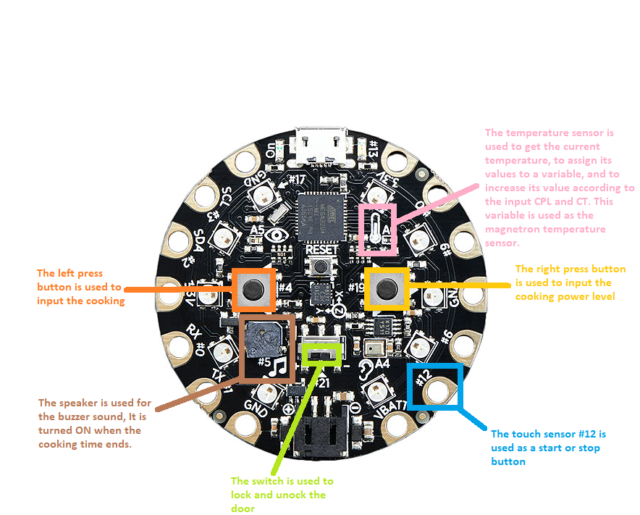

**LED lights significations:**

