**Implementation of the scenario:**

* The MJR lights are displayed in the left side of the circuit and the MNR lights are displayed in the right side.
* When the controller starts, the traffic lights (TL) are green for the major road (MJR) and red for the minor road (MNR). This state is the default state.
* I have ensured that if TL has just changed into the default state, then MJR will stay GREEN for at least 20 seconds irrespective, before changing again to any other states. I did this by using a variable nominated ‘TL’. If a 20 second has passed after starting the default state, then ‘TL’ value is changed to ‘1’ so that the 20 second wait isn’t done again.
  + During this state if both MNR sensors and the pedestrian crossing are requested then a priority to the pedestrian crossing id done before the MNR sensors. I have given this priority to pedestrian crossing because after pedestrian crossing we can allow the MNR light to be red and MJR light to be red (so I considered the MNR sensor before going back to the initial state). However, if I have given priority to MNR sensor then a return to the default state is happened before allowing the pedestrian crossing. So, the pedestrian crossing waits too long.
* A suitably positioned sensors on MNR are triggered when a vehicle approaches the junction on either side: this has been implemented by using the touch sensor number 10 as the first side MNR sensor, and the touch sensor number 12 as the second side MNR sensor. If we keep touching one of them then a 5 second wait is done. After that the TL becomes red for MJR and green for MNR. This state takes 20 seconds after that a return to the default state happens.
* There is a pedestrian crossing on the major road only. In my design I used the left and right button of the controller. If one of the buttons is pressed, then I consider that a pedestrian-sensor is triggered. When it is triggered TL in both MJR and MNR becomes red to allow people to cross. People crossing takes 15 seconds.
* After this state if the MNR sensors is triggered then no return to the initial state is done before allowing the cars in the MNR to cross.
* A camera is positioned on MJR to detect if cars cross during the MJR red light. The camera is designed by using the two touch sensors in the right side of the circuit. While the MJR light is red, if we touch the touch sensor number ‘1’ and after 1 second if the touch sensor number ‘3’ is pressed that means the vehicle has crossed while the light is red, so a number is saved, and it is increased all the time when a new vehicle is offended.
  + If the switch is changed to the positive side, then all the car that has been saved by the camera are displayed in the serial monitor.

**ASM:**

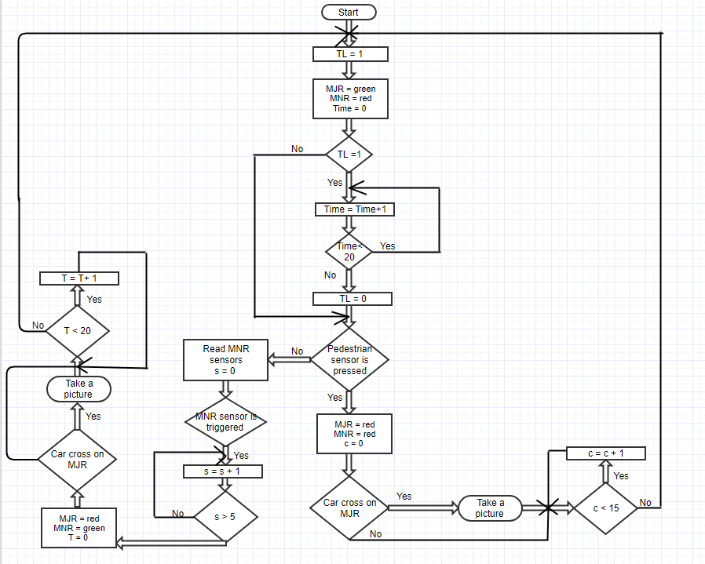

**Design consideration:**

