TEXT SUMMARIZATION TOOL
Project Report

BACHELOR OF TECHNOLOGY (CSE)
Specialization with Artificial Intelligence, Machine Learning & Deep Learning
PROJECT MENTOR :  Umesh Chandra Garjola | SUBMITTED BY:  Somil Jain

May - August 2025



FACULTY OF ENGINEERING & COMPUTING SCIENCES
TEERTHANKER MAHAVEER UNIVERSITY, MORADABAD

ACKNOWLEDGEMENT
I would like to express my sincere gratitude to my project guides, both external and internal, for their invaluable guidance and support throughout this internship project. Special thanks to the team at EliteTech Intern for providing the opportunity to work on this task and for their mentorship. I am also thankful to my faculty at Teerthanker Mahaveer University for their encouragement. This project would not have been possible without the resources and knowledge shared by open-source communities, particularly in NLP and web development.
Somil jain
Place: Moradabad
Date: September 21, 2025

DECLARATION

We hereby declare that this Project Report titled Text Summarization Tool submitted by me and approved by my project guide , the College of Computing Sciences and Information Technology (CCSIT), Teerthanker Mahaveer University, Moradabad, is a bonafide work undertaken by me and it is not submitted to any other University or Institution for the award of any degree diploma / certificate or published any time before.

Student Name: | Somil jain | Signature
Project Mentor : | Umesh Chandra Garjola | Signature

Brief About the Company
EliteTech Intern is a dynamic and innovative software development company based in Delhi, India, founded in 2023. With a small team of 1-10 employees, the company specializes in delivering cutting-edge solutions to clients, focusing on software development, technology training, and internship programs. EliteTech Intern offers remote, on-site, and hybrid internship opportunities, allowing interns to gain hands-on experience in areas like web development, natural language processing, and software engineering. The company is committed to fostering talent through practical projects and has received positive reviews for its work-life balance, rated 3.9/5 on platforms like AmbitionBox, with an overall company rating of 3.5/5 based on employee feedback. Interns at EliteTech often work on real-world tasks, such as building AI-driven tools, which help bridge the gap between academic learning and industry requirements. The company emphasizes innovation and provides a supportive environment for skill development in emerging technologies.
EliteTech Intern's internship programs are designed to be flexible, with opportunities in fields like data science, machine learning, and full-stack development. As part of their initiatives, they encourage interns to contribute to open-source projects and build portfolios through GitHub repositories. The company's culture promotes collaboration and continuous learning, making it an ideal place for students to kickstart their careers in technology.

Contents
1 Project Title 6
2 Problem Statement 6
3 Project Description 6
3.1 Scope of the Work 6
3.2 Project Modules 7
3.3 Context Diagram (High Level) 7
4 Implementation Methodology 8
5 Technologies to be used 8
5.1 Software Platform 8
5.2 Hardware Platform 8
5.3 Tools, if any 8
6 Advantages of this Project 9
7 Assumptions, if any 9
8 Future Scope and further enhancement of the Project 9
9 Project Repository Location 9
10 Definitions, Acronyms, and Abbreviations 10
11 Conclusion 10
12 References 10

Appendix
A: Data Flow Diagram (DFD)
B: Entity Relationship Diagram (ERD)
C: Use Case Diagram (UCD)
D: Data Dictionary (DD)
E: Screen Shots

Project Title
Text Summarization Tool

Problem Statement
In today's information-rich world, people are overwhelmed with large volumes of text from articles, reports, and documents. Manually reading and extracting key points is time-consuming and inefficient. This project addresses the need for an automated tool that can quickly generate concise summaries while preserving essential information, using natural language processing techniques. The topic was selected due to the growing demand for AI-driven content processing in industries like journalism, research, and education, solving the problem of information overload.

Project Description
The Text Summarization Tool is a web-based application developed using Flask and Python, integrated with NLP libraries for summarizing input text. The scope includes processing user-provided text to generate extractive and abstractive summaries. The project structure consists of a core summarization script and a web interface for user interaction. Key modules include text input handling, summarization algorithms (word frequency, TF-IDF, and simple abstractive methods), and output display. A high-level context diagram shows text as input flowing into the system, processed by NLP algorithms, and outputting a summarized version.

Scope of the Work
In-Scope:
Development of a web interface for text input, implementation of extractive (word frequency and TF-IDF) and simple abstractive summarization, generation of text statistics, and demo/interactive modes for testing.
Out of Scope:
Advanced machine learning models like transformer-based summarization (e.g., BERT), integration with external APIs for real-time data fetching, multi-language support beyond English, and user authentication features.

Project Modules
- Input Module: Handles user text input via a web form or interactive console, including validation for empty or invalid inputs.
- Summarization Module: Core logic for processing text using NLP techniques, including tokenization, frequency calculation, TF-IDF scoring, and sentence ranking for extractive summaries, plus basic abstractive generation.
- Statistics Module: Generates additional insights like word count, sentence count, and readability scores.
- Output Module: Displays the summarized text and statistics on a results page or console, with navigation back to the input page.
- Demo Module: Provides pre-loaded sample texts for quick demonstration without user input.

Context Diagram (High Level)

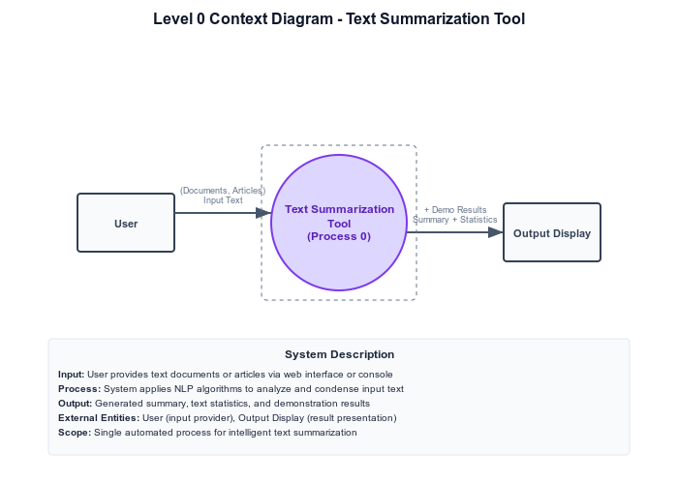

Implementation Methodology
The project follows an agile-like approach with iterative development: requirements gathering, design, implementation, testing, and deployment. Data Flow Diagrams (DFDs) illustrate the flow from input to summarization to output. Use Case Diagrams outline user interactions. No database is used, so ERD is minimal for conceptual entities. Class Diagrams define Python classes for summarizers. Testing involves unit tests for algorithms and functional tests via manual runs, with a defect log maintained in a simple text file tracking issues like summarization accuracy or web errors. Defects are logged with ID, description, severity, status, and resolution date.

Technologies to be used
Python for core logic, Flask for web framework, NLTK for NLP tasks.

Software Platform
a. Front-end: HTML, CSS, JavaScript (for web interface).
b. Back-end: Python with Flask and NLTK.

Hardware Platform
- RAM: Minimum 4 GB (recommended 8 GB for smooth NLP processing).
- Hard Disk: 500 MB free space.
- OS: Windows/Linux/Mac (Python-compatible).
- Editor: VS Code or PyCharm.
- Browser: Google Chrome or Firefox for web access.

5.3 Tools, if any
- NLTK (Natural Language Toolkit), Vendor: Open-source, Version: Latest (e.g., 3.8.1) - Used for tokenization, stop words removal, and summarization algorithms during implementation.
- Flask, Vendor: Open-source, Version: 2.x - Used for web application development.
- Git, Vendor: Open-source - For version control

Advantages of this Project
- Reduces time spent on reading long texts by providing quick summaries.
- Improves productivity in research and content creation.
- Open-source, allowing customization and cost-free deployment.
- Supports multiple summarization techniques for flexibility.
- Easy-to-use web interface accessible from any browser.

Assumptions, if any
- The input text is in English.
- Users have basic internet access for web version.
- NLTK corpora are downloaded during setup

Future Scope and further enhancement of the Project
The project can be enhanced by integrating advanced AI models like Hugging Face Transformers for better abstractive summaries. Add multi-language support using libraries like spaCy. Implement user accounts for saving summaries. Deploy as a cloud service (e.g., on Heroku) for wider access. Add features like PDF upload for summarization and sentiment analysis integration.

Project Repository Location
S no. | Project Artifacts | Location | Verified by Project Guide
 | Project Synopsis Report (Final Version) | GitHub: https://github.com/Somil-ai/text-summarization-app | Name and Signature
 | Project Progress updates | GitHub Issues/Commits in repo | Name and Signature
 | Project Requirement specifications | README.md in repo | Name and Signature
 | Project Report (Final Version) | attached | Name and Signature
 | Test Repository | Manual test cases in text file within repo | Name and Signature
 | Any other document, give details | GitHub: https://github.com/Somil-ai/text-summarization-project | Name and Signature

Definitions, Acronyms, and Abbreviations

Abbreviation | Description
NLP | Natural Language Processing
TF-IDF | Term Frequency-Inverse Document Frequency
FLASK | A lightweight web framework for Python
NLTK | Natural Language Toolkit, a Python library for NLP

Conclusion
This Text Summarization Tool effectively addresses the challenge of information overload by automating the summarization process using NLP techniques. It combines a user-friendly web interface with robust algorithms for extractive and abstractive summaries, demonstrating practical application in real-world scenarios. Recommendations include scaling the tool for enterprise use, ensuring compatibility with mobile devices, and incorporating user feedback for improvements. Considering human (ease of use), financial (low-cost open-source), and managerial (simple maintenance) implications, this tool is feasible and impactful for educational and professional settings.

References
S no. | Reference Details | Owner | Version | Date
1. | NLTK Documentation | NLTK Project | 3.8.1 | 2023
2. | Flask Documentation | Pallets Projects | 2.3.3 | 2023
3. | Project Repositories | Somil-ai | 1.0 | 2025

Annexure A
Data Flow Diagram (DFD)
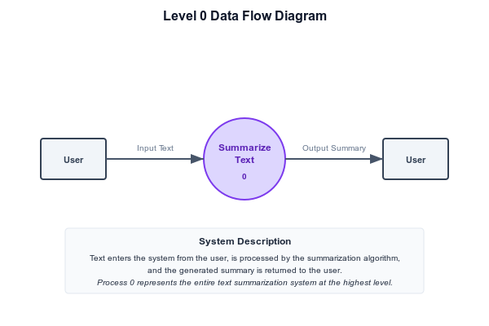

Annexure B
Entity-Relationship Diagram (ERD)
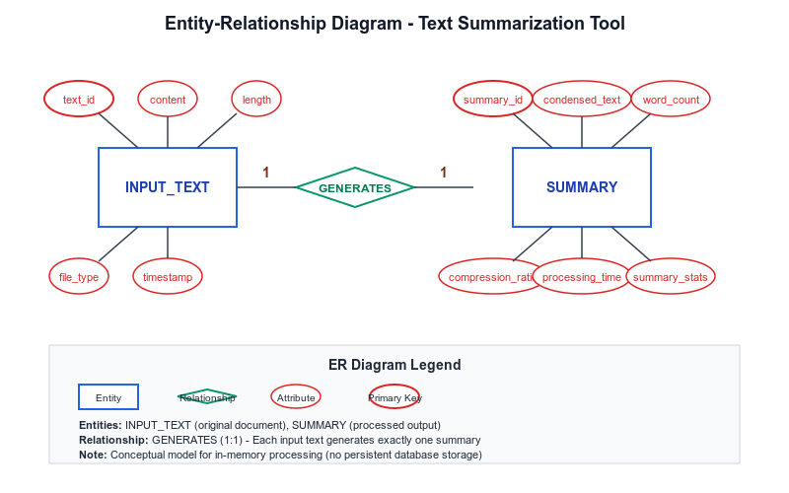

Annexure C
Use-Case Diagram (UCD)
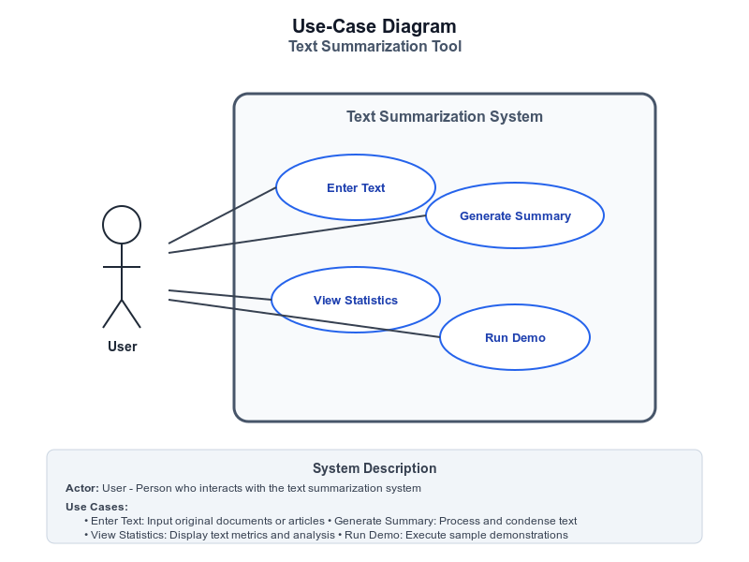
Annexure D
Data Dictionary (DD)

Input Text Table
Fields | Data type | Description
Text_Content | String | User-provided text
Word_Count | Integer | Number of words

Summary Table
Fields | Data type | Description
Summary_Text | String | Condensed output
Summary_Length | Integer | Length of summary
TF_IDF_Score | Float | Scoring metric

Annexure E
Screen Shots

