Personal Finance RAG
Team Rudra - GenAI Hackathon (Kaggle Week), EPITA
Project handbook: who built what on Day 1, what we changed on Day 2 after the professor's remarks, why, and how to run everything
Somitha Gudivada - Mekala Naveen Venkata Sai Kumar - Vijaya Venkata Krishna Rudra - Srikanth Galipelli
28 September 2026

Contents

If the table of contents above is empty, open the document in Word and choose References > Update Table (or right-click it > Update Field).

1. About this document
This handbook is written so that anyone - a teammate who missed a day, a jury member, or a reader who has never heard of RAG - can understand the whole project. Nothing is assumed: every technical word is explained the first time it appears, and Section 2 is a short course on the ideas behind the project.
The document answers four questions:
- What did each team member build on Day 1? (Section 4) - reconstructed from the Git history of the repository, file by file.
- What did the professor ask us to change? (Section 5) - the four remarks, and what was actually wrong in the Day-1 system.
- What did we change, and why? (Sections 6 to 8) - every new or modified file, what it does, how it works, and which remark it answers.
- How do we run it? (Section 9) - a step-by-step guide for Windows (and macOS / Linux), from an empty terminal to the working web app, the evaluation scripts and the Git commit.
Sections 10 to 12 cover testing, preparation for Demo Day (likely jury questions and good answers), and known limitations.

2. Background: the ideas behind the project

2.1 The problem
A Large Language Model (LLM) such as ChatGPT writes fluent text, but it has three weaknesses: it does not know documents it was not trained on, its knowledge stops at a training date, and when it does not know something it may invent a plausible answer (this is called a hallucination). If a student asks "What does our finance textbook say about the rule of 72?", a plain LLM cannot quote the textbook and cannot say which page the answer comes from.

2.2 The solution: Retrieval-Augmented Generation (RAG)
RAG adds a search step before the LLM writes. It works like an open-book exam:
- Retrieve - search the documents for the few passages most related to the question.
- Augment - paste those passages into the message sent to the LLM, with the instruction "answer only from these passages".
- Generate - the LLM writes the answer and says which passages (and therefore which pages) it used.
Because the answer is built from real passages, it can be checked: each claim points to a page of the book. That is exactly why the professor insists on citations.

2.3 Glossary
Term | Plain-language meaning
Corpus | The collection of documents the assistant knows. Ours: the OpenStax textbook "Principles of Finance" (629 PDF pages, about 1.6 million characters).
Chunk | A small piece of a page (a few sentences). The book is cut into chunks because the LLM can only read a limited amount of text per question, and small pieces make search precise.
Token | The unit LLMs count text in; roughly 4 characters or 3/4 of an English word. Prices are per million tokens.
Embedding | A list of 1,536 numbers produced by the model text-embedding-3-small that represents the meaning of a text. Texts with similar meaning get similar lists of numbers - like GPS coordinates for meaning.
Vector | Another word for that list of numbers.
Cosine similarity | A score between -1 and 1 saying how close two embeddings are (1 = same meaning). We use it to compare the question with every chunk.
FAISS | A library from Meta that stores all chunk vectors and finds the closest ones to a question vector very quickly. Our index is data/my_index.faiss.
Top-k | The k best chunks returned by the search (we use k = 8).
Dense search | Search by meaning, using embeddings and FAISS.
BM25 (keyword search) | A classic search-engine formula that scores a chunk by the rare words it shares with the question. Very good for exact terms such as acronyms (DDM, WACC) or codes ("2/10, net 30").
Hybrid search | Running dense and BM25 search together and merging the two ranked lists.
RRF (Reciprocal Rank Fusion) | The merging rule: each chunk gets 1/(60 + its rank) from each list, and the scores are added. A chunk ranked well by both lists wins.
Prompt / system prompt | The instructions sent to the LLM together with the question (for example "answer only from the passages, cite them as [n]").
Citation | A reference from a sentence of the answer to the passage and page it comes from. In our app: [1], [2] ... that open the PDF at the right page.
Out-of-scope question | A question the corpus cannot answer ("Who won the 2022 World Cup?"). The assistant must refuse instead of inventing.
Gradio | A Python library that turns Python functions into a web page (our user interface).
API key / .env | The secret password that lets our code use OpenAI models (and spend the team budget). It is stored in a file named .env that is never pushed to GitHub.
Git / GitHub / pull request (PR) | Git records every version of the code; GitHub hosts it; a pull request is a proposal to merge one person's branch into the main code.

2.4 Hackathon rules that shaped our choices
- From scratch: no LangChain or LlamaIndex - every step is our own Python code.
- Only two models: gpt-4o-mini (chat) and text-embedding-3-small (embeddings).
- Budget: $5 per team for the whole week, so we embed once, cache everything and track costs.
- Allowed libraries: openai, faiss-cpu, pymupdf, pdfplumber, beautifulsoup4, numpy, tiktoken, gradio, python-dotenv, rank_bm25 (optional), sentence-transformers (optional). Our BM25 is written by hand with numpy, so it needs no extra library.
- Checkpoints: working chatbot with citations and out-of-scope handling by Tuesday 2 PM; Demo Day on Friday (15 minutes: live demo + questions).

3. The system at a glance
The project has two phases. The preparation phase runs once; the answering phase runs for every question.
PREPARATION (once)
data/sources/principles-finance_-_WEB.pdf
| scripts/extract.py (one entry per PDF page)
v
data/corpus.json (629 pages)
| app/chunking.py (sentence chunks + section titles)
| app/build_index.py (embeddings, FAISS index)
v
data/chunks.json + data/my_index.faiss

ANSWERING (every question)
question (+ chat history)
-> follow-up? rewrite it as a standalone question (conversation memory)
-> BM25 keyword search + FAISS vector search
-> Reciprocal Rank Fusion, max 2 chunks per page (several pages)
-> best similarity below 0.40 ? -> refuse, no LLM call (out of scope)
-> gpt-4o-mini with prompt v3 and passages [1]..[8]
-> answer streamed with [n] citations
-> Gradio UI: clickable [n] + "Sources" list + Sources panel
Repository layout after Day 2 (the data/ folder is not on GitHub; it is shared through Teams):
personal-finance-corpus/
README.md EVALUATION.md requirements.txt .env.example .gitignore
app/ __init__.py config.py text_utils.py chunking.py build_index.py
bm25.py retriever.py llm.py generator.py rag.py tracking.py app.py
prompts/ v1.txt v2.txt v3.txt CHANGELOG.md
scripts/ extract.py EXTRACTION_REPORT.md retrieval_checker.py eval_runner.py
demo_dry_run.py cost_report.py FAILURE_LOG.md
tests/ test_offline.py
data/ sources/ corpus.json sample.json questions.json chunks.json my_index.faiss
(+ files created while running: cost_log.json, query_log.jsonl, ...)

4. Day 1: each member's part
This section is reconstructed from the Git history of the repository (git log): who wrote each commit, which files it touched, and who merged each pull request. It describes the Day-1 code as it was, before any Day-2 change.
Member | Commits / pull requests | Files
Mekala Naveen Venkata Sai Kumar | "Prepare personal finance corpus extraction" and "Update team members" (21 Sep); "Implement retrieval and answer generation" (28 Sep); owner of the GitHub repository; merged PR #1 (rag-retrieval) | scripts/extract.py, scripts/EXTRACTION_REPORT.md, .gitignore, README.md, app/retriever.py, app/generator.py
Somitha Gudivada | "Add FAISS index and embedding artifacts"; merged PR #2 (embeddings-faiss) | app/build_index.py (run), data/chunks.json, data/my_index.faiss
Vijaya Venkata Krishna Rudra | "Add corpus loading and chunking pipeline"; merged PR #3 (chunking) | app/build_index.py (chunking functions)
Srikanth Galipelli | "Add Gradio UI and project documentation"; merged PR #4 (ui-documentation) | app/app.py, README.md, EVALUATION.md

Work that does not appear as a separate commit (choosing the corpus, writing the 47 evaluation questions, testing) was shared. The copy of the project in Kaggle_Week/personal-finance-corpus_demo (Naveen's working copy) also contains Day-1 evaluation scripts: evaluate.py, analyze_evaluation.py and inspect_failures.py, and their results file evaluation_results.json, which we reuse in Section 8 as the baseline.

4.1 Naveen - corpus extraction, retrieval and generation

scripts/extract.py (Assignment 0)
Goal: turn the PDF into clean text that a program can use. The script opens every file in data/sources/, reads PDFs page by page with PyMuPDF, reads .txt/.md files directly and HTML with BeautifulSoup (removing menus, scripts and footers), and writes data/corpus.json: one entry per page with source, page, char_count and text. It also writes sample.json (first 10 entries) and prints statistics.
Cleaning steps in clean_text(): normalise line endings, collapse repeated spaces, join words split by a hyphen at a line end ("finan-\ncial" -> "financial"), join lines broken in the middle of a sentence, and remove empty lines.
Result (from EXTRACTION_REPORT.md): 1 source file, 629 entries, 1,614,510 characters, 2,567 characters per page on average, 3 near-empty pages (pages 1 and 2 are images, page 14 is a footer) - kept, as the assignment requires, and reported.

app/retriever.py
Loads the FAISS index and chunks.json when the module is imported, embeds the question with text-embedding-3-small, normalises the vector (so that the FAISS inner product equals cosine similarity) and returns the k closest chunks with their score. It had a small command-line test: type a question and see the retrieved chunks.

app/generator.py
Builds a context from the retrieved chunks ("Source / Page / Text" blocks), sends it to gpt-4o-mini with a system prompt of 8 rules (use only the context, combine chunks for cross-reference questions, refuse with the exact sentence "I don't have enough information to answer this question.", always include source and page, never invent) and returns the answer text. Temperature 0 makes answers deterministic.

4.2 Somitha - embeddings and FAISS index
Somitha ran the indexing pipeline and committed its two outputs so that the rest of the team did not have to pay for embeddings again (the hackathon tip "one person embeds, everyone shares"):
- data/chunks.json - 4,347 chunks, each with its text, page and source.
- data/my_index.faiss - 4,347 vectors of 1,536 numbers (26.7 MB), stored in an IndexFlatIP (exact search by inner product).
How the embedding code works: chunks are sent to OpenAI in batches of 50 (one API call per batch), each answer contains one vector per chunk, the vectors are converted to a numpy array of 32-bit floats, normalised to length 1 with faiss.normalize_L2, added to the index and saved with faiss.write_index. Normalising matters: for unit-length vectors the inner product is the cosine similarity, so a higher score means a closer meaning.

4.3 Vijaya Venkata Krishna Rudra - loading and chunking
Rudra wrote the part of build_index.py that loads corpus.json and cuts it into chunks: chunk_text() takes 500 characters, then moves forward by 400 characters (500 - 100 overlap) and repeats; chunk_corpus() applies it to every page and copies the page number and source onto each chunk. The 100-character overlap makes sure a sentence cut at the end of one chunk still appears whole at the start of the next.
Why this matters: chunk size is a trade-off. Small chunks are precise but may lose context; large chunks carry context but dilute the match. 500 characters is a reasonable first choice; Day 2 improves it (Section 7.2).

4.4 Srikanth - web interface and documentation
Srikanth built the Gradio interface app/app.py: a question box, Submit and Clear buttons, four example questions, an Answer box and a Source Citations box, with a blue "Soft" theme. He also wrote the README (team, features, architecture, installation, run instructions, example questions) and EVALUATION.md (the 47-question evaluation set, 5 priority questions, the change from top-5 to top-10 retrieval that fixed cross-reference questions such as the American Airlines one, and out-of-scope tests).
To keep the UI usable before the index was ready, he added a demo fallback: if the retriever cannot be loaded, the app answers four known questions from hard-coded passages. This was a sensible idea for development, but it is at the origin of the first remark - see Section 5.

5. The professor's remarks and what was really wrong
# | Remark | What we found in the Day-1 system
1 | More than one source should be shown | The UI imported a class Retriever that did not exist in retriever.py (the file only has a function retrieve), so the import silently failed and the app always used the hard-coded demo fallback - which returns exactly ONE passage. Even with the real pipeline, answers cited a single page in free text ("Source: principles-finance_-_WEB.pdf, Page 229") and the top-10 often contained several overlapping chunks of the same page.
2 | UI citations | Citations were a plain text list "file, p. N" with no link, no passage text, no section and no indication of which passage supported which sentence. In the real code path generate_answer() returned a string while app.py expected a dictionary (result.get("answer")), which would have crashed.
3 | Features adding | Single question box without memory (follow-up questions impossible), no settings, no feedback, no export, no insight into the index or costs.
4 | Extensions | None of the optional extensions from 7_extensions.md were implemented (hybrid search, threshold, chunking improvements, prompt versioning, evaluation toolkit, cost tracker ...). Assignment 2's required tools (retrieval_checker.py, FAILURE_LOG.md) were also missing from the main repository.

Other bugs fixed along the way: files were opened with paths relative to the folder you launch Python from ("data/chunks.json"), so running from another folder failed; questions.json names the book "Principles_of_Finance-WEB.pdf" while chunks.json uses "principles-finance_-_WEB.pdf", so an automatic check of expected pages would always fail; and the demo fallback could present invented passages as if they were real citations.

6. Changes for remarks 1 and 2: several sources, citations in the UI

6.1 Numbered passages and mandatory multi-citation (prompts/v2 and v3)
What: the passages sent to the model are numbered [1] to [8], and each header shows document, section and page, for example:
[2] Principles of Finance (OpenStax, 2022) | 7.4 Applications of TVM in Finance | PDF page 229 (printed page 215)
... at 9% your money takes 72/9, or 8, years to double ...
The new system prompt (prompts/v3.txt) makes citations mandatory: a [n] right after each fact, all supporting passages when several apply ([2][5]), read every passage and use each one that is relevant, never invent a number. It also contains a short example (a "few-shot" example) showing the exact format.
Why: a model follows a format far more reliably when it is shown one; numbers are easy for code to find in the answer (regular expression \[(\d+)\]), which is what makes clickable citations possible; and asking for all supporting passages is what produces answers built from several pages.

6.2 Diversity: at most two chunks from the same page
What: after ranking, retriever.py walks down the list and skips a chunk if two chunks of the same page were already taken (MAX_CHUNKS_PER_PAGE = 2).
Why: with overlapping chunks, the top-10 of Day 1 could contain 4 pieces of the same page; the model then only ever saw (and cited) one page. The cap frees slots for other pages, so cross-reference questions (answers spread over two chapters) get both chapters.

6.3 Citations in the chat bubble
render_answer() in app.py transforms every [n] of the answer into a link. Clicking it opens the PDF at the cited page in a new browser tab (the link is /gradio_api/file=<path to the PDF>#page=229; Gradio serves the file because data/sources is declared in allowed_paths, and the browser's PDF viewer understands #page=). Hovering the link shows the full reference. Under the answer, a list states how many passages, pages and documents were cited, e.g. "Sources - 4 passage(s) from 3 page(s) in 1 document(s)", followed by each reference with its similarity score.
If the question is refused, no source is shown and the reason is given ("best match similarity 0.18 is below the confidence threshold 0.40").

6.4 The Sources panel
The right-hand column lists every retrieved passage as a card: number, badge "cited in answer" (green border) or "retrieved, not cited" (grey), how it was found (keyword / vector), full reference with section, PDF page and printed page, a similarity bar, BM25 and RRF scores, the words of the question highlighted in yellow, a "show full passage" expander and an "open PDF at this page" link.
Why: the jury can verify every claim in two clicks, and we can see at a glance whether a wrong answer comes from retrieval (the right passage is absent) or from generation (it is present but not used).
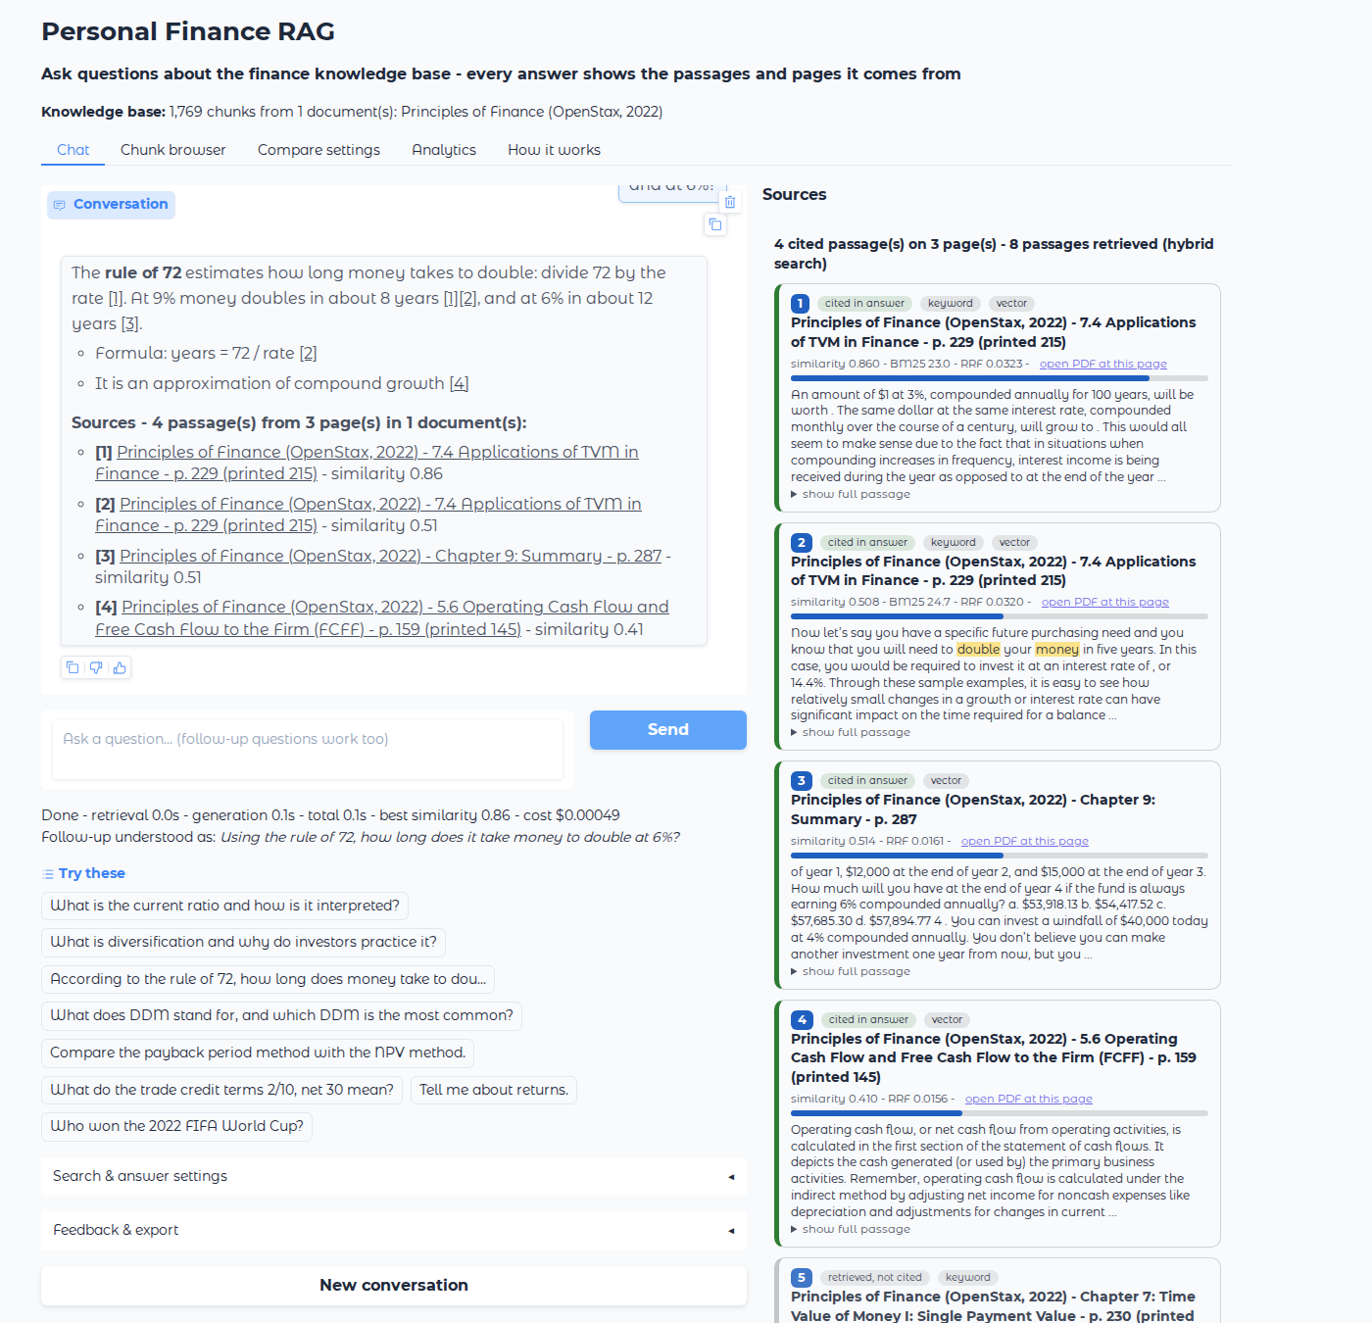
Figure 1 - Chat tab: inline [n] links, Sources list under the answer, Sources panel on the right (screenshot from our local test with a simulated model).

6.5 Section titles and printed page numbers
Every OpenStax page ends with a running footer, e.g. "7.4 • Applications of TVM in Finance 215" (odd pages) or "216 7 • Time Value of Money I ... Access for free at openstax.org" (even pages). parse_page_footer() in text_utils.py recognises these two patterns (528 of the 629 pages), removes the footer from the text (it was noise for search) and stores the section title and printed page number on every chunk. Citations therefore read "7.4 Applications of TVM in Finance - p. 229 (printed 215)": the PDF page for the link, and the page number a reader sees in the printed book. For the existing Day-1 index, the retriever reads the same footers from corpus.json at start-up and attaches them to the chunks - no re-embedding.

6.6 Removing the fake demo answers
The hard-coded fallback passages were removed. Without an API key the app now runs a real offline mode: BM25 keyword search on the real chunks and an extractive answer (the sentences sharing the most words with the question, each with its [n] citation), with a clear banner saying so. Every citation shown is therefore always a real passage of the book.

7. Changes for remarks 3 and 4: features and extensions

7.1 Hybrid search (BM25 + FAISS + Reciprocal Rank Fusion)
File: app/bm25.py (new), app/retriever.py (rewritten).
Problem: embeddings capture meaning, but short exact terms carry little meaning for them. On Day 1, "What does DDM stand for?" did not retrieve the page that says "The most common DDM is the Gordon growth model", so the model refused.
How BM25 works: for each word of the question, a chunk earns points if it contains the word, more if the word is rare in the book (IDF = inverse document frequency), with diminishing returns when the word repeats (parameter k1 = 1.5) and a correction for long chunks (b = 0.75). An inverted index (word -> list of chunks containing it) makes this fast. We wrote it from scratch in about 60 lines.
How the fusion works: we take the 40 best chunks of each method; each chunk gets 1/(60 + rank) from each list where it appears; we sort by the sum. No need to compare BM25 points with cosine scores, which have different scales.
Measured effect (real data, no API needed): on the same Day-1 chunks, BM25 alone finds at least one expected page for 100% of the questions (Day-1 dense search: 97%) and all expected pages for 92% (Day 1: 72%), and puts the DDM page first. Hybrid combines this with the meaning-based search.
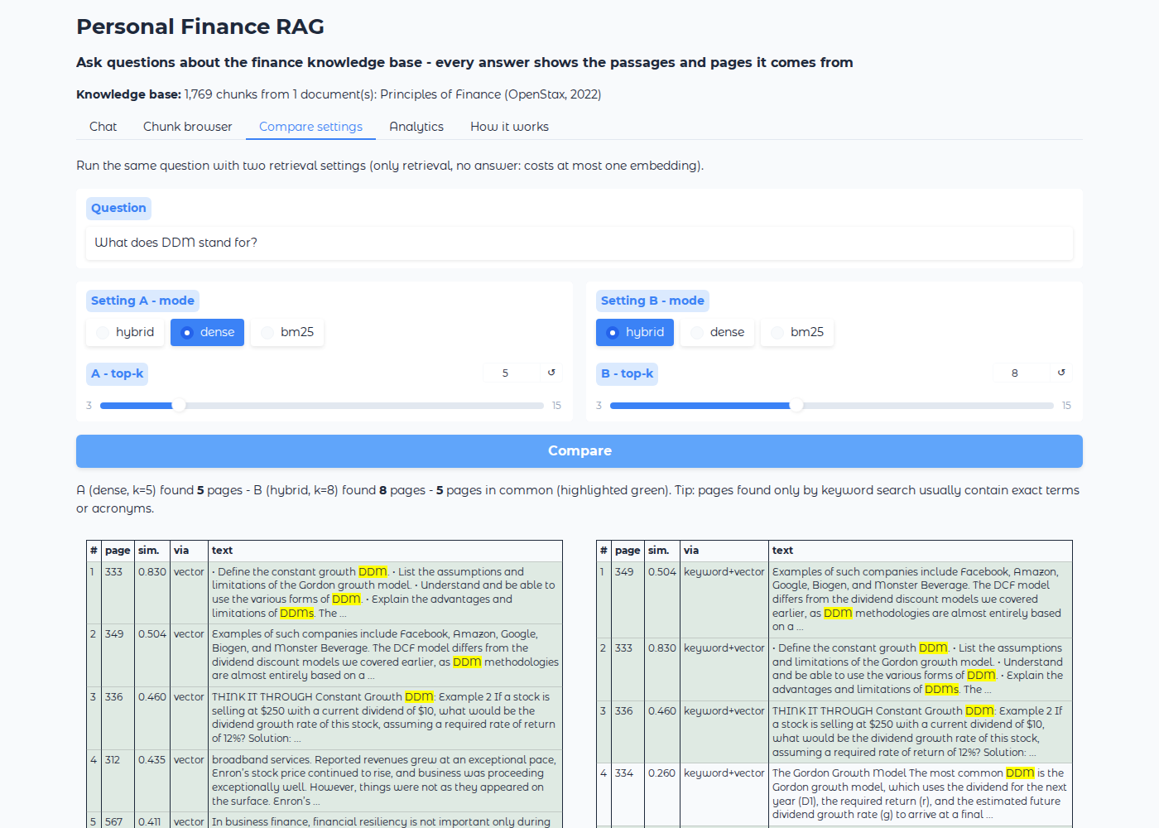
Figure 2 - Compare tab: dense top-5 (left) vs hybrid top-8 (right); pages found by both are green.

7.2 Sentence-boundary chunking
File: app/chunking.py (new). Instead of cutting every 500 characters (which cuts words and sentences), the page is split into sentences, and whole sentences are grouped until about 300 tokens (~1,200 characters); the last sentences of a chunk (up to 60 tokens) are repeated at the start of the next. Result on our corpus: 1,769 chunks of 986 characters on average instead of 4,347 chunks of 458 characters, each a complete idea, and every chunk also carries chunk_id, section, printed_page and chunk_index. The Day-1 method is kept (--strategy fixed) for comparison. Important: using sentence chunks requires ONE rebuild of the index (about 436,000 tokens). Following the professor's embedding policy (Section 9.1), the app keeps the Day-1 index by default and still gets section titles without re-embedding.

7.3 Confidence threshold for out-of-scope questions
On the Day-1 results, off-topic questions had a best similarity between 0.14 and 0.36, while finance questions (even vague ones) were between 0.46 and 0.85. We set CONFIDENCE_THRESHOLD = 0.40: below it, the app refuses immediately without calling the LLM (saves money and removes any risk of an invented answer). Above it, the prompt still refuses when the passages do not contain the answer. The threshold is a slider in the UI, so we can show its effect live.

7.4 Conversation memory and follow-up questions
The chat keeps the history. Two mechanisms work together:
- Question rewriting (condense_question() in generator.py): when a question looks like a follow-up (pronouns such as "it / that / the second one", "what about", or 4 meaningful words or fewer), gpt-4o-mini rewrites it into a standalone question using the conversation, e.g. "And at 6%?" -> "Using the rule of 72, how long does it take money to double at 6%?". We search with the rewritten question - otherwise the search would look for "6%" alone. The UI shows "Follow-up understood as: ...".
- Memory window: the last 3 question/answer pairs are sent to the model so the answer is coherent (old citation numbers are removed from them, because they refer to older passages).

7.5 Streaming and loading indicators
rag.run() is a Python generator that emits events: status messages ("Understanding the follow-up question...", "Embedding the question and searching (hybrid)...", "Writing the answer from 8 passages..."), then the answer piece by piece, then the final result. The UI shows the text as it is written, like ChatGPT, and a status line with timings, best similarity and the cost of the question.

7.6 Prompt versioning, few-shot and dynamic prompts
The prompts live in prompts/v1.txt (Day 1), v2.txt (numbered citations), v3.txt (final) with CHANGELOG.md explaining what changed and why. A dropdown in the UI switches version live - useful to show the jury the difference. v3 adds: direct answer first, bullets and formulas, partial answers ("the book covers X but not Y"), reporting both values when two passages disagree (the book gives two different averages for DAL stock), and for vague questions an overview plus one clarifying question. generator.py also appends a dynamic hint chosen by a small rule-based classifier: yes/no, calculation, comparison, definition or list question.

7.7 Query expansion and optional reranking
- Query expansion (checkbox): gpt-4o-mini writes 2 paraphrases using textbook vocabulary (e.g. expands acronyms); the retriever searches with all three and fuses the results. Costs one extra small LLM call, so it is off by default.
- Cross-encoder reranking (checkbox, enabled only if sentence-transformers is installed): a small model reads question and passage together and re-orders the top 20. Optional because it downloads about 1 GB.

7.8 Other interface features
Feature | Where | What it does and why
Settings panel | Chat tab > Search & answer settings | top-k, search mode (hybrid / dense / bm25), threshold, document filter, prompt version, expansion, rerank. Lets us demonstrate each improvement live.
Feedback | thumbs icons in each bubble + Helpful / Not helpful buttons with a comment | Saved to data/feedback.jsonl, counted in Analytics - real user signal for improving the system.
Export | Feedback & export | Downloads the whole conversation with its sources as Markdown or PDF (PDF made with PyMuPDF, already a dependency).
Chunk browser | tab | Search chunks by keyword, document and page range; see section, printed page and size; click a row for the full text. Used to spot bad chunks.
Compare settings | tab | Same question, two retrieval settings side by side, pages in common highlighted. Costs at most one embedding.
Analytics | tab | Questions asked, refusal rate, average similarity and response time, feedback counts, spend per operation vs the $5 budget, most-cited pages, latest evaluation scorecard, last 50 questions.
How it works | tab | The pipeline explained for the jury.
Document filter | settings | Restrict search to one document - ready for a multi-document corpus.

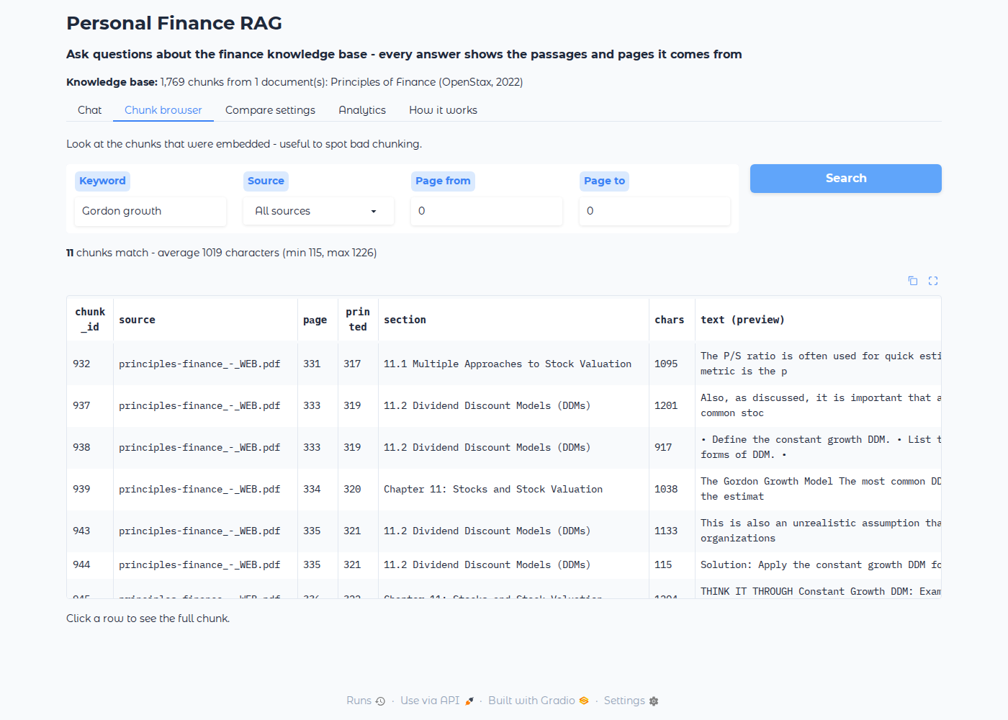
Figure 3 - Chunk browser: every chunk with its section and printed page.

7.9 Cost tracking and caching
- app/llm.py is now the only file that calls OpenAI. It reads the token counts OpenAI returns with every answer and tracking.log_cost() appends the call and its price to data/cost_log.json (prices in config.py: $0.02 per million embedding tokens; $0.15 / $0.60 per million input / output tokens for gpt-4o-mini). python scripts/cost_report.py prints the spend per operation.
- Query cache (data/query_cache.json): a question embedded once is never paid again (UI, eval runner and retrieval checker share it).
- Embedding cache (data/embedding_cache.npz): each chunk's vector is stored under a fingerprint (SHA-1 hash) of its text. Re-running build_index.py after adding a document only embeds the new chunks - this is the "document update pipeline" extension. It also resumes after a network error without paying twice.
- No automatic re-embedding: see the three guards in Section 9.1 (fingerprint, cache, typed confirmation).
Estimated costs: rebuilding the whole index about $0.009 (about 436,000 tokens - only when needed); one question with the answer about $0.0005 to $0.001; a full evaluation run with the judge about $0.05.

7.10 Round 2: extra features (all without re-embedding)
After the first round, we added a second set of features inspired by the extensions list and by what a student using the assistant would need. They live in two new files, app/tools.py and app/features.py, and are switched on or off in the settings panel. None of them embeds the book again.
Feature | How it works | Why it helps | Cost
Finance calculator tools (function calling) | For calculation questions, gpt-4o-mini receives the description of 10 Python functions (rule of 72, future value, present value, effective annual rate, NPV, IRR, payback period, loan payment, financial ratio, safe calculator). The model chooses a function and its numbers, OUR code computes the exact result, the model writes the answer with it. Every calculation is printed under the answer. | LLMs are unreliable at arithmetic such as (1.015)^12 - 1. Example: the textbook's credit-card question gives EAR = 19.5618% exactly. It is also the first step towards the Agentic AI project (an agent = an LLM that decides which tool to call). | 1-2 extra small calls, only for calculation questions
Confidence badge | HIGH / MEDIUM / LOW from three signals: best similarity, number of passages cited, share of sentences that carry a citation (and a penalty if the citation check found a problem). | Tells the user how much to trust an answer at a glance. | free
Citation check (optional) | A second gpt-4o-mini call reads each cited sentence and its passage and lists sentences that are not supported. | Catches hallucinated or mis-cited claims - a direct answer to 'how do you know the citations are right?'. | +1 call
Suggested follow-up questions | After each answer, 3 next questions answerable from the retrieved passages appear as buttons; clicking one asks it (with conversation memory). | Guides the user through the book; great for the live demo. | +1 small call
Answer cache (exact + semantic) | Answers are stored in data/answer_cache.json with the settings used. The same question (exact text) or a question with the same meaning (cosine >= 0.97 between the two question embeddings, which are cached anyway) is answered instantly. | Zero cost and instant answers for repeated demo questions; follows the professor's 'do not waste tokens' rule. | saves money
Answer styles | Standard, Simple (beginner, with an everyday analogy), Detailed (definition, formula, example, limits), Summary (3 bullets). Implemented as an extra instruction added to the system prompt. | Same knowledge, adapted to the reader. | free
French questions and answers | The language is detected automatically; a French question is translated to English for the search (the book and the index are English), and the answer is written in French with the same [n] citations. | Cross-language retrieval extension; useful for French-speaking users at EPITA. | +1 tiny call for French questions
Quiz tab | Choose a section of the book (106 sections read from the page footers) or type a topic; gpt-4o-mini writes 3-10 multiple-choice questions from those passages; you answer, press Check, and get the score, explanations and the page of each question (clickable). | Turns the assistant into a study tool. | about $0.001 per quiz

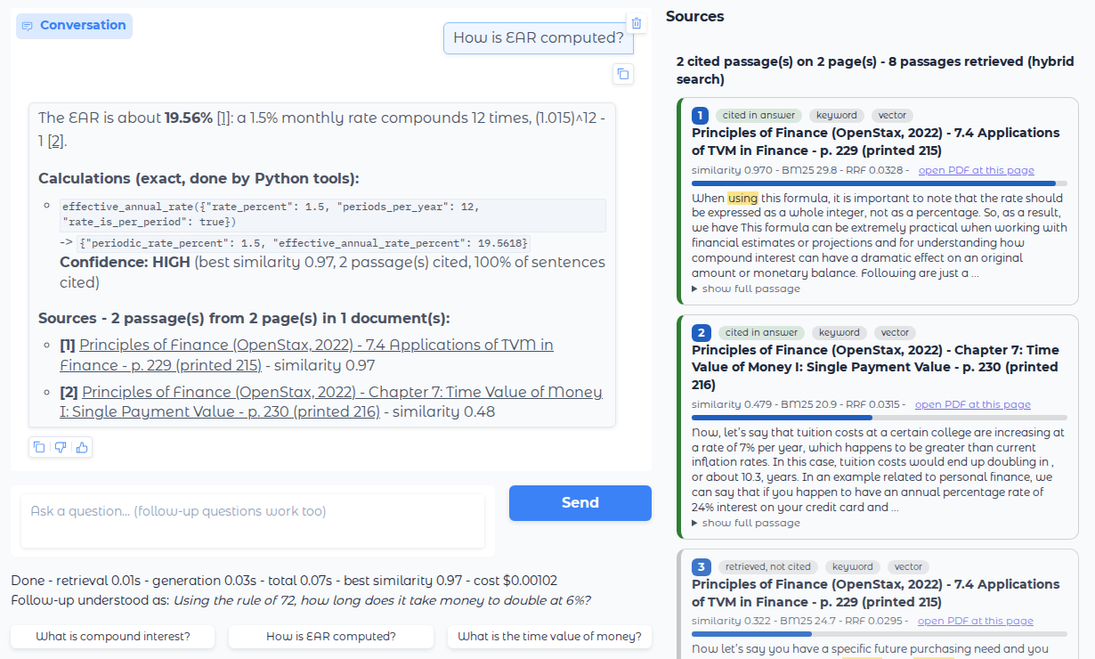
Figure 4 - Calculation question: exact tool result, confidence badge, sources, and three follow-up buttons (local test with a simulated model).
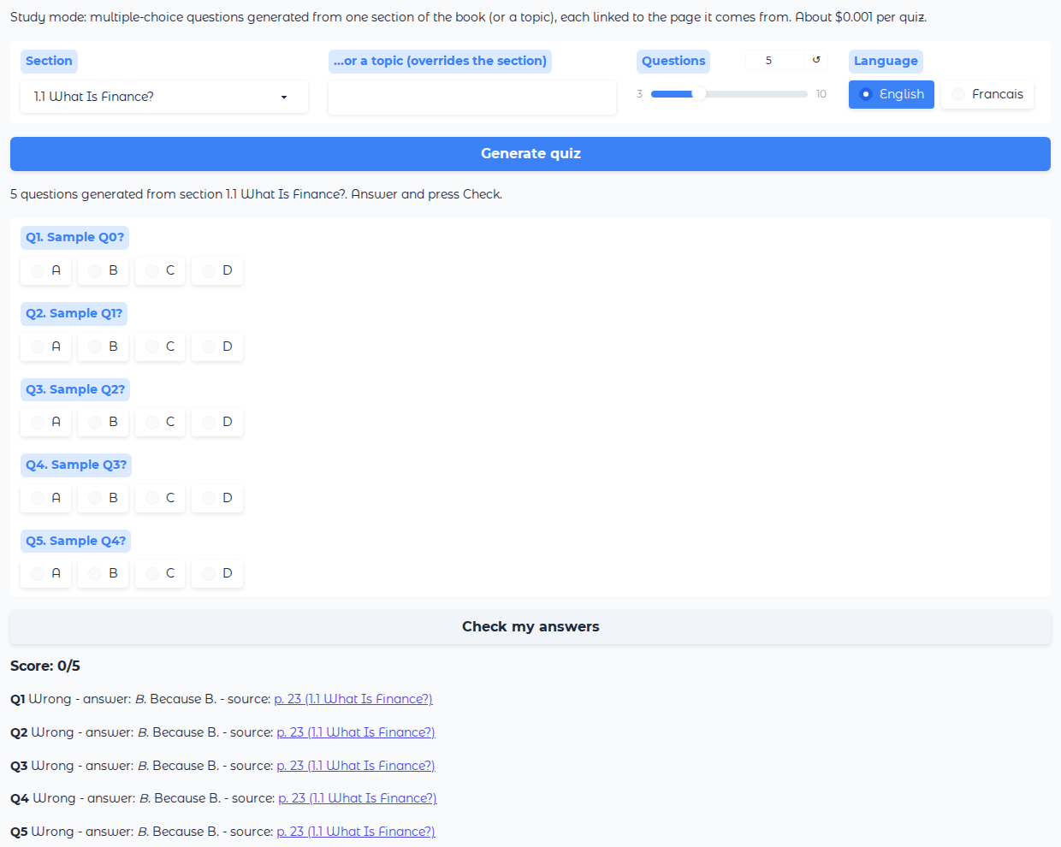
Figure 5 - Quiz tab: questions from one section, score and page links (placeholder questions from the simulated model).

8. Evaluation and debugging toolkit (Assignment 2)
Tool | Command | What it tells us
Retrieval checker (required) | python scripts/retrieval_checker.py --id 24  python scripts/retrieval_checker.py "any question"  --list shows all ids | The top-k passages with similarity, BM25 score, how they were found, section, and a check mark for each expected page; lists the missed pages. First tool to run when an answer is wrong.
Failure log (required) | scripts/FAILURE_LOG.md | Table: question, category, retrieval OK?, problem, fix, fixed? Pre-filled with 10 real failures from the Day-1 results.
Eval runner | python scripts/eval_runner.py --judge --tag v3-hybrid | Runs the 47 questions; scorecard overall, for priority questions, per category and per difficulty; lists failed questions with the reason (retrieval miss / wrong refusal / judge); saves data/eval_results.json and a copy in data/eval_history/.
Regression check | automatic in the eval runner | Compares with the previous run and prints REGRESSION (was passing, now failing) or FIXED for each question.
LLM-as-judge | --judge | gpt-4o-mini grades each answer against the expected answer: correct yes/no, correctness, faithfulness, completeness (1-5) and a reason.
Demo dry run | python scripts/demo_dry_run.py | 10 random questions + a follow-up: no crash, citations present, out-of-scope refused, response time.
Offline tests | python tests/test_offline.py | 6 unit tests (footer parsing, chunking, BM25, citation parsing, source-name matching, calculator tools + language detection); no key needed.

8.1 Metrics explained
- hit(all): every expected page is in the top-k. hit(any): at least one is. MRR (mean reciprocal rank): 1 if the first expected page is ranked 1st, 0.5 if 2nd, and so on.
- refusal accuracy: out-of-scope questions are refused; normal and ambiguous questions are not; the "DAL 2023" trap (on-topic but not in the book) must be refused or explicitly said to be not covered.
- cite-hit: the answer cites at least one expected page. pages: number of different pages cited per answer (our measure for remark 1).

8.2 Results so far
Setting | hit(all) | hit(any) | Notes
Day 1: dense, 500-char chunks, k = 10, prompt v1 | 72% (26/36) | 97% (35/36) | cross-reference, all pages: 3/10; out-of-scope refused 5/5; almost always 1 page cited
Day 2 measured: BM25 only, same chunks, k = 8 | 92% | 100% | MRR 0.84; run offline, no API cost
Day 2 full: hybrid + Day-1 chunks + prompt v3 | to run | to run | run the command in Section 9, step 9, and paste the scorecard into EVALUATION.md

Why the last line is empty: the environment in which the changes were prepared could not reach the OpenAI API, so no real embedding or answer was generated there. Everything that does not need the API was measured on the real data; the rest was tested with a simulated model (Section 10). The first full run is therefore the first thing to do with the team key.

9. Step-by-step: how to run everything
The commands below are for Windows (PowerShell or the VS Code terminal), which is what our laptop uses. macOS / Linux differences are given in brackets. Run every command from the project folder.

Step 1 - Open a terminal in the project folder
cd "C:\Users\EPW INDIA\Desktop\personal-finance-corpus"

Step 2 - Check that the data files are there
data/ is not on GitHub. It must contain: sources/principles-finance_-_WEB.pdf, corpus.json, questions.json (these three were copied from the Kaggle_Week demo folder), and chunks.json + my_index.faiss (Day-1 index; will be rebuilt in step 6). Teammates download them from the Teams channel.
dir data
dir data\sources

Step 3 - Create the Python environment (once)
If uv is missing: pip install uv (or see docs.astral.sh/uv).
uv venv --python 3.12
.venv\Scripts\activate (macOS/Linux: source .venv/bin/activate)
uv pip install -r requirements.txt
If PowerShell refuses to run the activate script, run once: Set-ExecutionPolicy -Scope CurrentUser RemoteSigned. When the environment is active, the prompt starts with (personal-finance-corpus) or (.venv).

Step 4 - Add the OpenAI key
copy .env.example .env (macOS/Linux: cp .env.example .env)
notepad .env -> OPENAI_API_KEY=sk-...your team key...
Never commit .env: it is listed in .gitignore. Without a key the app still starts in offline mode.

Step 5 - Run the offline tests (free, 2 seconds)
python tests/test_offline.py
Expected: 6 lines PASS and "All 6 tests passed."

Step 6 - Do NOT re-embed: use the existing index
The Day-1 index (data/my_index.faiss + data/chunks.json) is used as it is. Section titles and printed page numbers are added at start-up from corpus.json, with zero API calls. Skip this step unless the corpus changes (see Section 9.1).
Free check of what a rebuild would cost (no API call):
python app/build_index.py --dry-run

Step 7 - Start the web app
python app/app.py
Open http://127.0.0.1:7860 in the browser. Try: "According to the rule of 72, how long does money take to double at 9%?", then "And at 6%?", then "What does DDM stand for?", then "Who won the 2022 FIFA World Cup?". Click a [n] to open the PDF at the page. Stop the app with Ctrl + C in the terminal.

Step 8 - Check one question's retrieval
python scripts/retrieval_checker.py --list
python scripts/retrieval_checker.py --id 24

Step 9 - Full evaluation (about $0.05)
python scripts/eval_runner.py --judge --tag v3-hybrid
python scripts/eval_runner.py --mode dense --prompt v1 --tag day1-like --judge
The second run reproduces Day-1 settings, so the two scorecards show the improvement. Paste them into EVALUATION.md and add any new failure to scripts/FAILURE_LOG.md.

Step 10 - Demo rehearsal and costs
python scripts/demo_dry_run.py
python scripts/cost_report.py

Step 11 - Commit and push (one person, then the others pull)
git checkout -b day2-citations-features
git add .
git status (check that .env and data/ are NOT listed)
git commit -m "Day 2: multi-source citations, hybrid search, chat memory, eval toolkit"
git push -u origin day2-citations-features
Then open a pull request on GitHub and ask a teammate to review and merge it, as on Day 1.

9.1 Embedding policy (professor's message of 28 September)
The professor asked every team to stop re-embedding the corpus automatically: re-embedding must happen only when it is needed. For scale, one full embedding of our book is about 436,000-483,000 tokens (depending on the chunking), and the usage chart shows DSA 3 at 452,618 input tokens on 28 September - about one full embedding. The project now enforces the rule in code:
Guard | Where | Effect
Only one place embeds the corpus | app/build_index.py, run by hand | The app, the eval scripts and the tests only LOAD the saved index. Nothing embeds at start-up or on import.
Guard 1 - fingerprint | build_index.py + data/build_info.json | A hash of corpus text + chunking settings + model is stored after each build. If nothing changed, the script prints "Index is up to date" and stops with zero API calls. --force is required to override.
Guard 2 - embedding cache | data/embedding_cache.npz | Every chunk ever embedded is kept under a hash of its text. A rebuild only sends new or changed chunks (a new document = only its chunks).
Guard 3 - confirmation | build_index.py | Before any API call it prints the number of tokens and the price and waits for the user to type YES (--yes skips the question for a deliberate scripted run).
No re-embedding for metadata | app/retriever.py | Section titles and printed pages are read from corpus.json and attached to the existing chunks, instead of rebuilding the index.
Query cache | app/llm.py + data/query_cache.json | A question is embedded once; the UI, eval runner and retrieval checker reuse it (47 eval questions = about 700 tokens, once).

When is a rebuild needed? Only when a document is added to or changed in data/sources/ (then run scripts/extract.py), or when the team deliberately decides to switch the chunking strategy - once, by one person, after --dry-run, and the new my_index.faiss + chunks.json are shared on Teams so nobody else rebuilds:
python app/build_index.py --dry-run (free: shows chunks and tokens to embed)
python app/build_index.py (asks you to type YES before spending)

9.2 Troubleshooting
Symptom | Cause and fix
ModuleNotFoundError: No module named 'gradio' (or faiss, openai) | The virtual environment is not active or packages are missing: run step 3 again.
Banner says "Offline mode" | No valid key in .env (it must start with sk-). Check step 4 and restart the app.
"index has N vectors but chunks.json has M chunks" | chunks.json and my_index.faiss come from different builds: run step 6.
Clicking [n] does nothing / 403 | The PDF is not in data/sources, or its name differs from the 'source' field in chunks.json. Copy it there with the same name.
Port 7860 already in use | Another app is running: close it, or change server_port in app/app.py (main function).
openai.RateLimitError / network error during build | Just run build_index.py again: the embedding cache keeps what was already paid for.
git: index.lock exists | Another git command is running or crashed: close it, then delete .git\index.lock.

10. How the changes were tested
- Real data, no API: chunking of the 629 real pages (1,769 sentence chunks), footer parsing (528 pages), BM25 on the real 4,347 Day-1 chunks, and the retrieval-only evaluation of the 47 questions (Section 8.2).
- Embedding guards: a build followed by a second run printed "Index is up to date ... Nothing to embed"; a --force run reused all 1,769 cached vectors and sent 0 tokens; answering anything but YES cancels without an API call.
- Round-2 features: the 10 calculator tools were checked against the textbook's own examples (rule of 72 at 9% = 8 years; EAR of 1.5% per month = 19.56%; the embroidery machine's payback = 3.2 years); the tool loop, French detection and translation step, citation check, confidence badge, follow-up buttons, exact answer cache and the Quiz tab were tested end-to-end in the UI with the simulated model.
- Unit tests: tests/test_offline.py, also run on the team laptop after the files were written: all passed.
- Full pipeline with a simulated model: the OpenAI calls were replaced by a local fake (random vectors, a canned answer citing [1] to [4]) to test streaming, follow-up rewriting, query expansion, threshold refusals, citation parsing, links to the PDF page (HTTP 200, application/pdf), the Sources panel, export to .md and .pdf, chunk browser, compare and analytics tabs, eval runner, regression check and dry run, with Gradio 6.28 (the version in the team environment). The screenshots in this document come from that test.
- Not tested: the real answers of gpt-4o-mini and real similarity scores with the new chunks - they need the team key (Section 9, steps 6 and 9).

11. Preparing Demo Day

11.1 Suggested speaking parts
A suggestion that keeps each member on the part they built on Day 1 and extends it to the matching Day-2 code, so everyone can explain every line of their part (a hackathon rule):
Member | Day-1 part | Day-2 code to present
Naveen | extraction, retriever, generator | prompts v1-v3 and CHANGELOG, generator.py (citations, dynamic hints, follow-up rewriting, judge), rag.py (the pipeline), Section 5 bug analysis
Somitha | embeddings + FAISS index | build_index.py (embedding cache, incremental update), llm.py + tracking.py (cost tracker, query cache), confidence threshold, eval_runner.py and results
Rudra | loading and chunking | chunking.py (sentence chunks), text_utils.py (footer -> section, printed page), bm25.py, hybrid retrieval + RRF + diversity in retriever.py, retrieval_checker.py, FAILURE_LOG.md
Srikanth | Gradio UI + docs | app.py (clickable citations, Sources panel, chat memory UI, streaming, feedback, export, chunk browser, compare, analytics), README, EVALUATION.md, live demo driving

11.2 A 6-minute demo path
- Priority question: rule of 72 at 9% - show the [n] links, click one, the PDF opens at page 229.
- Follow-up "And at 6%?" - show "Follow-up understood as ...".
- Cross-reference: "How is beta defined in the regression chapter, and how is it interpreted in the risk and return chapter?" - Sources list shows two chapters.
- Acronym: "What does DDM stand for?" - then the Compare tab, dense vs hybrid.
- Vague: "Tell me about returns." - overview + clarifying question.
- Out of scope: "Who won the 2022 FIFA World Cup?" - refusal with the similarity explanation; move the threshold slider to show what happens.
- Calculation: "What is the effective annual interest rate on a credit card that charges 1.5% per month?" - show the calculator tool result and the confidence badge; click a suggested follow-up.
- French: "Quelle est la règle de 72 ?" - answered in French with the same citations.
- Quiz tab: generate 3 questions on section 7.4 and check the answers.
- Ask the first question again: answered from the cache at $0. Then the Analytics tab: cost so far and the evaluation scorecard.

11.3 Demo safety net
Risk during the demo | Protection | Command / setting
Slow network or OpenAI hiccup | The OpenAI client retries rate-limit, server and connection errors automatically (4 retries with back-off, 60 s timeout); errors are shown as a short readable message instead of a crash. | automatic (app/llm.py)
No network at all | Pre-answer the demo questions the evening before: they are stored in the answer cache and answered instantly for $0, even offline. | python scripts/warm_cache.py
The jury wants to try it themselves | Temporary public link, or access from the same Wi-Fi. | python app/app.py --share or --lan
Strangers spending our budget through the public link | Login page before the app. | APP_USERNAME and APP_PASSWORD in .env

Keep the default settings in the UI during the demo: the answer cache is keyed on the settings, so a changed setting means a new (paid, slower) answer. Re-run warm_cache.py after changing defaults.

11.4 Likely jury questions
Question | Short answer
Why hybrid search? | Embeddings miss exact terms (acronyms, tickers, codes). BM25 finds them. RRF merges ranks, so we do not need to calibrate two different score scales. Measured: expected-page recall from 72% to 92% with BM25 alone on the same chunks.
How do you prevent hallucinations? | Only-passages prompt, mandatory citations checked by code, temperature 0, threshold refusal before the LLM, exact refusal sentence, and every citation visible and clickable so it can be verified.
Why 0.40 for the threshold? | Measured on our eval set: off-topic max 0.36, finance min 0.46. We put the cut in the gap and still let the prompt refuse above it.
Why don't you rebuild the index every time? | Embedding the whole book costs about 436,000 tokens. The index is built once and shared; build_index.py refuses to rebuild if nothing changed, reuses cached vectors, and asks for confirmation before spending.
Why sentence chunks of ~300 tokens? | Fixed 500-character windows cut sentences; whole sentences keep ideas intact; 300 tokens (~1,200 characters) is about one paragraph; 60-token overlap keeps continuity.
What does a question cost? | About $0.0005-0.001 (one cached embedding + one gpt-4o-mini call); see Analytics or cost_report.py.
How do follow-ups work? | The question is rewritten as a standalone question from the last turns, then searched; the last 3 turns are also given to the model.
What if we add another document? | Put it in data/sources, run extract.py and build_index.py: only new chunks are embedded (cache); citations and the document filter handle several documents automatically.
How do you avoid calculation mistakes? | Function calling: the model chooses one of our 10 Python tools and passes the numbers; Python computes the exact value, which is shown under the answer.
Did you use LangChain? | No. Retrieval, BM25, fusion, prompts and UI are our own code; only openai, faiss, numpy, gradio, pymupdf, python-dotenv, tiktoken are used.

12. Limitations and next steps
- The full evaluation with the real model still has to be run (Section 9, step 9).
- Sentence chunking (Section 7.2) is implemented and tested, but it only takes effect after one deliberate rebuild of the index; following the professor's embedding policy we keep the Day-1 index until the team decides the rebuild is worth it (compare first with the Chunk browser and --dry-run).
- Tables and equations that are images in the PDF are not in the text (for example the WACC equation); answers about them can only use the surrounding text.
- Offline mode's out-of-scope check is weaker (it relies on unknown words), so a real key should be used for the demo.
- The corpus is a single book; the code is ready for more documents (per-document titles in config.SOURCE_TITLES, document filter), which would also make "several sources" mean several documents.
- The follow-up detector is rule-based; a question it does not flag is searched as-is (still answered with the conversation history).

Appendix A. Complete list of files changed
File | Status | Purpose | Remark
app/config.py | new | All settings and absolute paths; loads .env | bug fix, 4
app/text_utils.py | new | Token count, BM25 tokenizer, sentence splitter, footer parser, source-name matching, highlighting | 1, 2, 4
app/chunking.py | new | Fixed and sentence chunking with metadata | 4
app/build_index.py | rewritten | Embeddings with cache and retries, FAISS, build_info; guards against re-embedding (fingerprint, cache, YES confirmation), --dry-run, --force, --strategy | 4, embedding policy
app/bm25.py | new | BM25 keyword search + coverage score | 4
app/retriever.py | rewritten | Retriever class: dense / bm25 / hybrid, RRF, diversity, filter, expansion, rerank; old retrieve() kept | 1, 4
app/llm.py | new | Only OpenAI access: embeddings, chat, streaming, cost logging, query cache | 4
app/generator.py | rewritten | Versioned prompts, dynamic hints, numbered context, citation parsing, follow-up rewriting, query expansion, offline answer, LLM judge | 1, 2, 3, 4
app/rag.py | new | The complete pipeline as a stream of events | 3
app/tracking.py | new | Cost log, query log, feedback log | 3, 4
app/app.py | rewritten | Gradio UI: chat, citations, Sources panel, settings, feedback, export, tabs | 1, 2, 3
app/__init__.py | new | Makes app/ a Python package (imports work from any script) | bug fix
prompts/v1-v3.txt, CHANGELOG.md | new | Prompt versioning | 1, 2, 4
scripts/retrieval_checker.py | new | Assignment 2 tool 1 | 4
scripts/eval_runner.py | new | Scorecard, judge, regression check | 4
scripts/demo_dry_run.py | new | Demo rehearsal | 4
scripts/cost_report.py | new | Budget report | 4
scripts/warm_cache.py | new (round 3) | Pre-answers demo questions into the cache (demo safety) | 3
scripts/FAILURE_LOG.md | new | Assignment 2 tool 2 | 4
tests/test_offline.py | new | Unit tests without API (6 tests, incl. calculator tools and language detection) | 4
app/tools.py | new (round 2) | 10 finance calculator functions + function-calling schemas + safe calculator | 4
app/app.py + app/llm.py | updated (round 3) | Automatic retries, readable error messages, --share / --lan / --port options, optional password | 3
app/features.py | new (round 2) | Styles, French, tool loop, confidence, citation check, follow-ups, answer cache, quiz | 3, 4
README.md, EVALUATION.md | updated | Documentation | -
requirements.txt, .env.example, .gitignore | new / updated | Installation | -
scripts/extract.py, EXTRACTION_REPORT.md | unchanged | Day-1 extraction still valid | -
data/corpus.json, questions.json, sample.json, sources/*.pdf | copied | From the Kaggle_Week demo folder into the project's data/ (not on GitHub) | -

Appendix B. Main settings (app/config.py)
Setting | Value | Meaning
CHUNK_STRATEGY / CHUNK_TOKENS / CHUNK_OVERLAP_TOKENS | sentence / 300 / 60 | How the book is cut
DEFAULT_TOP_K | 8 | Passages given to the model and shown as sources
CANDIDATE_K | 40 | Candidates from each search before fusion
DEFAULT_SEARCH_MODE | hybrid | hybrid, dense or bm25
RRF_K | 60 | Standard constant of Reciprocal Rank Fusion
MAX_CHUNKS_PER_PAGE | 2 | Diversity cap
CONFIDENCE_THRESHOLD | 0.40 | Refuse below this best similarity
PROMPT_VERSION / TEMPERATURE | v3 / 0.0 | Prompt file and randomness
MAX_HISTORY_TURNS | 3 | Conversation memory window

