WEEK 3 TECHNICAL REPORT

Data Cleaning and Preprocessing Pipeline Development
Beauty & Personal Care Customer Sentiment Analysis
Project repository: https://github.com/SommayDewat/Beauty-Wellness-Sentiment-Analysis

Report item | Details
Task | Week 3 — Data Cleaning and Preprocessing Pipeline Development
Primary dataset | Amazon Reviews 2023 — Beauty_and_Personal_Care category
Planned sample | Approximately 50,000 English-language reviews, subject to availability and quality checks
Pilot currently documented | 5,000 reviews from one shard; exploratory pilot only, not assumed representative
Tools | Python, pandas, NumPy, regular expressions, matplotlib/seaborn, scikit-learn

Executive Summary
This report specifies a reproducible cleaning and preprocessing pipeline for public customer reviews in the Beauty and Personal Care domain. The pipeline is designed for review text, star ratings, product identifiers, timestamps, helpful-vote fields, and any available product/category metadata. It separates raw data preservation, quality profiling, deterministic cleaning, missing-value decisions, outlier review, feature creation, and validation. The objective is not to make the data look artificially uniform; it is to make analysis reliable while retaining legitimate customer opinions, unusual experiences, and meaningful extreme values.
The current pilot contains 5,000 reviews from one shard. In that pilot, 4,837 distinct product IDs and 4,667 parent product IDs were observed; rating-derived labels were 84.84% positive, 7.60% negative, and 7.56% neutral; mean review length was approximately 69.66 words. These are pilot-specific descriptive results only. A single-shard sample may be biased and must not be presented as representative of the full category. The broader sampling plan targets about 50,000 English reviews across available files/shards, with sampling coverage and exclusions documented.

1. Project Context and Preprocessing Goals
The project studies customer sentiment in beauty and personal care products using public review data. Reviews can contain product-specific terminology, spelling variation, emojis, repeated punctuation, short or empty text, duplicate records, multiple languages, and ratings that do not perfectly match the wording. Product metadata may be incomplete or inconsistent. Preprocessing must therefore support both quantitative analyses and later text-classification models.
- Create a consistent, documented analysis table without changing or overwriting the original source.
- Identify and quantify missing, duplicated, malformed, and potentially suspicious records.
- Standardize field formats and validate ratings and numeric measures against plausible ranges.
- Create transparent rating-derived sentiment labels: 1–2 stars = negative, 3 = neutral, 4–5 = positive.
- Prevent target leakage: star rating is used to create the weak label, but is excluded from text-model input features.
- Retain a record-level audit trail so exclusions, transformations, and final counts can be reproduced.

2. Dataset Scope and Known Pilot Limitations
Primary source: Amazon Reviews 2023, category Beauty_and_Personal_Care. The project uses the source review text and rating fields, with identifiers, dates, helpful-vote information, and metadata only where present in the chosen files. Exact schemas can differ between dataset files, so the pipeline begins by inspecting actual columns rather than assuming every field exists.
Pilot observation | Value | Interpretation / limitation
Review rows | 5,000 | Pilot size from one shard; not a full-category sample.
Distinct product IDs | 4,837 | Shows broad product coverage in this pilot, not unique customers.
Distinct parent product IDs | 4,667 | Identifier coverage; parent-product meaning should follow source schema.
Positive label share | 84.84% | Labels are derived from star ratings; imbalance can affect evaluation.
Negative label share | 7.60% | Small minority class; use stratified splits and macro-F1.
Neutral label share | 7.56% | Small minority class; inspect confusion with adjacent classes.
Mean review length | 69.66 words | Descriptive pilot statistic; length alone is not a quality judgment.

The reported label proportions are not proof that customers in the full market are overwhelmingly positive. They may reflect the shard, product mix, platform population, and sampling process. After the wider sample is assembled, the team should compare distributions by file/shard and, if available, product category or time period.

3. Likely Data Quality Issues in Beauty & Personal Care Reviews
Issue | Example / risk | Detection and response
Missing review text | Rating exists but review text is null or blank. | Measure missingness; exclude from text-model dataset, but retain in rating-only summaries if relevant.
Missing rating | Text exists without a usable star score. | Keep for unsupervised/text exploration if appropriate; exclude from rating-derived supervised labels.
Duplicate records | Repeated review ID or exact duplicate text/product/rating rows. | Check IDs first; use conservative duplicate rules and log removed rows.
Invalid rating | Rating is zero, negative, or above five. | Validate allowed scale; quarantine invalid records rather than silently clipping.
Text inconsistencies | Whitespace, HTML entities, escaped characters, repeated spaces. | Normalize Unicode and whitespace; preserve original text for audit.
Language mismatch | Non-English text enters an English-only study. | Use provided language metadata if reliable; otherwise use a language detector and document uncertain cases.
Outlier review length | Extremely long copy-pasted text or one-word reviews. | Flag via robust quantiles/IQR and manual samples; do not automatically delete genuine extremes.
Helpful-vote anomalies | Negative values or helpful votes greater than vote totals. | Check source semantics and ranges; treat missing counts separately from zero.
Inconsistent dates | Malformed timestamps or mixed timezone formats. | Parse with pandas; record parse failures; standardize to UTC/date granularity as required.
Product metadata gaps | Missing brand, category, or parent ID. | Keep review if core fields are valid; make product-level analysis conditional on metadata coverage.
Rating-text disagreement | Five-star rating with critical text, or one-star rating with praise. | Retain as a valid weak-label limitation; optionally flag for sensitivity analysis.
Potential spam / boilerplate | Repeated promotional language or highly similar reviews. | Flag duplicates and suspicious patterns; avoid claiming fraud without evidence.

4. Step-by-Step Cleaning and Preprocessing Pipeline

Step 1 — Preserve and register raw data
Store downloaded source files unchanged in a raw-data location excluded from Git if large or licensing/access terms require care. Record source URL/name, retrieval date, file/shard name, file size, and checksum where practical. Never overwrite raw files.

Step 2 — Inspect schema and types
Read a small sample first. Inspect column names, row counts, dtypes, unique values, and nested/list-like fields. Map source fields to canonical names such as review_id, product_id, parent_product_id, rating, review_text, review_date, helpful_vote, and total_vote. Only map columns that actually exist.

Step 3 — Profile before changing data
Create a baseline quality report: null counts and percentages, duplicate counts, rating distribution, text-length distribution, invalid numeric/date counts, and sample records for each issue. Save before-cleaning counts.

Step 4 — Standardize field formats
Strip leading/trailing whitespace from strings; normalize Unicode consistently; decode HTML entities when present; collapse repeated whitespace; parse dates consistently; coerce numeric fields safely. Keep a separate raw_review_text column or preserve source files so text transformations remain reversible.

Step 5 — Handle duplicates conservatively
Remove exact duplicate rows and duplicate stable review IDs where the source semantics support this. If no stable review ID exists, flag likely duplicates using normalized text + product ID + rating + date, but inspect collision risk before deletion. Two customers can legitimately write similar reviews.

Step 6 — Handle missingness
Report missingness per field. Do not fill missing review text with invented language. Exclude blank text only from tasks requiring text. Do not impute a missing rating for sentiment labels. For optional metadata, preserve nulls and use explicit 'unknown' categories only in a downstream analysis that requires them. Distinguish a missing vote count from a genuine zero.

Step 7 — Validate ranges and investigate outliers
Check ratings against the documented scale and counts against plausible non-negative ranges. Use percentiles and IQR for review length or helpfulness counts to flag extremes. Do not clip ratings or remove long reviews solely because they are extreme. Review flagged examples, apply documented rules, and report how many were excluded or retained.

Step 8 — Apply language and text eligibility rules
Because the planned study is English-language, use a trustworthy language field if available, otherwise apply a language-detection method with a confidence threshold and manually inspect uncertain cases. Record the method and exclusions. Avoid destructive token cleaning before storing the normalized text.

Step 9 — Create analysis features and weak labels
Compute review_word_count and character_count from cleaned text. Create sentiment_label from valid rating using the predefined mapping (1–2 negative, 3 neutral, 4–5 positive). Preserve the original numeric rating for descriptive analyses, but never include rating as a predictor for the model that predicts this rating-derived label.

Step 10 — Validate, export, and log
Run assertions and compare before/after row counts, missingness, duplicates, invalid values, and class proportions. Save cleaned data in Parquet or CSV depending on workflow, plus a cleaning summary and a machine-readable configuration/log. Include a dataset version or run date in filenames.

5. Missing-Value Policy
Field | Recommended policy | Reason
review_text | Normalize blank strings to missing; exclude from text model if absent. | Text cannot be reconstructed reliably.
rating | Do not impute for weak-label creation; exclude from supervised sentiment labels. | Imputed ratings would create artificial targets.
product_id / review_id | Retain only if the analysis permits missing IDs; otherwise exclude from ID-dependent joins/deduplication and report separately. | Missing identifiers limit traceability and product-level grouping.
review_date | Keep date missing if unparseable; exclude only from time-based analysis. | Date imputation may invent chronology.
helpful_vote / total_vote | Distinguish null from zero; validate semantics and range. | Null means unknown/not supplied, while zero means observed no votes.
brand/category metadata | Keep null and report coverage; use 'Unknown' only for an explicit grouping purpose. | Avoid losing valid review text because optional metadata is absent.

6. Outlier Detection Without Over-Cleaning
Outlier methods are screening tools, not automatic deletion rules. Beauty product reviews can include unusually long ingredient lists, detailed adverse reactions, or rare but important experiences. Those records may be valuable. Use the following process:
- Plot review word counts and numeric vote counts; inspect median, 95th/99th percentiles, and IQR.
- Flag values outside 1.5 × IQR for review length or other continuous variables, but retain them unless a clear data error is confirmed.
- Check impossible values separately using domain constraints, such as ratings outside the accepted scale.
- Manually review a reproducible sample of flagged rows and document the final decision rule.
- Run sensitivity checks with and without extreme review lengths if they materially affect model performance or summary statistics.

7. Python Tools and Why They Fit
Tool | Role in pipeline | Why suitable
pandas | Read files, inspect schemas, clean columns, detect nulls/duplicates, parse dates, group summaries, export. | Tabular API is concise, auditable, and well suited to review metadata.
NumPy | Numeric masks, percentile/IQR calculations, safe missing-value operations. | Efficient numerical operations and consistent missing-value support.
re / html / unicodedata | Pattern checks, HTML entity decoding, Unicode and whitespace normalization. | Useful for text hygiene without requiring a heavyweight NLP pipeline.
matplotlib / seaborn | Missingness charts, rating/label counts, length distributions, outlier plots. | Makes quality problems and before/after changes visible.
scikit-learn | Train/test splitting, TF-IDF and later classification; optional metrics. | Provides reproducible ML utilities; transformations should be fitted on training data only.
pyarrow / Parquet (optional) | Compact columnar storage for larger cleaned datasets. | Preserves types and is efficient for repeated analysis; CSV remains a portable alternative.
logging / json / hashlib | Run logs, configuration, checksums, and source tracking. | Supports reproducibility and integrity checks.

8. Illustrative Python Pseudocode
The following example is a template, not a claim that it has already been executed on every source shard. Adjust column mappings after inspecting the actual file schema.
import pandas as pd
import numpy as np
import re
import html
import unicodedata
df = pd.read_json("raw_reviews.jsonl", lines=True) # adapt to actual file format
df["source_row"] = np.arange(len(df))
# Map only columns confirmed in the source schema.
rename_map = {
"asin": "product_id",
"overall": "rating",
"reviewText": "review_text",
"reviewerID": "reviewer_id",
"reviewTime": "review_date",
}
df = df.rename(columns={k: v for k, v in rename_map.items() if k in df.columns})
before_rows = len(df)
quality_before = {
"rows": int(len(df)),
"missing_text": int(df["review_text"].isna().sum()) if "review_text" in df else None,
"duplicate_rows": int(df.duplicated().sum()),
}
if "rating" in df.columns:
df["rating"] = pd.to_numeric(df["rating"], errors="coerce")
df.loc[~df["rating"].isin([1, 2, 3, 4, 5]), "rating"] = np.nan
def clean_text(value):
if pd.isna(value):
return np.nan
value = html.unescape(str(value))
value = unicodedata.normalize("NFKC", value)
value = value.replace("\\n", " ").replace("\\t", " ")
value = re.sub(r"\\s+", " ", value).strip()
return value if value else np.nan
if "review_text" in df.columns:
df["review_text_raw"] = df["review_text"]
df["review_text_clean"] = df["review_text"].map(clean_text)
# Remove exact duplicate rows first; use review IDs if reliably available.
df = df.drop_duplicates()
if "review_id" in df.columns:
df = df.drop_duplicates(subset=["review_id"], keep="first")
# Labels are weak labels derived from rating; never use rating as model input.
def label_from_rating(r):
if pd.isna(r):
return np.nan
if r <= 2:
return "negative"
if r == 3:
return "neutral"
return "positive"
if "rating" in df.columns:
df["sentiment_label"] = df["rating"].map(label_from_rating)
if "review_text_clean" in df.columns:
df["review_word_count"] = df["review_text_clean"].str.split().str.len()
df["review_char_count"] = df["review_text_clean"].str.len()
# Keep only rows eligible for text-supervised modelling in a separate table.
model_df = df.dropna(subset=["review_text_clean", "sentiment_label"]).copy()
quality_after = {
"rows": int(len(df)),
"model_rows": int(len(model_df)),
"duplicate_rows": int(df.duplicated().sum()),
"label_distribution": model_df["sentiment_label"].value_counts(
normalize=True, dropna=False
).round(4).to_dict(),
}
Implementation note: the sample code assumes a JSON Lines input and a rating scale of integer values 1–5. Confirm the actual schema and scale first. If the dataset stores nested fields or review dates in another format, adapt the loader and mappings. In production code, use explicit review-ID rules and save a before/after audit table.

9. Quality Gates and Reproducibility
- Schema gate: required fields exist or the run stops with a clear message; optional fields are recorded as unavailable.
- Range gate: valid ratings fall within the documented rating scale; numeric vote fields follow the source semantics.
- Text gate: normalized text is either non-empty or marked missing; no placeholder sentences are invented.
- Duplicate gate: duplicate counts are measured before and after the documented deduplication rule.
- Label gate: sentiment label counts sum to the eligible labeled row count; rating is not included in text-model features.
- Integrity gate: log input/output row counts, exclusion counts, missingness, and class proportions.
- Reproducibility: record package versions, configuration, random seed, input filenames, run timestamp, and code commit.
- Data protection: do not commit large raw datasets or personal identifiers unnecessarily; keep only required fields and follow source terms.

10. How Preprocessing Supports Later Analysis and Modeling
Consistent text and valid ratings improve the interpretability of descriptive statistics and reduce avoidable noise in text models. Deduplication limits repeated records from disproportionately influencing results. Explicit missingness policies prevent artificial ratings or invented text. Standardized dates and numeric fields support optional time and helpful-vote analyses. Review-length features allow comparisons by sentiment without treating unusual length as an automatic error. Class-distribution reporting informs the use of stratified train/test splits and metrics such as macro-F1, balanced accuracy, per-class precision/recall, and confusion matrices.
The labels are weak labels because they are derived from star ratings, not manually annotated emotion or sentiment. Neutral reviews and rating-text disagreement require careful interpretation. A classifier trained on these labels learns to predict the rating-derived class, which is not identical to detecting every nuance of customer emotion.

11. Preprocessing Flowchart
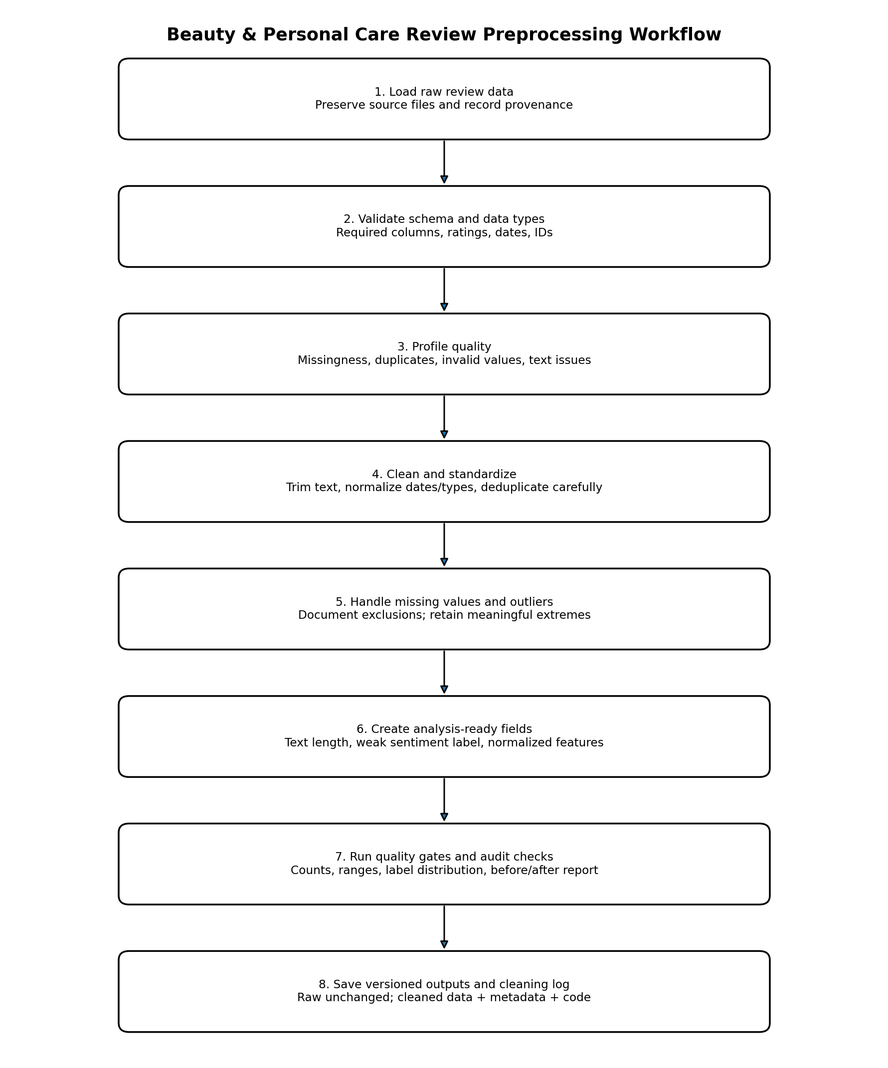
Figure 1. Recommended sequence from immutable raw files to validated, versioned analysis-ready outputs.

12. Work Plan (30–35 Hours)
Activity | Estimated hours | Evidence / output
Inspect source schema and document data provenance | 3 | Schema notes, input manifest
Profile missingness, duplicates, ranges, and text quality | 5 | Baseline quality report and plots
Implement standardization and deduplication rules | 6 | Cleaning functions and tests
Implement missing-value and outlier policies | 5 | Exclusion/flag log and rationale
Create features and weak sentiment labels | 3 | Analysis-ready columns and label counts
Run quality gates and compare before/after data | 4 | Validation report
Document pipeline, flowchart, and reproducibility | 4 | Word report, workflow diagram, run notes
Review limitations and prepare handoff for analysis/modeling | 2 | Final checklist and next-step notes
Total | 32 | Within the 30–35 hour assignment scope

13. Risks, Limitations, and Mitigations
- Sampling bias: one-shard pilot is not representative. Mitigation: sample across available shards/files and report coverage.
- Class imbalance: pilot labels are heavily positive. Mitigation: stratified evaluation, macro-F1, class-level metrics, and no misleading accuracy-only claim.
- Weak labels: ratings can disagree with review text. Mitigation: clearly name labels rating-derived and conduct optional disagreement/sensitivity checks.
- Over-cleaning: deleting long, critical, or unusual reviews can remove meaningful evidence. Mitigation: flag first; delete only for documented invalidity.
- Schema variation: source files may not contain all expected columns. Mitigation: inspect schema and conditionally process fields.
- Language detection errors: short product reviews can be misclassified. Mitigation: confidence threshold, manual sample inspection, and documented uncertainty.
- Data access and terms: public availability does not remove source terms or privacy considerations. Mitigation: cite the source, use only necessary fields, and avoid redistributing raw data unnecessarily.

14. Deliverables and Completion Criteria
- A documented cleaning and preprocessing strategy with field-level decisions.
- A flowchart showing the sequence and rationale of processing stages.
- Python/pandas pseudocode illustrating core transformations.
- A before/after quality summary when the pipeline is executed on the full working sample.
- A reproducible log of row counts, exclusions, missingness, duplicate handling, and label distribution.

15. References
- Amazon Reviews 2023 dataset (project primary source): https://amazon-reviews-2023.github.io/
- pandas documentation: https://pandas.pydata.org/docs/
- NumPy documentation: https://numpy.org/doc/
- scikit-learn documentation: https://scikit-learn.org/stable/
- Matplotlib documentation: https://matplotlib.org/stable/

Appendix A — Suggested Cleaning Log Fields
run_id, run_timestamp_utc, source_name, source_file, source_checksum, code_version, input_rows, output_rows, missing_text_rows, missing_rating_rows, invalid_rating_rows, exact_duplicates_removed, duplicate_ids_removed, language_exclusions, rows_excluded_from_text_model, outlier_flags, final_negative_count, final_neutral_count, final_positive_count, package_versions, notes.

Appendix B — Recommended Output Structure
data/
raw/ # source files; do not overwrite or commit large data
processed/
reviews_cleaned.parquet
cleaning_quality_summary.csv
cleaning_run_metadata.json
src/
prepare_data.py
validate_data.py
reports/
week_03_data_cleaning_and_preprocessing_pipeline.docx
results/
week_03_quality_checks/

16. Practical Execution and Validation Results
The illustrative pipeline was executed locally against the 5,000-row pilot file data/processed/beauty_reviews_pilot.csv. The first run exposed a timestamp parsing issue: the numeric review_date values were interpreted as nanoseconds instead of milliseconds. The script was corrected to parse numeric Unix timestamps with unit='ms', and a second run produced the validated output beauty_reviews_pilot_cleaned_v2.csv and the summary week_03_cleaning_quality_summary_v2.json. The original pilot file was preserved.
Validation check | Observed result | Interpretation
Input and output rows | 5,000 → 5,000 | All pilot records were preserved.
Output shape | 5,000 rows × 18 columns | Cleaning and feature columns were added.
Missing values in cleaned output | 0 | No null values were detected by pandas in the final 18 columns.
Blank review text | 0 | No blank original or cleaned review text was detected by the validation check.
Invalid ratings | 0 | All ratings were in the expected 1–5 set.
Duplicate output rows | 0 | No exact duplicate rows remained.
Parsed date values missing | 0 | All 5,000 dates parsed after the millisecond correction.
Date range | 2009-01-11 to 2023-03-14 UTC | Range is consistent with a historical review dataset; timestamps are normalized to UTC.
Review-length outliers | 162 flagged | Flagged using IQR fences; not automatically removed.
Text-model eligible rows | 5,000 | All records had non-empty cleaned text and a valid rating-derived label.

16.1 Rating and sentiment distribution
Rating-derived sentiment | Count | Share
Positive | 4,242 | 84.84%
Negative | 380 | 7.60%
Neutral | 378 | 7.56%
The original sentiment field and the new sentiment_label agreed on all 5,000 rows in this pilot. This is a consistency check, not independent evidence that the labels represent human sentiment accurately. The labels are rating-derived weak labels and should be described that way in downstream analysis.

16.2 Interpretation and limitations
- The successful checks describe this 5,000-row pilot only; they do not establish that a broader category-level sample is representative.
- The 84.84% positive share indicates class imbalance in this pilot. Later modelling should report macro-F1, balanced accuracy, per-class precision/recall, and a confusion matrix.
- The 162 review-length outliers remain in the dataset. They should be inspected or handled only under a documented, justified rule; long reviews can contain valid and useful experiences.
- The source includes a pre-existing sentiment field that matched the rating-derived label exactly in this sample. Preserve both fields and document their relationship rather than treating them as independent targets.
- The corrected date parsing uses Unix milliseconds for numeric values and stores a UTC-normalized timestamp in review_date_utc. Keep the original review_date field for traceability.

16.3 Output artifacts from the local run
- Cleaned data: data/processed/beauty_reviews_pilot_cleaned_v2.csv
- Quality summary: results/week_03_cleaning_quality_summary_v2.json
- Cleaning script: src/clean_reviews.py
- Original pilot preserved: data/processed/beauty_reviews_pilot.csv

