WEEK 4 PROJECT REPORT

Building and Evaluating
a Financial Forecast Model
Next-Day Stock Closing Price Prediction

Prepared by | Sommay Dewat
Project | Financial Analytics with Python — Week 4
Modeling task | Predict the next available day's closing price
Dataset | Simulated OHLCV financial time-series data

A documented forecasting workflow covering data preparation, chronological validation, model comparison, error analysis, and practical limitations.

Executive Summary
This project develops and evaluates a basic next-day closing-price forecasting workflow using a simulated financial dataset. The dataset contains 499 observations and eight original fields: Date, Open, High, Low, Close, Volume, Price_Change, and Daily_Return_Pct. After converting dates, creating a next-day closing-price target, and removing rows with missing modeling values, 497 rows remained. The data was split chronologically into 397 training observations and 100 test observations, without shuffling.
Two approaches were compared: a Naive Baseline that uses the current close as the next-day estimate, and a Linear Regression model trained on seven available numeric features. On the held-out test set, the baseline recorded MAE 1.2784, RMSE 1.5876, and R² 0.8718; Linear Regression recorded MAE 1.3218, RMSE 1.6241, and R² 0.8658. The baseline therefore had slightly lower absolute and squared prediction errors on this dataset. The result illustrates why a simple benchmark is important: a more complex model does not automatically improve forecast accuracy.
The data is simulated, so the findings are educational and should not be interpreted as evidence of performance on real securities or as investment guidance.

1. Project Objectives
- Prepare historical OHLCV-style data for a supervised next-day closing-price prediction task.
- Select and implement a transparent regression model and a simple benchmark.
- Use a time-ordered train-test split to evaluate predictions on later observations.
- Compare model performance with MAE, RMSE, and R² and inspect prediction errors visually.
- Document limitations and identify improvements needed before any real-world financial application.

2. Dataset and Data Preparation
The project uses a simulated daily financial time series copied into the Week_4/data folder. The original file contains 499 rows and eight columns. Date was initially stored as text and was converted to a datetime type; records were sorted chronologically. The target variable, Target_Next_Day_Close, was created by shifting the Close column by one row toward the past, so each feature row is associated with the following observation's close.
Preparation check | Observed result | Handling / meaning
Original dataset | 499 rows × 8 columns | Simulated OHLCV-style data
Missing values | 1 in Price_Change; 1 in Daily_Return_Pct | Rows with missing features/target removed for modeling
Duplicate rows | 0 | No duplicate rows reported
Modeling dataset | 497 rows × 9 columns | Seven features + target + date
Remaining missing values | 0 | Verified after dropping incomplete modeling rows
Features used: Open, High, Low, Close, Volume, Price_Change, and Daily_Return_Pct. The target was Target_Next_Day_Close. The final target row has no subsequent observation by construction, so it cannot be used as a supervised target.

3. Validation Strategy and Model Selection

Chronological 80:20 split
The observations were kept in time order and split at 80% of the modeling dataset. The first 397 observations were used for training and the final 100 for testing. The training feature-date range shown in the notebook was 2024-01-02 through 2025-07-10; the test feature-date range was 2025-07-11 through 2025-11-27. No random shuffle was applied, which helps prevent later observations from being mixed into the training set.

Model A — Naive Baseline
The baseline predicts the next observation's close using the current row's Close value. This persistence benchmark is simple, interpretable, and useful for testing whether a more involved model adds value.

Model B — Linear Regression
A scikit-learn LinearRegression estimator was fitted using the seven numeric features and the training subset. The trained model generated predictions for the held-out test subset. No random train-test split was used. The project did not include hyperparameter tuning or cross-validation; this was a basic baseline model exercise.

4. Evaluation Metrics and Results
MAE measures the average absolute prediction error in the target's units. RMSE is also expressed in the target's units but penalizes larger errors more strongly. R² describes the proportion of target variation accounted for relative to a constant-mean reference; it should be interpreted alongside error metrics and the baseline.
Model | MAE | RMSE | R²
Naive Baseline | 1.2784 | 1.5876 | 0.8718
Linear Regression | 1.3218 | 1.6241 | 0.8658

Interpretation
The Naive Baseline produced a lower MAE than Linear Regression by 0.0434 and a lower RMSE by 0.0365. Its R² was higher by 0.0060. These differences are modest, but the direction is consistent across the reported metrics: Linear Regression did not outperform the persistence benchmark on this test set. This does not establish that the baseline will perform better on other periods or on real market data.

5. Visual Analysis
The following figures are included from the notebook outputs. The line chart compares observed target closes with both model predictions across the test period. The residual histogram compares error distributions, where residual = actual value − predicted value. Residuals above zero indicate underprediction; below zero indicate overprediction.
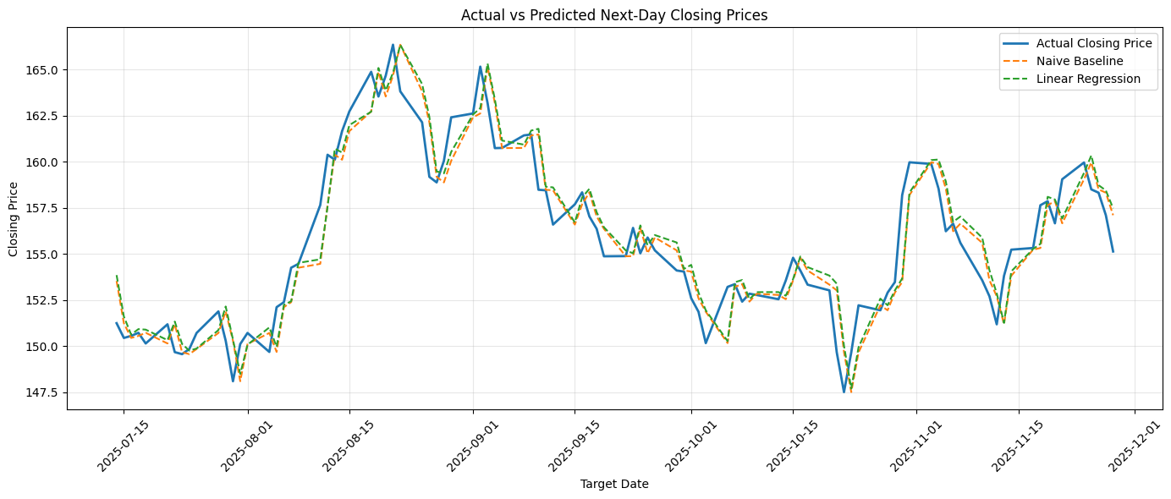
Figure 1. Actual versus predicted next-day closing prices (notebook visualization).
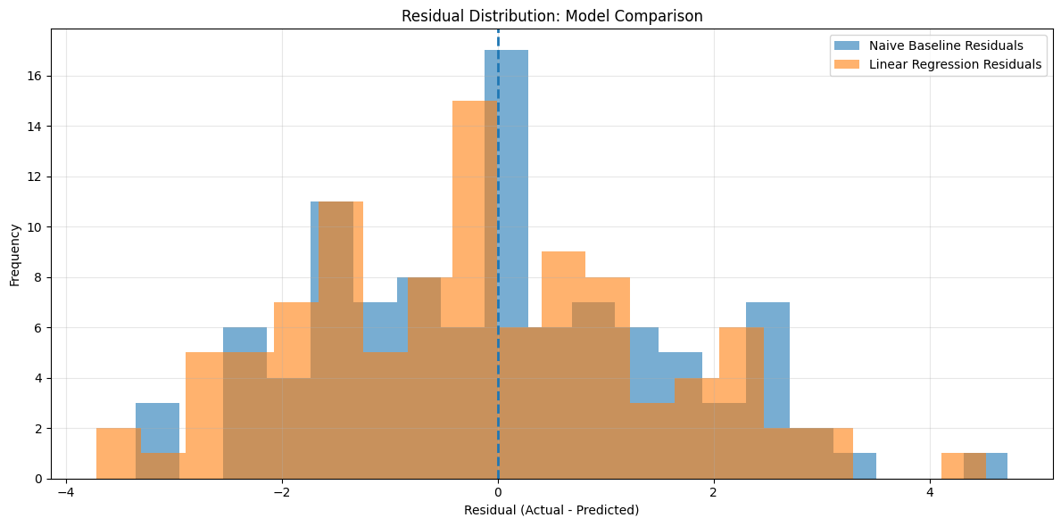
Figure 2. Residual distribution comparison for the Naive Baseline and Linear Regression.

Residual and Error Discussion
The residual histogram shows that both models produce a range of positive and negative errors, with most observations nearer to zero than the most extreme residuals. There are also errors several units away from zero, indicating that neither model captures every movement. A residual histogram alone cannot establish that errors are independent, normally distributed, or stable over time. A fuller analysis would also inspect residuals over time, error autocorrelation, and error size during different market regimes.

6. Code and Output Overview
- Load the CSV with pandas and inspect shape, data types, missing values, and duplicates.
- Convert Date to datetime, sort chronologically, create the shifted next-day target, and remove incomplete modeling rows.
- Select seven predictor columns and split features/target into chronological training and testing subsets.
- Fit LinearRegression and create baseline predictions from the current Close column.
- Calculate MAE, RMSE, and R² for both models and compare the results in a table.
- Generate actual-versus-predicted and residual-distribution plots.
- Export test predictions and evaluation metrics to CSV files.
Expected project outputs:
- Week_4/outputs/forecast_predictions.csv — date-aligned actual values, predictions, and residuals.
- Week_4/outputs/model_evaluation_metrics.csv — model metrics for the two approaches.
- Week_4/visualizations/actual_vs_predicted.png — prediction comparison chart.
- Week_4/visualizations/model_residuals.png — residual histogram.

7. Financial Analytics Applications
A next-day close forecast can serve as a learning example for time-series feature engineering, model validation, and error monitoring. In a professional workflow, forecast outputs might be used as one input to scenario analysis, monitoring dashboards, or research workflows—not as a standalone buy/sell signal. Any deployment would require real, properly licensed data, point-in-time feature availability, transaction-cost and risk considerations, and testing across multiple market conditions.

8. Limitations and Future Improvements
- Synthetic data: The dataset is simulated and may not reproduce real market dynamics, liquidity, volatility clustering, gaps, or structural breaks.
- Small test window: Only 100 observations were used for the holdout evaluation; results may vary substantially across other periods.
- Limited model scope: Only a persistence baseline and ordinary Linear Regression were compared. No regularization, time-series model, or tree-based model was tested.
- Feature timing: In a real forecasting setup, every predictor must be known at the forecast timestamp. Features such as same-day High, Low, Close, and return values must be aligned carefully to avoid look-ahead leakage.
- Validation depth: A single chronological holdout is a useful first check, but rolling-origin or walk-forward validation would provide a more robust view.
- Metric context: R² is not a measure of trading profitability and should not be treated as a financial decision rule.
Recommended next steps are to verify target-date alignment end-to-end, add a walk-forward validation scheme, compare with additional simple time-series benchmarks, inspect residuals over time, and document feature availability explicitly before testing on real financial data.

9. Conclusion
This project completed a reproducible introductory forecasting workflow: data inspection and preparation, target construction, chronological splitting, model fitting, baseline comparison, quantitative evaluation, visualization, and export of results. On the held-out simulated data, the Naive Baseline slightly outperformed Linear Regression on MAE, RMSE, and R². The main lesson is to evaluate predictive models against simple benchmarks and interpret results in the context of data quality, validation design, and limitations. The work is an educational exercise and is not intended for investment decisions.

Appendix: Evaluation Snapshot
The metrics reported in this document match the notebook's displayed comparison table. The output CSVs should be retained with the notebook so the reported results can be checked and reproduced.

